VLSI Design
EEL-6167

Professor: Dr. Subbarao Wunnava

Florida International University
Department of Electrical and Computer Engineering

Silos III supplement

Submitted by

Bangalore K. Rao

Vinayak Ganapathy

03/09/2004
Solution A: Silos simulation for NAND2 (2-input NAND gate)

The Silos III simulation graph for simulating NAND2 is shown below:
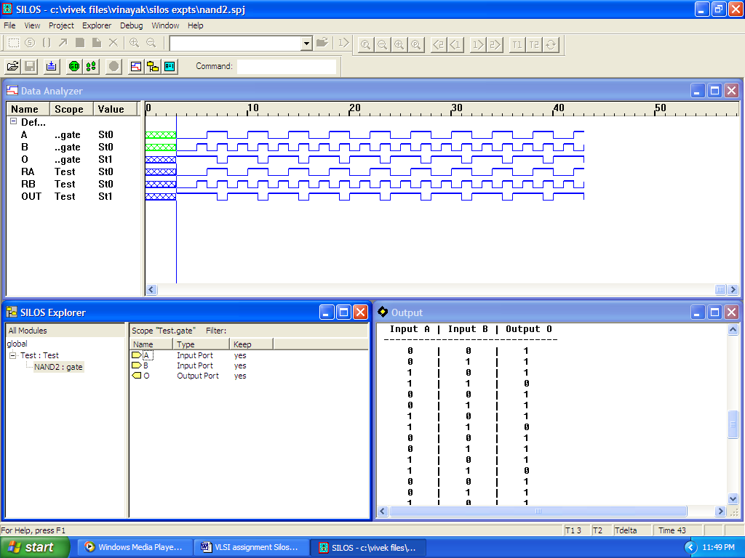

The Verilog HDL code for the same is below:
// Verilog HDL testbed for NAND2 gate.
// B. K. Kiran Rao & Vinayak Ganapathy

module NAND2 (A, B, O);
input A, B;
output O;
assign O = ~(A&B);
endmodule

module Test;
reg RA, RB;
wire OUT;

initial begin
#3 RA = 0; RB = 0;
repeat (10)
begin
#1 RA = 0; RB = 0;
#1 RA = 0; RB = 1;
#1 RA = 1; RB = 0;
#1 RA = 1; RB = 1;
end
end

initial begin
#1 $display (" Input A | Input B | Output O");
#2 $display ("------------------------------");
$monitor (" %b | %b | %b", RA, RB, OUT);
end

NAND2 gate(RA, RB, OUT);
endmodule

Simulation code output for NAND2 is as follows:
!file .sav="nand2"
!control .sav=3
!control .savcell=0
!control .disk=1000M

Reading "nand2.v"
sim to 0
Highest level modules (that have been auto-instantiated):
Test
3 total devices.
Linking ...

4 nets total: 12 saved and 0 monitored.
66 registers total: 66 saved.
Done.

0 State changes on observable nets.
Simulation stopped at the end of time 0.
Ready: sim
Input A | Input B | Output O
------------------------------
0 | 0 | 1
0 | 1 | 1
1 | 0 | 1
1 | 1 | 0
0 | 0 | 1
0 | 1 | 1
1 | 0 | 1
1 | 1 | 0
0 | 0 | 1
0 | 1 | 1
1 | 0 | 1
1 | 1 | 0
0 | 0 | 1
0 | 1 | 1
1 | 0 | 1
1 | 1 | 0
0 | 0 | 1
1 | 1 | 0
140 State changes on observable nets.

Simulation stopped at the end of time 43.
Ready:
Solution B: Silos simulation for NOR2 (2-input NOR gate)

The Silos III simulation graph for simulating NOR2 is shown below:
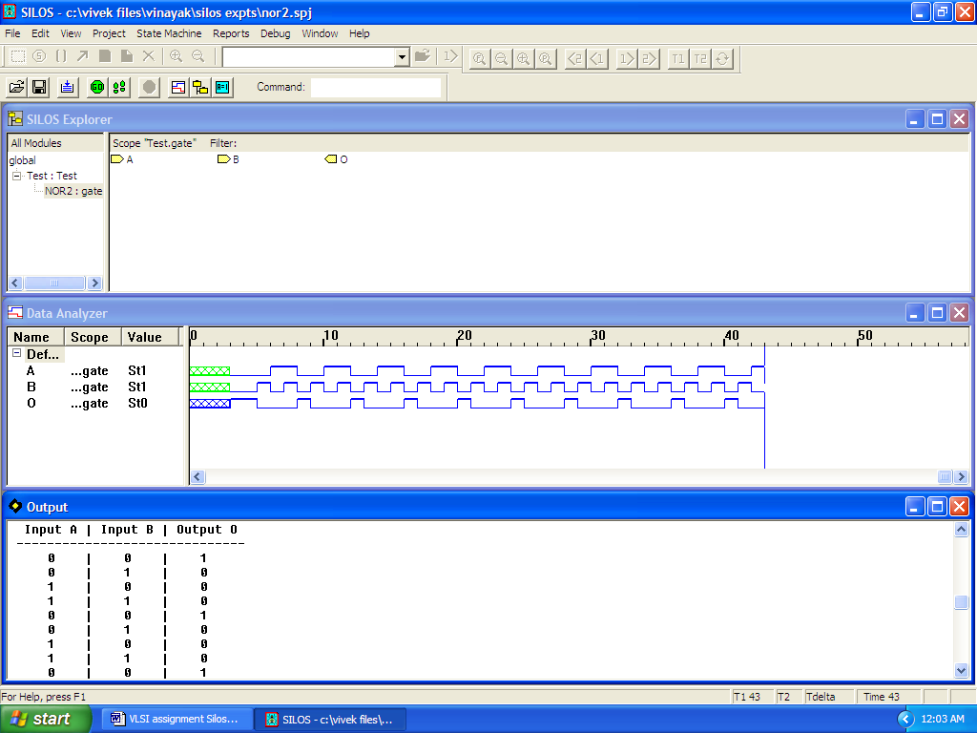

The Verilog HDL code for the same is below:
// Verilog HDL testbed for NOR2 gate.
// B. K. Kiran Rao & Vinayak Ganapathy

module NOR2 (A, B, O);
input A, B;
output O;
assign O = ~(A|B);
endmodule

module Test;
reg RA, RB;
wire OUT;

initial begin
#3 RA = 0; RB = 0;
repeat (10)
begin
#1 RA = 0; RB = 0;
#1 RA = 0; RB = 1;
#1 RA = 1; RB = 0;
#1 RA = 1; RB = 1;
end
end

initial begin
#1 $display (" Input A | Input B | Output O");
#2 $display ("------------------------------");
$monitor (" %b | %b | %b", RA, RB, OUT);
end

NOR2 gate(RA, RB, OUT);
endmodule

Simulation code output for NOR2 is as follows:
!file .sav="nor2"
!control .sav=3
!control .savcell=0
!control .disk=1000M

Reading "nor2.v"
sim to 0
Highest level modules (that have been auto-instantiated):
(Test Test
3 total devices.
Linking ...

4 nets total: 12 saved and 0 monitored.
66 registers total: 66 saved.
Done.

0 State changes on observable nets.

Simulation stopped at the end of time 0.
Ready: sim
Input A | Input B | Output O
------------------------------
0 | 0 | 1
0 | 1 | 0
1 | 0 | 0
1 | 1 | 0
0 | 0 | 1
0 | 1 | 0
1 | 0 | 0
1 | 1 | 0
0 | 0 | 1
0 | 1 | 0
1 | 0 | 0
1 | 1 | 0
0 | 0 | 1
0 | 1 | 0
1 | 0 | 0
1 | 1 | 0
0 | 0 | 1
0 | 1 | 0

140 State changes on observable nets.
Simulation stopped at the end of time 43.
Ready:
Solution C: Silos simulation for NAND4 (4-input NAND gate)

The Silos III simulation graph for simulating NAND4 is shown below:
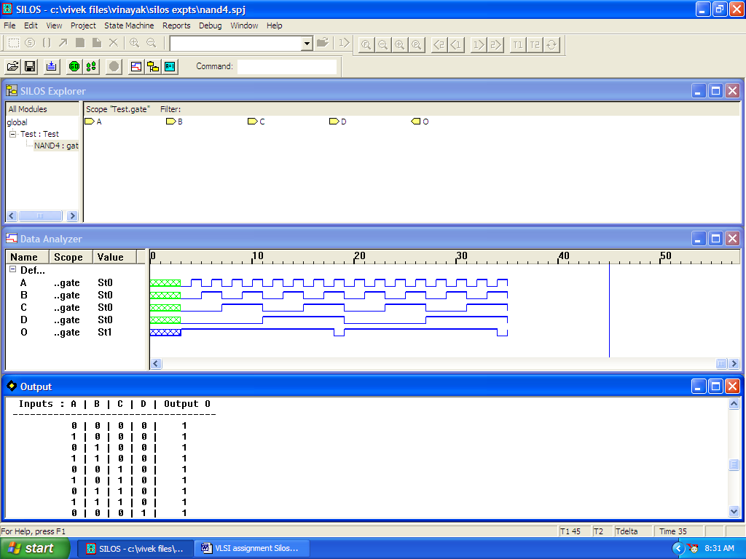

The Verilog HDL code for the same is below:
// Verilog HDL testbed for NAND4 gate.
// B. K. Kiran Rao & Vinayak Ganapathy

module NAND4 (A, B, C, D, O);
input A, B, C, D;
output O;
assign O = ~(A & B & C & D);
endmodule

module Test;
reg [4:0] R;
wire OUT;

initial begin
#3 R = 4'b0000;
repeat (32)
begin
#1 R = R + 1;
end
end

initial begin
#1 $display (" Inputs : A | B | C | D | Output O");
#2 $display ("-----------------------------------");
$monitor (" %b | %b | %b | %b | %b", R[0], R[1], R[2], R[3], OUT);
end

NAND4 gate(R[0], R[1], R[2], R[3], OUT);
endmodule

Simulation code output for NAND4 is as follows:
!file .sav="nand4"
!control .sav=3
!control .savcell=0
!control .disk=1000M

Reading "nand4.v"
sim to 0
Highest level modules (that have been auto-instantiated):
Test
3 total devices.
Linking ...

6 nets total: 14 saved and 0 monitored.
69 registers total: 69 saved.
Done.

0 State changes on observable nets.
Simulation stopped at the end of time 0.
Ready: sim
Inputs : A | B | C | D | Output O
-----------------------------------
0 | 0 | 0 | 0 | 1
1 | 0 | 0 | 0 | 1
0 | 1 | 0 | 0 | 1
1 | 1 | 0 | 0 | 1
0 | 0 | 1 | 0 | 1
1 | 0 | 1 | 0 | 1
0 | 1 | 1 | 0 | 1
1 | 1 | 1 | 0 | 1
0 | 0 | 0 | 1 | 1
1 | 0 | 0 | 1 | 1
0 | 1 | 0 | 1 | 1
1 | 1 | 0 | 1 | 1
0 | 0 | 1 | 1 | 1
1 | 0 | 1 | 1 | 1
0 | 1 | 1 | 1 | 1
1 | 1 | 1 | 1 | 0
0 | 0 | 0 | 0 | 1
1 | 0 | 0 | 0 | 1
0 | 1 | 0 | 0 | 1
1 | 1 | 0 | 0 | 1
0 | 0 | 1 | 0 | 1

136 State changes on observable nets.
Simulation stopped at the end of time 35.
Ready:
Solution C: Silos simulation for NOR4 (4-input NOR gate)

The Silos III simulation graph for simulating NOR4 is shown below:
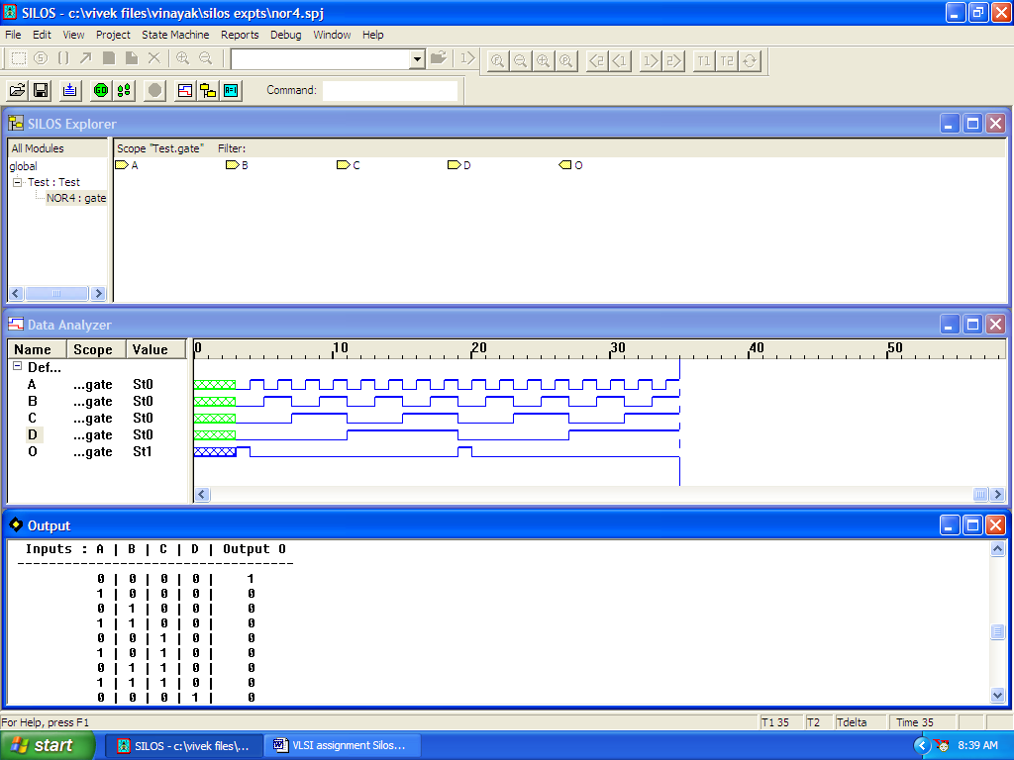

The Verilog HDL code for the same is below:
// Verilog HDL testbed for NOR4 gate.
// B. K. Kiran Rao & Vinayak Ganapathy

module NOR4 (A, B, C, D, O);
input A, B, C, D;
output O;
assign O = ~(A | B | C | D);
endmodule

module Test;
reg [4:0] R;
wire OUT;

initial begin
#3 R = 4'b0000;
repeat (32)
begin
#1 R = R + 1;
end
end

initial begin
#1 $display (" Inputs : A | B | C | D | Output O");
#2 $display ("-----------------------------------");
$monitor (" %b | %b | %b | %b | %b", R[0], R[1], R[2], R[3], OUT);
end

NOR4 gate(R[0], R[1], R[2], R[3], OUT);
endmodule

Simulation code output for NOR4 is as follows:
!file .sav="nor4"
!control .sav=3
!control .savcell=0
!control .disk=1000M

Reading "nor4.v"
sim to 0
Highest level modules (that have been auto-instantiated):
Test
3 total devices.
Linking ...

6 nets total: 14 saved and 0 monitored.
69 registers total: 69 saved.
Done.

0 State changes on observable nets.
Simulation stopped at the end of time 0.
Ready: sim
Inputs : A | B | C | D | Output O
-----------------------------------
0 | 0 | 0 | 0 | 1
1 | 0 | 0 | 0 | 0
0 | 1 | 0 | 0 | 0
1 | 1 | 0 | 0 | 0
0 | 0 | 1 | 0 | 0
1 | 0 | 1 | 0 | 0
0 | 1 | 1 | 0 | 0
1 | 1 | 1 | 0 | 0
0 | 0 | 0 | 1 | 0
1 | 0 | 0 | 1 | 0
0 | 1 | 0 | 1 | 0
1 | 1 | 0 | 1 | 0
0 | 0 | 1 | 1 | 0
1 | 0 | 1 | 1 | 0
0 | 1 | 1 | 1 | 0
1 | 1 | 1 | 1 | 0
0 | 0 | 0 | 0 | 1
1 | 0 | 0 | 0 | 0
0 | 1 | 0 | 0 | 0
1 | 1 | 0 | 0 | 0
0 | 0 | 1 | 0 | 0

136 State changes on observable nets.
Simulation stopped at the end of time 35.
Ready:
Solution D: Silos simulation for MUX4 (4:1 Multiplexer)

The Silos III simulation graph for simulating MUX4 is shown below:
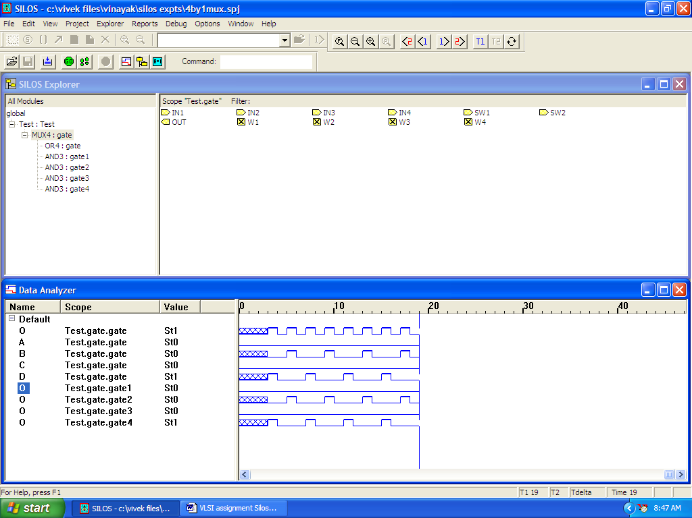

The Verilog HDL code for the same is below:
// Verilog HDL testbed for MUX4 gate.
// B. K. Kiran Rao & Vinayak Ganapathy

module AND3 (A, B, C, O);
input A, B, C;
output O;
assign O = A & B & C;
endmodule

module OR4 (A, B, C, D, O);
input A, B, C, D;
output O;
assign O = A | B | C | D;
endmodule

module MUX4 (IN1, IN2, IN3, IN4, SW1, SW2, OUT);
input IN1, IN2, IN3, IN4, SW1, SW2;
output OUT;
wire W1, W2, W3, W4;

// 3-input AND gates will switch:
AND3 gate1(IN1, SW1, SW2, W1);
AND3 gate2(IN2, ~SW1, SW2, W2);
AND3 gate3(IN3, SW1, ~SW2, W3);
AND3 gate4(IN4, ~SW1, ~SW2, W4);

// ADD the AND3 outputs for MUX4 output
OR4 gate(W1, W2, W3, W4, OUT);
endmodule

module Test;
reg [2:0] SW;
wire OUT;

initial begin
#3 SW = 2'b00;
repeat (16)
begin
#1 SW = SW + 1;
end
end

initial begin
#1 $display (" Inputs: SW1 | SW2 | Output O");
#2 $display ("------------------------------");
$monitor (" %b | %b | %b", SW[0], SW[1], OUT);
end

MUX4 gate(1'b0, 1'b1, 1'b0, 1'b1, SW[0], SW[1], OUT);
endmodule

Simulation code output for MUX4 is as follows:
!file .sav="4by1mux"
!control .sav=3
!control .savcell=0
!control .disk=1000M

Reading "mux4.v"
sim to 0
Highest level modules (that have been auto-instantiated):
Test
8 total devices.
Linking ...

10 nets total: 18 saved and 0 monitored.
67 registers total: 67 saved.
Done.

0 State changes on observable nets.
Simulation stopped at the end of time 0.
Ready: sim
Inputs: SW1 | SW2 | Output O
------------------------------
0 | 0 | 1
1 | 0 | 0
0 | 1 | 1
1 | 1 | 0
0 | 0 | 1
1 | 0 | 0
0 | 1 | 1
1 | 1 | 0
0 | 0 | 1
1 | 0 | 0
0 | 1 | 1
1 | 1 | 0
0 | 0 | 1
1 | 0 | 0
0 | 1 | 1
1 | 1 | 0
0 | 0 | 1

118 State changes on observable nets.
Simulation stopped at the end of time 19.
Ready:

Conclusion:

Silos III is a good tool to extend the level of abstraction of circuits from transistor (Switch Level) to gates and registers (Register Transfer Level). Unlike Aim-Spice and MicroCap which use Berkeley SPICE language, the Silos III analysis tool uses Verilog HDL which is similar to “C” programming language with which most engineers of today are familiar. Like SPICE, Verilog has an initial learning curve. Once learnt, the simulation at gate and register level is significantly easy with automatic generation of timing waveforms which are critically important to electrical engineers.

