Department of Electrical and Computer Engineering
Florida International University
Miami, FL

EEL-6167 VLSI DESIGN
SPRING 2004 TERM PROJECT

Mirror Circuits: Design and Simulation

Craig Chin 589-81-5491
Miguel Alonso Jr. 593-72-2253

Instructor: Dr. Subbarao Wunnava

Introduction
It is generally desired to produce fast, robust, VLSI designs. There exist several methods that have been developed. These designs often overcome problems that have arisen with the increasing use and speed of VLSI networks. One of these techniques comes in the form of mirror circuits.
Mirror circuits are based on series-parallel configurations of MOSFETs. The layout is similar to the and-or-invert (AOI) structure commonly used for compressing three or more primitive operations into a single logic gate [4]. As can be seen in figure 1, the basic structure for a one and two input gate structure is symmetric about the junction where the pFET array meets the nFET array. This point is usually the output of the gate.

(a) (b)
Figure 1- Mirror Circuit for (a) Inverter and (b) Generic two input logic gate
It is important to realize that the two-FET inverter is an example of the simplest mirror circuit. Another consequence of mirror circuits can be observed by analyzing figure1b. Any two-input logic gate, NAND, NOR, EXOR, or EXNOR can be constructed using the mirror circuit structure. The various functionalities are implemented by varying the inputs at each gate. This is a very important consequence when laying out logic circuits based on these types of gates. Only one general layout is necessary. The various logic gates are implemented by using connections on different layers in the silicon layout. This simplifies the layout process ten fold, allowing for the quick design of very complex circuits.
There is, however, one drawback to using mirror circuits. The rise times and fall times of the EXOR and EXNOR gates are shorter than their AOI counterparts, but the same cannot be said about the AND and NOR gates. If we use an RC switch model, such as Uyemura does in Chapter 9 [4], we arrive at the time constants shown in table 1.
Table 1- Rise Times and fall times of Mirror Circuits vs. Conventional Circuits

The rise times and fall times of the NAND and NOR gates are a slight bit longer.

Methods
There several CAD tools that aid the engineering in designing VLSI circuits and systems. Among those, are aimspice, winspice, pspice, VHDL, verilog, Mentorgraphics ASIC Design Suite, LASI, just to name a few.
Once the layouts have been completed, the next step would be to send the layout to be manufactured in the form of an IC. MOSIS, a US-based company, provides low-cost prototyping and low-volume production for VLSI circuit development.
The circuits to be explored ( Inverter, NAND, NOR, EXOR, D Flip Flop, 4 bit counter, and 4 bit shift register), will be designed using a combination of Orcad’s PSPICE for the circuit simulation, and the LASI utility for designing the physical layout.

Mosis
The website, www.mosis.org, provides information on design rules for various processes, along with the scalable CMOS (SCMOS) design rule set. Most of the processing from various vendors that Mosis offers is compatible with the SCMOS design rule set. Additionally, the site offers PSPICE process parameters for many of the vendor processes which they offer, such as the Taiwan Semiconductor Manufacturing Corporation (TSMC).

SCMOS
The scalable CMOS (SCMOS) design rule set allows for flexibility when designing the layout for VLSI circuits. These design rules, shown in figures 2 and 3, are based on reference measurement lambda (λ), which has units in microns. All of the dimensions in the layout are written in the form

$\text{Value}=mλ$[4]

Thus, for example, W=4λ and L=2 λ. This makes the physical layout independent of the process. In order to submit to any process, λ must be assigning a physical value [3]. Then, all of the scaled measurements become physical measurement. This is advantageous for example, when one type of process becomes too expensive and another cheaper process is needed. There is no need to redesign the entire layout. It is simply a matter of changing the physical value of lambda in the CAD program.

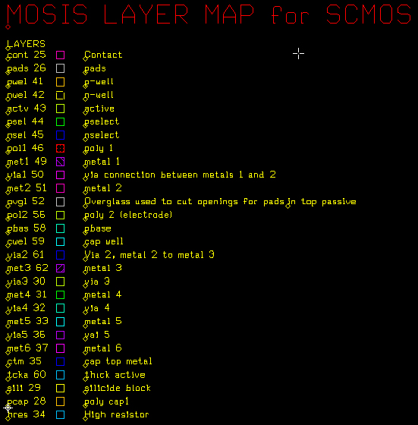
Figure 2- Layer Map for SCMOS
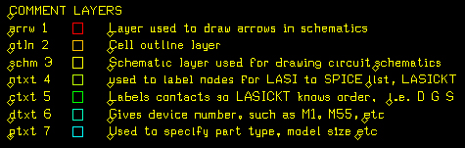
Figure 3- Layer Map for SCMOS (cont'd)

LASI
The Mosis website offers information on various CAD tools available. One tool listed, LASI, is available free from http://members.aol.com/lasicad [1]. This tool combines the layout process with PSPICE, giving a very accurate representation of the physical model using SPICE. It auto-route layouts, calculate parasitic capacitances, and provide circuit files for use during SPICE simulation. Additionally, it has the capability of perform design rule checks for a set of design rules. In this case, the design rules used were those available for the SCMOS type design provided by Mosis.

TSMC
The Taiwan Semiconductor Manufacturing Corporation (TSMC) was chosen to be the process because their process parameters are the only ones available on the Mosis website. All other vendors do not offer process parameters free to public unless paperwork is filed to obtain the usage rights. Details can be found at www.mosis.org [2].
Specifically, the TSMC35 P2 process was chosen. This process is well suited for 5 Volt designs, offering VIA3 and METAL4 for, with the pad stacks on METAL4. These are more than enough layers for the designs being explored.
The SPICE parameters used can be found in appendix A, and they are also available through the Mosis website.

Circuit Diagrams and Layouts
Since the process parameters have already been defined, in order to provide an accurate model for simulation, the length and width of the NFET and PFET were specified to be

$L_{n}=0\text{.}7μm$ $\text{Wn}=1\text{.}4μm$ $L_{p}=0\text{.}7μm$ $\text{Wp}=3\text{.}5μm$

The (W/L) ratio for the NFET is 2 and for the PFET is 5, in order to maintain the device trans-conductance’s the same [4]. These values, in addition to the spice model parameters, are used for performing the circuit simulations for the Inverter, NAND, NOR, EXOR, and the D Flip Flop. The reader is directed to Digital Design (3rd Edition) by M. Morris Mano, for an in depth description of the functionality of the basic logic gates.
Taking advantage of the CAD tools, it very easy to create complex logic circuits for simulation, such as the 4 bit counter or shift register by employing the sub-circuit or sub-cell feature. Beginning with the basic gates, namely the inverter, nand, and nor gates, the gates are designed and tested. Once the gates have been designed, a hierarchical structure is setup so that each transistor circuit becomes a general input-output sub-circuit block. Then, in the next hierarchical level, circuits composed of inverter blocks, nand block, or nor block can be constructed. This is the case for the design of the D Flip Flop, as shown in figures 14 and 15. A D Latch is first created using the sub-circuits for the nand and inverter gates. A similar procedure is used to create the final edge-triggered D Flip Flop.

Basic NMOS/PMOS FETS
The basic NMOS gate is fabricated on a p-type substrate. The drain and source are both n-plus doped regions, with the gate being composed of poly-silicon. The gate oxide layer thickness can be found in the process parameters. As can be seen by the figures, the pMOS FET is about 2.5 times bigger than the nMOS FET, in order to keep the transconductances more or less equal. Also, in order to prevent latch-up, the sources of both FET are connected to their respective substrate regions. This provides a path for any currents that would otherwise result in the latch up condition .The layer map shown in figures 2 and 3 can be used to understand the various layers in the design.

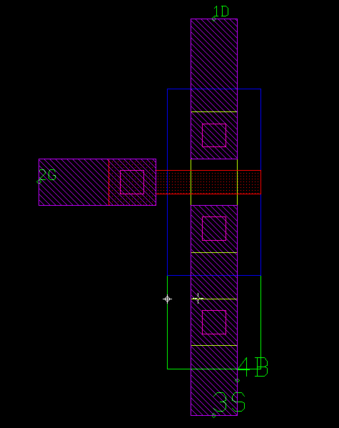
Figure 4-NMOS FET Layout

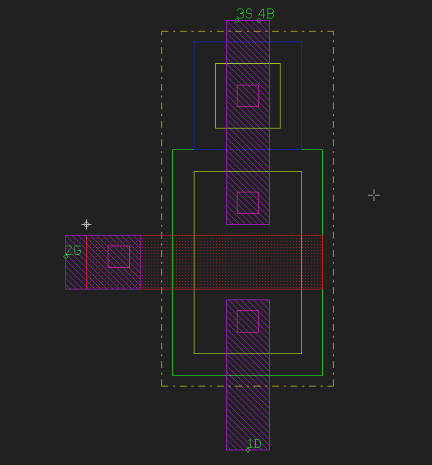
Figure 5- PMOS FET Layout

Inverter
The schematic for the Inverter gate is shown in figure 4. The inverter is composed of a mirror circuit consisting of one pMOS and one nMOS FET. This is the most primitive logic device. The corresponding silicon layout is shown in figure 5. In order to simplify the understanding, it is understood that the Vdd and GND nodes are connected to the respective power and ground layers. The basic FETs are used as low level cells to create the higher level Inverter layout in LASI. The remaining gates, NAND, NOR, EXOR are designed in the same fashion, with the routing for these cells done by hand. The more complex D Flip Flop, Counter, and Shift Register are designed in a similar fashion except that the routing is done automatically by the LASI software.

Figure 6- Inverter Schematic
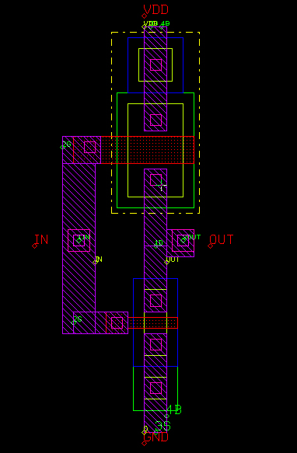
Figure 7- Inverter Layout

NAND

Figure 8-NAND Gate Schematic
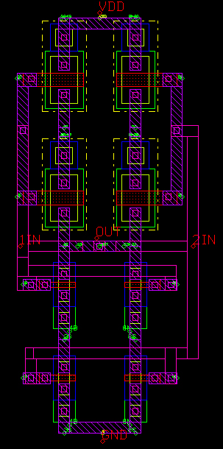
Figure 9-NAND Layout

NOR
Figure 10-NOR Gate Schematic
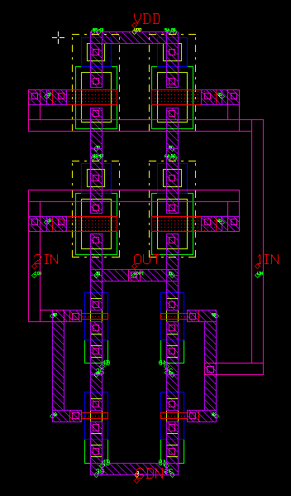
Figure 11-NOR Layout

EXOR
Figure 12-EXOR Gate Schematic
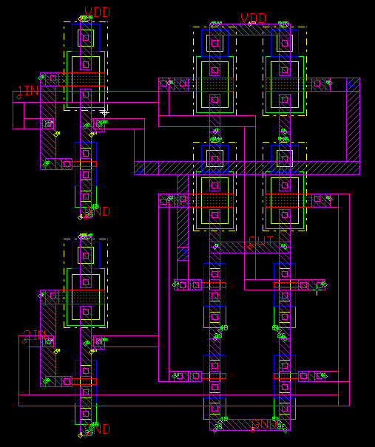
Figure 13-EXOR Layout

Edge Triggered D Flip Flop

Figure 14-D Latch Schematic

Figure 15- D Flip Flop Schematic (Made from basic latch in figure 12)
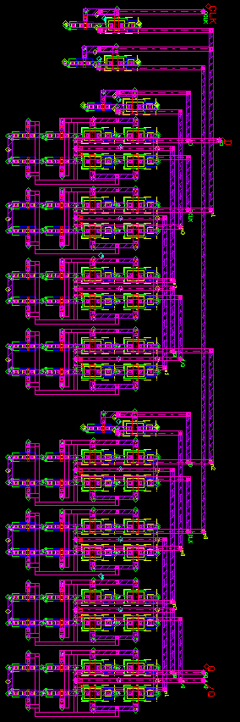
Figure 16- D Flip-Flop

4 Bit Counter and Shift Register

Figure 17- D Flip Flop based 4 bit ripple counter

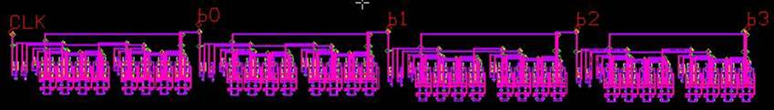
Figure 18- 4 Bit Ripple Counter Layout

Figure 19- D flip flop based 4 bit shift register
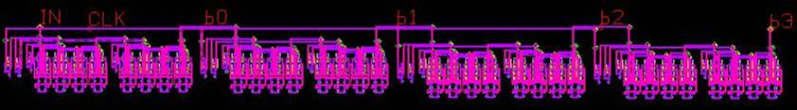

Figure 20- 4 Bit Shift Register Layout

Results of Simulation
The simulation results for the Inverter, NAND, NOR, and EXOR gates, as well as the D Flip Flops are shown in the figures 21 through 35.

Inverter
Figure 21- Inverter Output f=1MHz

Figure 22- Inverter Output f=10MHz

Figure 23- Inverter Output f=100MHz

NAND
Figure 24-NAND Gate output f=1MHz

Figure 25-NAND Gate output f=10MHz

Figure 26-NAND Gate output f=100MHz

NOR
Figure 27-NOR Gate output f=1MHz

Figure 28-NOR Gate output f=10MHz

Figure 29-NOR Gate output f=100MHz

EXOR
Figure 30-EXOR Gate output f=1MHz

Figure 31-EXOR Gate output f=10MHz

Figure 32-EXOR Gate output f=100MHz

D Flip Flop
Figure 33-D Flip Flop Gate output f=1MHz

Figure 34-D Flip Flop Gate output f=10MHz

Figure 35--D Flip Flop Gate output f=100MHz

Discussion
The true limitations of these devices can be seen at 100 MHz. Although the rise times and fall times of the various circuits is independent of the frequency of operation, the operational limitations of the circuitry can only be seen at these high frequencies, when the rise and fall times become significant with respect to the frequency of operation.
The rise times and fall times of the simplest circuit versus the most complex circuit are chosen to be discussed, as they convey the most useful information and allow the reader to grasp the system performance. The times are as follows:
- The rise time for the inverter was .24 ns
- The fall time for the inverter was 0.04 ns
- The propagation delay for the D Flip Flop was 2.72 ns
- The rise time for the D Flip Flop was 2.02 ns
- The fall time for the D Flip Flop was 0.916 ns
It is evident that the rise times and fall times of the Inverter are not remotely equal. This is probably due to the fact that the transconductances are not entirely equal, given the nMOS – pMOS (W/L) ratio scaling factor of 2.5. Perhaps another scaling factor will produce better results. It is also interesting to note that the rise time and fall time of the D Flip Flip is significantly higher. This is due to the loading effects of the various sub-circuits used in the design of the Flip Flop. Another consequence of the loading effects is the propagation delay, reaching a value of 2.72 ns for the D Flip Flop. Again, this is the inherent nature of these devices.

Conclusion
Mirror Circuits were investigated using the various tools available, namely Orcad’s PSPICE and the LASI layout tool. These tools are very powerful in the design of transistor level devices. They are not practical, however, for the design of million transistor systems. They can be used to develop the foundations basic cells in FPGA’s for example, with the higher level design taking place using tools such as VHDL, Verilog, or SystemC.
The advantage of using mirror circuits comes in the layout process. It is much easier to design one highly optimized “blank” mirror circuit layout, than to design layouts for different gates. Mirror circuits do, however, experience changes in the rise and fall times when compared to their minimal realization counter parts. In critical applications, minimal realization of logic circuits and custom layouts and routing can provide tighter rise and fall times, as well as propagation delays and setup and hold times.
This is evident from the simulation plots
In general, in order to improve the performance of the various circuits, there several suggestions:
- Select a better process that allows for smaller geometries
- Since the SCMOS design convention was used, there is no need to redesign the layouts, it is simply a matter of rescaling them
- Perhaps, if the above does not improve performance, the placement of the various sub-cells can be improved to minimize metallization paths

References

Appendix A- CODE - PSPICE MODELS – PROCESS Parameters

FET Models
.model MbreaknD NMOS ( LEVEL = 7
+VERSION = 3.1 TNOM = 27 TOX = 7.7E-9
+XJ = 1E-7 NCH = 2.2E17 VTH0 = 0.4737706
+K1 = 0.5824799 K2 = 8.11778E-3 K3 = 96.2727323
+K3B = -6.1947761 W0 = 2.700191E-5 NLX = 2.083266E-7
+DVT0W = 0 DVT1W = 0 DVT2W = 0
+DVT0 = 4.3980137 DVT1 = 0.7171277 DVT2 = -0.1080294
+U0 = 362.8973445 UA = -7.42132E-10 UB = 2.200466E-18
+UC = 3.827538E-11 VSAT = 1.452933E5 A0 = 1.1270999
+AGS = 0.1655255 B0 = 1.060433E-6 B1 = 5E-6
+KETA = 2.011502E-3 A1 = 0 A2 = 0.4936368
+RDSW = 855.0105543 PRWG = -0.0459015 PRWB = -0.0966899
+WR = 1 WINT = 1.486341E-7 LINT = 5.292541E-10
+XL = -5E-8 XW = 1.5E-7 DWG = -4.068542E-9
+DWB = 8.2373E-9 VOFF = -0.0796631 NFACTOR = 1.2068796
+CIT = 0 CDSC = 2.4E-4 CDSCD = 0
+CDSCB = 0 ETA0 = 0.7492832 ETAB = -0.0390417
+DSUB = 0.78159 PCLM = 1.490984 PDIBLC1 = 1.944604E-3
+PDIBLC2 = 5.987715E-7 PDIBLCB = 0.1 DROUT = 0
+PSCBE1 = 7.310861E8 PSCBE2 = 9.494637E-4 PVAG = 0
+DELTA = 0.01 RSH = 79.8 MOBMOD = 1
+PRT = 0 UTE = -1.5 KT1 = -0.11
+KT1L = 0 KT2 = 0.022 UA1 = 4.31E-9
+UB1 = -7.61E-18 UC1 = -5.6E-11 AT = 3.3E4
+WL = 0 WLN = 1 WW = 0
+WWN = 1 WWL = 0 LL = 0
+LLN = 1 LW = 0 LWN = 1
+LWL = 0 CAPMOD = 2 XPART = 0.5
+CGDO = 2.79E-10 CGSO = 2.79E-10 CGBO = 1E-12
+CJ = 8.918562E-4 PB = 0.8 MJ = 0.3534487
+CJSW = 3.57525E-10 PBSW = 0.8146587 MJSW = 0.1331765
+CJSWG = 1.82E-10 PBSWG = 0.8146587 MJSWG = 0.1331765
+CF = 0 PVTH0 = -0.0199259 PRDSW = -87.5466049
+PK2 = 2.754154E-3 WKETA = -7.698947E-4 LKETA = -2.706215E-3 )

.model MbreakpD PMOS ( LEVEL = 7
+VERSION = 3.1 TNOM = 27 TOX = 7.7E-9
+XJ = 1E-7 NCH = 8.52E16 VTH0 = -0.7482928
+K1 = 0.4088906 K2 = -8.575971E-3 K3 = 64.9719334
+K3B = -5 W0 = 5.652246E-6 NLX = 2.411327E-7
+DVT0W = 0 DVT1W = 0 DVT2W = 0
+DVT0 = 2.4385401 DVT1 = 0.6534475 DVT2 = 0.0336004
+U0 = 146.6363388 UA = 1E-10 UB = 1.554136E-18
+UC = -2.50914E-11 VSAT = 1.158448E5 A0 = 0.9834203
+AGS = 0.3498974 B0 = 3.014933E-6 B1 = 5E-6
+KETA = -5.567367E-3 A1 = 0 A2 = 0.6767726
+RDSW = 4E3 PRWG = -0.1174124 PRWB = 0.1956899
+WR = 1 WINT = 1.481075E-7 LINT = 0
+XL = -5E-8 XW = 1.5E-7 DWG = -1.237406E-8
+DWB = 1.314322E-8 VOFF = -0.1341843 NFACTOR = 2
+CIT = 0 CDSC = 2.4E-4 CDSCD = 0
+CDSCB = 0 ETA0 = 0.0247927 ETAB = -5.470312E-3
+DSUB = 0.4066258 PCLM = 4.3395303 PDIBLC1 = 3.712474E-3
+PDIBLC2 = 2.843199E-3 PDIBLCB = -1E-3 DROUT = 0.0493039
+PSCBE1 = 7.972605E10 PSCBE2 = 5.002845E-10 PVAG = 2.4985005
+DELTA = 0.01 RSH = 154.7 MOBMOD = 1
+PRT = 0 UTE = -1.5 KT1 = -0.11
+KT1L = 0 KT2 = 0.022 UA1 = 4.31E-9
+UB1 = -7.61E-18 UC1 = -5.6E-11 AT = 3.3E4
+WL = 0 WLN = 1 WW = 0
+WWN = 1 WWL = 0 LL = 0
+LLN = 1 LW = 0 LWN = 1
+LWL = 0 CAPMOD = 2 XPART = 0.5
+CGDO = 2.75E-10 CGSO = 2.75E-10 CGBO = 1E-12
+CJ = 1.429787E-3 PB = 0.99 MJ = 0.5495301
+CJSW = 3.794122E-10 PBSW = 0.99 MJSW = 0.3012354
+CJSWG = 4.42E-11 PBSWG = 0.99 MJSWG = 0.3012354
+CF = 0 PVTH0 = 3.478791E-3 PRDSW = 33.4845306
+PK2 = 1.529109E-3 WKETA = 2.584294E-3 LKETA = -1.775326E-3 )

Inverter Circuit
* source INVERTER
V_VCC VCC 0 5V
V_V1 N00770 0
+PULSE 0V 5V 0 0.01n 0.01n 0.5u 1u
M_M3 N02689 N00770 0 0 MbreaknD
+ L=0.7e-6
+ W=1.4e-6
+ PD=6.3e-6
+ PS=6.3e-6
M_M4 N02689 N00770 VCC VCC MbreakpD
+ L=1.75e-6
+ W=1.4e-6
+ PD=11.2e-6
+ PS=11.2e-6

NAND Circuit
* source NAND2
V_VCC VCC 0 5Vdc
M_M7 N01025 VA N01118 N01118 MbreaknD
+ L=0.7e-6
+ W=1.4e-6
+ PD=6.3e-6
+ PS=6.3e-6
M_M8 N01118 VB 0 0 MbreakND
+ L=0.7e-6
+ W=1.4e-6
+ PD=6.3e-6
+ PS=6.3e-6
M_M2 N01025 VA N00963 N00963 MbreakPD
+ L=1.75e-6
+ W=3.5e-6
+ PD=11.2e-6
+ PS=11.2e-6
M_M3 N00994 VB VCC VCC MbreakPD
+ L=1.75e-6
+ W=3.5e-6
+ PD=11.2e-6
+ PS=11.2e-6
M_M4 N01025 VB N00994 N00994 MbreakPD
+ L=1.75e-6
+ W=3.5e-6
+ PD=11.2e-6
+ PS=11.2e-6
V_V1 VA 0
+PULSE 0V 5V 0 0.01n 0.01n 0.5u 1u
V_V2 VB 0
+PULSE 0V 5V 0 0.01n 0.01n 1u 2u
M_M5 N01025 VA N01087 N01087 MbreakND
+ L=0.7e-6
+ W=1.4e-6
+ PD=6.3e-6
+ PS=6.3e-6
M_M1 N00963 VA VCC VCC MbreakpD
+ L=1.75e-6
+ W=3.5e-6
+ PD=11.2e-6
+ PS=11.2e-6
M_M6 N01087 VB 0 0 MbreakND
+ L=0.7e-6
+ W=1.4e-6
+ PD=6.3e-6
+ PS=6.3e-6

NOR Circuit
* source NOR2
V_VCC VCC 0 5Vdc
M_M7 N01025 VB N01118 N01118 MbreaknD
+ L=0.7e-6
+ W=1.4e-6
+ PD=6.3e-6
+ PS=6.3e-6
M_M1 N00963 VA VCC VCC MbreakpD
+ L=1.75e-6
+ W=3.5e-6
+ PD=11.2e-6
+ PS=11.2e-6
M_M8 N01118 VB 0 0 MbreakND
+ L=0.7e-6
+ W=1.4e-6
+ PD=6.3e-6
+ PS=6.3e-6
M_M2 N01025 VB N00963 N00963 MbreakPD
+ L=1.75e-6
+ W=3.5e-6
+ PD=11.2e-6
+ PS=11.2e-6
M_M3 N00994 VA VCC VCC MbreakPD
+ L=1.75e-6
+ W=3.5e-6
+ PD=11.2e-6
+ PS=11.2e-6
M_M4 N01025 VB N00994 N00994 MbreakPD
+ L=1.75e-6
+ W=3.5e-6
+ PD=11.2e-6
+ PS=11.2e-6
V_V1 VA 0
+PULSE 0V 5V 0 0.01n 0.01n 0.005u 0.01u
V_V2 VB 0
+PULSE 0V 5V 0 0.01n 0.01n 0.01u 0.02u
M_M5 N01025 VA N01087 N01087 MbreakND
+ L=0.7e-6
+ W=1.4e-6
+ PD=6.3e-6
+ PS=6.3e-6
M_M6 N01087 VA 0 0 MbreakND
+ L=0.7e-6
+ W=1.4e-6
+ PD=6.3e-6
+ PS=6.3e-6

EXOR
* source XOR2
V_VCC VCC 0 5Vdc
M_M7 N01025 VA N01118 N01118 MbreaknD
+ L=0.7e-6
+ W=1.4e-6
+ PD=6.3e-6
+ PS=6.3e-6
V_V3 NEGVA 0
+PULSE 5V 0V 0 0.01n 0.01n 0.05u 0.1u
M_M1 N00963 VA VCC VCC MbreakpD
+ L=1.75e-6
+ W=3.5e-6
+ PD=11.2e-6
+ PS=11.2e-6
M_M8 N01118 VB 0 0 MbreakND
+ L=0.7e-6
+ W=1.4e-6
+ PD=6.3e-6
+ PS=6.3e-6
M_M2 N01025 NEGVB N00963 N00963 MbreakPD
+ L=1.75e-6
+ W=3.5e-6
+ PD=11.2e-6
+ PS=11.2e-6
M_M3 N00994 NEGVA VCC VCC MbreakpD
+ L=1.75e-6
+ W=3.5e-6
+ PD=11.2e-6
+ PS=11.2e-6
M_M4 N01025 VB N00994 N00994 MbreakPD
+ L=1.75e-6
+ W=3.5e-6
+ PD=11.2e-6
+ PS=11.2e-6
V_V1 VA 0
+PULSE 0V 5V 0 0.01n 0.01n 0.05u 0.1u
V_V2 VB 0
+PULSE 0V 5V 0 0.01n 0.01n 0.1u 0.2u
V_V4 NEGVB 0
+PULSE 5V 0V 0 0.01n 0.01n 0.1u 0.2u
M_M5 N01025 NEGVA N01087 N01087 MbreaknD
+ L=0.7e-6
+ W=1.4e-6
+ PD=6.3e-6
+ PS=6.3e-6
M_M6 N01087 NEGVB 0 0 MbreakND
+ L=0.7e-6
+ W=1.4e-6
+ PD=6.3e-6
+ PS=6.3e-6

D Flip Flop
* source DFLIP
M_U2_not1_M3 U2_N00355 DIN 0 0 MbreaknD
+ L=0.7e-6
+ W=1.4e-6
+ PD=6.3e-6
+ PS=6.3e-6
M_U2_not1_M4 U2_N00355 DIN U2_not1_N03094 U2_not1_N03094 MbreakpD
+ L=1.75e-6
+ W=1.4e-6
+ PD=11.2e-6
+ PS=11.2e-6
V_U2_not1_VCC U2_not1_N03094 0 5V
M_U2_nand1_M7 U2_N00637 DIN U2_nand1_N01118 U2_nand1_N01118 MbreaknD
+ L=0.7e-6
+ W=1.4e-6
+ PD=6.3e-6
+ PS=6.3e-6
M_U2_nand1_M8 U2_nand1_N01118 N04483 0 0 MbreakND
+ L=0.7e-6
+ W=1.4e-6
+ PD=6.3e-6
+ PS=6.3e-6
M_U2_nand1_M2 U2_N00637 DIN U2_nand1_N00963 U2_nand1_N00963 MbreakPD
+ L=1.75e-6
+ W=3.5e-6
+ PD=11.2e-6
+ PS=11.2e-6
M_U2_nand1_M3 U2_nand1_N00994 N04483 U2_nand1_N00925 U2_nand1_N00925
+ MbreakPD
+ L=1.75e-6
+ W=3.5e-6
+ PD=11.2e-6
+ PS=11.2e-6
M_U2_nand1_M4 U2_N00637 N04483 U2_nand1_N00994 U2_nand1_N00994 MbreakPD
+
+ L=1.75e-6
+ W=3.5e-6
+ PD=11.2e-6
+ PS=11.2e-6
M_U2_nand1_M5 U2_N00637 DIN U2_nand1_N01087 U2_nand1_N01087 MbreakND
+ L=0.7e-6
+ W=1.4e-6
+ PD=6.3e-6
+ PS=6.3e-6
M_U2_nand1_M1 U2_nand1_N00963 DIN U2_nand1_N00925 U2_nand1_N00925
+ MbreakpD
+ L=1.75e-6
+ W=3.5e-6
+ PD=11.2e-6
+ PS=11.2e-6
M_U2_nand1_M6 U2_nand1_N01087 N04483 0 0 MbreakND
+ L=0.7e-6
+ W=1.4e-6
+ PD=6.3e-6
+ PS=6.3e-6
V_U2_nand1_VCC U2_nand1_N00925 0 5Vdc
M_U2_nand2_M7 U2_N00406 N04483 U2_nand2_N01118 U2_nand2_N01118 MbreaknD
+
+ L=0.7e-6
+ W=1.4e-6
+ PD=6.3e-6
+ PS=6.3e-6
M_U2_nand2_M8 U2_nand2_N01118 U2_N00355 0 0 MbreakND
+ L=0.7e-6
+ W=1.4e-6
+ PD=6.3e-6
+ PS=6.3e-6
M_U2_nand2_M2 U2_N00406 N04483 U2_nand2_N00963 U2_nand2_N00963 MbreakPD
+
+ L=1.75e-6
+ W=3.5e-6
+ PD=11.2e-6
+ PS=11.2e-6
M_U2_nand2_M3 U2_nand2_N00994 U2_N00355 U2_nand2_N00925 U2_nand2_N00925
+ MbreakPD
+ L=1.75e-6
+ W=3.5e-6
+ PD=11.2e-6
+ PS=11.2e-6
M_U2_nand2_M4 U2_N00406 U2_N00355 U2_nand2_N00994 U2_nand2_N00994
+ MbreakPD
+ L=1.75e-6
+ W=3.5e-6
+ PD=11.2e-6
+ PS=11.2e-6
M_U2_nand2_M5 U2_N00406 N04483 U2_nand2_N01087 U2_nand2_N01087 MbreakND
+
+ L=0.7e-6
+ W=1.4e-6
+ PD=6.3e-6
+ PS=6.3e-6
M_U2_nand2_M1 U2_nand2_N00963 N04483 U2_nand2_N00925 U2_nand2_N00925
+ MbreakpD
+ L=1.75e-6
+ W=3.5e-6
+ PD=11.2e-6
+ PS=11.2e-6
M_U2_nand2_M6 U2_nand2_N01087 U2_N00355 0 0 MbreakND
+ L=0.7e-6
+ W=1.4e-6
+ PD=6.3e-6
+ PS=6.3e-6
V_U2_nand2_VCC U2_nand2_N00925 0 5Vdc
M_U2_nand3_M7 N04677 U2_N00637 U2_nand3_N01118 U2_nand3_N01118 MbreaknD
+
+ L=0.7e-6
+ W=1.4e-6
+ PD=6.3e-6
+ PS=6.3e-6
M_U2_nand3_M8 U2_nand3_N01118 N/A 0 0 MbreakND
+ L=0.7e-6
+ W=1.4e-6
+ PD=6.3e-6
+ PS=6.3e-6
M_U2_nand3_M2 N04677 U2_N00637 U2_nand3_N00963 U2_nand3_N00963 MbreakPD
+
+ L=1.75e-6
+ W=3.5e-6
+ PD=11.2e-6
+ PS=11.2e-6
M_U2_nand3_M3 U2_nand3_N00994 N/A U2_nand3_N00925 U2_nand3_N00925
+ MbreakPD
+ L=1.75e-6
+ W=3.5e-6
+ PD=11.2e-6
+ PS=11.2e-6
M_U2_nand3_M4 N04677 N/A U2_nand3_N00994 U2_nand3_N00994 MbreakPD
+ L=1.75e-6
+ W=3.5e-6
+ PD=11.2e-6
+ PS=11.2e-6
M_U2_nand3_M5 N04677 U2_N00637 U2_nand3_N01087 U2_nand3_N01087 MbreakND
+
+ L=0.7e-6
+ W=1.4e-6
+ PD=6.3e-6
+ PS=6.3e-6
M_U2_nand3_M1 U2_nand3_N00963 U2_N00637 U2_nand3_N00925 U2_nand3_N00925
+ MbreakpD
+ L=1.75e-6
+ W=3.5e-6
+ PD=11.2e-6
+ PS=11.2e-6
M_U2_nand3_M6 U2_nand3_N01087 N/A 0 0 MbreakND
+ L=0.7e-6
+ W=1.4e-6
+ PD=6.3e-6
+ PS=6.3e-6
V_U2_nand3_VCC U2_nand3_N00925 0 5Vdc
M_U2_nand4_M7 N/A N04677 U2_nand4_N01118 U2_nand4_N01118 MbreaknD
+ L=0.7e-6
+ W=1.4e-6
+ PD=6.3e-6
+ PS=6.3e-6
M_U2_nand4_M8 U2_nand4_N01118 U2_N00406 0 0 MbreakND
+ L=0.7e-6
+ W=1.4e-6
+ PD=6.3e-6
+ PS=6.3e-6
M_U2_nand4_M2 N/A N04677 U2_nand4_N00963 U2_nand4_N00963 MbreakPD
+ L=1.75e-6
+ W=3.5e-6
+ PD=11.2e-6
+ PS=11.2e-6
M_U2_nand4_M3 U2_nand4_N00994 U2_N00406 U2_nand4_N00925 U2_nand4_N00925
+ MbreakPD
+ L=1.75e-6
+ W=3.5e-6
+ PD=11.2e-6
+ PS=11.2e-6
M_U2_nand4_M4 N/A U2_N00406 U2_nand4_N00994 U2_nand4_N00994 MbreakPD
+ L=1.75e-6
+ W=3.5e-6
+ PD=11.2e-6
+ PS=11.2e-6
M_U2_nand4_M5 N/A N04677 U2_nand4_N01087 U2_nand4_N01087 MbreakND
+ L=0.7e-6
+ W=1.4e-6
+ PD=6.3e-6
+ PS=6.3e-6
M_U2_nand4_M1 U2_nand4_N00963 N04677 U2_nand4_N00925 U2_nand4_N00925
+ MbreakpD
+ L=1.75e-6
+ W=3.5e-6
+ PD=11.2e-6
+ PS=11.2e-6
M_U2_nand4_M6 U2_nand4_N01087 U2_N00406 0 0 MbreakND
+ L=0.7e-6
+ W=1.4e-6
+ PD=6.3e-6
+ PS=6.3e-6
V_U2_nand4_VCC U2_nand4_N00925 0 5Vdc
V_V2 CLOCK 0
+PULSE 5V 0V 0 0.01n 0.01n 0.005u 0.01u
V_V1 DIN 0
+PULSE 0V 5V 0 0.01n 0.01n 0.01u 0.02u
M_U3_M3 N04483 CLOCK 0 0 MbreaknD
+ L=0.7e-6
+ W=1.4e-6
+ PD=6.3e-6
+ PS=6.3e-6
M_U3_M4 N04483 CLOCK U3_N03501 U3_N03501 MbreakpD
+ L=1.75e-6
+ W=1.4e-6
+ PD=11.2e-6
+ PS=11.2e-6
V_U3_VCC U3_N03501 0 5V
M_U4_M3 N04712 N04483 0 0 MbreaknD
+ L=0.7e-6
+ W=1.4e-6
+ PD=6.3e-6
+ PS=6.3e-6
M_U4_M4 N04712 N04483 U4_N03501 U4_N03501 MbreakpD
+ L=1.75e-6
+ W=1.4e-6
+ PD=11.2e-6
+ PS=11.2e-6
V_U4_VCC U4_N03501 0 5V
M_U5_not1_M3 U5_N00355 N04677 0 0 MbreaknD
+ L=0.7e-6
+ W=1.4e-6
+ PD=6.3e-6
+ PS=6.3e-6
M_U5_not1_M4 U5_N00355 N04677 U5_not1_N03094 U5_not1_N03094 MbreakpD
+ L=1.75e-6
+ W=1.4e-6
+ PD=11.2e-6
+ PS=11.2e-6
V_U5_not1_VCC U5_not1_N03094 0 5V
M_U5_nand1_M7 U5_N00637 N04677 U5_nand1_N01118 U5_nand1_N01118 MbreaknD
+
+ L=0.7e-6
+ W=1.4e-6
+ PD=6.3e-6
+ PS=6.3e-6
M_U5_nand1_M8 U5_nand1_N01118 N04712 0 0 MbreakND
+ L=0.7e-6
+ W=1.4e-6
+ PD=6.3e-6
+ PS=6.3e-6
M_U5_nand1_M2 U5_N00637 N04677 U5_nand1_N00963 U5_nand1_N00963 MbreakPD
+
+ L=1.75e-6
+ W=3.5e-6
+ PD=11.2e-6
+ PS=11.2e-6
M_U5_nand1_M3 U5_nand1_N00994 N04712 U5_nand1_N00925 U5_nand1_N00925
+ MbreakPD
+ L=1.75e-6
+ W=3.5e-6
+ PD=11.2e-6
+ PS=11.2e-6
M_U5_nand1_M4 U5_N00637 N04712 U5_nand1_N00994 U5_nand1_N00994 MbreakPD
+
+ L=1.75e-6
+ W=3.5e-6
+ PD=11.2e-6
+ PS=11.2e-6
M_U5_nand1_M5 U5_N00637 N04677 U5_nand1_N01087 U5_nand1_N01087 MbreakND
+
+ L=0.7e-6
+ W=1.4e-6
+ PD=6.3e-6
+ PS=6.3e-6
M_U5_nand1_M1 U5_nand1_N00963 N04677 U5_nand1_N00925 U5_nand1_N00925
+ MbreakpD
+ L=1.75e-6
+ W=3.5e-6
+ PD=11.2e-6
+ PS=11.2e-6
M_U5_nand1_M6 U5_nand1_N01087 N04712 0 0 MbreakND
+ L=0.7e-6
+ W=1.4e-6
+ PD=6.3e-6
+ PS=6.3e-6
V_U5_nand1_VCC U5_nand1_N00925 0 5Vdc
M_U5_nand2_M7 U5_N00406 N04712 U5_nand2_N01118 U5_nand2_N01118 MbreaknD
+
+ L=0.7e-6
+ W=1.4e-6
+ PD=6.3e-6
+ PS=6.3e-6
M_U5_nand2_M8 U5_nand2_N01118 U5_N00355 0 0 MbreakND
+ L=0.7e-6
+ W=1.4e-6
+ PD=6.3e-6
+ PS=6.3e-6
M_U5_nand2_M2 U5_N00406 N04712 U5_nand2_N00963 U5_nand2_N00963 MbreakPD
+
+ L=1.75e-6
+ W=3.5e-6
+ PD=11.2e-6
+ PS=11.2e-6
M_U5_nand2_M3 U5_nand2_N00994 U5_N00355 U5_nand2_N00925 U5_nand2_N00925
+ MbreakPD
+ L=1.75e-6
+ W=3.5e-6
+ PD=11.2e-6
+ PS=11.2e-6
M_U5_nand2_M4 U5_N00406 U5_N00355 U5_nand2_N00994 U5_nand2_N00994
+ MbreakPD
+ L=1.75e-6
+ W=3.5e-6
+ PD=11.2e-6
+ PS=11.2e-6
M_U5_nand2_M5 U5_N00406 N04712 U5_nand2_N01087 U5_nand2_N01087 MbreakND
+
+ L=0.7e-6
+ W=1.4e-6
+ PD=6.3e-6
+ PS=6.3e-6
M_U5_nand2_M1 U5_nand2_N00963 N04712 U5_nand2_N00925 U5_nand2_N00925
+ MbreakpD
+ L=1.75e-6
+ W=3.5e-6
+ PD=11.2e-6
+ PS=11.2e-6
M_U5_nand2_M6 U5_nand2_N01087 U5_N00355 0 0 MbreakND
+ L=0.7e-6
+ W=1.4e-6
+ PD=6.3e-6
+ PS=6.3e-6
V_U5_nand2_VCC U5_nand2_N00925 0 5Vdc
M_U5_nand3_M7 Q U5_N00637 U5_nand3_N01118 U5_nand3_N01118 MbreaknD
+ L=0.7e-6
+ W=1.4e-6
+ PD=6.3e-6
+ PS=6.3e-6
M_U5_nand3_M8 U5_nand3_N01118 /Q 0 0 MbreakND
+ L=0.7e-6
+ W=1.4e-6
+ PD=6.3e-6
+ PS=6.3e-6
M_U5_nand3_M2 Q U5_N00637 U5_nand3_N00963 U5_nand3_N00963 MbreakPD
+ L=1.75e-6
+ W=3.5e-6
+ PD=11.2e-6
+ PS=11.2e-6
M_U5_nand3_M3 U5_nand3_N00994 /Q U5_nand3_N00925 U5_nand3_N00925
+ MbreakPD
+ L=1.75e-6
+ W=3.5e-6
+ PD=11.2e-6
+ PS=11.2e-6
M_U5_nand3_M4 Q /Q U5_nand3_N00994 U5_nand3_N00994 MbreakPD
+ L=1.75e-6
+ W=3.5e-6
+ PD=11.2e-6
+ PS=11.2e-6
M_U5_nand3_M5 Q U5_N00637 U5_nand3_N01087 U5_nand3_N01087 MbreakND
+ L=0.7e-6
+ W=1.4e-6
+ PD=6.3e-6
+ PS=6.3e-6
M_U5_nand3_M1 U5_nand3_N00963 U5_N00637 U5_nand3_N00925 U5_nand3_N00925
+ MbreakpD
+ L=1.75e-6
+ W=3.5e-6
+ PD=11.2e-6
+ PS=11.2e-6
M_U5_nand3_M6 U5_nand3_N01087 /Q 0 0 MbreakND
+ L=0.7e-6
+ W=1.4e-6
+ PD=6.3e-6
+ PS=6.3e-6
V_U5_nand3_VCC U5_nand3_N00925 0 5Vdc
M_U5_nand4_M7 /Q Q U5_nand4_N01118 U5_nand4_N01118 MbreaknD
+ L=0.7e-6
+ W=1.4e-6
+ PD=6.3e-6
+ PS=6.3e-6
M_U5_nand4_M8 U5_nand4_N01118 U5_N00406 0 0 MbreakND
+ L=0.7e-6
+ W=1.4e-6
+ PD=6.3e-6
+ PS=6.3e-6
M_U5_nand4_M2 /Q Q U5_nand4_N00963 U5_nand4_N00963 MbreakPD
+ L=1.75e-6
+ W=3.5e-6
+ PD=11.2e-6
+ PS=11.2e-6
M_U5_nand4_M3 U5_nand4_N00994 U5_N00406 U5_nand4_N00925 U5_nand4_N00925
+ MbreakPD
+ L=1.75e-6
+ W=3.5e-6
+ PD=11.2e-6
+ PS=11.2e-6
M_U5_nand4_M4 /Q U5_N00406 U5_nand4_N00994 U5_nand4_N00994 MbreakPD
+ L=1.75e-6
+ W=3.5e-6
+ PD=11.2e-6
+ PS=11.2e-6
M_U5_nand4_M5 /Q Q U5_nand4_N01087 U5_nand4_N01087 MbreakND
+ L=0.7e-6
+ W=1.4e-6
+ PD=6.3e-6
+ PS=6.3e-6
M_U5_nand4_M1 U5_nand4_N00963 Q U5_nand4_N00925 U5_nand4_N00925
+ MbreakpD
+ L=1.75e-6
+ W=3.5e-6
+ PD=11.2e-6
+ PS=11.2e-6
M_U5_nand4_M6 U5_nand4_N01087 U5_N00406 0 0 MbreakND
+ L=0.7e-6
+ W=1.4e-6
+ PD=6.3e-6
+ PS=6.3e-6
V_U5_nand4_VCC U5_nand4_N00925 0 5Vdc

TSMC35 P2 Process Parameters

MOSIS PARAMETRIC TEST RESULTS

RUN: T41K (MM_EPI) VENDOR: TSMC
TECHNOLOGY: SCN035 FEATURE SIZE: 0.35 microns

INTRODUCTION: This report contains the lot average results obtained by MOSIS
from measurements of MOSIS test structures on each wafer of
this fabrication lot. SPICE parameters obtained from similar
measurements on a selected wafer are also attached.

COMMENTS: TSMC 035

TRANSISTOR PARAMETERS W/L N-CHANNEL P-CHANNEL UNITS

MINIMUM 0.6/0.4
Vth 0.54 -0.80 volts

SHORT 20.0/0.4
Idss 528 -213 uA/um
Vth 0.57 -0.78 volts
Vpt 9.1 -9.8 volts

WIDE 20.0/0.4
Ids0 < 2.5 < 2.5 pA/um

LARGE 50/50
Vth 0.52 -0.78 volts
Vjbkd 8.8 -8.4 volts
Ijlk <50.0 <50.0 pA
Gamma 0.58 0.36 V^0.5

K' (Uo*Cox/2) 95.7 -31.9 uA/V^2
Low-field Mobility 426.80 142.27 cm^2/V*s

COMMENTS: Poly bias varies with design technology. To account for mask
bias use the appropriate value for the parameter XL in your
SPICE model card.
Design Technology XL (um) XW (um)
----------------- ------- ------
SCMOS_SUBM (lambda=0.20) -0.05 0.15
thick oxide -0.10 0.15
SCMOS (lambda=0.25) -0.15 0.15
thick oxide -0.25 0.15

FOX TRANSISTORS GATE N+ACTIVE P+ACTIVE UNITS
Vth Poly >10.0 <-10.0 volts

PROCESS PARAMETERS N+ P+ POLY POLY2 M1 M2 M3 UNITS
Sheet Resistance 79.8 154.7 9.2 46.8 0.07 0.07 0.07 ohms/sq
Contact Resistance 64.5 123.7 7.1 35.3 0.91 0.98 ohms
Gate Oxide Thickness 77 angstrom

PROCESS PARAMETERS M4 POLY2_ME N\PLY N_W UNITS
Sheet Resistance 0.04 46.8 1031 987 ohms/sq
Contact Resistance 0.96 ohms

COMMENTS: N\POLY is N-well under polysilicon.

CAPACITANCE PARAMETERS N+ M2 P+ M3 POLY POLY2 M1 M4 N_W UNITS
Area (substrate) 894 17 1418 7 109 26 11 111 aF/um^2
Area (N+active) 17 12 4501 35 10 aF/um^2
Area (P+active) 4561 aF/um^2
Area (poly) 15 9 908 47 7 aF/um^2
Area (poly2) 45 aF/um^2
Area (metal1) 37 14 9 aF/um^2
Area (metal2) 37 14 aF/um^2
Area (metal3) 36 aF/um^2
Fringe (substrate) 356 30 364 52 44 12 aF/um
Fringe (poly) 37 28 61 23 aF/um
Fringe (metal1) 51 37 28 aF/um
Fringe (metal2) 55 37 aF/um
Fringe (metal3) 59 aF/um
Overlap (N+active) 279 aF/um
Overlap (P+active) 275 aF/um

CIRCUIT PARAMETERS UNITS
Inverters K
Vinv 1.0 1.19 volts
Vinv 1.5 1.32 volts
Vol (100 uA) 2.0 0.22 volts
Voh (100 uA) 2.0 2.86 volts
Vinv 2.0 1.42 volts
Gain 2.0 -18.71
Ring Oscillator Freq.
DIV256 (31-stg,3.3V) 171.50 MHz
D256_THK (31-stg,5.0V) 109.32 MHz
Ring Oscillator Power
DIV256 (31-stg,3.3V) 0.15 uW/MHz/gate
D256_THK (31-stg,5.0V) 0.30 uW/MHz/gate

COMMENTS: SUBMICRON

