Error correcting codes.

Codes that correct errors are essential to modern civilization and are used in devices from modems to planetary satellites. The theory is mature, difficult, and mathematically oriented, with tens of thousands of scholarly papers and books, but this project will describe only a simple and elegant code, discovered in 1949.

Description of the Hamming Code.
Richard Hamming found a beautiful binary code that will correct any single error and will detect any double error (two separate errors). The Hamming code has been used for computer RAM, and is a good choice for randomly occurring errors. (If errors come in bursts, there are other good codes.) Unlike most other error-correcting codes, this one is simple to understand.
The code uses extra redundant bits to check for errors, and performs the checks with special check equations. A parity check equation of a sequence of bits just adds the bits of the sequence and insists that the sum be even (for even parity) or odd (for odd parity). This section uses even parity. Alternatively, one says that the sum is taken modulo 2 (divide by 2 and take the remainder), or one says that the sum is taken over the integers mod 2, Z₂.
A simple parity check will detect if there has been an error in one bit position, since even parity will change to odd parity. (Any odd number of errors will show up as if there were just 1 error, and any even number of errors will look the same as no error.)
One has to force even parity by adding an extra parity bit and setting it either to 1 or to 0 to make the overall parity come out even. It is important to realize that the extra parity check bit participates in the check and is itself checked for errors, along with the other bits.
The Hamming code uses parity checks over a portion of the positions in a block. Suppose there are bits in consecutive positions from 1 to n-1. The positions whose position number is a power of 2 are used as check bits, whose value must be determined from the data bits. Thus the check bits are in positions 1, 2, 4, 8, 16, ..., up to the largest power of 2 that is less than or equal to the largest bit position. The remaining positions are reserved for data bits.
Each check bit has a corresponding check equation that covers a portion of all the bits, but always includes the check bit itself. Consider the binary representation of the position numbers: 1 = 1₂, 2 = 10₂, 3 = 11₂, 4 = 100₂, 5 = 101₂, 6 = 110₂, and so forth. If the position number has a 1 as its rightmost bit, then the check equation for check bit 1 covers those positions. If the position number has a 1 as its next-to-rightmost bit, then the check equation for check bit 2 covers those positions. If the position number has a 1 as its third-from-rightmost bit, then the check equation for check bit 4 covers those positions. Continue in this way through all check bits. Table 1 summarizes this pattern.
Position | 1 | 2 | 3 | 4 | 5 | 6 | 7 | 8 | 9 | 10 | 11 | 12 | 13 | 14 | 15 | 16 | 17
Bin Rep | 1 | 10 | 11 | 100 | 101 | 110 | 111 | 1000 | 1001 | 1010 | 1011 | 1100 | 1101 | 1110 | 1111 | 10000 | 10001
Check:1 | X |  | x |  | x |  | x |  | x |  | x |  | x |  | X |  | x
Check:2 |  | x | x |  |  | x | x |  |  | x | x |  |  | x | X
Check:4 |  |  |  | x | x | x | x |  |  |  |  | x | x | x | X
Check:8 |  |  |  |  |  |  |  | x | x | x | x | x | x | x | X
Check:16 |  |  |  |  |  |  |  |  |  |  |  |  |  |  |  | x | x
Table 1. Position of the parity checks for the first 17 positions of the Hamming code. (Check bits are in positions 1, 2, 4, 8, and 16, in red italic).

Table 2 below assumes one starts with data bits 1101101 (in black below). The check equations above are used to determine values for check bits in positions 1, 2, 4, and 8, to yield the word 11101010101 below, with check bits in red italic here and below.

Position | 1 | 2 | 3 | 4 | 5 | 6 | 7 | 8 | 9 | 10 | 11
Binary | 1 | 10 | 11 | 100 | 101 | 110 | 111 | 1000 | 1001 | 1010 | 1011
Word | 1 | 1 | 1 | 0 | 1 | 0 | 1 | 0 | 1 | 0 | 1
Check:1 | 1 |  | 1 |  | 1 |  | 1 |  | 1 |  | 1
Check:2 |  | 1 | 1 |  |  | 0 | 1 |  |  | 0 | 1
Check:4 |  |  |  | 0 | 1 | 0 | 1
Check:8 |  |  |  |  |  |  |  | 0 | 1 | 0 | 1
Table 2. Implementation of Hamming code for data bits 1101101.

Intuitively, the check equations allow one to ``zero-in'' on the position of a single error. For example, suppose a single bit is transmitted in error. If the first check equation fails, then the error must be in an odd position, and otherwise it must be in an even position. In other words, if the first check fails, the position number of the bit in error must have its rightmost bit (in binary) equal to 1; otherwise it is zero. Similarly the second check gives the next-to-rightmost bit of the position in error, and so forth.
Table 3 below gives the result of a single error in the decimal position 11 (changed from a 1 to a 0). Three of the four parity checks fail, as shown below. Adding the decimal position number of each failing check gives the position number of the error bit, decimal 11 in this case.
Position | 1 | 2 | 3 | 4 | 5 | 6 | 7 | 8 | 9 | 10 | 11 | Result of
 |  |  |  |  |  |  |  |  |  |  |  | Check
Binary | 1 | 10 | 11 | 100 | 101 | 110 | 111 | 1000 | 1001 | 1010 | 1011
Word | 1 | 1 | 1 | 0 | 1 | 0 | 1 | 0 | 1 | 0 | 0 (error)
Check:1 | 1 |  | 1 |  | 1 |  | 1 |  | 1 |  | 0 | 1 fails
Check:2 |  | 1 | 1 |  |  | 0 | 1 |  |  | 0 | 0 | 2 fails
Check:4 |  |  |  | 0 | 1 | 0 | 1 |  |  |  |  | 4 passes
Check:8 |  |  |  |  |  |  |  | 0 | 1 | 0 | 0 | 8 fails
Table 3. Results of a single error in decimal position 11.

The above discussion shows how to get single-error correction with the Hamming code. One can also get double-error detection by using a single extra check bit, which is in position 0. (All other positions are handled as above.) The check equation in this case covers all bits, including the new bit in position 0. In case of a single error, this new check will fail. If only the new equation fails, but none of the others, then the position in error is the new 0th check bit, so a single error of this new bit can also be corrected. In case of two errors, the overall check (using position 0) will pass, but at least one of the other check equations must fail. This is how one detects a double error. In this case there is not enough information present to say anything about the positions of the two bits in error. Three or more errors at the same time can show up as no error, as two errors detected, or as a single error that is ``corrected'' with a bogus correction.
Notice that the Hamming code without the extra 0th check bit would correct a double error in some bogus position as if it were a single error. Thus the extra check bit and the double error detection are very important for this code. Notice also that the check bits themselves will also be corrected if one of them is transmitted in error (without any other errors).
Block sizes for the Hamming Code.
The Hamming code can accommodate any number of data bits, but it is interesting to list the maximum size for each number of check bits. Table 4 below includes the overall check bit, so that this is the full binary Hamming code, including double error detection.

Check bits | Max Data bits | Max Total size
3 | 1 | 4
4 | 4 | 8
5 | 11 | 16
6 | 26 | 32
7 | 57 | 64
8 | 120 | 128
Table 4. Check bits, Data bits, and full Hamming code, including double error detection.

For example, with 64 bits or 8 bytes, one gets 7 bytes of data (plus 1 bit) and uses 1 byte for the check bits (actually, only 7 bits). Thus an error-prone storage or transmission system would only need to devote 1 out of each 8 bytes 12.5% to error correction/detection.

Hardware Description Language Hamming Code Implementation

For this project, we decided to implement the correction of a bit on 8 bits of data. In order to accomplish the goal of checking 8 bits of data, it is necessary to add another 4 bits of parity check to perform the Hamming code. Therefore, the total input length of our error detector is 12 bits. Once the device has performed the checking and correcting of the bits, it will output the 8 data bits. We decided to implement the detector in VHDL with the following inputs and outputs:

i_word : this is the actual input of the detector and it is 13 bits wide (std_logic_vector)

start : this input switches the device ON/OFF (std_logic)

parity : this input is used to select between even and odd parity (std_logic)

clk : this input is the clock that controls the input of data to the device (std_logic)

out_word : this is the output of the detector and it is 8 bits wide (std_logic_vector)

error_pos : this output shows the position of an error, it is 4 bits wide (std_logic_vector)

rep_word : this output indicates that the data word must be retransmitted (std_logic)

error_flag : this output indicates that an error has occurred (std_logic)

busy : this output specifies that the error detector is busy processing data (std_logic)

The detector has two different stages:

Figure 1. Stage 1 of the Hamming Error Detector/Corrector
In Stage 1, the 12 input bits are processed to evaluate the parity of the parity check bits and to generate the necessary values to be employed in Stage 2.

Figure 2. Stage 2 of the Hamming Error Detector/Corrector
In Stage 2, the error detection and correction takes place. Once Stage 1 generated the parity signals correct1, correct2, correct3, and correct4, these signal are employed to correct the data error if any occurs. After the data correction has taken place, the system outputs the actual 8 data bits removing the parity check bits.

VHDL Code

The following source code is the VHDL code that was generated to create the Hamming Code Error Detector/Corrector.

LIBRARY IEEE;
USE IEEE.std_logic_1164.all;
USE IEEE.numeric_bit.all;
USE IEEE.numeric_std.all;
USE IEEE.std_logic_arith.all;

ENTITY parity_checker IS
PORT (
i_word : IN std_logic_vector( 12 DOWNTO 0 ) ;
start : IN std_logic ;
parity : IN std_logic ;
clk : IN std_logic ;

out_word : OUT std_logic_vector( 7 DOWNTO 0 ) ;
error_pos : OUT std_logic_vector( 3 DOWNTO 0 ) ;
rep_word : OUT std_logic ;
error_flag : OUT std_logic ;
busy : OUT std_logic);

END parity_checker ;

ARCHITECTURE parity_checker OF parity_checker IS
SIGNAL correct : std_logic_vector( 3 DOWNTO 0 );
SIGNAL input_word : std_logic_vector( 12 DOWNTO 0 );
SIGNAL error_0 : std_logic;

BEGIN
JAIME: PROCESS ( start, clk )
BEGIN
IF rising_edge(clk) THEN
IF start = '0' THEN
input_word <= i_word;

error_0 <= (i_word(0) xor i_word(1) xor i_word(2) xor i_word(3) xor i_word(4) xor i_word(5) xor i_word(6) xor i_word(7) xor i_word(8) xor i_word(9) xor i_word(10) xor i_word(11) xor i_word(12)) xor parity;

correct(0) <= (i_word(1) xor i_word(3) xor i_word(5) xor i_word(7) xor i_word(9) xor i_word(11)) xor parity;

correct(1) <= (i_word(2) xor i_word(3) xor i_word(6) xor i_word(7) xor i_word(10) xor i_word(11)) xor parity;

correct(2) <= (i_word(4) xor i_word(5) xor i_word(6) xor i_word(7) xor i_word(12)) xor parity;

correct(3) <= (i_word(8) xor i_word(9) xor i_word(10) xor i_word(11) xor i_word(12)) xor parity;

END IF ;
END IF ;

END PROCESS JAIME;

ED: PROCESS ( start, clk )
BEGIN
IF rising_edge(clk) THEN
IF start = '0' THEN
busy <= '1';
ELSE
busy <= '0';
END IF ;
END IF ;

END PROCESS ED;

AHMED: PROCESS ( start, clk )
BEGIN
IF falling_edge(clk) THEN
IF start = '1' THEN
IF correct = "0000" and error_0 = '0' THEN

out_word(0) <= input_word(3);
out_word(1) <= input_word(5);
out_word(2) <= input_word(6);
out_word(3) <= input_word(7);
out_word(4) <= input_word(9);
out_word(5) <= input_word(10);
out_word(6) <= input_word(11);
out_word(7) <= input_word(12);

error_flag <= '0';
rep_word <= '0';

ELSIF correct /= "0000" and error_0 = '1' THEN

error_pos <= correct;

IF correct = "0011" THEN
out_word(0) <= not (input_word(3));
out_word(1) <= input_word(5);
out_word(2) <= input_word(6);
out_word(3) <= input_word(7);
out_word(4) <= input_word(9);
out_word(5) <= input_word(10);
out_word(6) <= input_word(11);
out_word(7) <= input_word(12);
ELSIF correct = "0101" THEN
out_word(0) <= input_word(3);
out_word(1) <= not (input_word(5));
out_word(2) <= input_word(6);
out_word(3) <= input_word(7);
out_word(4) <= input_word(9);
out_word(5) <= input_word(10);
out_word(6) <= input_word(11);
out_word(7) <= input_word(12);
ELSIF correct = "0110" THEN
out_word(0) <= input_word(3);
out_word(1) <= input_word(5);
out_word(2) <= not (input_word(6));
out_word(3) <= input_word(7);
out_word(4) <= input_word(9);
out_word(5) <= input_word(10);
out_word(6) <= input_word(11);
out_word(7) <= input_word(12);
ELSIF correct = "0111" THEN
out_word(0) <= input_word(3);
out_word(1) <= input_word(5);
out_word(2) <= input_word(6);
out_word(3) <= not (input_word(7));
out_word(4) <= input_word(9);
out_word(5) <= input_word(10);
out_word(6) <= input_word(11);
out_word(7) <= input_word(12);
ELSIF correct = "1001" THEN
out_word(0) <= input_word(3);
out_word(1) <= input_word(5);
out_word(2) <= input_word(6);
out_word(3) <= input_word(7);
out_word(4) <= not (input_word(9));
out_word(5) <= input_word(10);
out_word(6) <= input_word(11);
out_word(7) <= input_word(12);
ELSIF correct = "1010" THEN
out_word(0) <= input_word(3);
out_word(1) <= input_word(5);
out_word(2) <= input_word(6);
out_word(3) <= input_word(7);
out_word(4) <= input_word(9);
out_word(5) <= not (input_word(10));
out_word(6) <= input_word(11);
out_word(7) <= input_word(12);
ELSIF correct = "1011" THEN
out_word(0) <= input_word(3);
out_word(1) <= input_word(5);
out_word(2) <= input_word(6);
out_word(3) <= input_word(7);
out_word(4) <= input_word(9);
out_word(5) <= input_word(10);
out_word(6) <= not (input_word(11));
out_word(7) <= input_word(12);
ELSE
out_word(0) <= input_word(3);
out_word(1) <= input_word(5);
out_word(2) <= input_word(6);
out_word(3) <= input_word(7);
out_word(4) <= input_word(9);
out_word(5) <= input_word(10);
out_word(6) <= input_word(11);
out_word(7) <= not (input_word(12));
END IF ;
error_flag <= '1';
rep_word <= '0';

ELSIF correct = "0000" and error_0 = '1' THEN

error_pos <= "0000";

out_word(0) <= input_word(3);
out_word(1) <= input_word(5);
out_word(2) <= input_word(6);
out_word(3) <= input_word(7);
out_word(4) <= input_word(9);
out_word(5) <= input_word(10);
out_word(6) <= input_word(11);
out_word(7) <= input_word(12);

error_flag <= '1';
rep_word <= '0';

ELSE
error_flag <= '1';
rep_word <= '1';

END IF ;
END IF ;
END IF ;

END PROCESS AHMED;

END parity_checker;

In order to write the code, simulate it and synthesize it, the following Mentor Graphics tools were employed: ModelSim and Leonardo Spectrum. The following pages contain the results of several simulations with different parameters, which were performed to confirm the proper behavior and functionality of the device.

RESULTS

Test 1:

Original 8 bit input word: 00001101

Encoded word with parity ‘1’: 0000111011011

Received encoded word: 0000111011011 (No errors)

Output word: 00001101

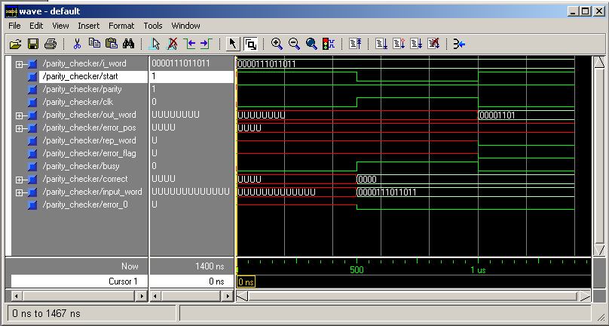
Figure 3. Hamming Error Detector/Corrector Simulation

Test 2:

Original 8 bit input word: 00001101

Encoded word with parity ‘1’: 0000111011011

Received encoded word: 0010111011011 (One error, bit 10)

Error flag output signal is asserted.

Error is corrected and its position is given in output error_pos: 1010

Output word: 00001101

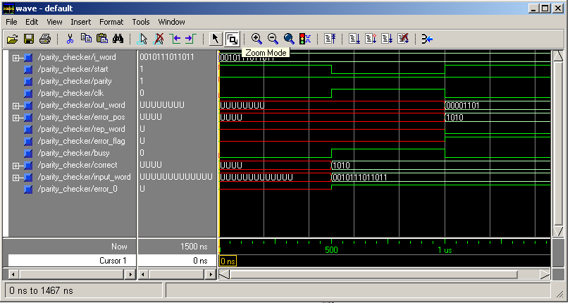
Figure 4. Hamming Error Detector/Corrector Simulation

Test 3:

Original 8 bit input word: 00001101

Encoded word with parity ‘1’: 0000111011011

Received encoded word: 1010111011011 (Two errors, bits 10 and 12)

Repeat word output signal is asserted.

Error flag output signal is asserted.

No output.

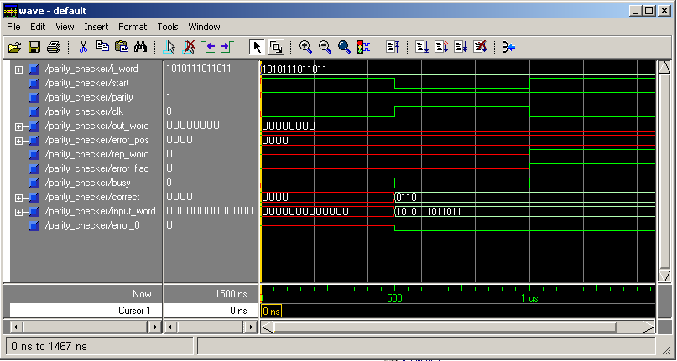
Figure 5. Hamming Error Detector/Corrector Simulation

Test 4:

Original 8 bit input word: 01001101

Encoded word with parity ‘0’: 0100111001010

Received encoded word with event parity: 0100111001010 (No errors).

Output word: 01001101

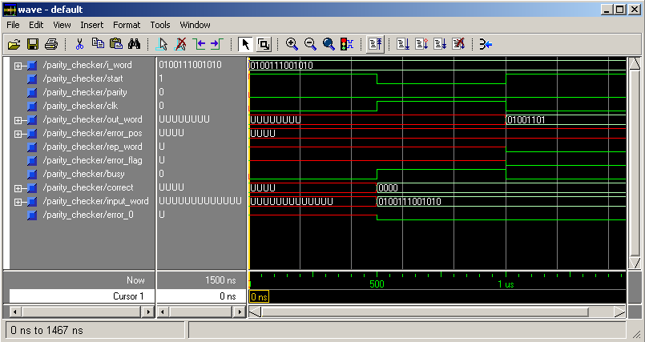
Figure 6. Hamming Error Detector/Corrector Simulation

Test 5:

Original 8 bit input word: 01001101

Encoded word with parity ‘0’: 0100111001010

Received encoded word: 0100111001011 (One error, bit 0)

Error flag output signal is asserted.

Error is corrected and its position is given in output error_pos: 0000

Output word: 01001101

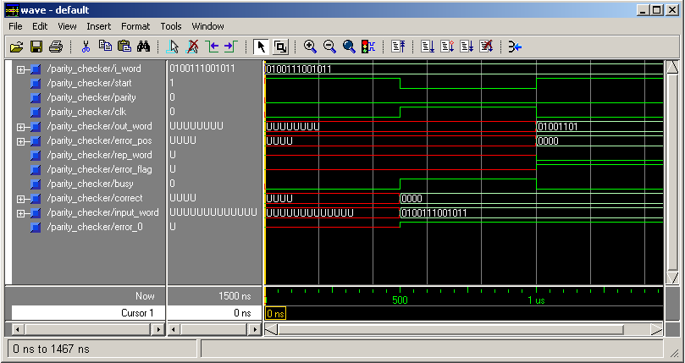
Figure 7. Hamming Error Detector/Corrector Simulation

Test 6:

Original 8 bit input word: 01001101

Encoded word with parity ‘0’: 0100111001010

Received encoded word: 0110111001011 (Two errors, bits 0 and 10)

Repeat word output signal is asserted.

Error flag output signal is asserted.

No output.

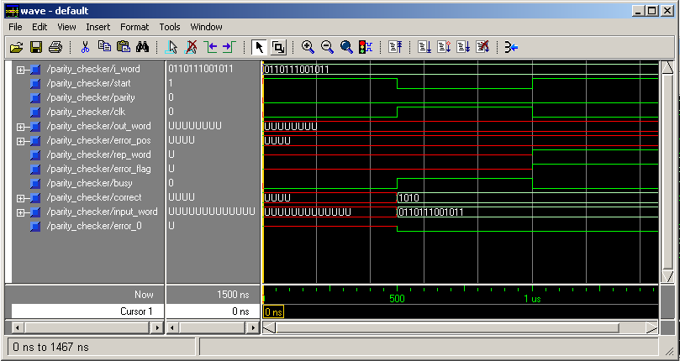
Figure 8. Hamming Error Detector/Corrector Simulation

The following pages include the synthesis diagrams of the code performed by Leonardo Spectrum. Figure 10 is the RTL Schematic of the Design, and Figure 11 is the Technology Schematic of the Design.

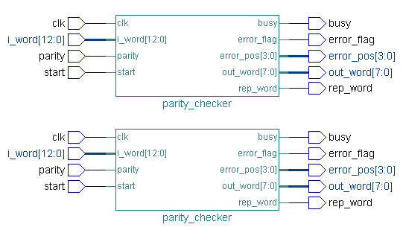

Figure 9. Black Box of Hamming Error Detector/Corrector

Figures 10 and 11 in next 2 pages

