The "Linux server" can be accessed from "Windows platform" using "EXCEED" software installed on every windows workstation machines.

You could access Exceed by going to
Start → All Program → Humming Bird Connectivity V7.1.1 → Exceed → Exceed XDMCP Broadcast.

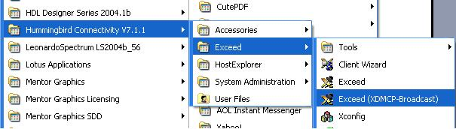

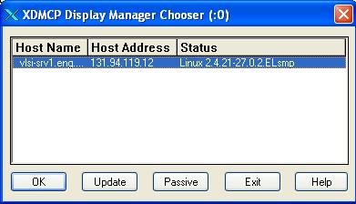
Once you click on this, you will get a window, select "vlsi-srv1.eng.fiu.edu" in that and click OK.

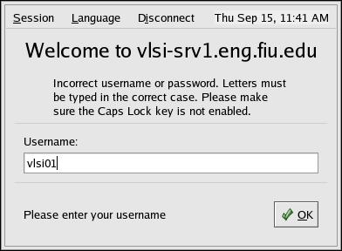
A dialog box will appear prompting for User name.

Enter your username and Click OK.

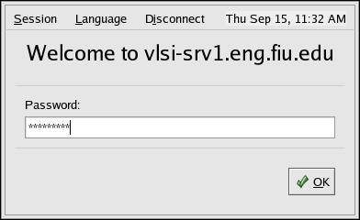
A dialog box will appear prompting for Password

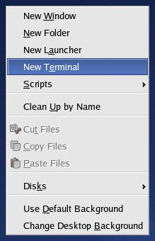
Enter your password and click OK.

Once you successfully logged into Linux operating system, Right Click on your desktop which will show you options:

Select "New Terminal", which opens command prompt.
Type vsim in the command prompt to open Modelsim.
Once you finish your programming, save your programs and close all application windows and logout from linux.
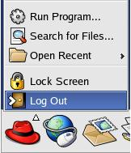

Press Windows button  in your keyboard to get back to windows workstation and close the Exceed software by right clicking on it and select close.

