SAP NetWeaver
mySAP SCM
mySAP PLM
mySAP
SRM
mySAP
CRM

mySAP
ERP ECC 6.0

ISE 5346 Logistics Engineering
(Spring, 2010)

Demand Planning
&
Inventory Management
Exercises

(ECC 6.0 – Release January 2008)

Exercise 75A: Create Material Master for Product Group
Purpose of Exercise

A product group combines other product groups and materials according to whatever criteria best meet the needs of your enterprise; for example, manufacturing procedure, product design, or market niche. The product group can be used at a higher level in forecasting than end items. This enables you to forecast at the group level and the system will then determine the individual requirements at the end item level.

Navigation
Menu Path | Logistics → Materials Management →Material Master →Material →Create (General) → Immediately
Trans Code | MM01

Enter the following information:
- Enter Material PGPen_ _ _
- Material Type Product group
System Menu: Defaults→ Views
- Select the following views: MRP 1
MRP 2
MRP 3
Costing 2

- Select View selection only on request
- Select Create views selected
- (Enter)

System Menu: Default→ Organization levels… Copy from…
Company code: C997 C997
Plant: P997 P997

- (Enter)
- MRP 1 Tab
- Description Executive Pen & Set Product Group _ _ _
- Base Unit EA
- MRP Type ND
- MRP 2 Tab N/A
- MRP 3 Tab Availability Check KP
- Costing 2 Tab Set Price control to S
- (Save)

Record the system message:

Exercise 75B: Assign members for Product Group
Purpose of Exercise

The Exercise will have you create your product group

Navigation
Menu Path | Logistics → Production - Process→SOP → Product Group → Change
Trans Code | MC86

Enter the following information:
- Enter Product Group PGPen_ _ _
- Plant P997
(Enter)
- Define Members Type Select Materials
(Enter)
- Member Number Plant Proportion V M Fx
- EPEN _ _ _ P997 75 *
- ESET _ _ _ P997 25 *

Note: Follow the following path: System Menu: Extras→ MRP Flag…to select MRP flag for EPEN _ _ _ and ESET_ _ _shown as below.

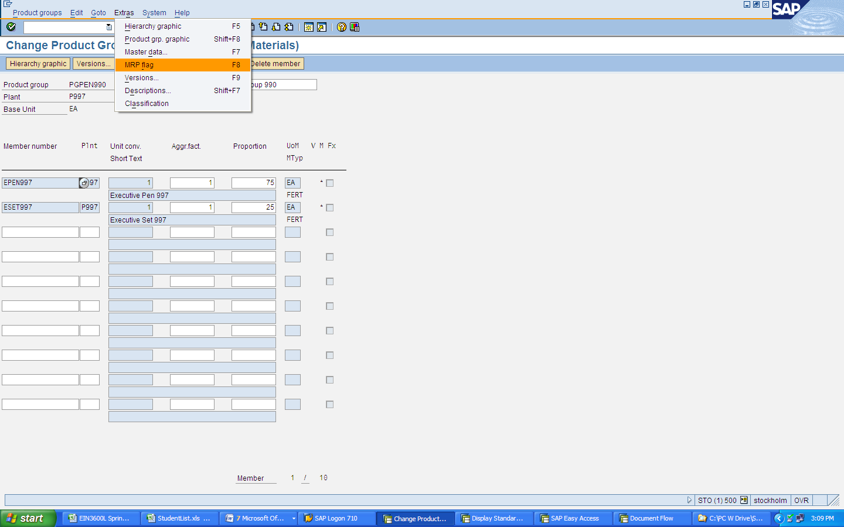
- (Enter)
- (Save)

Record the system message:

Exercise 76: Create a Production Plan
Purpose of Exercise

Enter a 9-month sales plan and create a production plan. This exercise will be setting the sales expectations for the next 9 months for the product group defined in the previous exercise. Generally, this would be considered a manual forecast. From this ‘forecast’ a production plan can be generated. This production plan be changed or modified by the production supervisor.

Navigation
Menu Path | Logistics → Production → SOP → Planning → For Product Group → Change
Trans Code | MC82

Enter the following information:
- Product group PGPen_ _ _
- Plant P997
Version selection
- Version Selection
Record your version number (A00)
Version Number

- (Enter)

SOP: plan individual product group
Planning Table | Current month | Current month +1 | Current month +2 | Current month +3 | Current month +4 | Current month +5 | Current month +6 | Current month +7 | Current month +8 | Current month +9
Sales |  | 80 | 80 | 80 | 100 | 100 | 100 | 120 | 120 | 120
Production
Stock level
Days of Supply
Target Days of Supply |  | 4 | 4 | 4 | 4 | 6 | 6 | 6 | 6 | 6

- (Enter)
Note the impact on stock levels
System Menu: Edit→ Create productn plan→ Synchronous to sales
Note the impact on production plan and stock levels.
System Menu: Edit→ Create productn plan→ Target days’ supply
Note the impact on production plan and stock levels.
- Record the planning values in the chart above
- Select for a graphic view of your planning data
- Review the Planning Graphs

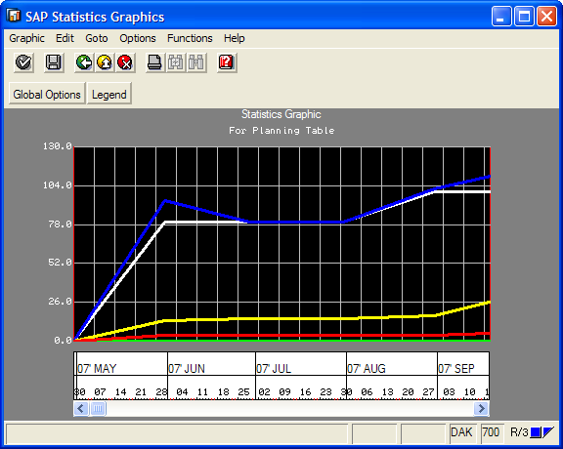

- (Back)
- (Save)

Record the system message:
Message

Exercise 77: Display Stock/Requirements List
Purpose of Exercise

The Stock/requirements list is a dynamic list. It will change whenever a transaction occurs. At this point we want to get a BEFORE picture of the status of supplies on hand and the demand against it. The report should show that there is none in stock, but also list a demand of 100 for the safety stock we designated on the material master.

Navigation
Menu Path | Logistics → Production → MRP → Evaluations → Stock/Requirements List
Trans Code | MD04

Enter the following information:
Individual access Tab
- Material EPEN _ _ _
- Plant P997
- (Enter)

Your Stock/Requirements report should contain this information:
Date | MRP… | MRP Element data | Rec./Req. Qty | Available Qty
MM/DD/YY | Stock |  | 0
MM/DD/YY | SafeSt | Safety stock | 100- | 100-

Exercise 78: Transfer Planning Data to Demand Management
Purpose of Exercise

Previously, the production plan was generated based upon the sales plan for the product group. This exercise will use that plan for the group and break it down into the individual components for the end item material based upon the proportional factors of the product group.

Navigation
Menu Path | Logistics → Production → SOP → Disaggregation →  Transfer Product Group to Planning
Trans Code | MC75

Enter the following information:
- Product group PGPen_ _ _
- Plant P997
- Version Your Version Number Recorded from Exercise 76
Transfer strategy and period
- Select Prod plan for mat or PG members as proportion of PG
- Select Invisible transfer
Independent requirement specifications
- Select Active
- (Back)

Exercise 79: Review Demand Management
Purpose of Exercise

In reviewing the requirements for the product group we now see there are production requirements for the individual production items. In reviewing the group we will see the production plan for the ESET and EPEN.

Navigation
Menu Path | Logistics → Production → Production Planning →Demand Management →  Planned Independent Requirements → Display
Trans Code | MD63

Enter the following information:
Planned independent requirements for
- Select Product Group PGPen_ _ _
- Plant P997
- (Enter)
- Notice the planned values for PGPEN are now independent demand at the material level for EPEN and ESET.

- (Back)

Exercise 80: Display Stock/Requirements List
Purpose of Exercise

The Stock/requirements list is a dynamic list. It will change whenever a transaction occurs. At this point we want to get a before picture of the status of supplies on hand and the demand against it. The report should show that there is none in stock, but also list a demand of 100 for the safety stock we designated on the material master.

Navigation
Menu Path | Logistics → Production → MRP → Evaluations → Stock/Requirements List
Trans Code | MD04

Enter the following information:
Individual access Tab
- Material EPEN _ _ _
- Plant P997
- (Enter)

Record your Stock/Requirements report information.
Date | MRP… | MRP Element data | Rec./Req. Qty | Available Qty
MM/DD/YY | Stock |  | 0 | 0
MM/DD/YY | SafeSt | Safety stock | 100- | 100-

Record the system message:
Message

Exercise 81: Run Master Production Schedule
Purpose of Exercise

When the MPS planning is run the product group requirements will be converted to planned orders to be executed on the shop floor thus creating a lower level demand for components and also meeting the forecast demand with finished product.

Navigation
Menu Path | Logistics → Production → Production Planning → MPS → MPS →  SINGLE Item Multi-level
Trans Code | MD41

Enter the following information:
- Plant P997
MRP control parameters
- Processing key NETCH
- Create purchase req. 2
- Schedule lines 3
- Create MRP list 1
- Planning mode 1
- Scheduling 1
- Check Display Material List
- (Enter) A warning message appears stating “Please check input parameters”
- (Enter) again to confirm and bypass the warning message
- To start the planning run, press continue

Record materials planned
Materials | Comments

- (Exit)

Exercise 82: Display Stock/Requirements List
Purpose of Exercise
The Stock/requirements list is a dynamic list. It will change whenever a transaction occurs.

Navigation
Menu Path | Logistics → Production → MRP → Evaluations → Stock/Requirements List
Trans Code

Enter the following information
Individual access Tab
- Material EPEN_ _ _
- Plant P997
- (Enter)
- Select the first planned order and click to review the pegged requirements.
- (Back)
- Select the first planned order again and click on to review the order report.
- Here you can view the availability status of the raw materials for your order. If you double click on one of the raw materials you will see the stock requirements screen for that item in the bottom half of the screen.
- Double click on EPEN_ _ _
- Select
- Select the planned order above the Dep Req for ESET_ _ _ and click to review the pegged requirements. You should see that this planned order is for the product ESET. (Back)

Record the system message:
Message

