Navigation in SAP Systems
Introduction to Navigation in SAP solutions on the basis of SAP ERP

Product  SAP ERP  G.B.I.  Release 6.07  Level  Beginner  Focus  Navigation  Authors  Babett Koch  Stefan Weidner  Version  2.40  Last Update  February 2015 | MOTIVATION  This material explains how to navigate in SAP systems. It is aimed at students at universities, universities of applied sciences and other educational institutions with no previous experience of SAP software. It can be used in the class or for self-study.  After completion of the course, students will be able to navigate through the user interface to work on business processes and case studies on their own.  Furthermore, this material serves as a reference for occasional users of SAP systems. |  | LEARNING METHOD  The learning method used is “guided learning.” This is a suitable method because navigating in SAP systems is a fundamental skill but also very complex.  The benefit of this method is that knowledge is imparted quickly. Students also acquire practical skills and competencies. Similar to a case study, this method explains a process or procedure in detail.  By using exercises at the end of each part, students can put their knowledge into practice and gain a sustainable understanding of the underlying processes.

 | Logging On
Task Log on to the system. Time 10 min  Short Description Use the SAP GUI to log on to the SAP system. |  |  | Time 10 Min.
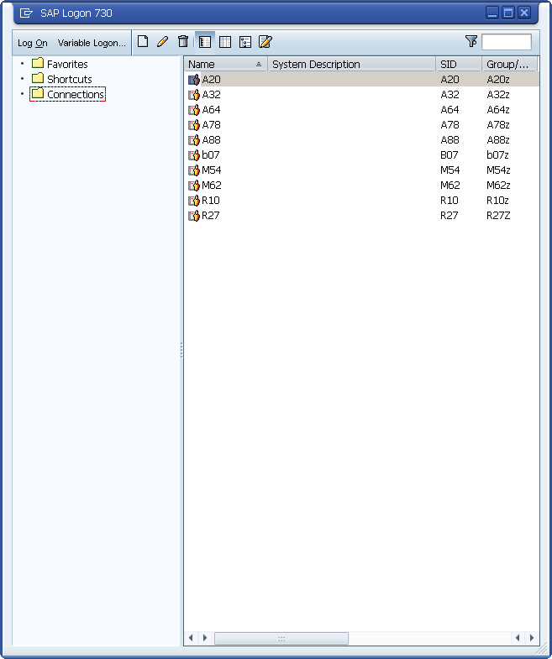  Find and double-click on the icon depicted on the left side of this page that you can find on your desktop. If it is not there, choose Start ► All Programs ► SAP Front End ► SAP Logon  A dialog box similar to the one shown on the right appears. Select the SAP system specified by your lecturer and choose Log on or Enter.  The logon screen appears. The system requests the client, your user, password, and preferred language. |  | SAP Logon
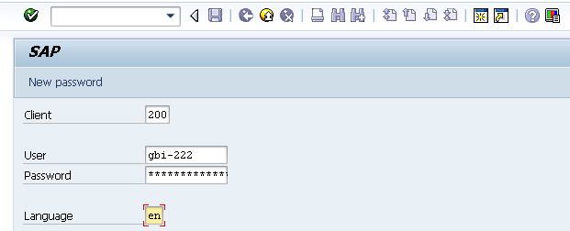 |  | Client: _ _ _  User: _ _ _ _ _ _ _  Password: _ _ _ _ _ _ _  Language: _ _
Before you log on, you need to know the definition of the term “client.”
SAP systems are client systems. With the client concept several separate companies can be managed in one system at the same time.  Clients are the highest organizational level in the system. In business terms, each client can represent a group of companies, a company, or a firm – regardless of the size of the organization.  In commercial, organizational and technical terms, a client is therefore a self-contained unit with separate master records and its own set of tables. In SAP systems, different clients are identified by their client numbers. |  | Client
Use the client number given by your instructor. For you to be able to log on as a user, a user master record must be created for you in the relevant client. For reasons of access protection, you must enter a password when you log on. Your password entry is case-sensitive.  SAP systems are multilingual. Choose the language for your session in the Language field. Then choose or Enter. |  | Logon screen
Enter the user name, the initial password and the logon language given by your lecturer.
User: GBI-### Password: gbiinit log on
When you log on for the first time, a dialog box appears in which you enter your new individual password twice. Client: _ _ _
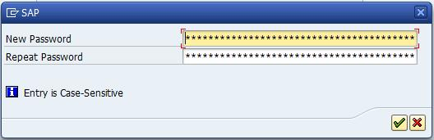
The first time you log on you will see a copyright note. Confirm it with or Enter. The initial screen with the SAP Easy Access Menu appears.
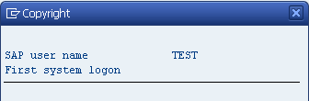

 | Initial Screen
Task Get familiar with the SAP system screen.  Short Description Identify and familiarize with each element of the SAP system screen. |  |  | Time 10 Min.
This is the initial screen as described in more detail below.
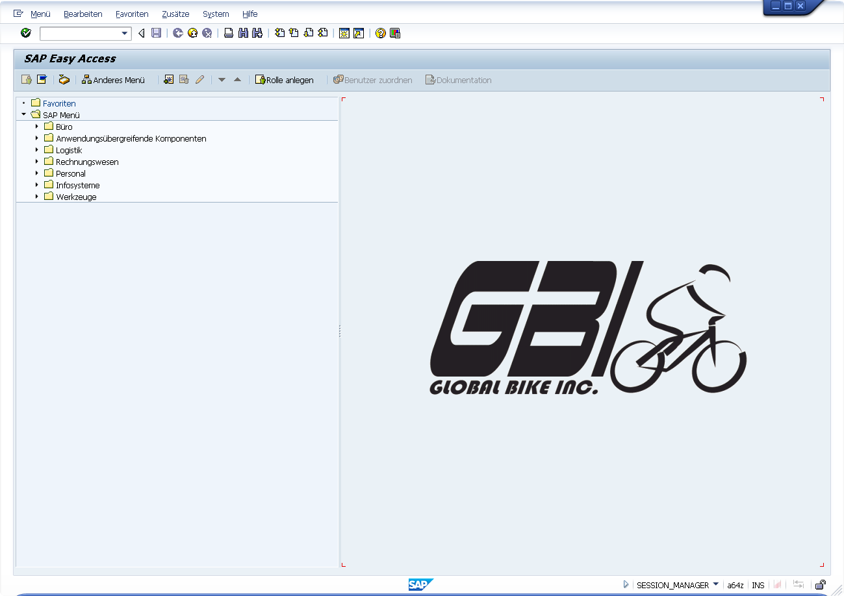 |  | Initial screen
Menu Bar  The displayed menus depend on the action/transaction in the SAP system except for the system and help menu. This dependency is described as context sensitive. |  | Menu Bar

User specific settings
Using the command field enter transaction SU3 and switch to the Defaults tab. In this tab, general settings like Logon Language, Decimal Notation and Date Format can be determined for your user.
Please choose EN (English) for Logon Language, 1,234,567.89 for Decimal Notation and MM/DD/JJJJ as Date Format.

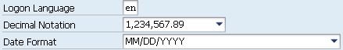
Save your entries using .
Standard Toolbar  Icons in the standard toolbar are available on all screens. Icons that you cannot use in the current application are grayed out. By pausing the cursor above an icon, a quick info text appears. |  | Standard Toolbar
Exercise 1 For the following exercise switch to transaction VA03, to do so leave the current transaction by using .
  - Which meanings have the following symbols in the Standard Toolbar? (Tipp By pausing the cursor over an icon, a help text is depicted. If there is no help text for each icon you simply have to go into a transaction.)

.
.
.
1.2 Why is the icon (Save) grayed out in the initial screen?
.
.
.
1.3 Which of the following icons can create a new session?
1.4 How many sessions can be open in the system in parallel? (Tipp Click on the corresponding icon until the system does not create another session.)
.
1.5 To close a session, choose the icon in the Standard Toolbar or go to the entry System ► End Session in the menu list.
What is the difference between the icons and ?
.
.
Title Bar  The title bar displays the name of the transaction you are currently using. It is located on every primary window and dialog window under the standard toolbar and above the application toolbar. |  | Title Bar
Application Toolbar  The application toolbar contains icons and buttons applicable to the transaction you are currently using. |  | Application Toolbar
SAP Easy Access Menu  The SAP system displays the SAP Easy Access menu on the start screen as standard. It enables you to navigate in the system using a clear tree structure.  Click on the small arrows to expand the menu tree. The menu tree is specific to your role (business function in the company).  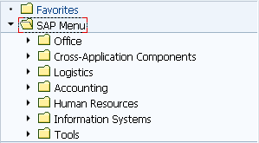 |  | SAP Easy Access Menu
Exercise
Open the following tree structure!
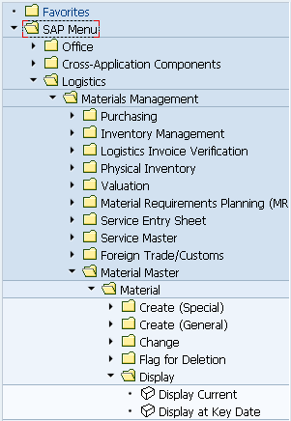
Exercise 2
2.1 What is the difference between the transactions Display Current and Display at Key Date?
.
.
.
Status Bar  The status bar shows information about the current system status as well as warning and error messages. |  | Status Bar

 | Favorites
Task Create personal favorites.  Short Description Create your own favorites in SAP GUI and add objects to them. |  |  | Time 10 Min.
If you frequently use a transaction, you can use drag&drop to add it to your favorites (or choose Favorites ► Add). You can then double-click it to run it without having to navigate through the SAP Easy Access menu. Furthermore you can add folders, reports, files and web addresses as favorites. |  | Other objects
By clicking Favorites with the right mouse button, you can create your own hierarchical folder structure.
You can add any link to your favorites, to do so click Favorites with the secondary mouse button. Choose Add other objects then Web Address or File. In the dialog box, enter a name and the URL shown below. To confirm choose .
Exercise 3
Create/Expand your own favorites menu.
  - Add the SAP Help Portal using the URL help.sap.com.
  - Add the following transaction as a favorite:
Logistics ► Sales and Distribution ► Sales ► Order ► Display

 | Transaction Codes
Task Get familiar with SAP transaction codes  Short description Learn how to effectively make use of SAP transaction codes and parameters. |  |  | Time 10 Min.
There are several possibilities to call up transactions in the SAP system. |  | Transaction Concept
The quickest way to run a transaction in the SAP system is to enter the transaction code. Every transaction has a code, which generally has four characters. |  | Transaction Code
SAP Easy Access Menu  By navigating through the SAP Easy Access Menu and using path structures you get to the transactions. Then double-click on the transaction to run it.  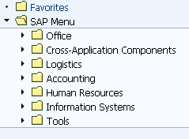 |  | SAP Easy Access Menu
Transaction Code  Every business transaction (not every screen) has a corresponding transaction code in SAP. To display transaction codes choose Extras ► Settings and select Display technical names. |  | Transaction Code
Note: the command field in which transaction codes are entered can be found on the upper left. By clicking the small triangle you set it to visible/invisible.
or
or.
You can use various control parameters to influence what happens to the session when you call a transaction.
/n Exits the current transaction  /i Closes the current session  /o Opens a new session |  | /n  /i  /o
Exercise 4
  - Which business function is displayed with the transaction code VA03?
.
  - Which business function describes the menu path Logistics ► Sales and Distribution ► Master Data► Business Partner ► Customer ► Display ► Complete ?
.
  - What is the difference between the transactions VD03 and XD03?
.
.
.
  - Which business processes describe the following transaction codes?
XK01: .
MM02: .
ME23N: .
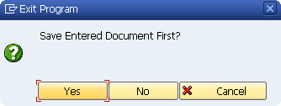
When leaving a transaction using , or you may be confronted with this displayed dialog window. Be sure that no unsaved data is displayed in the current session. Then choose yes.

 | Help
Task Get familiar with SAP’s help functions.  Short Description Get familiar with help functions in SAP systems. Use the F1 and F4 help as well as the SAP Help Portal. |  |  | Time 10 Min.
Several types of help are available in the SAP system. The most frequently used ones are the F1 and F4 keys. |  | F1 and F4 help
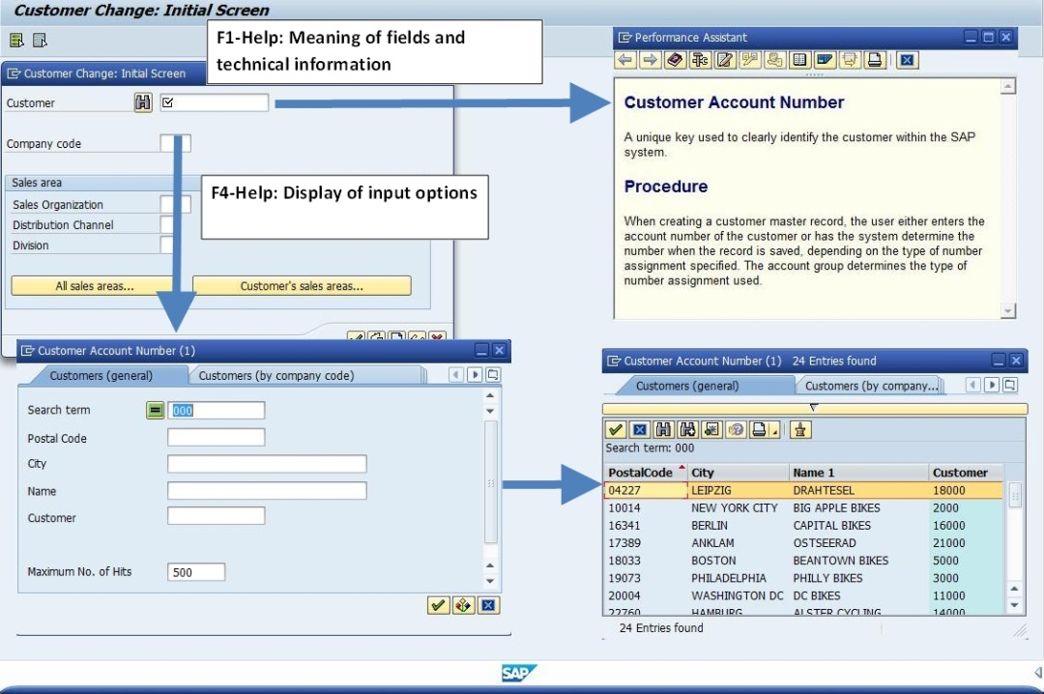
F1 provides you with explanations for fields, menus, functions, and messages. In the F1 help, you can choose to get technical information. |  | F1
F4 gives you information and possible entries. You can also use the F4 help by choosing directly to the right of a selected field. |  | F4
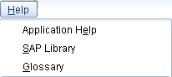Further help can be found in the help menu. Choose Application Help for context-sensitive help on the transaction you are currently using. Choose SAP Library to open the online SAP Library. You can also access it on the Internet at help.sap.com.
Exercise 5
5.1 Call up transaction VA01 and select the field Distribution Channel. Press the F1-button.
What is a distribution channel (in a few keywords)?

5.2 Close the window with definition of the Distribution Channel. Stay in transaction VA01. Click the field Order Type and press F4. What do the order types SO and OR stand for?
SO
OR
5.3 What is the difference between these two types of orders?

 | Configuration Position Overview
Task Learn some useful tips for configuration of overviews and how to work more efficient therefore. |  |  | Time 5 Min.
To configure your position overview for sales orders chose transaction VA03 in the initial screen.
Use F4 in the order field to find any purchase order number. To do so choose enter. Choose any order number by double clicking it. Afterwards press Enter or click the Enter icon.
To adapt the position overview to your requirements, choose the Item overview tab choose the configuration symbol in the middle of the screen. |  | Configuration
You will get to the following overview:
In the Table Settings you can configure your own overview. Therefore choose a term and write it into the field Variant. By using the button a new setting will be created. Be sure that your new setting name is entered in the field Current settings and Standard settings. Then choose the button Administrator. Now you are able to change your system settings.
Here you can choose which rows are to be displayed. By setting the check mark in the row Invisible you can determine which values shall not be displayed.
For invisible select Product Hierarchy, Material group 1 and 2, WBS Element, Profit Center, Customer Group, Price Group and Sales District
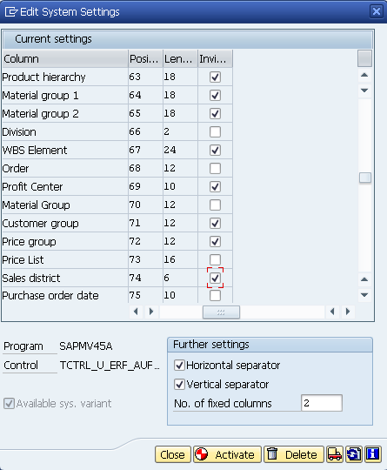
Afterwards select the button Activate, close the pop up and select Save.
The following screenshot is an example of a configured position overview.
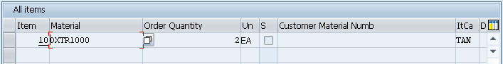

 | Multiple Selection
Task Understand and perform multiple selection.  Short description Understand and perform multiple selection in SAP GUI and get to know useful hints about it. |  |  | Time 10 Min.
Choose transaction MMBE to get to the Stock Overview Screen. Display the stock from the plants in Dallas and Miami.
Please assure, that when you enter the two plants in the overview as shown below, you will not get the correct result.
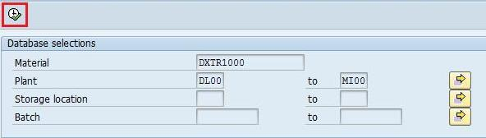
As you will see in the following screen, the plant in Heidelberg was chosen as well. This is due to the fact that the SAP system displays all plants which range alphabetically between DL00 and MI00.
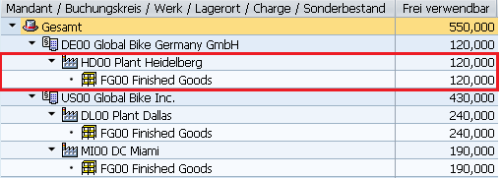
Therefore select the black Deluxe Touring Bike ( DXTR1000) and click afterwards.  Choose multiple selection. Then choose the plants you want to display and press Enter. Afterwards select Execute . |  | DXTR1000
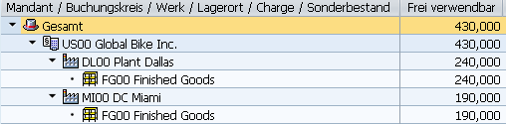

 | Working at GBI
Task Display GBI information in SAP GUI.  Short Description Navigate through the SAP system to display the most important information of your enterprise in GBI. |  |  | Time 15 Min.
Exercise 6
  - How many black Deluxe Touring Bikes do you have in stock?
(Tip Therefore use transaction MMBE.)

  - Which customers can be identified in GBI?
Follow the menu path: Logistics ► Sales and Distribution ► Master Data ► Business Partner ► Customer ► Display ► Complete
(Hint Click on the field Customer and press F4. Then enter your Company Code (DE00).
  - What is a debitor?

 | Logging Off
Task Log off the system. Time 5 min  Short Description Log off the SAP system. |  |  | Time 5 Min.
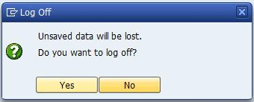  Choose System ► Log off to end the current session. The confirmation prompt shown on the right informs you that unsaved data will be lost. Once you are certain that you have saved all entries, you can confirm the prompt by choosing Yes. |  | Log Off

