Eating egg yolks is as 'bad as smoking' in speeding up coronary heart disease
- Egg yolks were found to contribute to the build-up of plaques in the arteries
By Daily Mail Reporter
PUBLISHED: 11:54 EST, 14 August 2012 | UPDATED: 11:16 EST, 15 August 2012
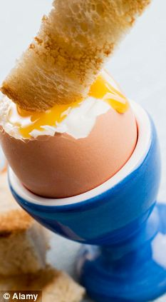
Regularly eating egg yolks is about two-thirds as bad as smoking when it comes to the build-up of plaques in arteries
Scientists have unscrambled the truth about eggs - eating the yolk is almost as bad as smoking for people at risk of heart disease.
The problem lies in an increased risk of the hardening of the arteries, known as atherosclerosis.
It is a disorder of the arteries where plaques, aggravated by cholesterol, form on the inner arterial wall.
As a key component of a traditional English breakfast, the new findings may not put off egg lovers.
But Dr David Spence revealed eating the yolk of an egg is about two-thirds as bad as smoking when it comes to the build-up of plaques.
Having surveyed 1,231 men and women, Dr Spence, of the University of Western Ontario, London, Canada, linked the findings to stroke and heart attack risk factors.
Plaque rupture is the usual cause of most heart attacks and many strokes.
The study involved patients, with an average age of 61.5, attending vascular prevention clinics in Ontario.
Ultrasound was used to establish a measurement of total plaque area and questionnaires were filled out regarding the patients’ lifestyles.
The research found carotid plaque area increased in line with age after 40, but increased above the average rise after years of regular smoking and egg yolk consumption.
The study also found those eating at least three yolks a week had significantly more plaque area than those who ate up to two yolks per week.
Dr Spence, 67, who is also a neurology professor, said: 'The mantra ‘eggs can be part of a healthy diet for healthy people’ has confused the issue.
'High cholesterol intake increases the risk of cardiovascular events, and egg yolks have a very high cholesterol content.
'The study shows that, with age, plaque builds up gradually in the arteries and egg yolks make it build up faster.'
Dr Spence added that the effects were independent of sex, cholesterol, blood pressure, smoking, body mass index and diabetes.
He said that while he feels more research should be done, he stressed the regular consumption of egg yolk should be avoided by persons at risk of cardiovascular disease.
The research has been published online in the journal Atherosclerosis
Read more: http://www.dailymail.co.uk/health/article-2188265/Eating-egg-yolks-bad-smoking-speeding-coronary-artery-disease.html#ixzz24HfcJVGT

