Senior Design II General Meeting Attendance
By department regulations, attendance at general meetings is mandatory
In case of absence, provide valid proof of reasons to your mentor
Project Title: SDR-Based Ground Penetrating Device for Lead Pipe Detection
Team #: 1
Team name: RadTech Innovators
Mentor: Satheesh Bojja Venkatakrishnan

ABSTRACT.
Detecting underground lead water pipes is a critical challenge for municipalities and environmental agencies due to the health risks posed by lead contamination. This project aims to develop a portable and efficient Ground Penetrating Radar (GPR) system using Software-Defined Radio (SDR) technology. The SDR-based GPR leverages electromagnetic wave propagation and advanced signal processing to detect and characterize lead pipes in diverse subsurface conditions. Through iterative design, analysis, and stakeholder feedback, the system has been engineered to deliver accurate depth and diameter measurements while providing real-time data visualization on portable devices. Testing results demonstrate the system's ability to achieve high detection accuracy within a 2-meter depth range. By addressing a pressing societal need, this project contributes to public health initiatives and infrastructure improvement, showcasing a cost-effective and innovative solution to underground pipe detection.
- Project Status
The project status demonstrates significant progress in signal processing, particularly in chirp generation and reflected signal processing. We have successfully generated a sawtooth waveform to enable frequency modulation and created FMCW signals with distinguishable transmitted and received signals. In the reflected signal processing stage, we captured raw return signals that exhibit clear phase differences, enabling the extraction of a beat signal. Further analysis of the beat signal's frequency spectrum revealed identifiable peaks, which provide essential information about object distance and velocity. Additionally, we are actively working to determine the optimal frequency for radar operation to maximize detection accuracy and signal clarity. Moving forward, we aim to reduce noise, refine distance and velocity measurements, and finalize the frequency selection process.

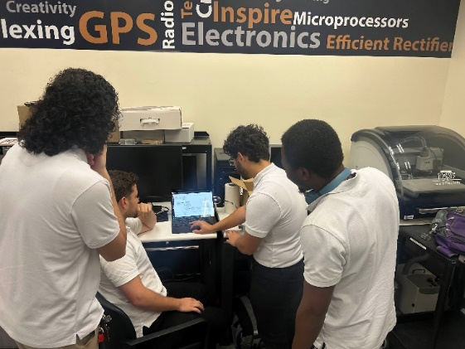 |  | 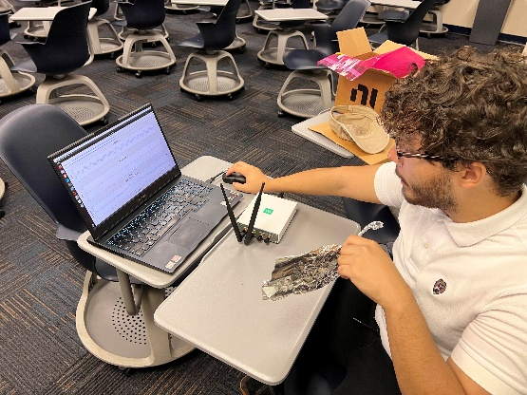

- Expectation for Demonstration Readiness
By the demonstration date, we expect to have implemented a functional SDR-based Ground Penetrating Radar system utilizing the USRP-2901 radio platform for underground lead pipe detection. The core signal processing pipeline will be operational, demonstrating real-time data acquisition and analysis capabilities through our Linux-based computing infrastructure. The system will showcase accurate depth measurement functionality through calibrated electromagnetic wave propagation and advanced signal processing algorithms for clutter rejection. Our visualization interface will be fully integrated, providing immediate feedback on pipe location and characteristics through an intuitive display system. The demonstration will verify the system's ability to detect and measure pipe diameter within the specified 2-meter depth range, supported by comprehensive test data from controlled environments. We will present initial field-testing results that validate the system's detection accuracy across various subsurface conditions. While some advanced features like multi-layer soil analysis and automated pipe material classification may still be under development, the core pipe detection and measurement capabilities will be fully operational. The demonstration will include live scanning sessions showing the system's effectiveness in identifying and characterizing buried test pipes, along with data visualization of the processed radar returns.
- Concerns
The handling of our data is our top priority. Our system must appropriately interpret the data to achieve our goal of a system that can accurately identify a hidden metallic pipe. Stated otherwise, our system must differentiate the lead pipe's frequency response from the rest of the medium, which is undoubtedly the most difficult assignment of our project. New concerns are such of Omnidirectional antennas which are a type of antennas that radiates or receive radio frequency electromagnetic fields equally in all horizontal directions in contrast with a directional antenna which sends the signal in a particular direction (which would be ideal). Some common concerns for the omnidirectional antennas are limited range, signal interference, coverage overlap and directionality limitations.

