Senior Design II General Meeting Attendance
By department regulations, attendance at general meetings is mandatory
In case of absence, provide valid proof of reasons to your mentor
Project Title: Smart Lock
Team #: 11
Team name: Ledwin Acosta, Nicolle Duron, Yamileth Leiva, Donavan Dorival, Brian Piquette
Mentor: Dr. Atoussa Tehrani

ABSTRACT.
The development of inventive auto-lock door systems offers a compelling solution to meet the changing needs of contemporary consumers in the quickly changing field of smart home security. The design and installation of an advanced auto-lock door system that puts security, usability, and flexibility in access control first is the main goal of this project. Utilizing state-of-the-art features like keypad authentication, Bluetooth, and Firebase connectivity, the system provides a variety of authentication options to guarantee easy and safe access to residential properties. By combining these functions, which offer both conventional PIN code authentication and hands-free proximity-based unlocking, the user experience is intended to be improved. Furthermore, the system offers internet-based communication channels and smartphone connectivity for remote access control and monitoring. Through meticulous design, rigorous testing, and iterative refinement, this project endeavors to deliver a reliable and user-centric solution that aligns with the evolving demands of smart home security.

- Project Status
The smart lock project is progressing well, with the basic software components nearing completion. The software development team has successfully implemented core functionalities such as remote access and keypad authentication and is currently working on the mobile app integration. However, the project is awaiting the finalization of the hardware aspect, specifically the lock's physical casing. Hence, we have already built a solid door frame. Once the casing is designed and manufactured, the smart lock can undergo full integration and further testing to ensure seamless operation between the software and hardware. The team is optimistic about overall progress on the project and looking forward to the final product.
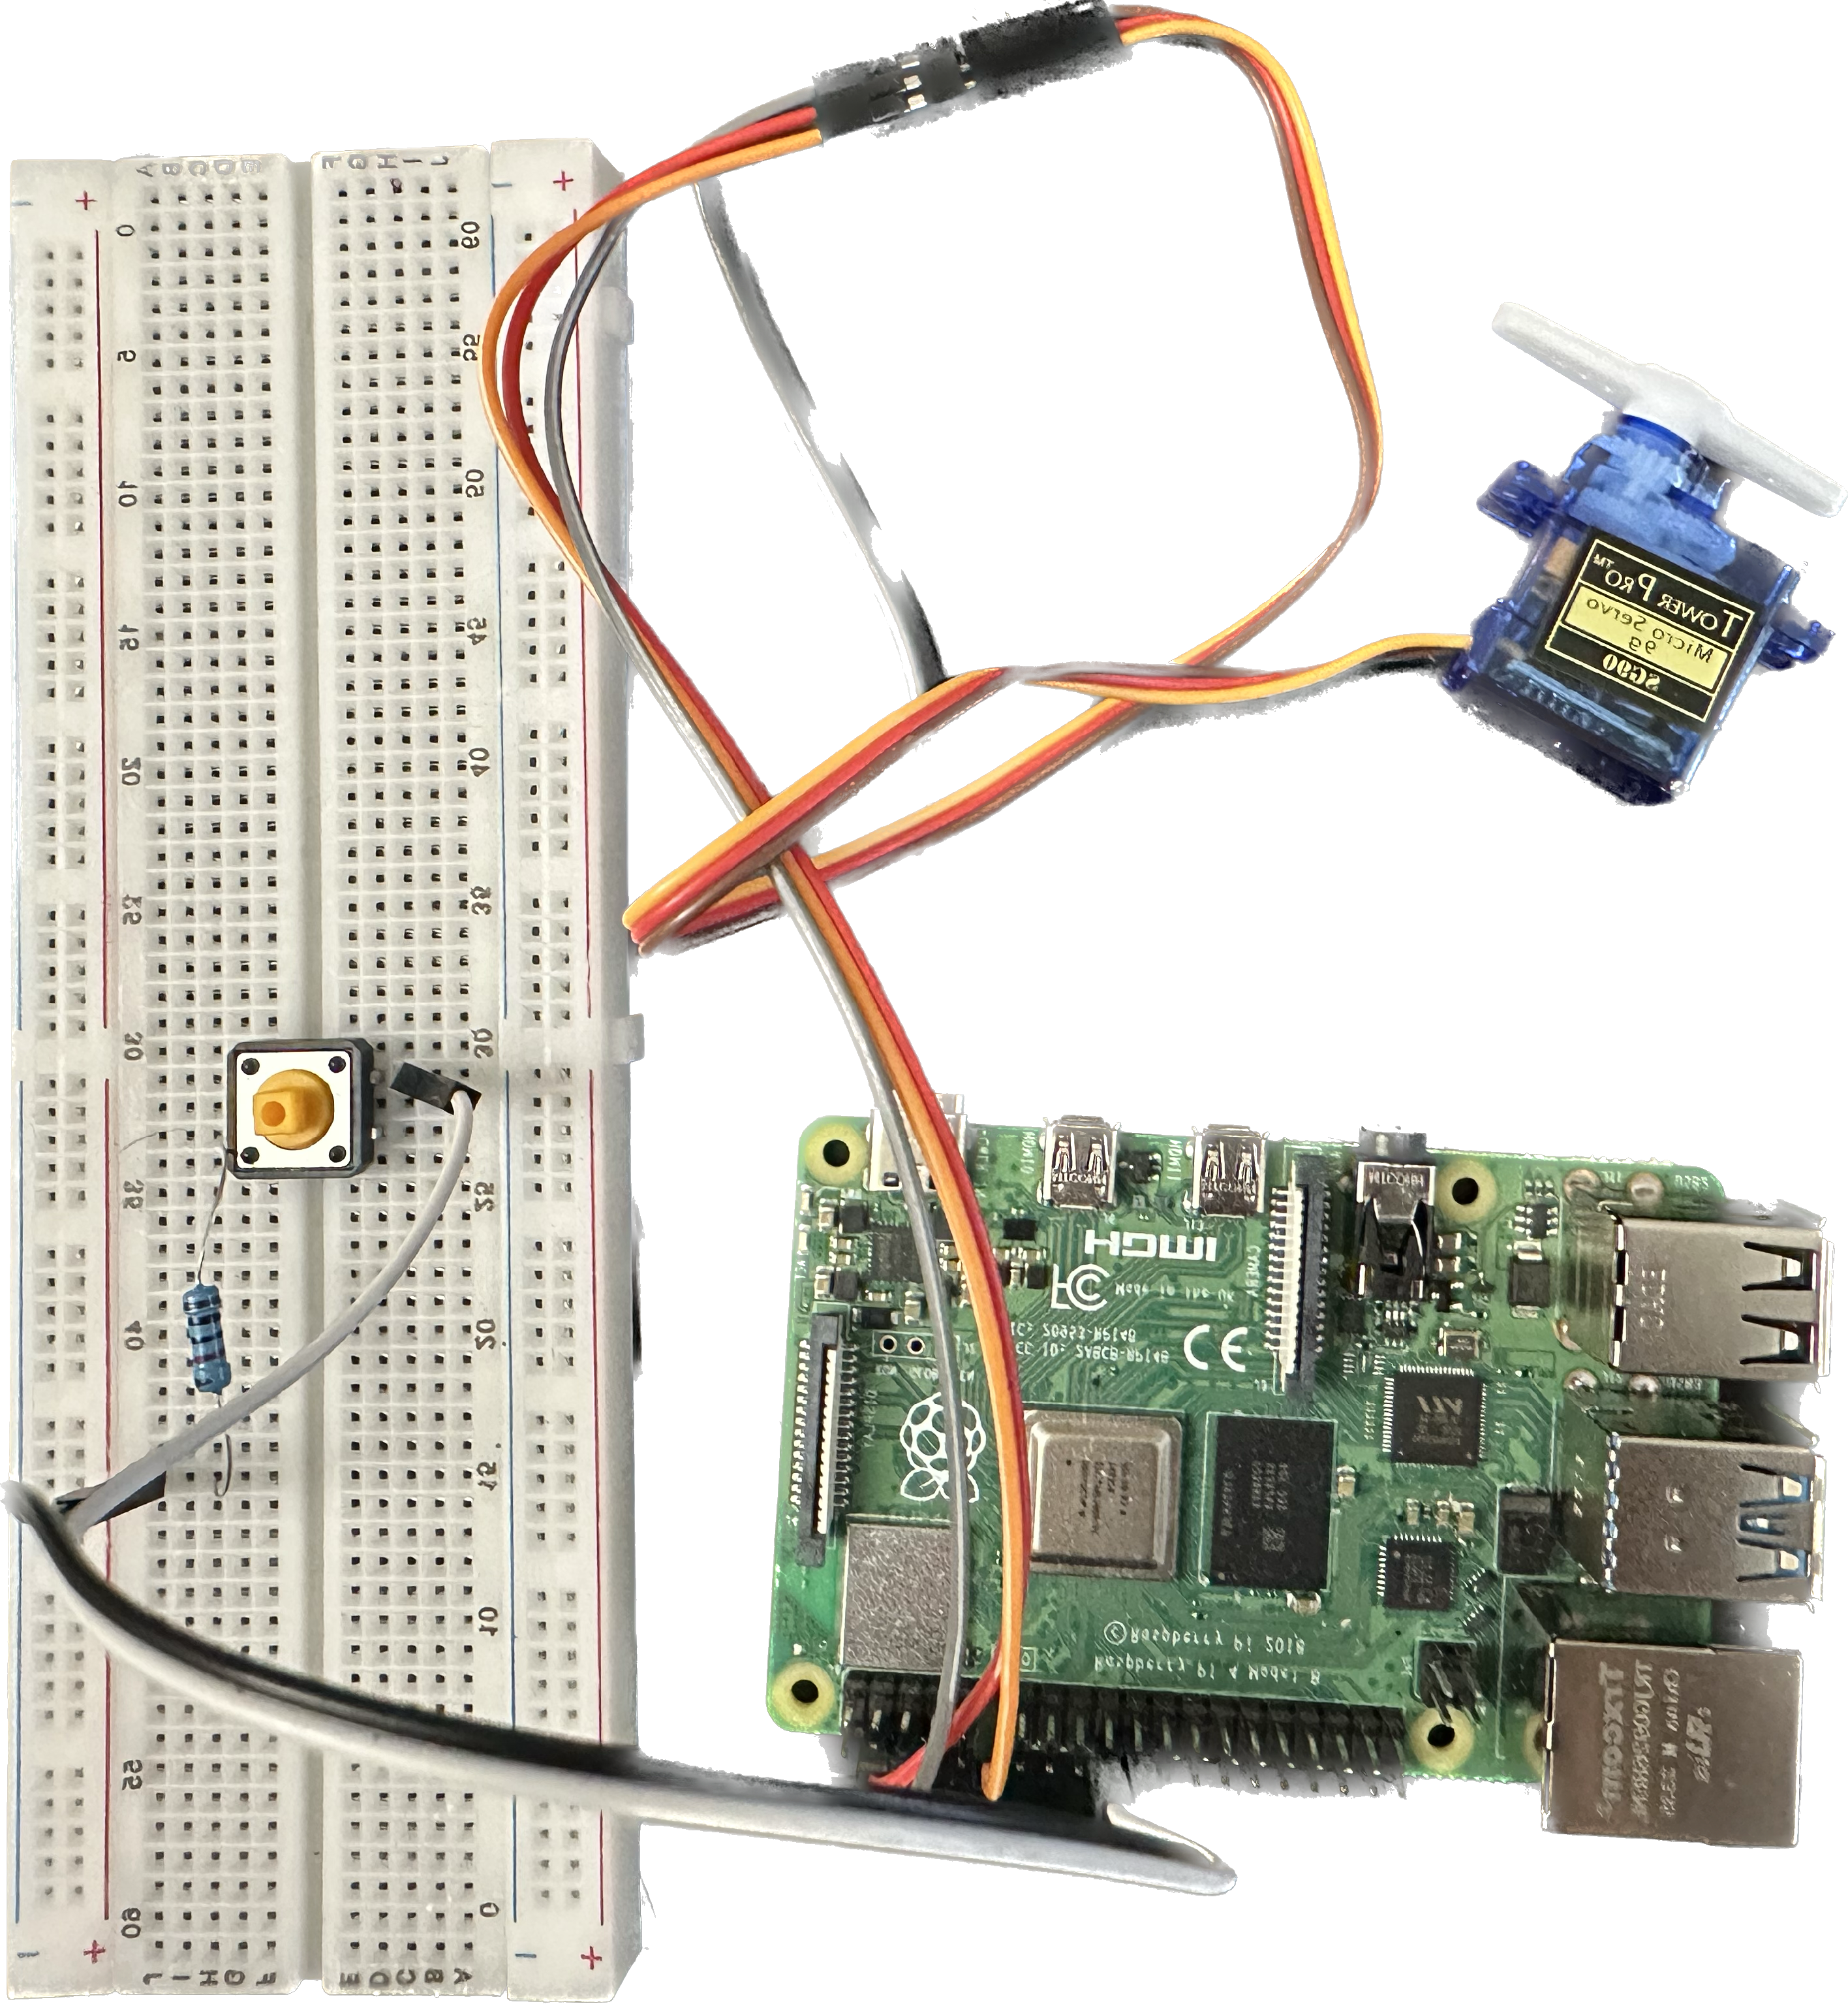
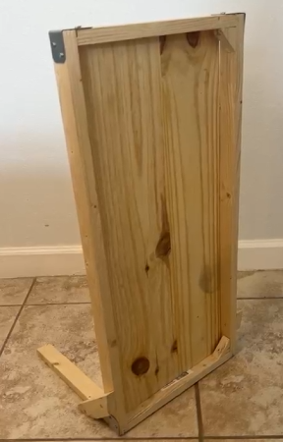
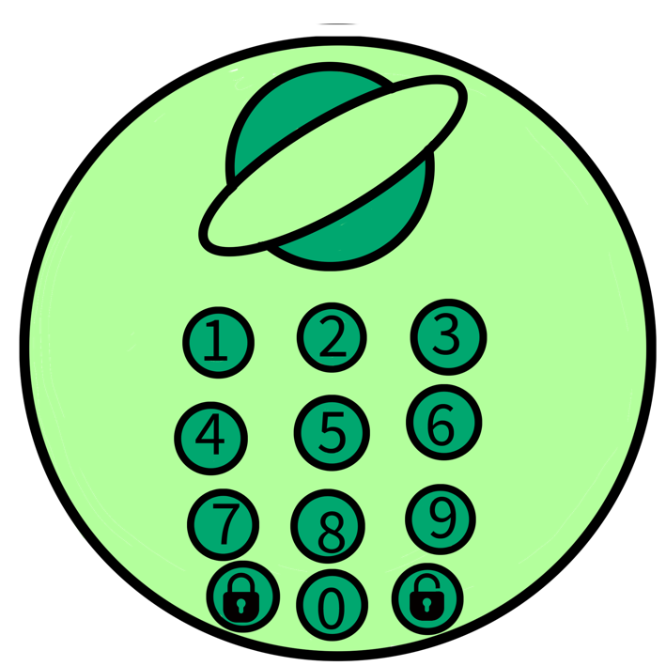

- Expectation for Demonstration Readiness
The smart lock project is progressing well, with the software development nearly complete. Key features like remote access, keypad authentication, and real-time alerts have been successfully tested and integrated. However, the hardware case for the lock is just starting its development phase. To meet the July demonstration date, the team is accelerating the design and manufacturing process of the hardware case, prioritizing rapid prototyping and iterative testing. Concurrently, final touches on the software and extensive security testing are underway. Despite the tight timeline, coordinated efforts and a clear action plan ensure that the project will be ready for a successful demonstration.

- Concerns
At this time, our main concerns center on ensuring the smooth and timely completion of the hardware case for the smart lock. Although the software development is nearly complete, the hardware case is just beginning, and it must be finished to a high standard to meet the July demonstration date. Coordinating effectively between the hardware and software teams is crucial to address any integration issues promptly. There is enough time to achieve this, provided we maintain a focused and efficient workflow, but we must remain vigilant against potential delays in the supply chain or manufacturing process.

