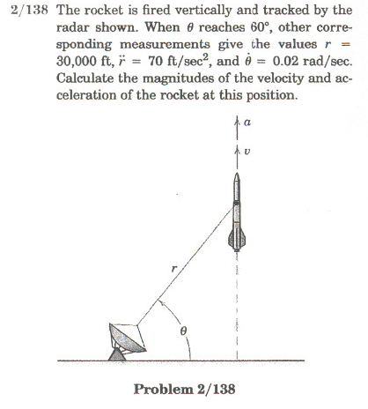

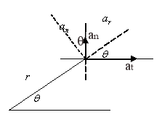
$\overset{¨}{r}=\text{70}$ $\overset{˙}{θ}=0\text{.}\text{02}{\text{rad}}/s$
$h=r\text{sin}θ$ $\overset{˙}{h}=\overset{˙}{r}\text{sin}θ+r\text{cos}θ\overset{˙}{θ}$
$$\overset{˙}{r}=−r\text{cos}θ\overset{˙}{θ}$$
$\overset{˙}{x}=0=\overset{˙}{r}\text{cos}θ−r\text{sin}θ\overset{˙}{θ}$ $\overset{¨}{x}=\overset{¨}{r}\text{cos}θ−2\overset{˙}{r}\text{sin}θ\overset{˙}{θ}−r\text{cos}θ{\overset{˙}{θ}}^{2}−r\text{sin}θ\overset{¨}{θ}=0$
$$\overset{˙}{r}\text{=+}r\text{tan}θ\overset{˙}{θ}\text{=+}\text{30000}\text{tan}\text{60}(0\text{.}\text{02})=\text{1039}\text{.}\text{23}{\text{ft}}/s$$
$\overset{¨}{r}=\frac{2\overset{˙}{r}\text{sin}θ\overset{˙}{θ}+r\text{cos}θ{\overset{˙}{θ}}^{2}+r\text{sin}θ\overset{¨}{θ}}{\text{cos}θ}$ $\overset{¨}{θ}=\frac{\overset{¨}{r}\text{cos}θ−2\overset{˙}{r}\text{sin}θ\overset{˙}{θ}−r\text{cos}θ\overset{˙}{θ}}{r\text{sin}θ}=−0\text{.}\text{00027}{\text{rad}}/{s^{2}}$
$y=r\text{sin}θ$ $\overset{˙}{y}=\overset{˙}{r}\text{sin}θ+r\text{cos}θ\overset{˙}{θ}$ $\overset{¨}{y}=\overset{¨}{r}\text{sin}θ+2\overset{˙}{r}\text{cos}θ\overset{˙}{θ}+r\text{cos}θ\overset{¨}{θ}−r\text{sin}θ{\overset{˙}{θ}}^{2}=\left[\frac{2\overset{˙}{r}{\text{sin}}^{2}θ\overset{˙}{θ}+r\text{cos}θ\text{sin}θ{\overset{˙}{θ}}^{2}+r{\text{sin}}^{2}θ\overset{¨}{θ}}{\text{cos}θ}\right]$

+$\left[\frac{2\overset{˙}{r}θ{\text{cos}}^{2}θ+r{\text{cos}}^{2}θ\overset{¨}{θ}−r\text{sin}θ\text{cos}θ{\overset{˙}{θ}}^{2}}{\text{cos}θ}\right]$
$a_{r}\text{sin}θ+a_{θ}\text{cos}θ=\overset{¨}{y}$=a_{n} here $a\text{cos}θ−a_{θ}\text{sin}θ=\overset{¨}{x}$=a_{t} here
Or $\overset{¨}{x}\text{cos}θ+\overset{¨}{y}\text{sin}θ=a_{r}=\overset{¨}{y}\text{sin}θ$ $−\overset{¨}{x}\text{sin}θ+\overset{¨}{y}\text{cos}θ=a_{θ}=\overset{¨}{y} \text{sin}θ$
$$\overset{¨}{y}=\frac{2\overset{˙}{r}\overset{˙}{θ}+r\overset{¨}{θ}}{\text{cos}θ}=\text{66}\text{.}\text{97}{\text{ft}}/{s^{2}}=a$$

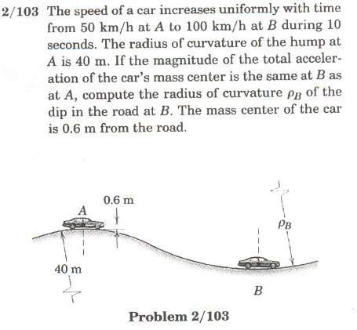

$$\overset{˙}{V}=\frac{\text{100}−\text{50}}{\text{10}s}=\frac{5{\text{km}}/{\text{hr}}}{\text{sec}}∗\frac{\text{1000}m}{\text{hr}}∗\frac{\text{hr}}{\text{3600}s}=\frac{\text{5000}}{\text{3600}}m/{s^{2}}=1\text{.}\text{39}m/{s^{2}}$$
$ρ_{A}= \text{40}+0\text{.}6=\text{40}\text{.}6m$ $V_{A}=\text{50}{\text{km}}/{\text{hr}}=\text{13}\text{.}\text{89}m/s$ $a_{A}=\sqrt{(\frac{V_{A}^{2}}{ρ_{A}})^{2}+{\overset{˙}{V}}^{2}}=4\text{.}\text{95}m/{s^{2}}$
$a_{B}=a_{A}$ $V_{B}=\frac{\text{100}\text{km}}{\text{hr}}=\text{27}\text{.}\text{78}m/s$ $∴a_{B_{A}}^{2}−{\overset{˙}{V}}^{2}=a_{A}^{2}−{\overset{˙}{V}}^{2}⇒\frac{V_{B}^{2}}{ρ^{'_{B}}}=\frac{V_{A}^{2}}{ρ_{A}}$
$ρ^{'_{B}}=\frac{V_{B}^{2}ρ_{A}}{V_{A}^{2}}=$$\frac{{\text{100}}^{2}}{{\text{50}}^{2}}ρ_{A}=4ρ_{A}=\text{162}\text{.}4m$, $ρ$_{B}=$ρ^{'_{B}}$+0.6=163 m
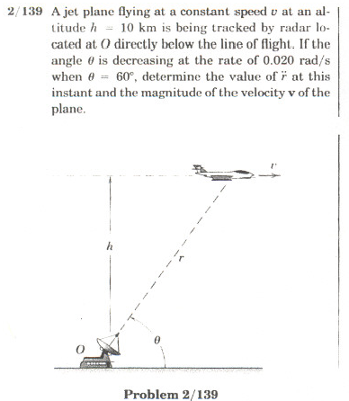
$h=\text{10000}=r\text{sin}θ=r\text{sin}\text{60}°⇒r=\text{11547} m$ $v=\text{const}$
$\overset{˙}{h}=0=\overset{˙}{r}\text{sin}θ+r\text{cos}θ\overset{˙}{θ}$ $⇒$ $\overset{˙}{r}=−r\text{cot}θ\overset{˙}{θ}=−\text{11547}\text{cot}\text{60}(−0\text{.}\text{02})=\text{133}\text{.}\text{33}m/{s^{\text{**}}}$
$$v=\sqrt{{\overset{˙}{r}}^{2}+(r\overset{˙}{θ})^{2}}=\sqrt{(\text{133}\text{.}\text{33})^{2}+(\text{11547}⋅0\text{.}\text{02})^{2}}=\text{266}\text{.}\text{66}m/s$$
$$v=\text{266}\text{.}\text{66}\frac{m}{s}×\text{3600}\frac{s}{\text{hr}}×\frac{1\text{km}}{\text{1000}m}=\text{960}{\text{km}}/{\text{hr}}$$
$v$ is constant, $⇒$ a=0, $⇒$ $a_{r}=0$, $a_{θ}=0$ $⇒$ $\overset{⋅=r{\overset{}{θ}}^{2}=4\text{.}\text{6188}m/{s^{2}}}{r}$
the other method is to take ** and differentiate it with time again. That will give $\overset{¨}{r}$ in terms of d²θ/dt². Now since v=constant, then take dv/dt, which will involve both $\overset{¨}{r}$ and d²θ/dt². But dv/dt=0 and so you can solve for either d²θ/dt² or $\overset{¨}{r}$

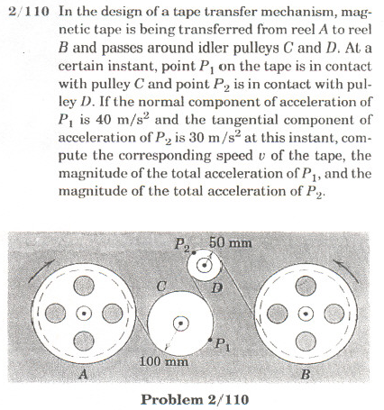

$a_{n_{ρ_{1}}}=\text{40}m/{s^{2}}$ $a_{t_{ρ_{2}}}=\text{30}m/{s^{2}}$
$\frac{v^{2}}{ρ_{ρ_{1}}}=a_{n_{ρ_{1}}}$ $∴v=\sqrt{a_{n_{ρ_{1}}}⋅ρ}=\sqrt{\text{40}(0\text{.}1m)}=2m/s$

Since tape doesn’t stretch $a_{t_{ρ_{1}}}=a_{t_{ρ_{2}}}=\text{30}$$m/{s^{2}}$ $∴a_{ρ_{1}}=\sqrt{{\text{40}}^{2}+{\text{30}}^{2}}=\text{50}m/{s^{2}}$
$a_{n_{ρ_{2}}}=\frac{v^{2}}{ρ_{ρ_{2}}}=\text{80}m/{s^{2}}$ $a_{ρ_{2}}=\sqrt{{\text{30}}^{2}+{\text{80}}^{2}}=\text{85}\text{.}\text{44}m/{s^{2}}$

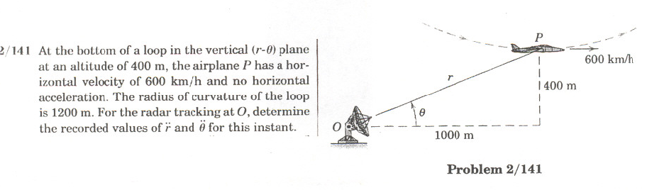
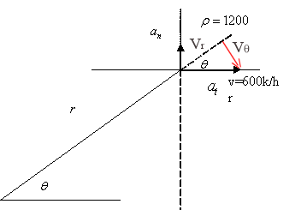
v=600k/hr

$\overset{˙}{v}=0$ $a_{n}=\frac{v^{2}}{ρ}=\frac{(\text{600}⋅\frac{1}{3\text{.}6})^{2}}{\text{1200}}\text{23}\text{.}\text{148}m/{s^{2}}$ $a=0$ $∴a=\text{23}\text{.}\text{148}m/{s^{2}}$
$r\text{cos}θ=\text{1000}$ $r\text{sin}θ=\text{400}$ ⇒ $\text{tan}θ=0\text{.}4$ $θ=\text{21}\text{.}\text{80}°$ m
$$a_{n}\text{sin}θ=a_{r}=\text{23}\text{.}\text{148}⋅\text{sin}\text{21}\text{.}\text{80}\text{°=}8\text{.}\text{596} m/{s^{2}}=\overset{¨}{r}−r{\overset{˙}{θ}}^{2}$$
$$a_{n}\text{cos}θ=a_{θ}=\text{23}\text{.}\text{148}⋅\text{cos}\text{21}\text{.}\text{80}\text{°=}\text{21}\text{.}\text{493} m/{s^{2}}=2\overset{˙}{r}\overset{˙}{θ}+r\overset{¨}{θ}$$
$$V_{r}=V\text{cos}θ=\overset{˙}{r}=\text{166}\text{.}\text{67}⋅\text{cos}\text{21}\text{.}\text{80}\text{°= \{}\overset{˙}{r}=\text{154}\text{.}\text{75}m/s$$
$V_{θ}=V\text{sin}θ=r\overset{˙}{θ}=−\text{61}\text{.}\text{869}=r\overset{˙}{θ}$ $∴\overset{˙}{θ}=−0\text{.}\text{057469}{\text{rad}}/s$
$\overset{¨}{r}=a_{r}+r{\overset{˙}{θ}}^{2}=\text{12}\text{.}\text{153}m/{s^{2}}$ $\overset{¨}{θ}=\frac{a_{θ}−2\overset{˙}{r}\overset{˙}{θ}}{r}=0\text{.}\text{03647}{\text{rad}}/s$

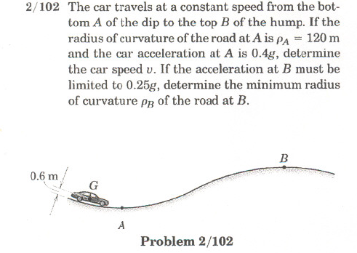

$\overset{˙}{v}=0$ $a_{n}=\frac{v^{2}}{ρ}$ $⇒$ $0\text{.}4g=0\text{.}4(9\text{.}\text{81})=\frac{v^{2}}{ρ^{'}}$ $⇒$ $ρ^{'}=\text{120}−0\text{.}6=\text{119}\text{.}4$ $v=\text{21}\text{.}\text{65}m/s$
Since $\overset{˙}{v}=0$ $a_{B}=\frac{v_{B}^{2}}{ρ_{B^{′}}}$ ; $a_{A}=\frac{v_{A}^{2}}{ρ_{A^{′}}}$
$$∴ρ_{B^{′}}⋅a_{B}=ρ_{A^{′}}⋅a_{A}=v_{B}^{2}=v_{A}^{2}$$
$$ρ_{B^{′}}=ρ_{A^{′}}⋅\frac{a_{A}}{a_{B}}=\text{119}\text{.}4⋅\frac{0\text{.}4g}{0\text{.}\text{25}g}=\text{191}\text{.}\text{04}m$$
$$∴ρ_{B}=ρ_{B^{′}}−0\text{.}6=\text{190}\text{.}\text{44}m$$

