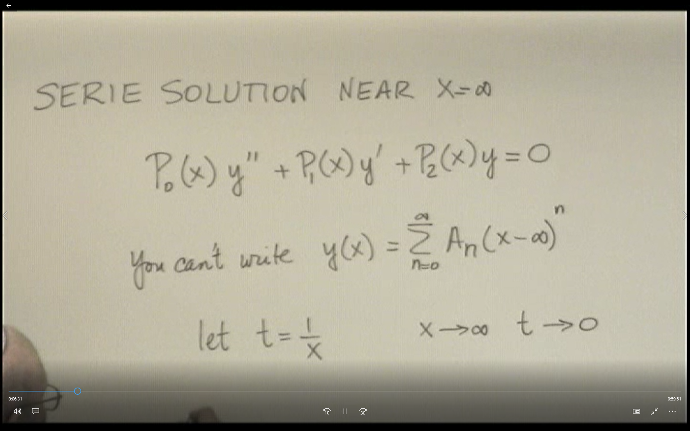

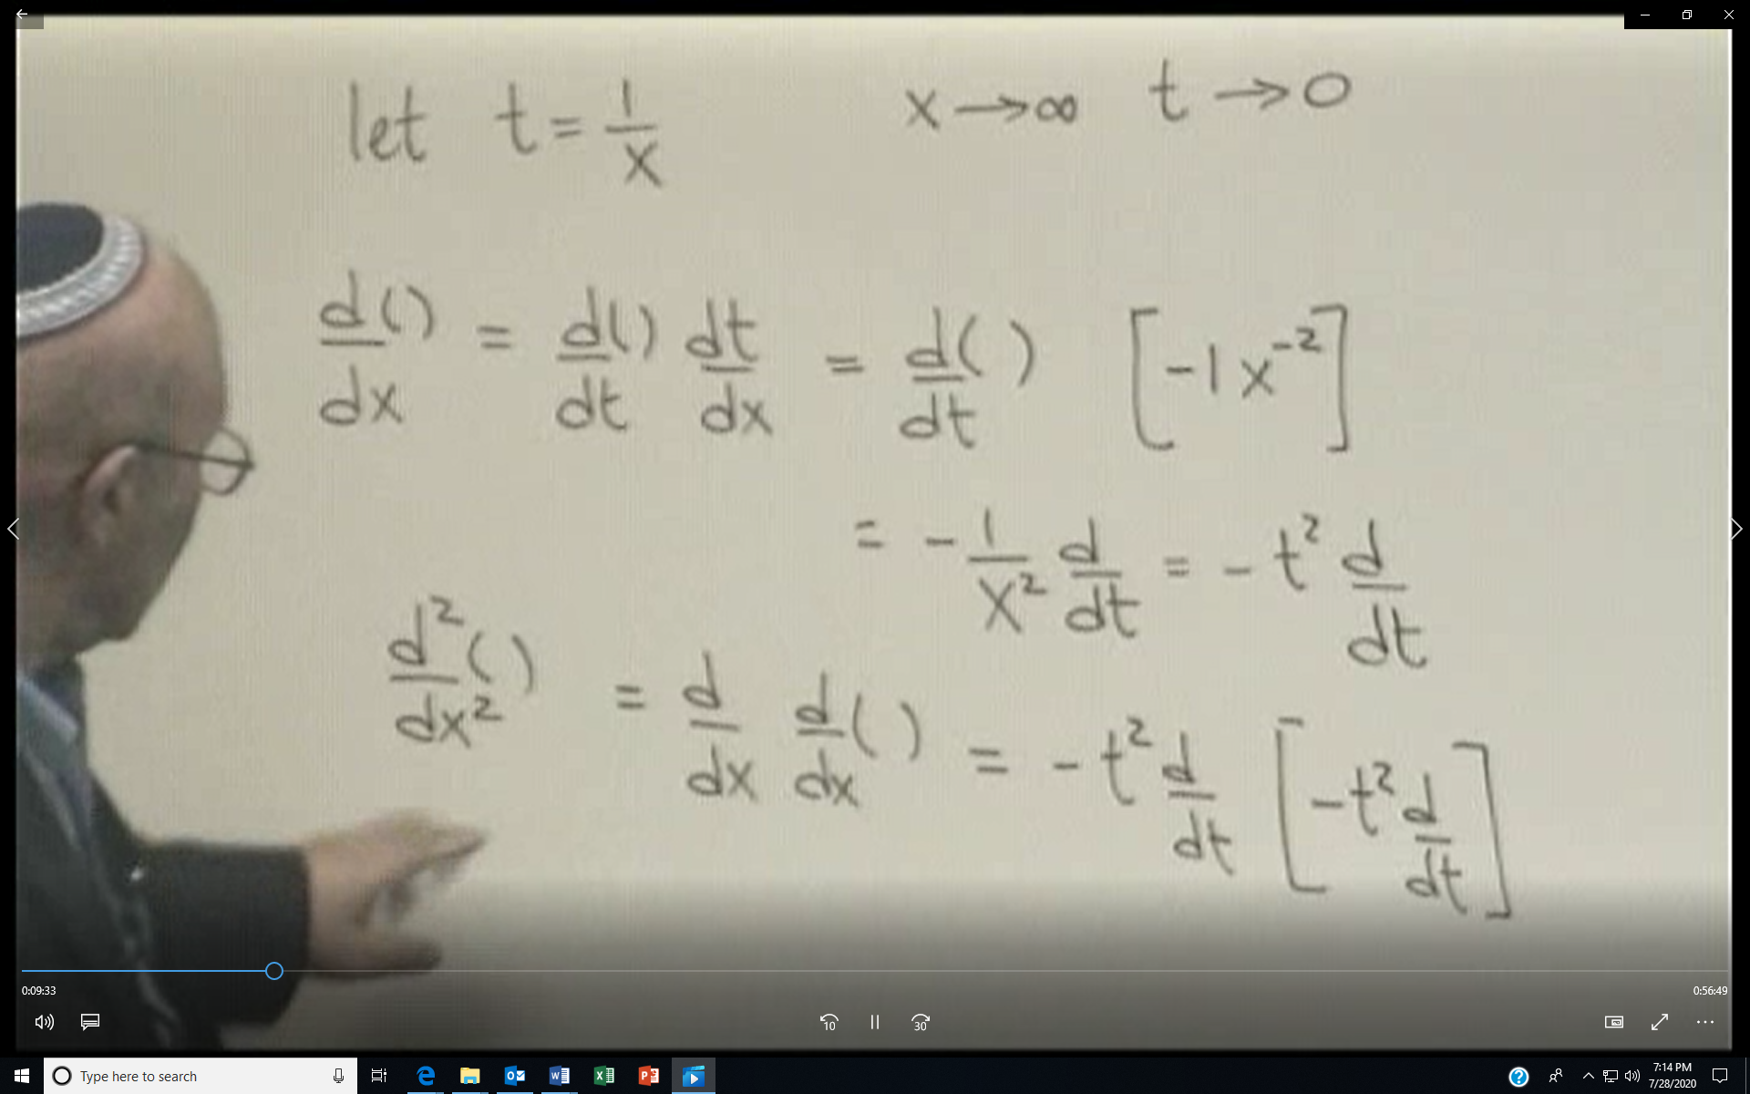

So if we apply this idea to an equation like x2y”+xy’+y=0 in the vicinity of x=∞

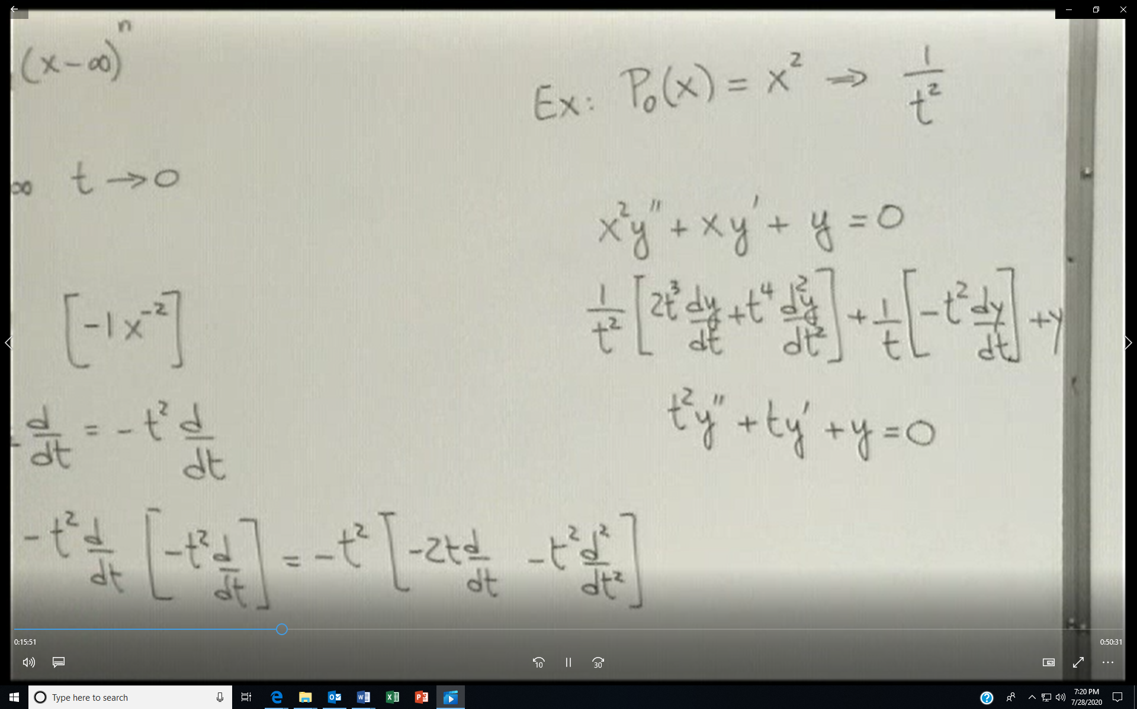

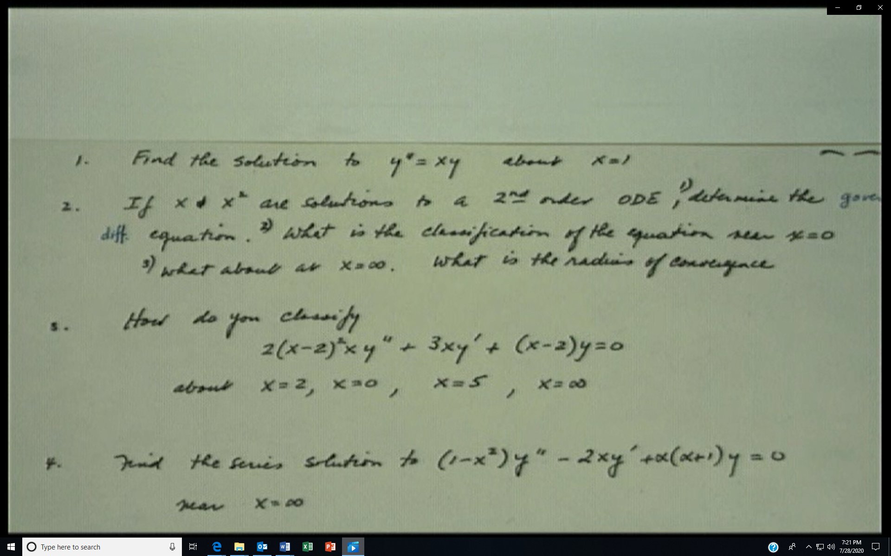

Po(x)=1, P1(x)=0 and P2(x)=-x for problem 1.