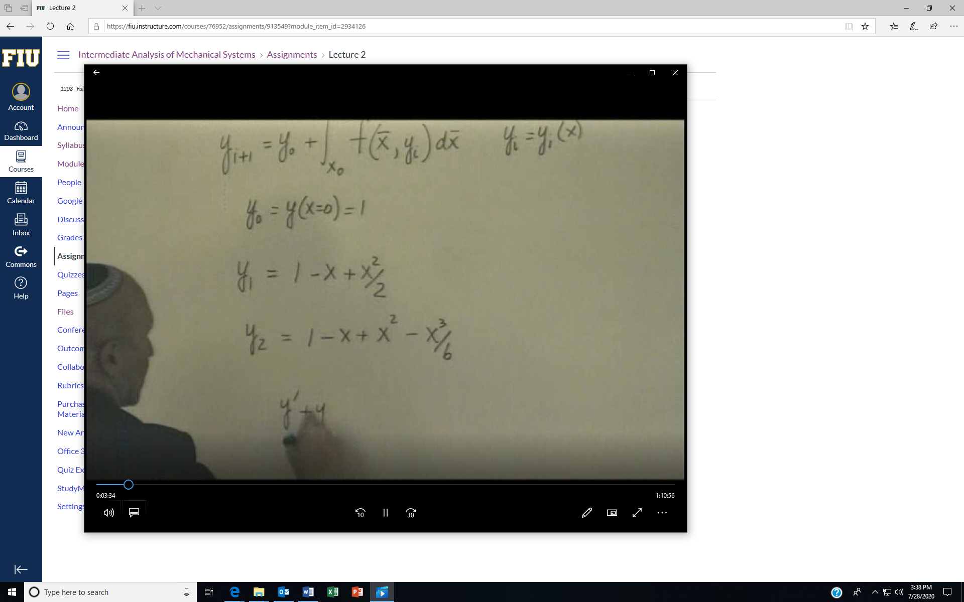

This example shows application of Picard’s method twice. Note error is always in the last term.

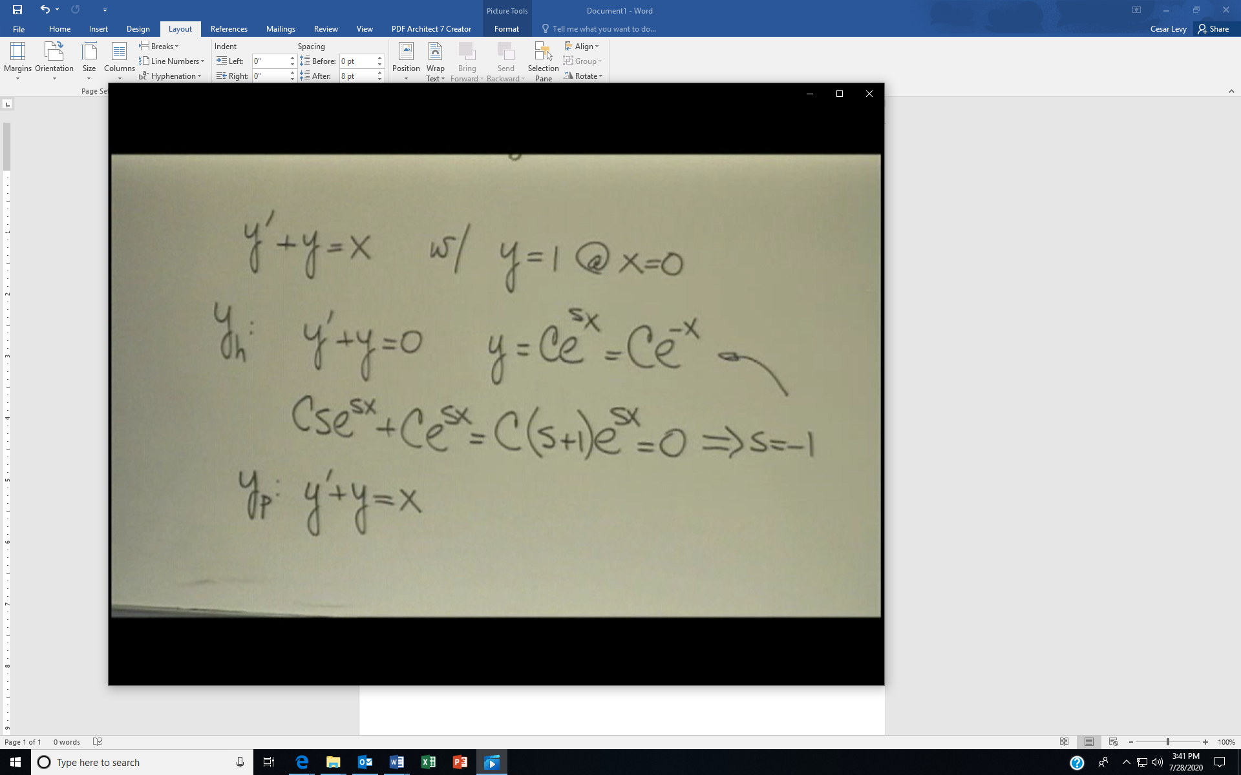

The screen shows the solution of the differential equation by finding the solution to the homogeneous part first.

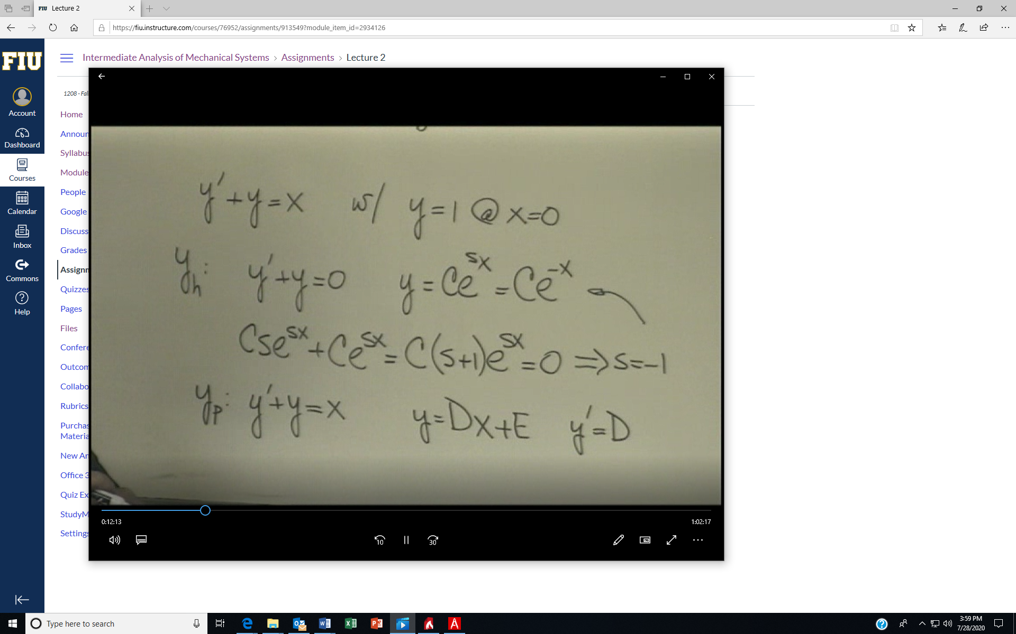

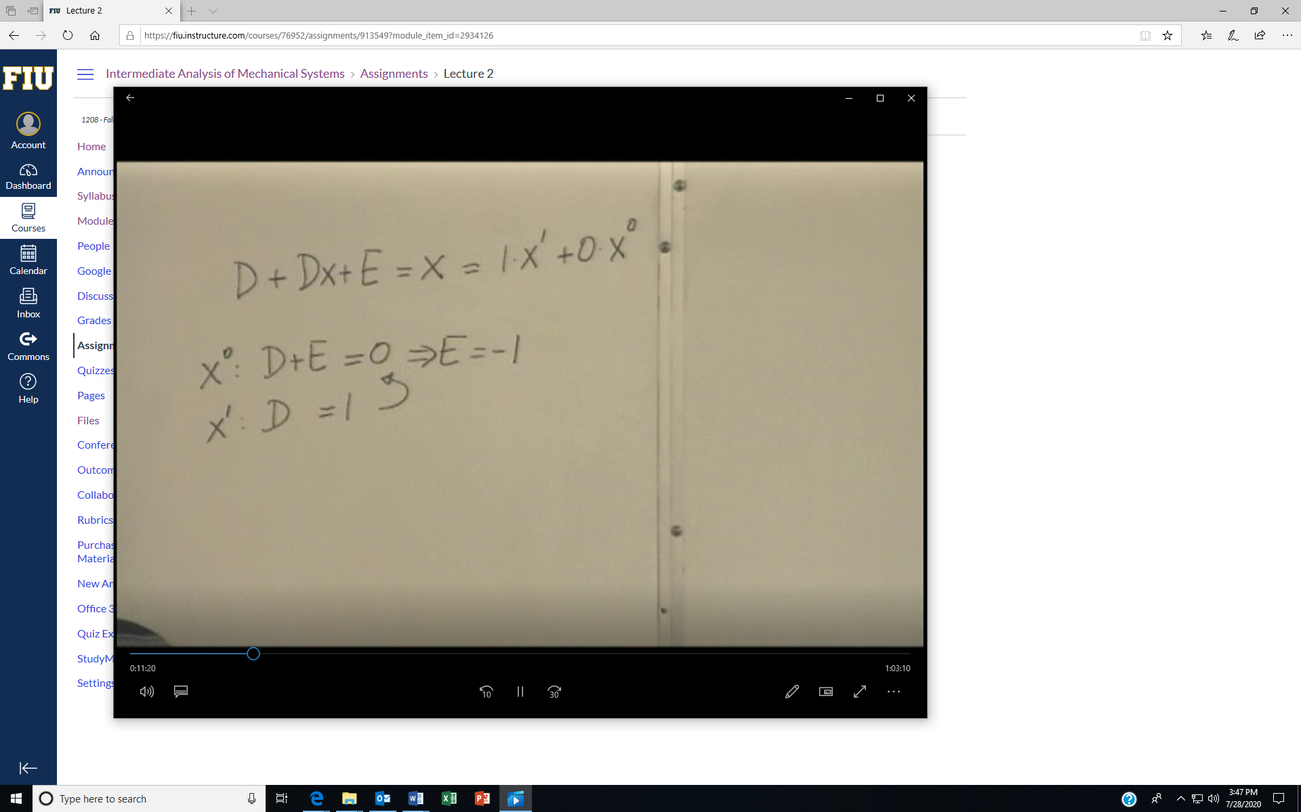

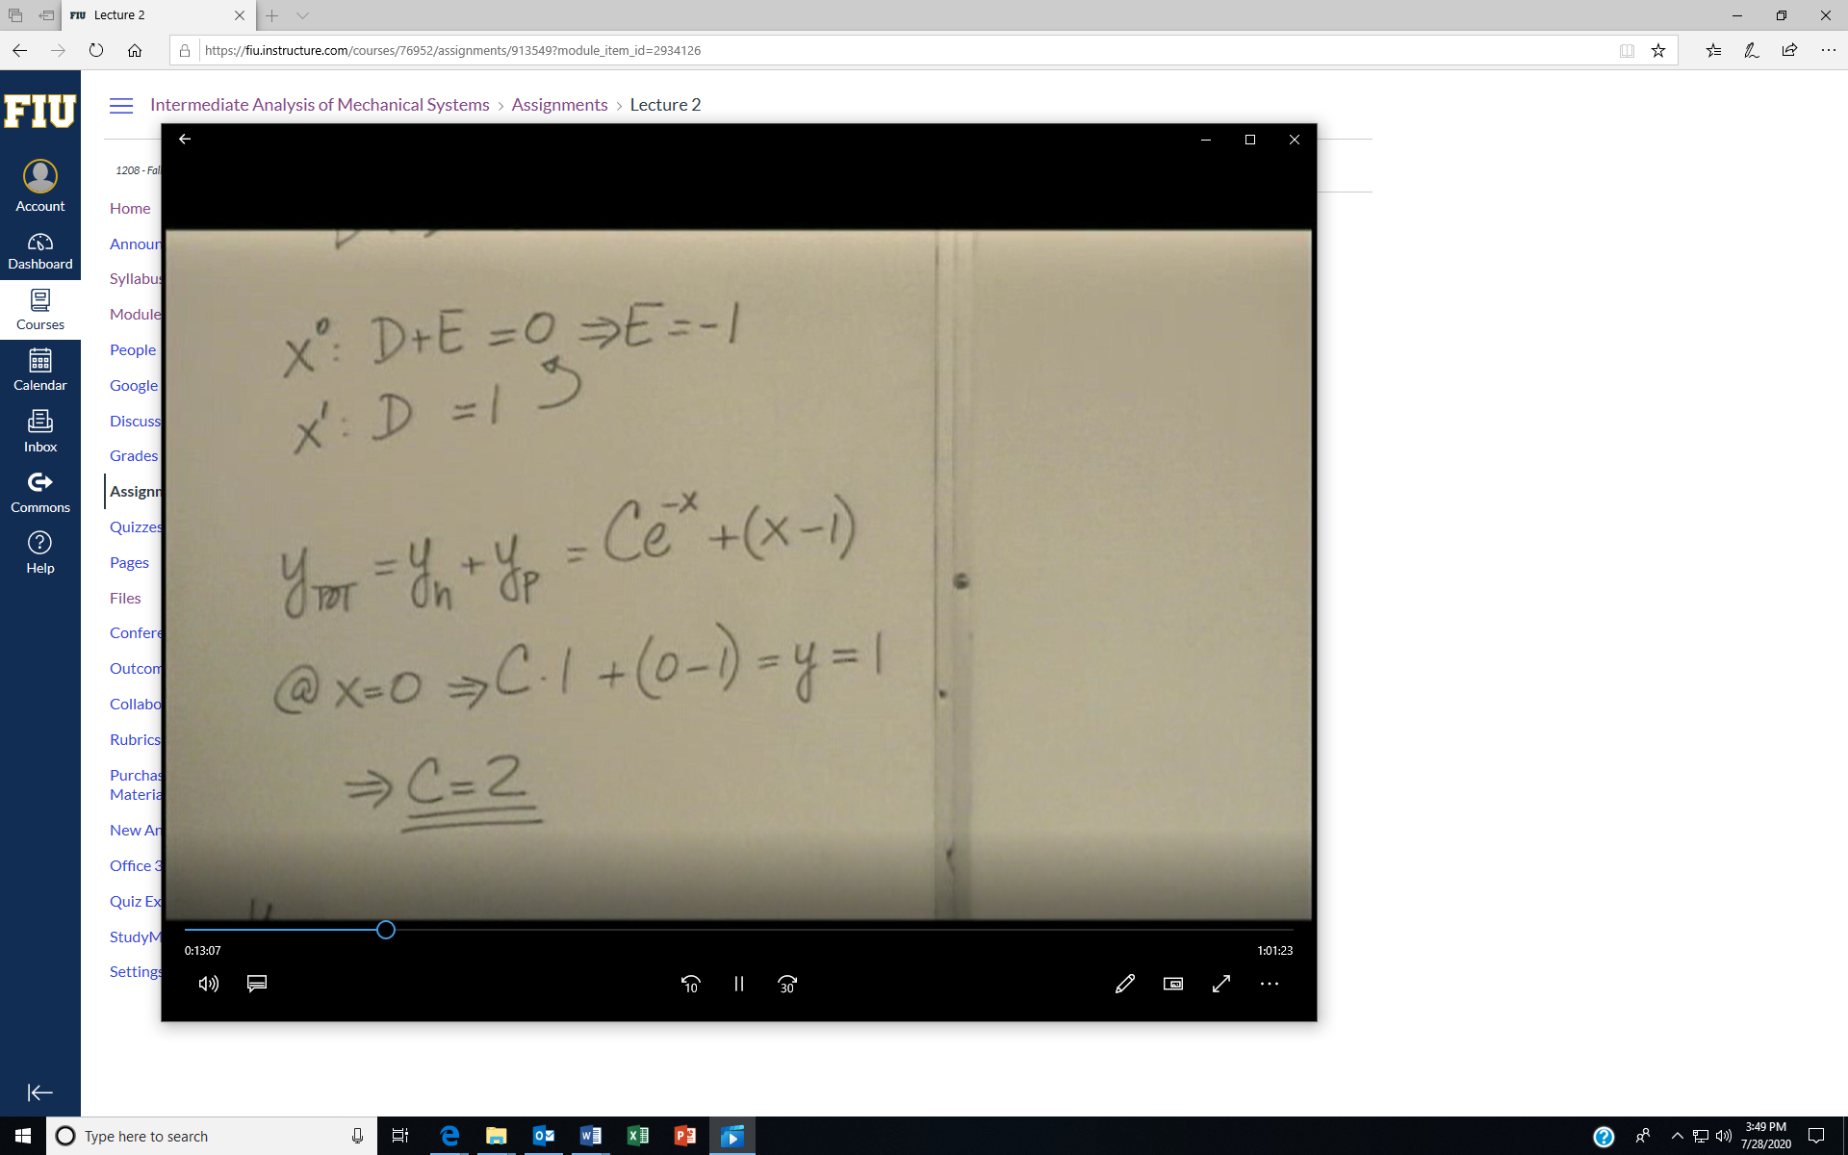

You now can get the full solution before the initial condition and by applying the IC, you find the full solution

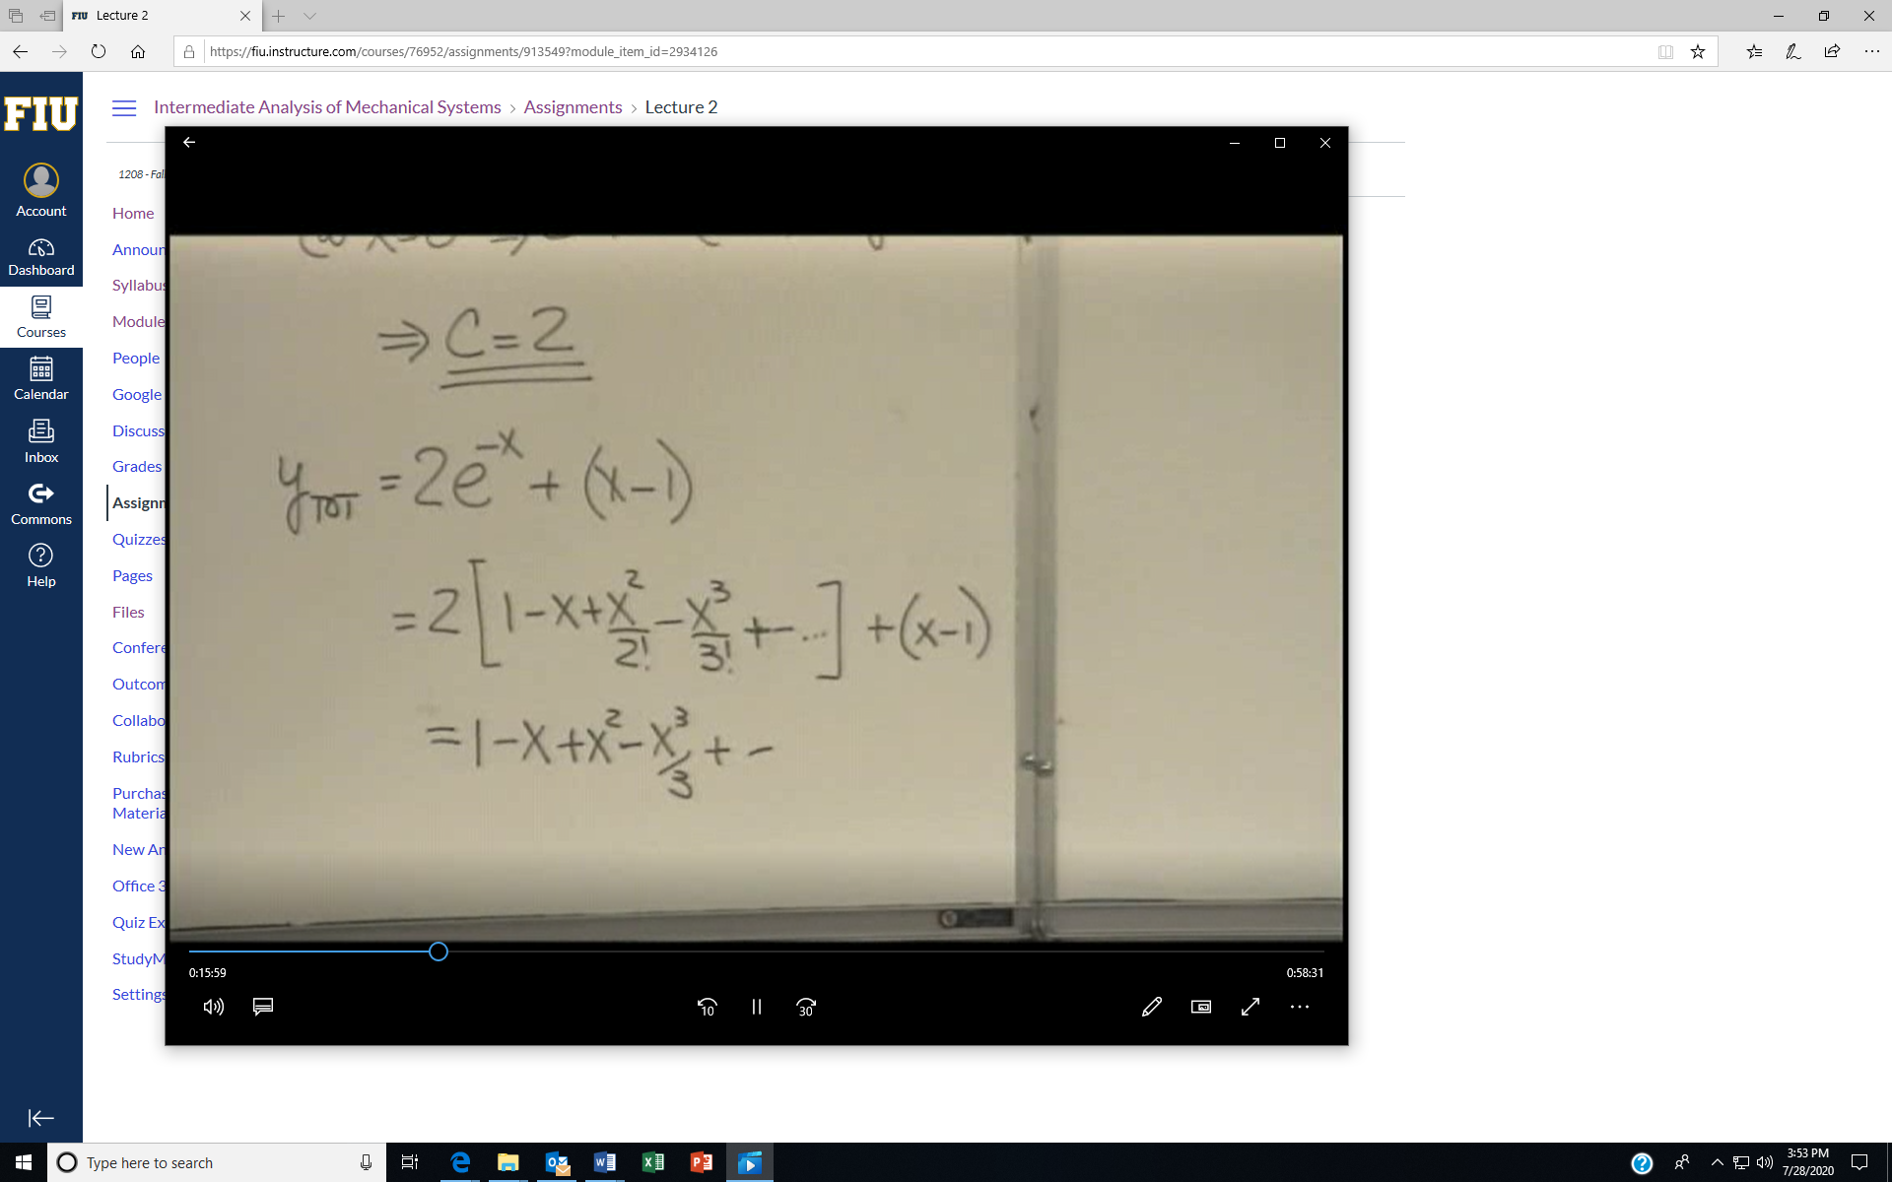

Comparing the results to iterates of Picard’s method leads to the fact that the error is always in the last term