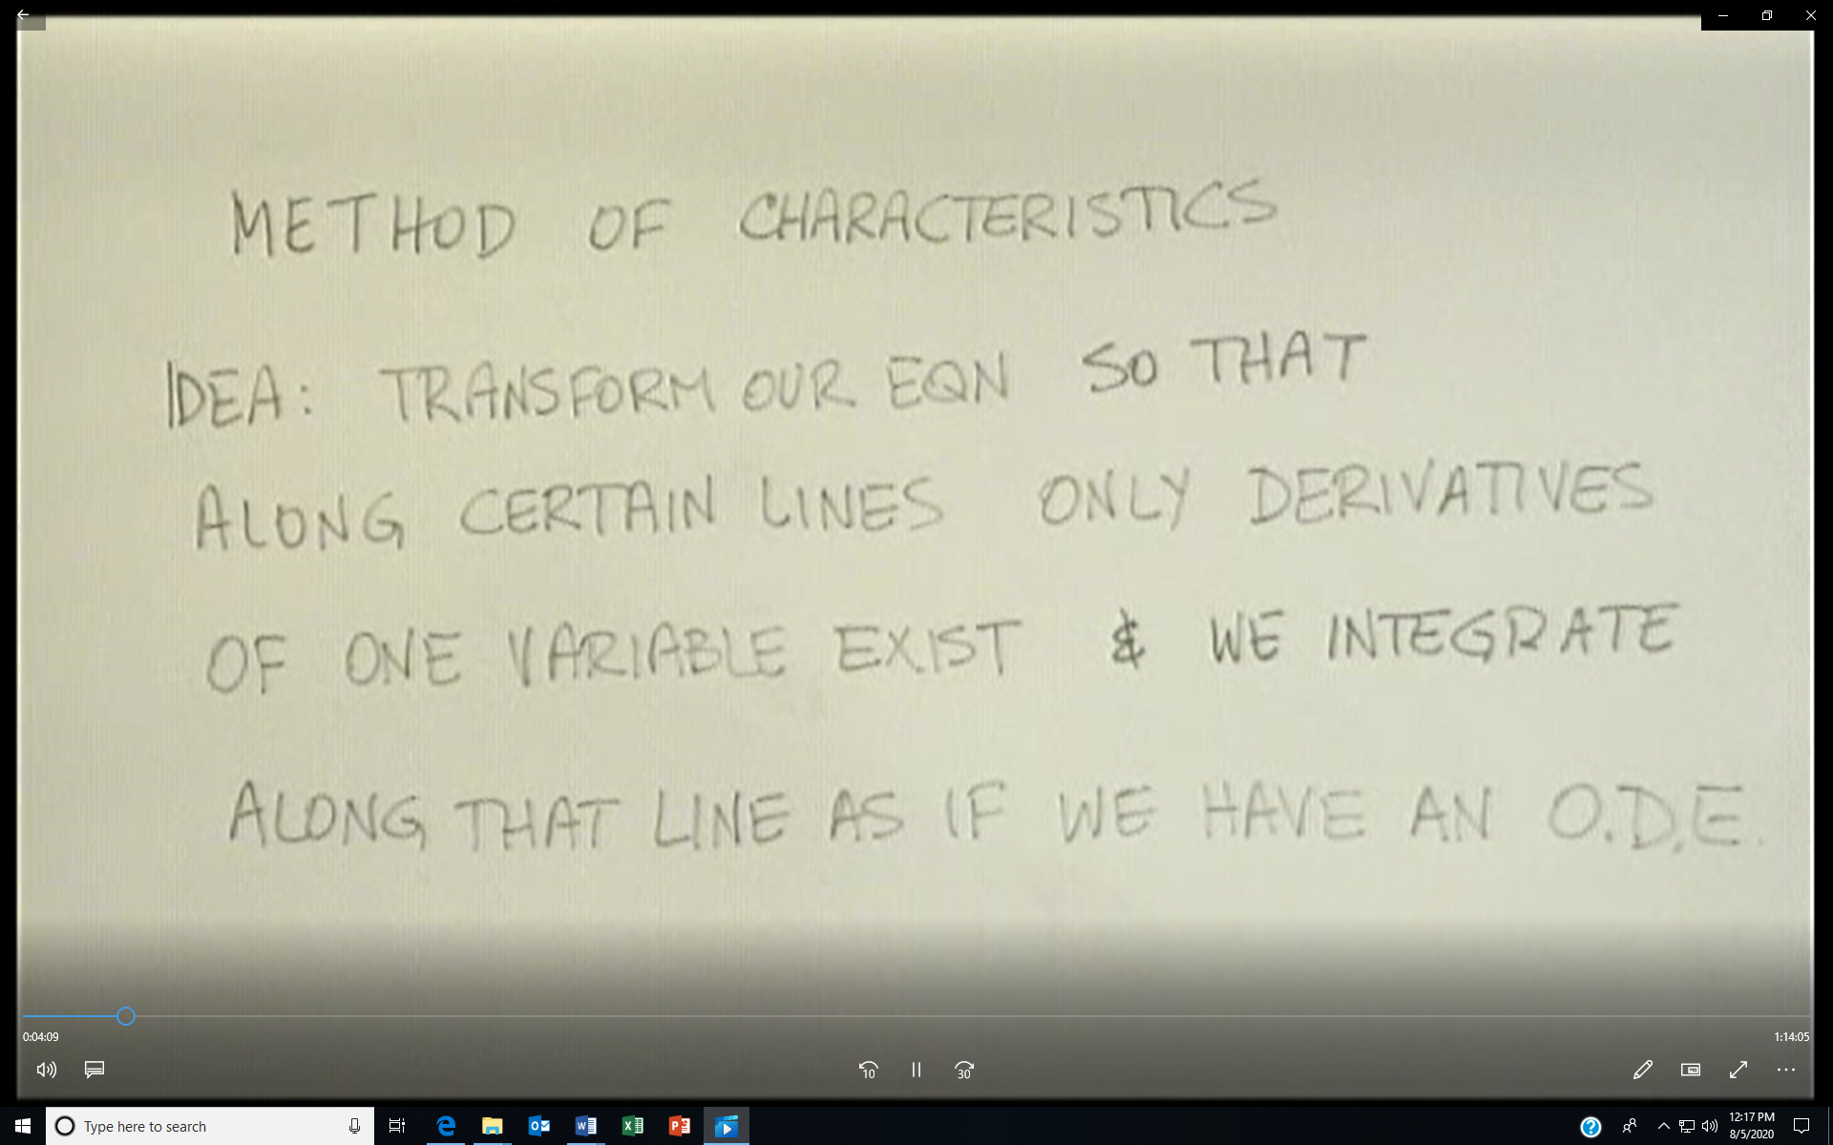
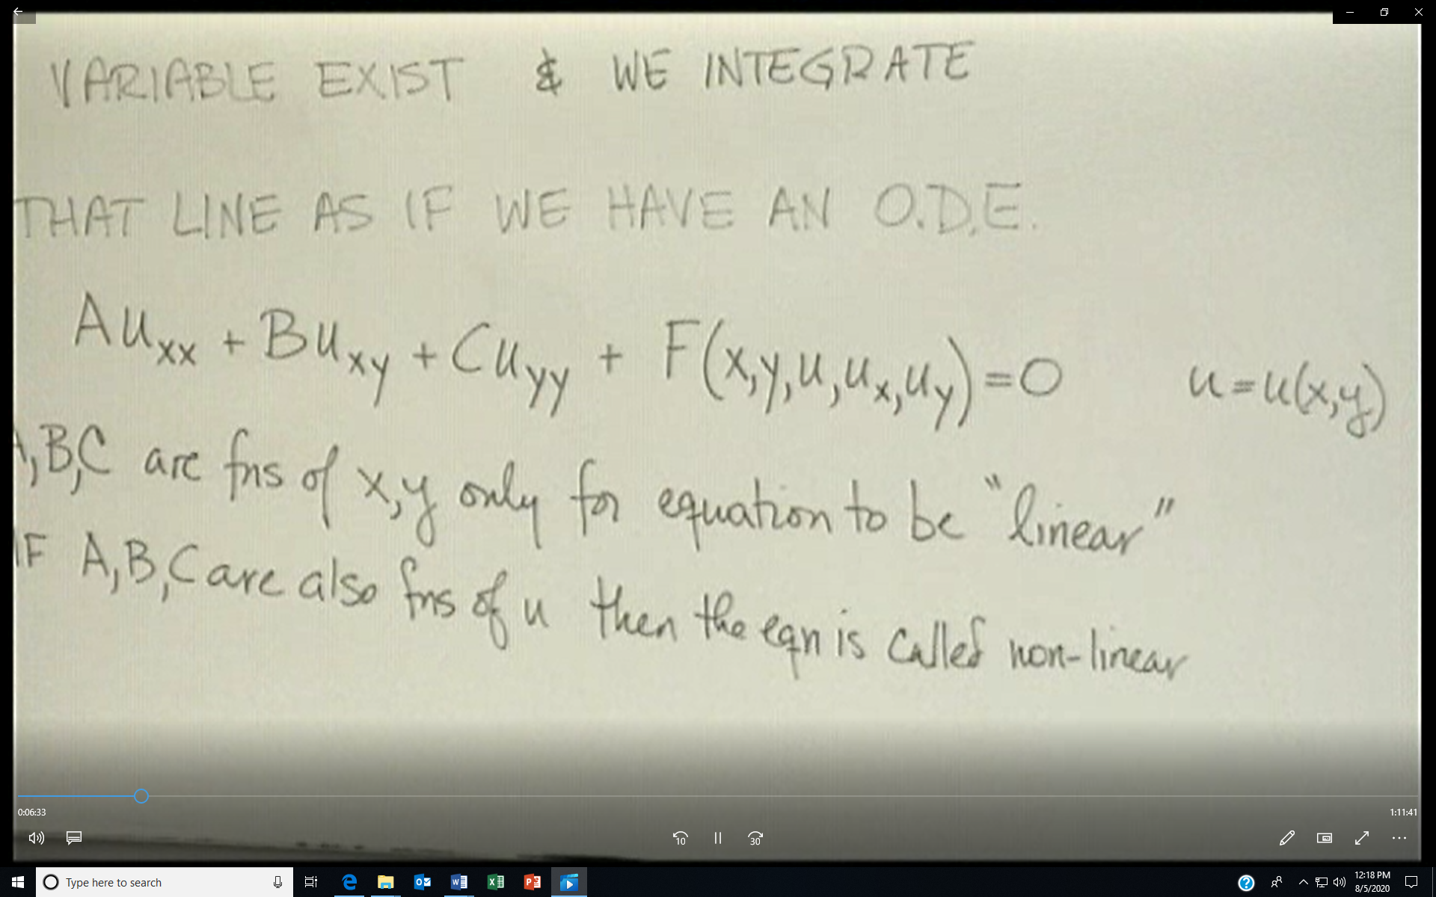

The method of characteristics for a 1-D PDE
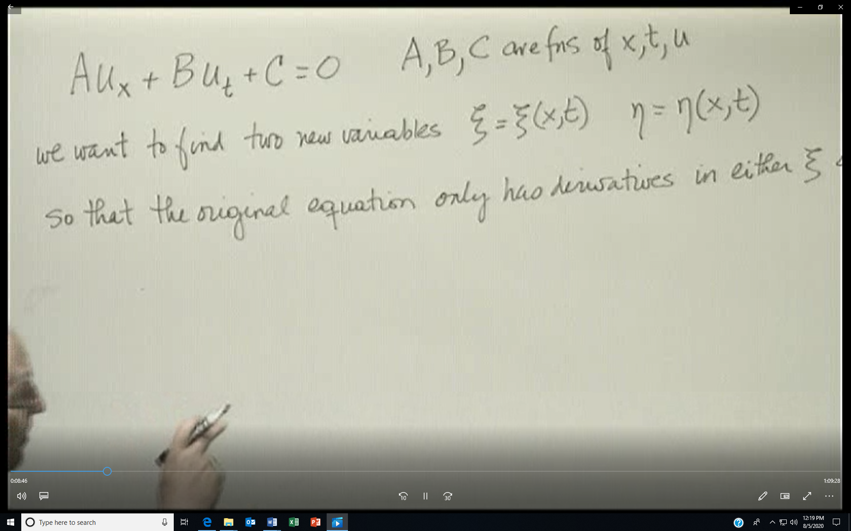

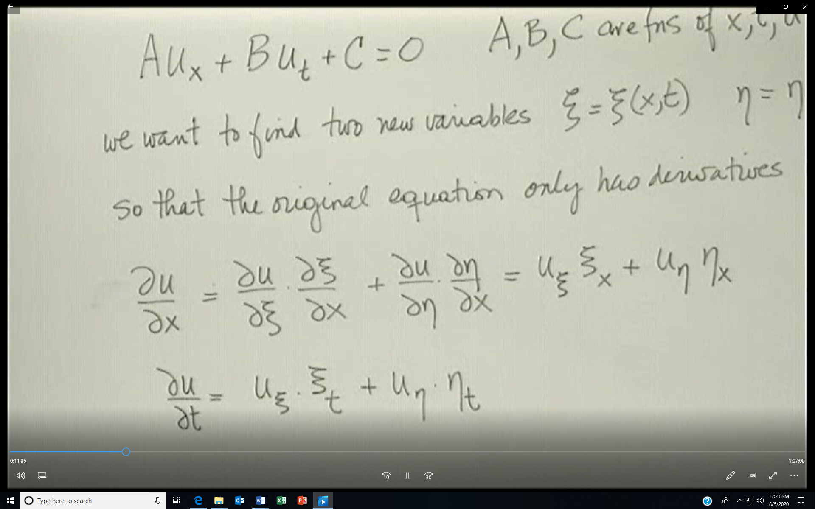
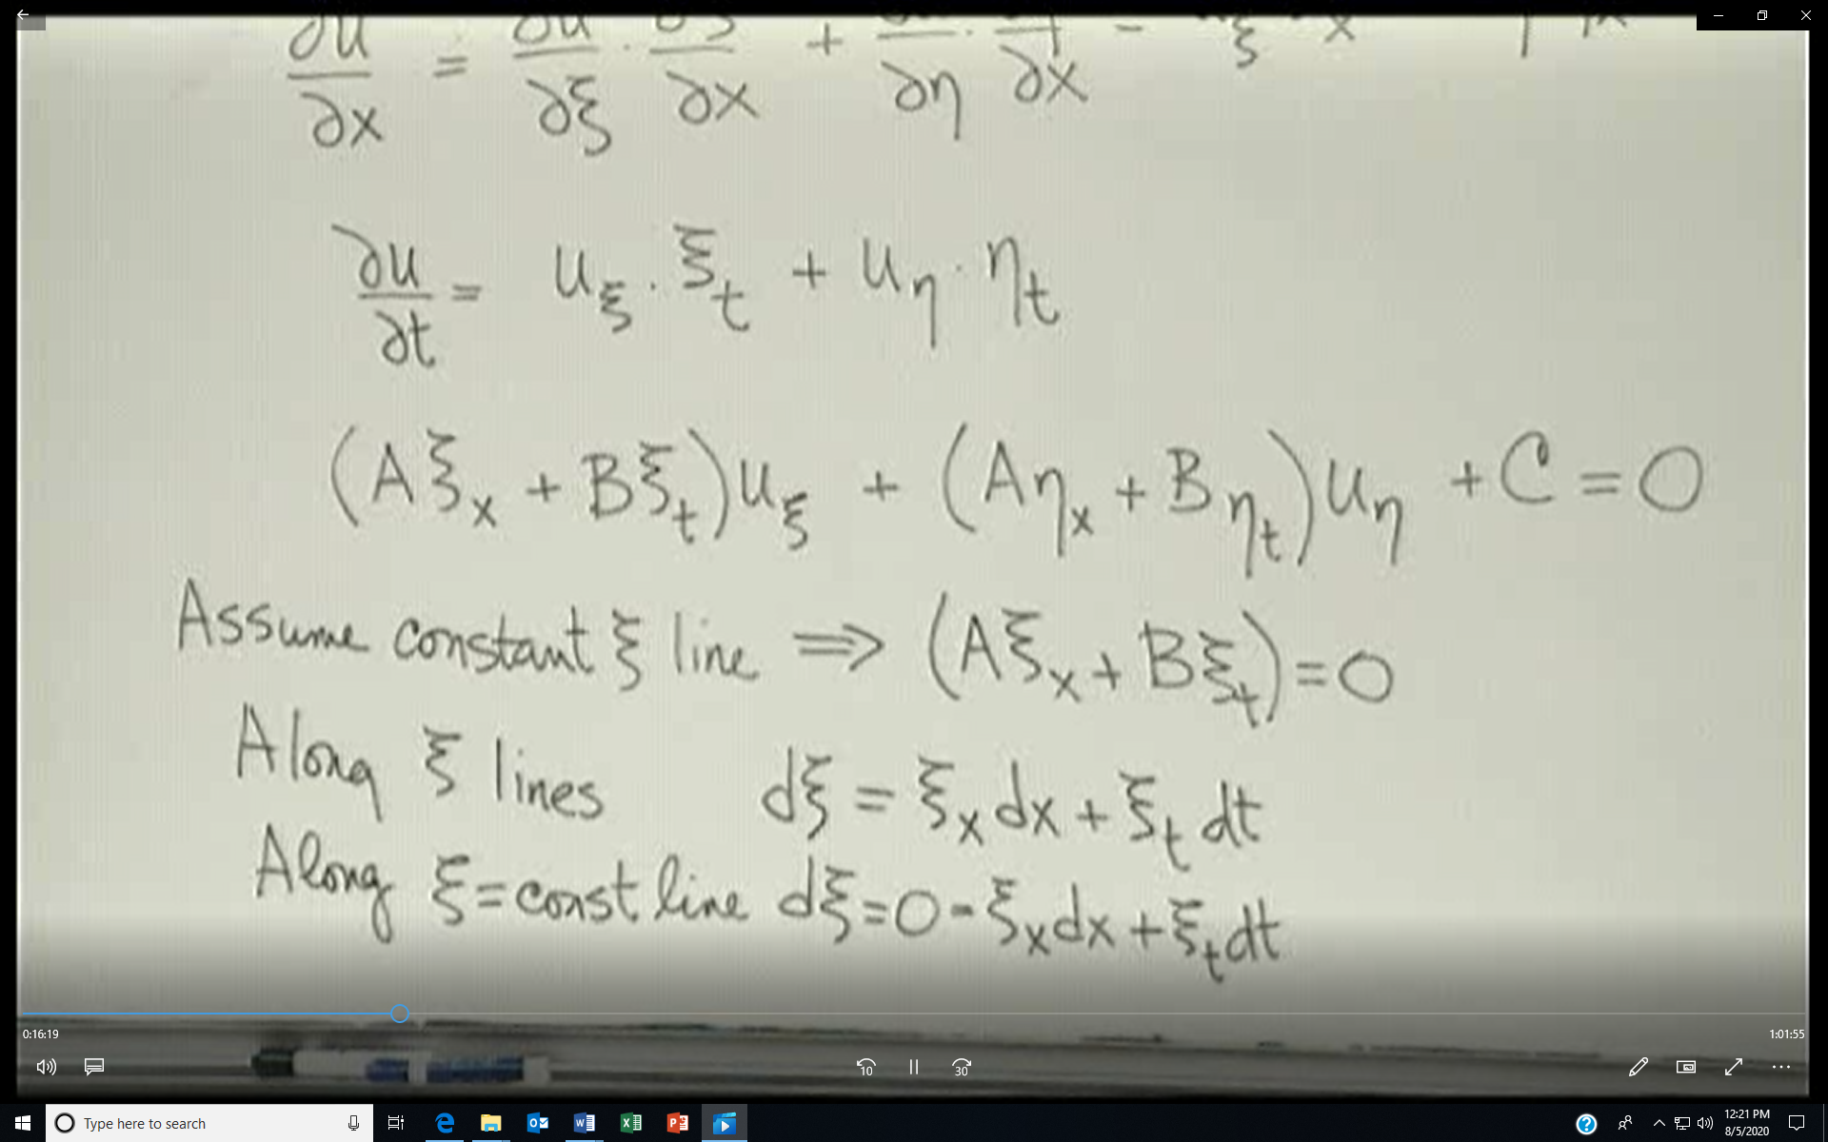

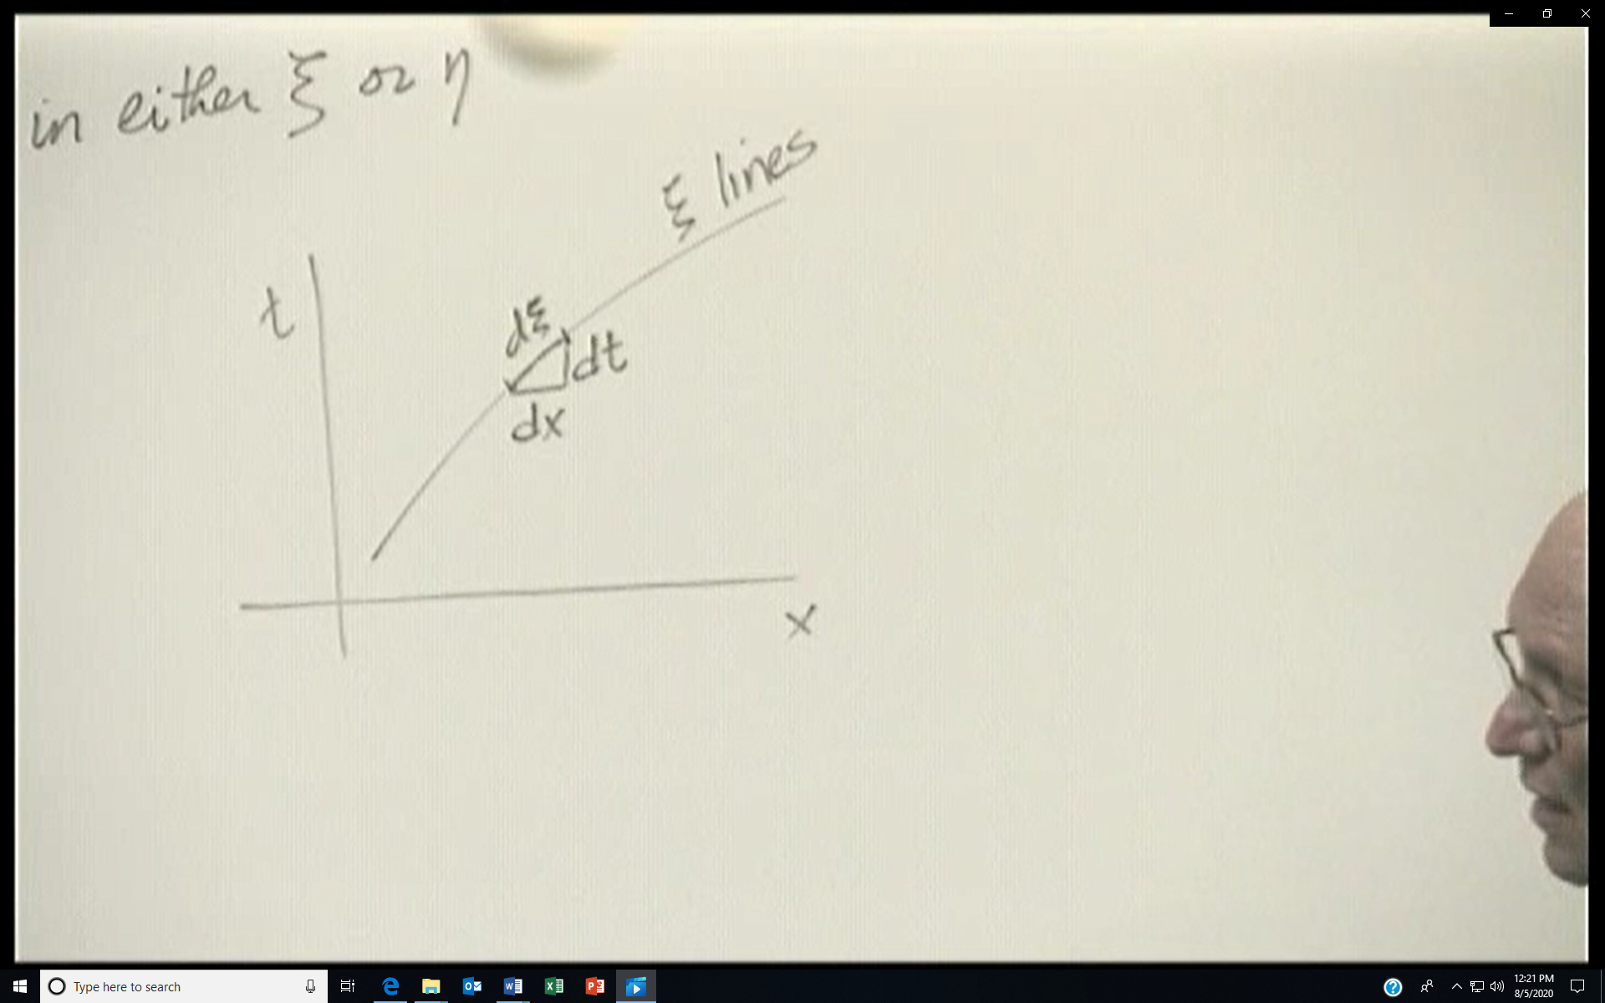
Defining the ξ characteristic in the x-t plane. η is any line that crosses ξ and is not parallel to it.
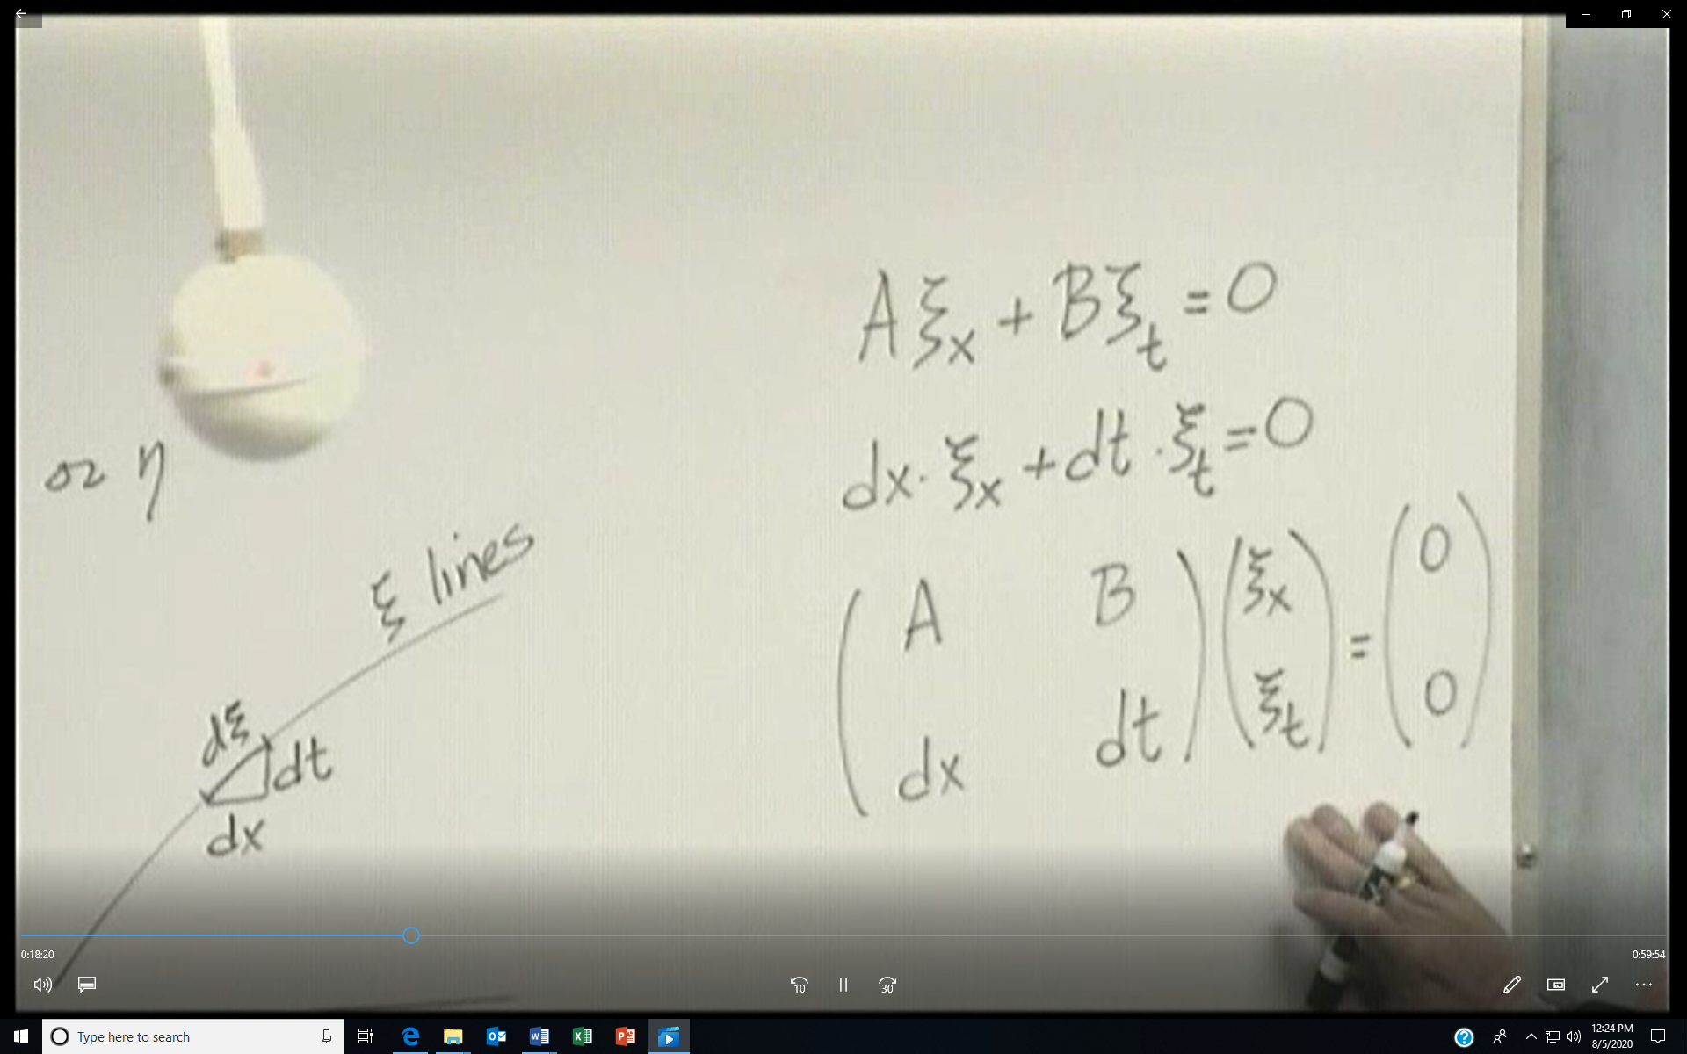
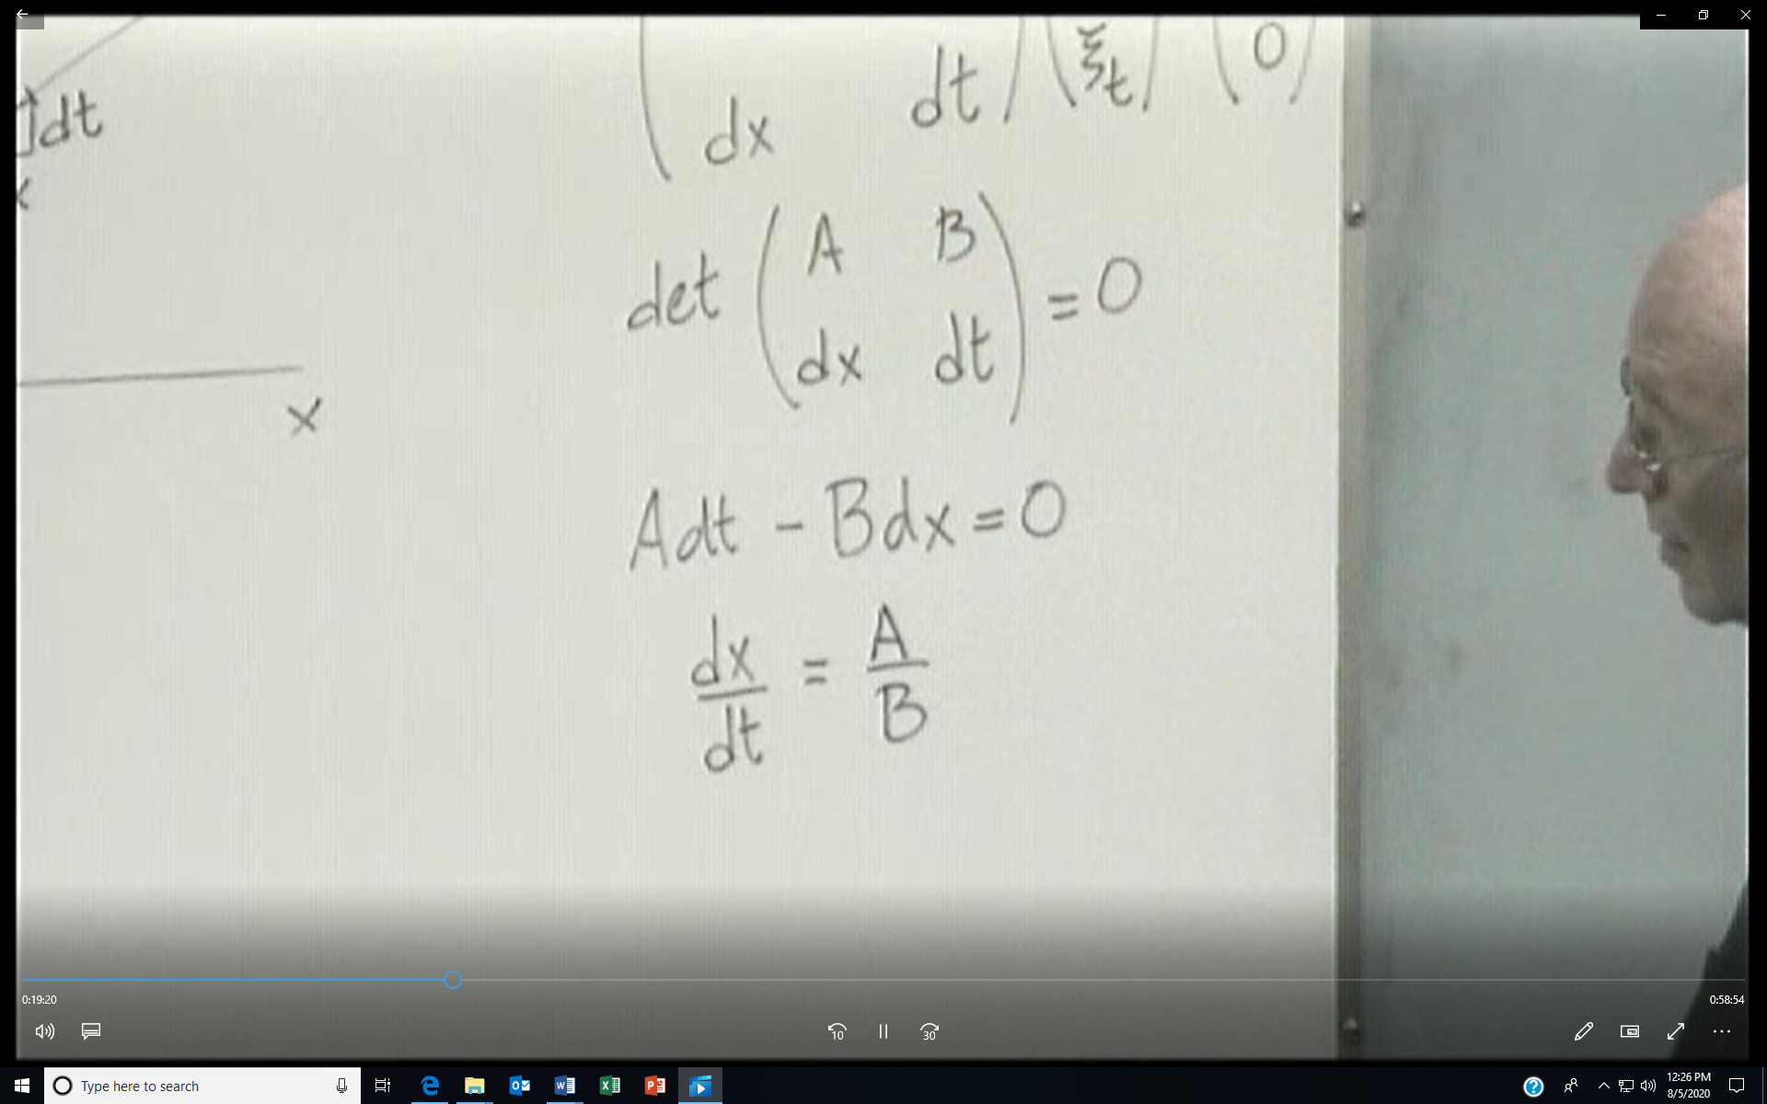
dx/dt is the slope along the characteristic and we can integrate to get the equation of the characteristic
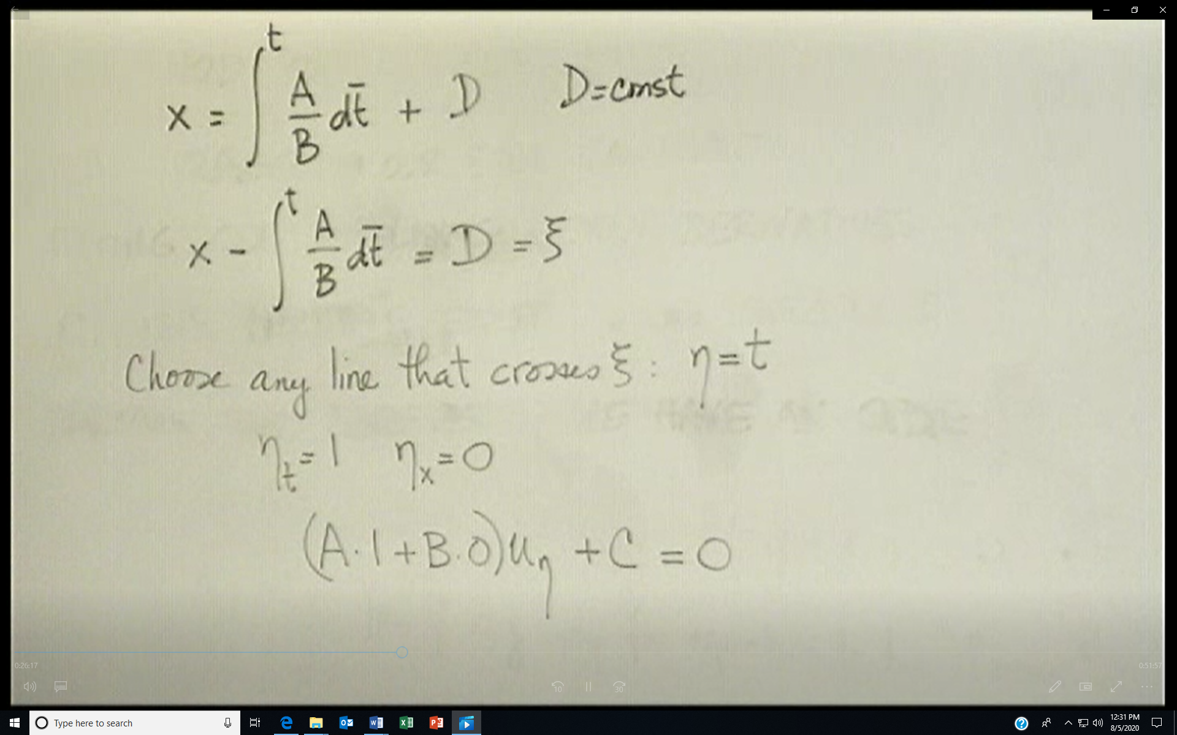
Please note that the last equation above is incorrect but it is corrected below. How do we get u?

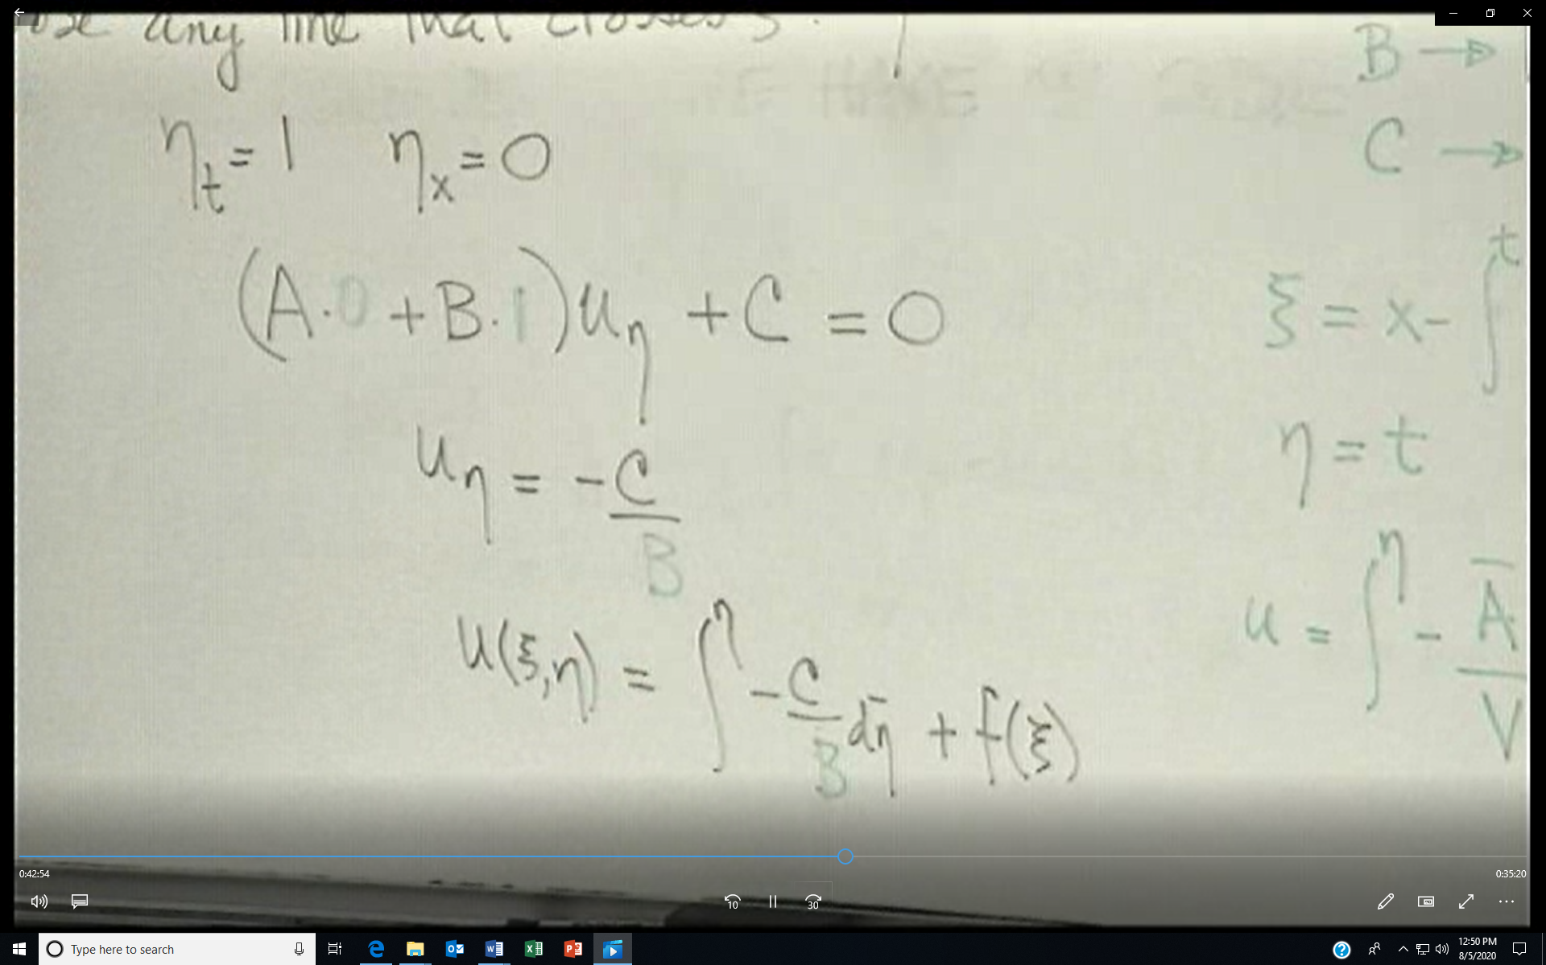

An example
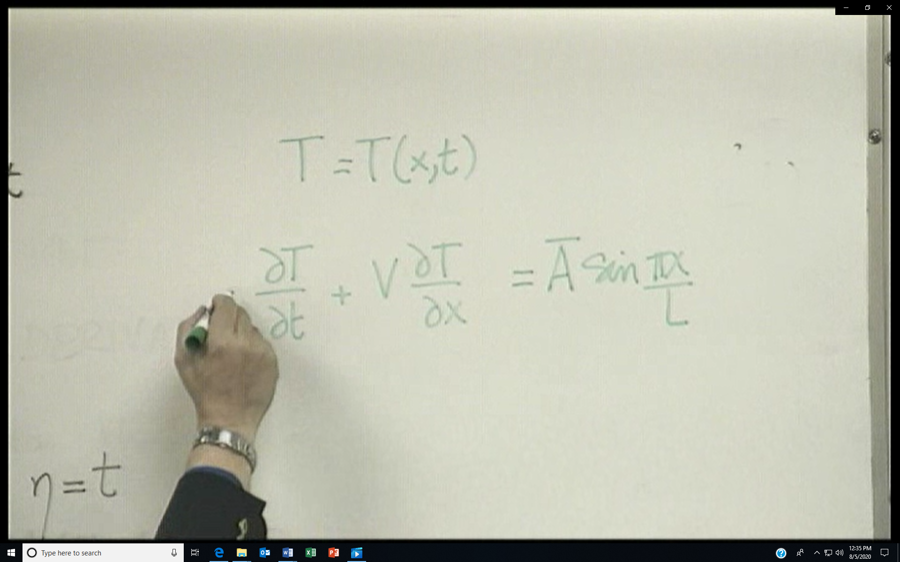
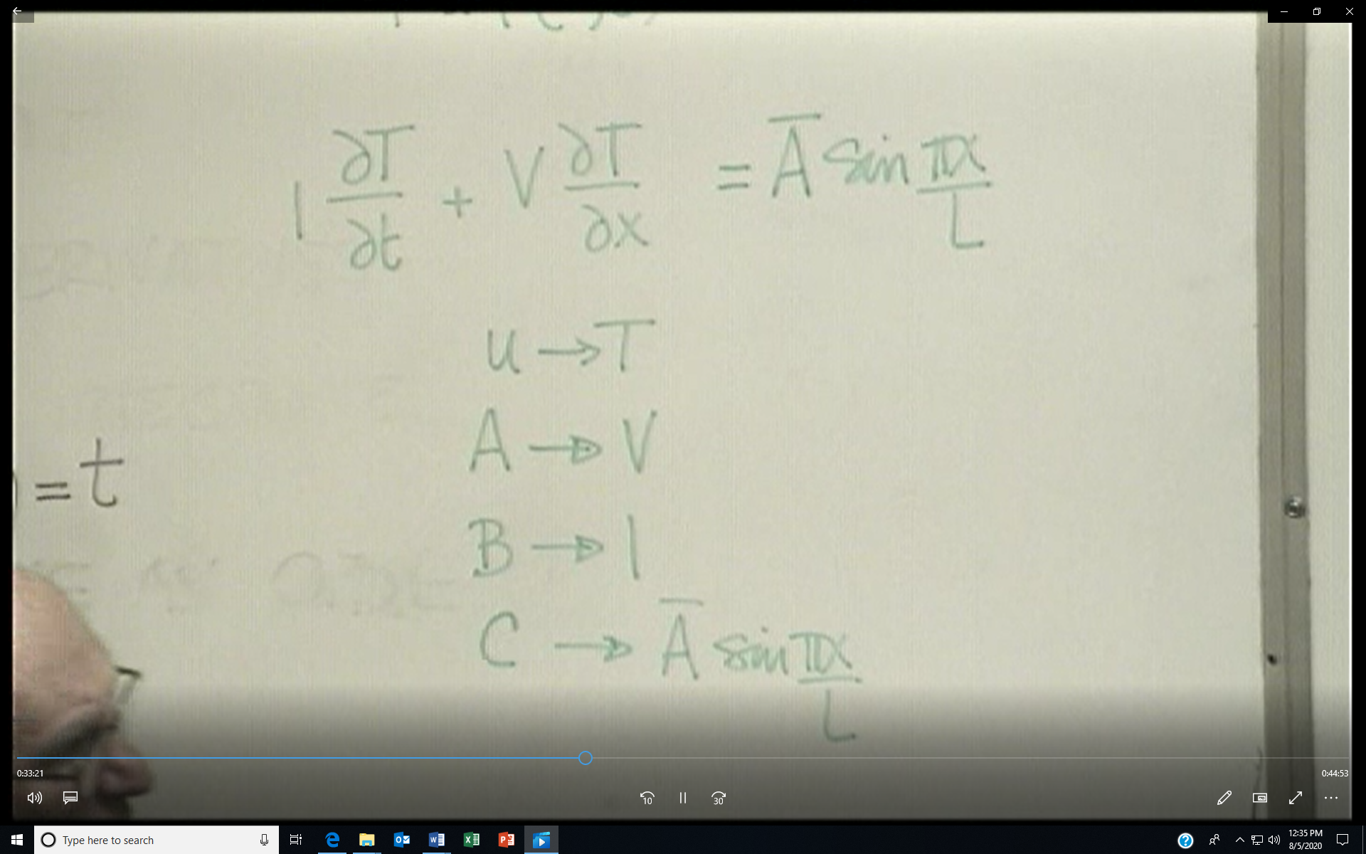
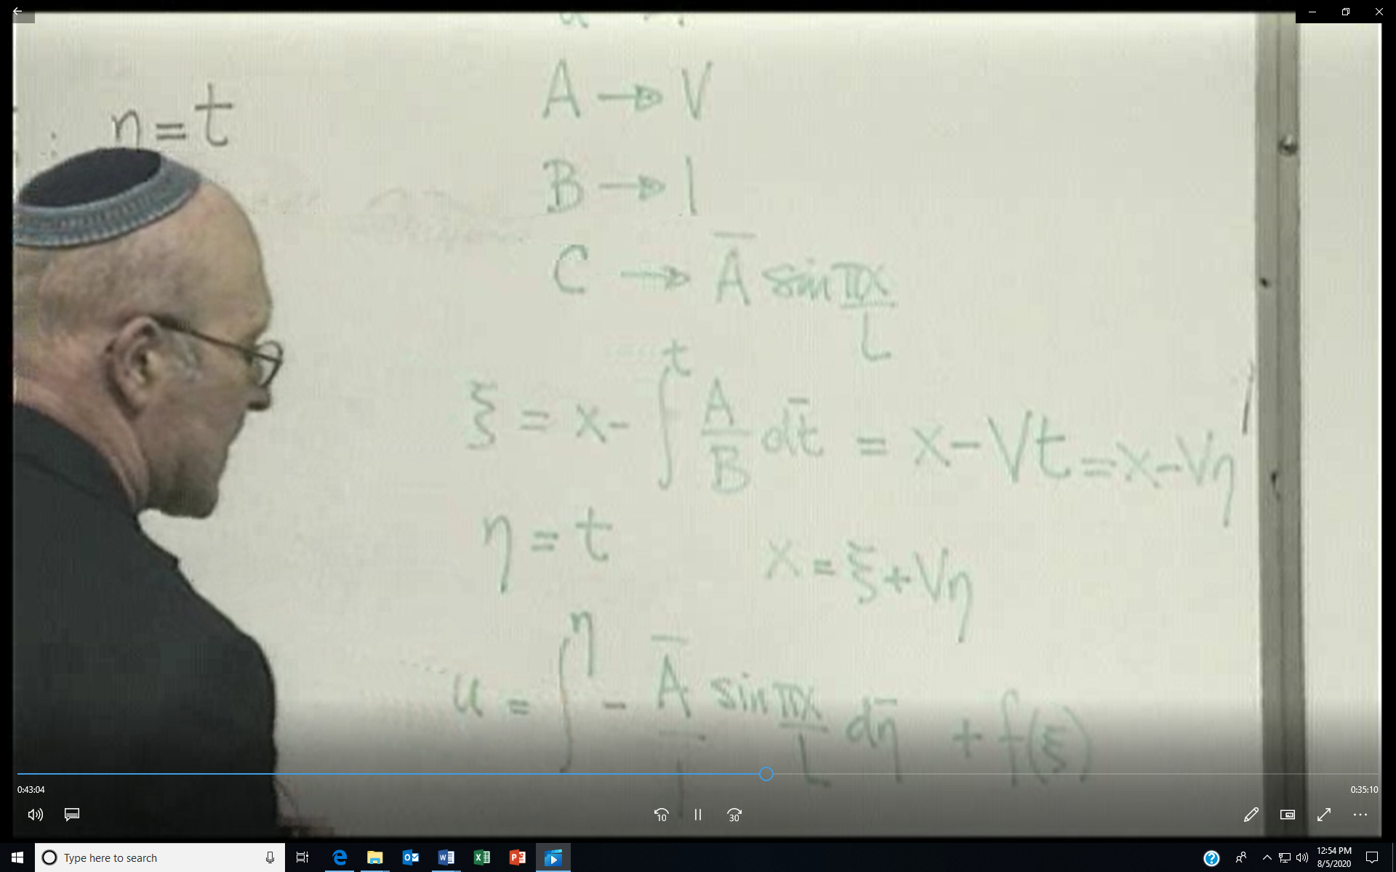
Following the methodology outlined we get the above. The solution for ξ assumes that V here is a constant. Now must replace x since the u equation is in terms of ξ and η. Also ξ = x- Vt= x -Vη and solve for x = ξ + Vη
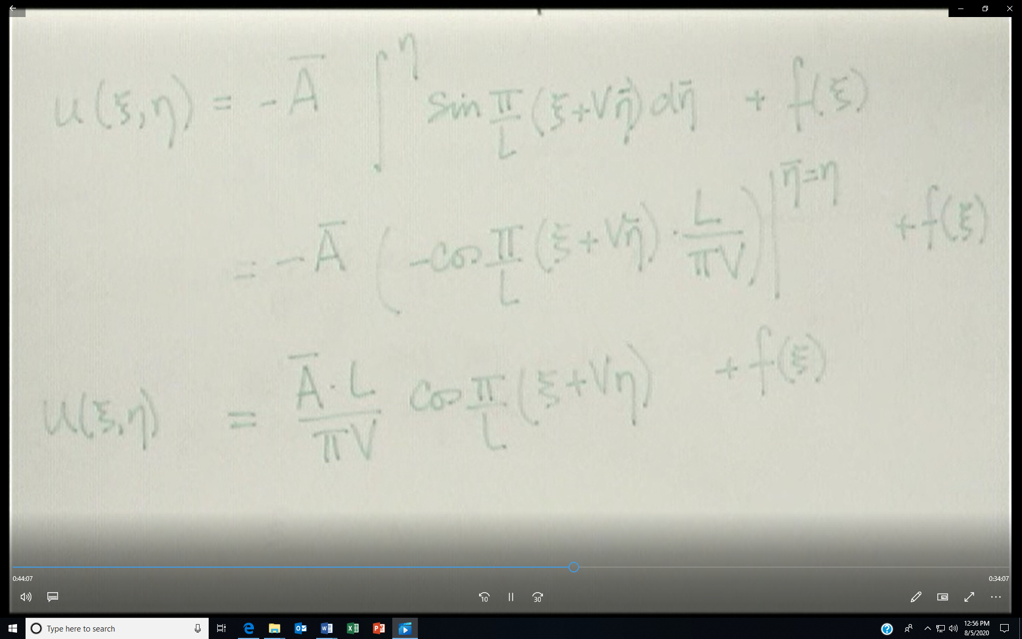
Since C was originally on the left of the equation, then the solution for u is actually the negative of the result found above. Now we convert all definitions of ξ and η back to x and t. The result below is correct.
