Method of Characteristics for 2nd order PDE
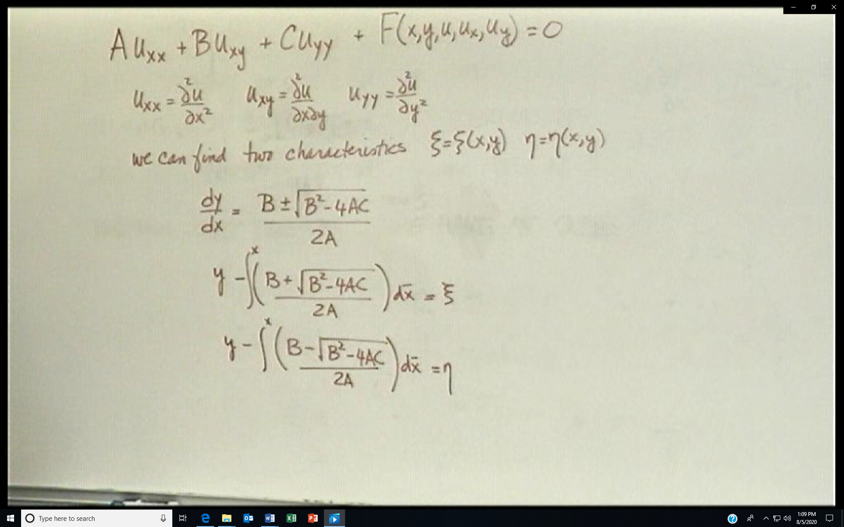
Here dy/dx is the slope of the characteristics and ξ and η are the two characteristics.
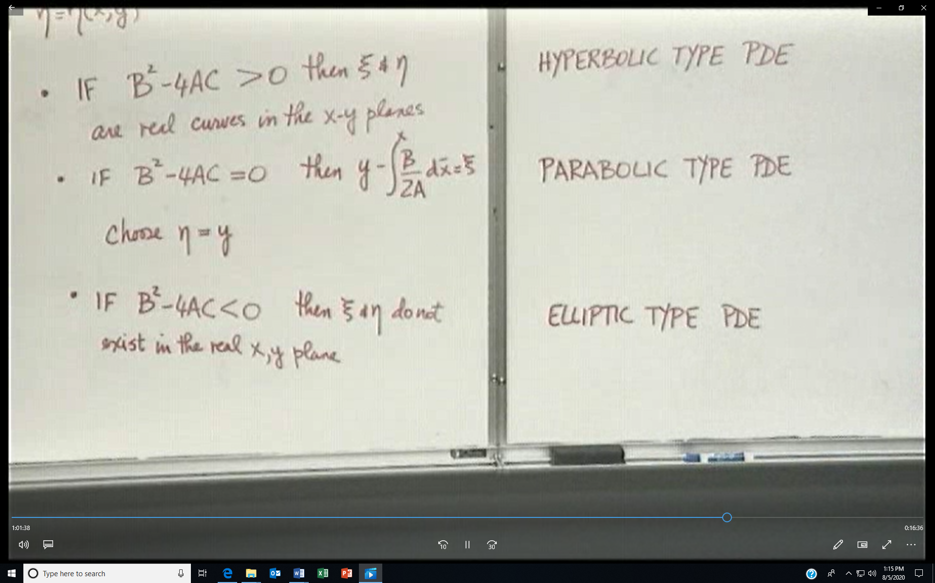
Naming the PDEs
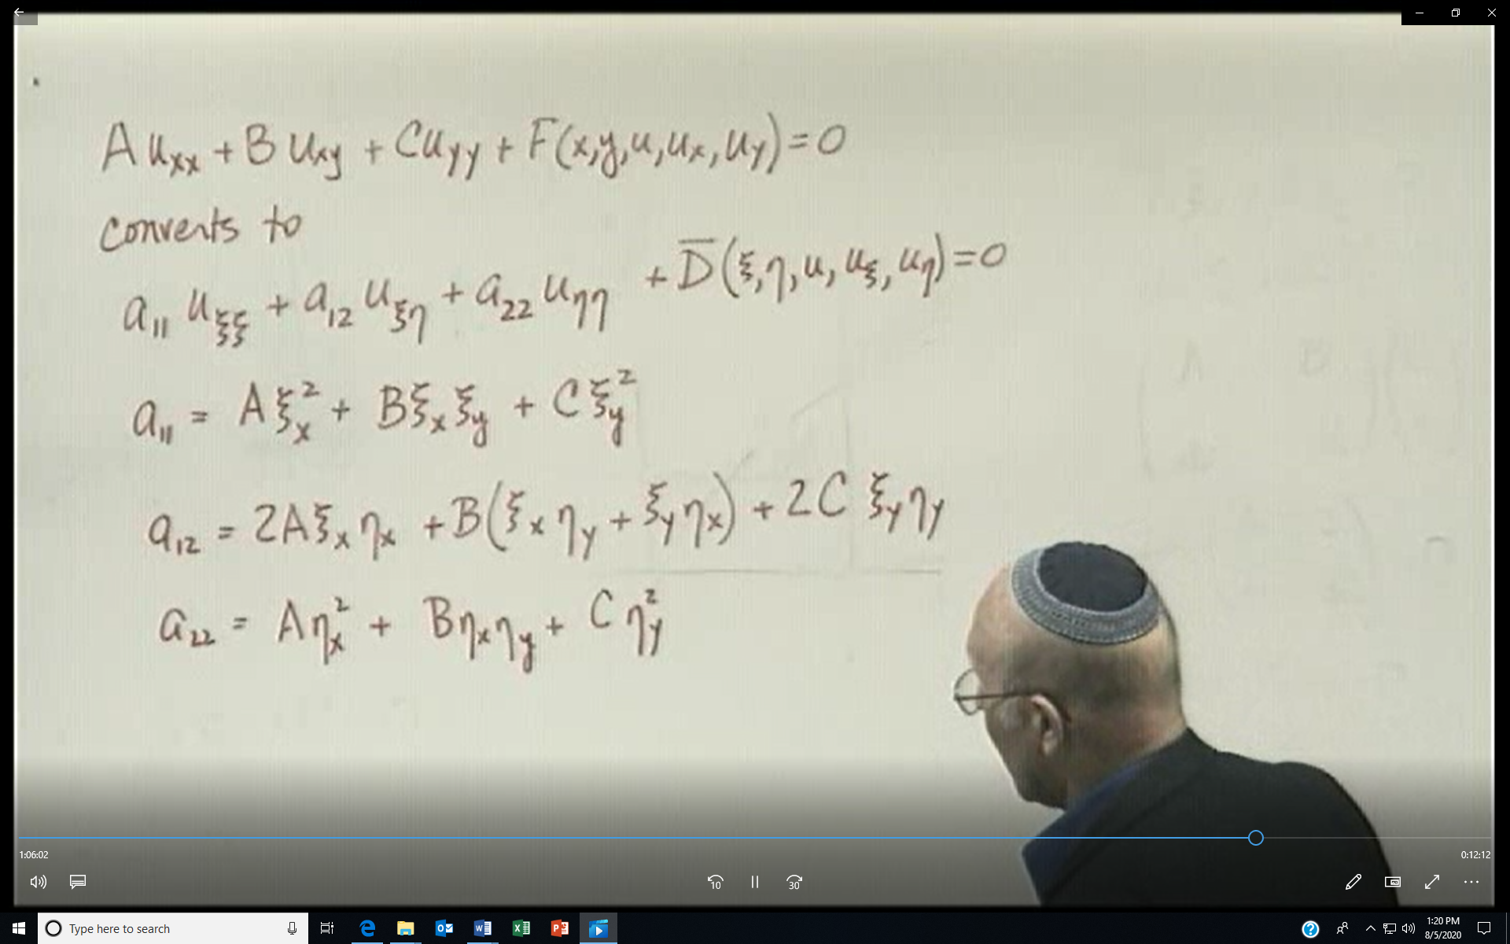
For the different type PDEs
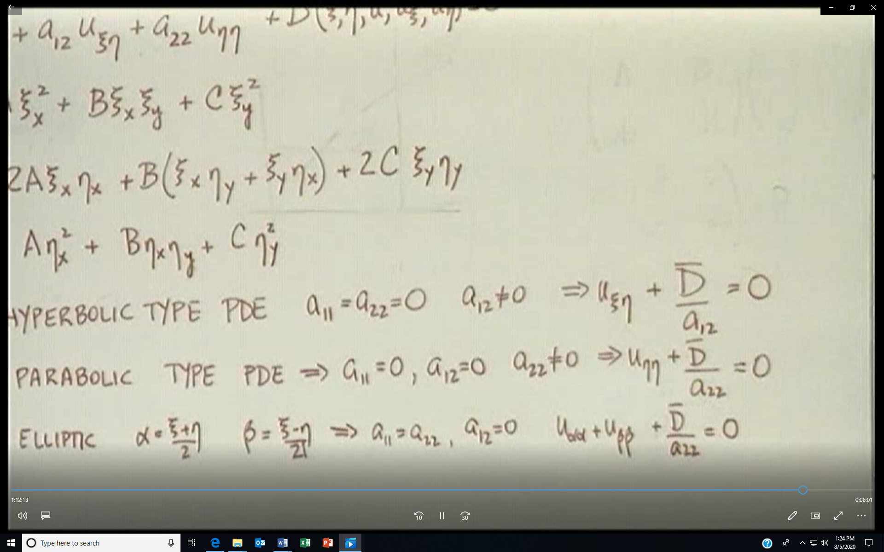
Alternate hyperbolic form is