More on BCs
When we look at heat type problems boundary conditions on heat flow are of the Neuman type since q, the heat is related to the normal derivative to the boundary (see Ch 1 of Trim)
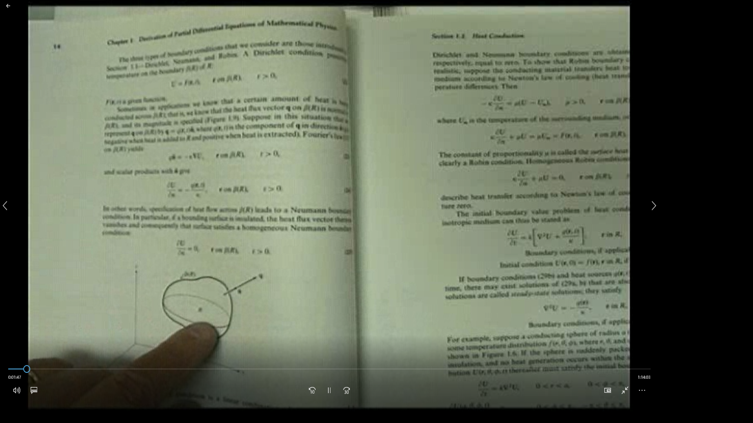
Look at exercise 1.2 problem 2 in Trim
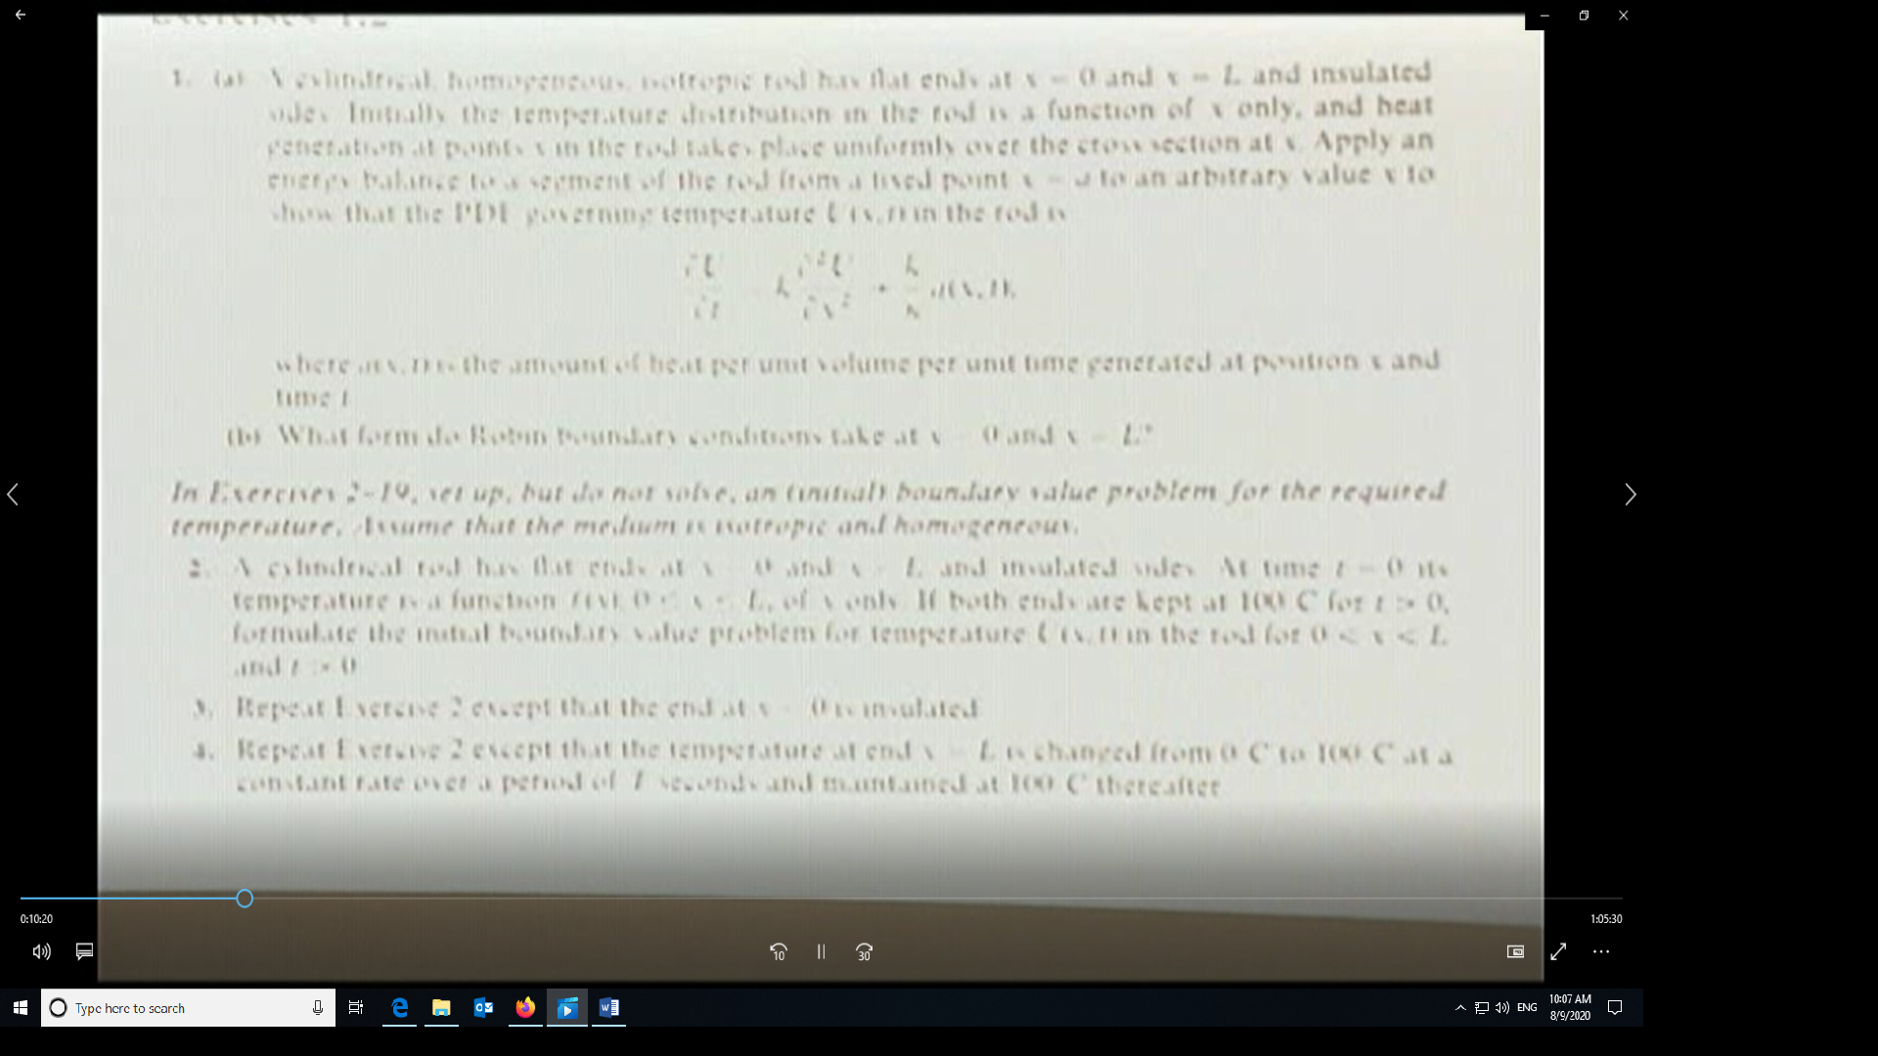
If this were a 3-D problem, then the governing equation would be given by
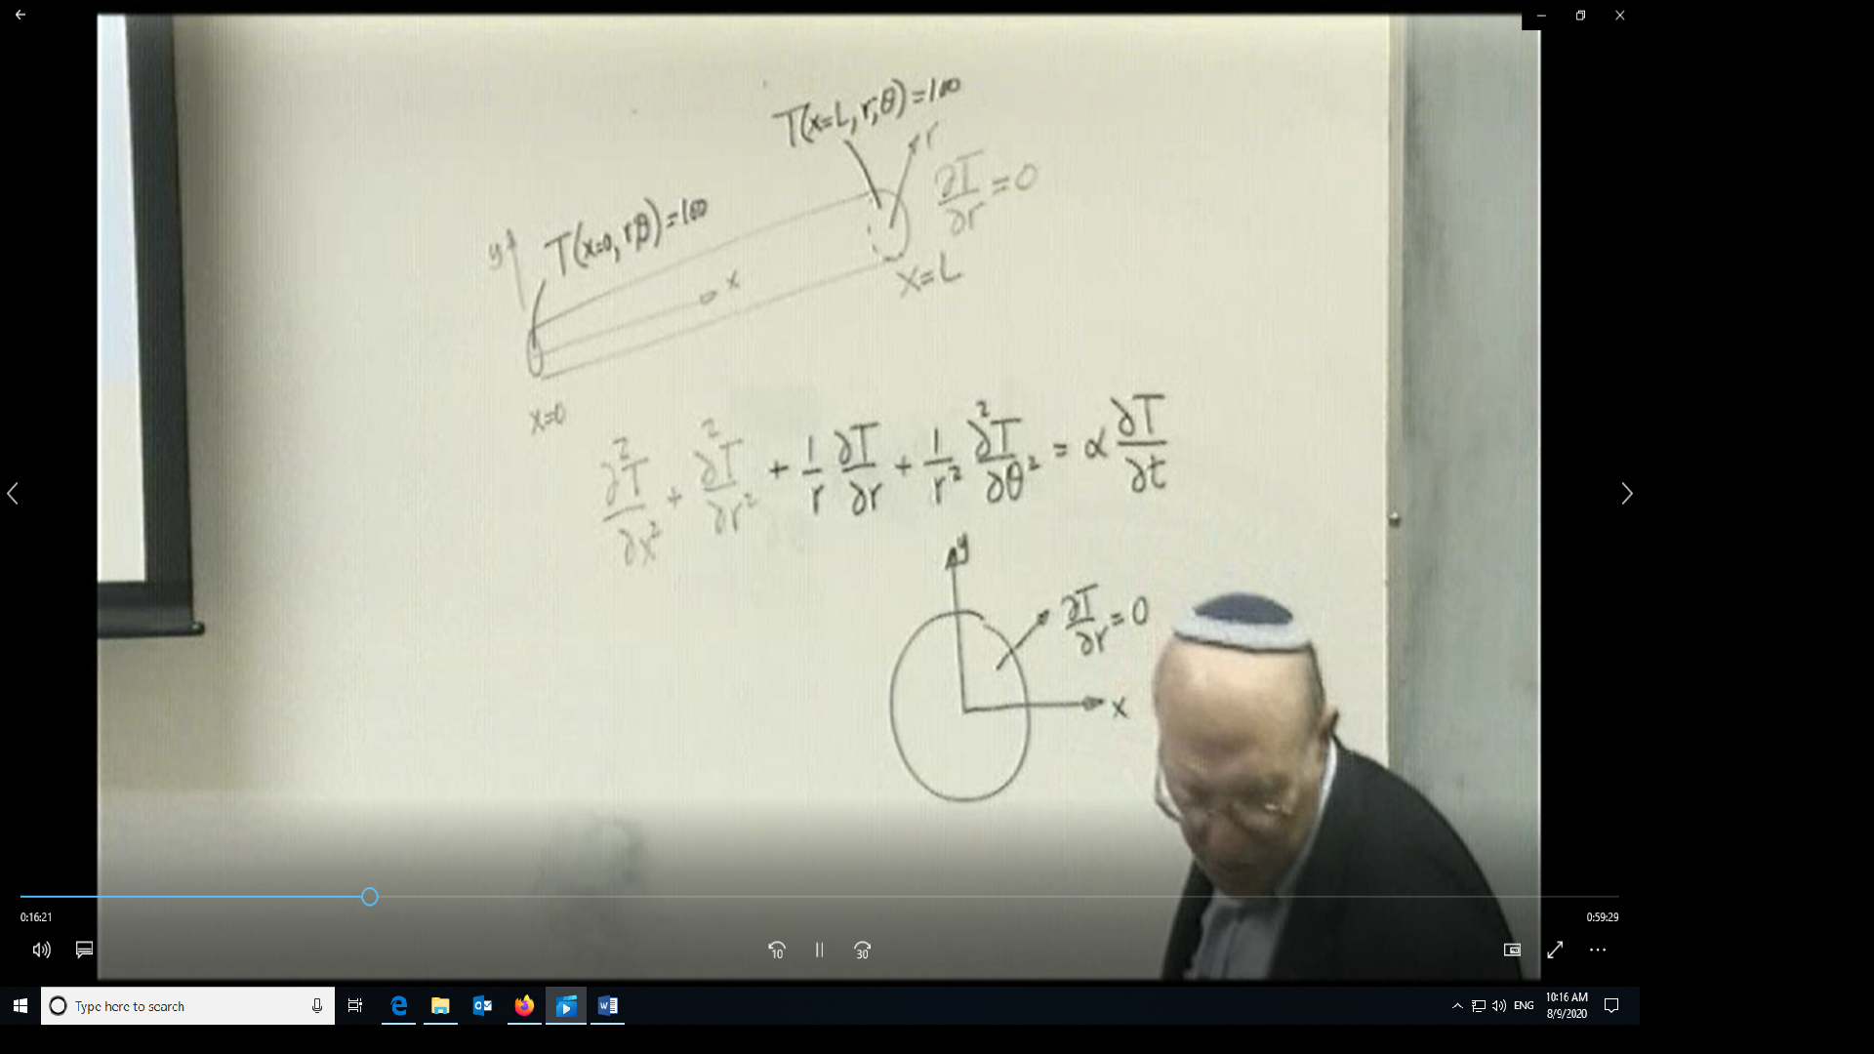
Where the heat flow rate in the radial direction ∂T/∂r=0 means that the radial surface is insulated (q=0). The last three terms on the left hand side of the equation are the laplacian written in r and theta.
However, the problem statement for problem 2 only asks to solve the problem as a 1-D heat conduction problem so
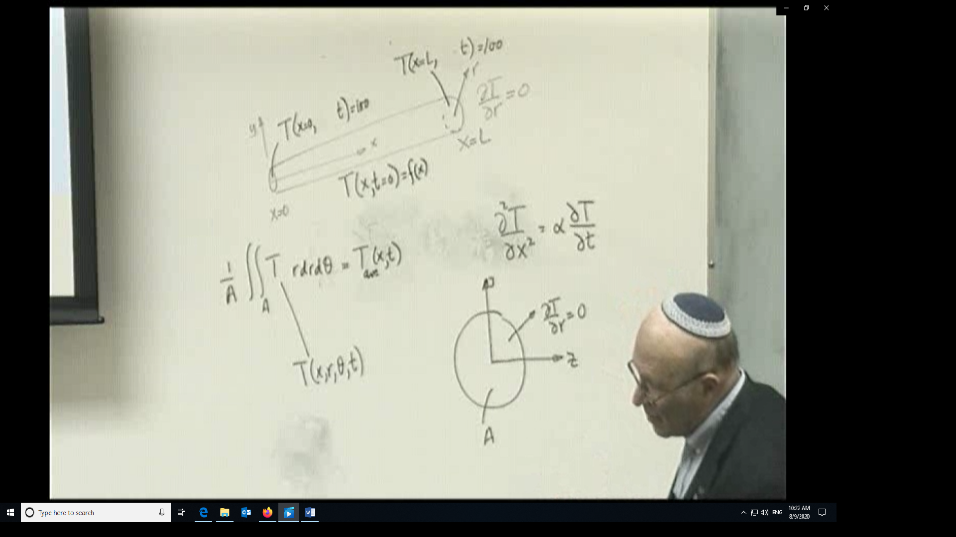
And the temperature T here is the averaged temperature over the cross-sectional area. Since we only have 2 derivatives in x and one in T, we need two BCs in at x=0 and at x=L and one IC namely f(x).
In the case where the left hand boundary at x=0 is insulated instead of having the temperature specified then the left hand BS is replaced by ∂T/∂x=0. Supposing the RHS BC is changed from a constant to a ramp type condition
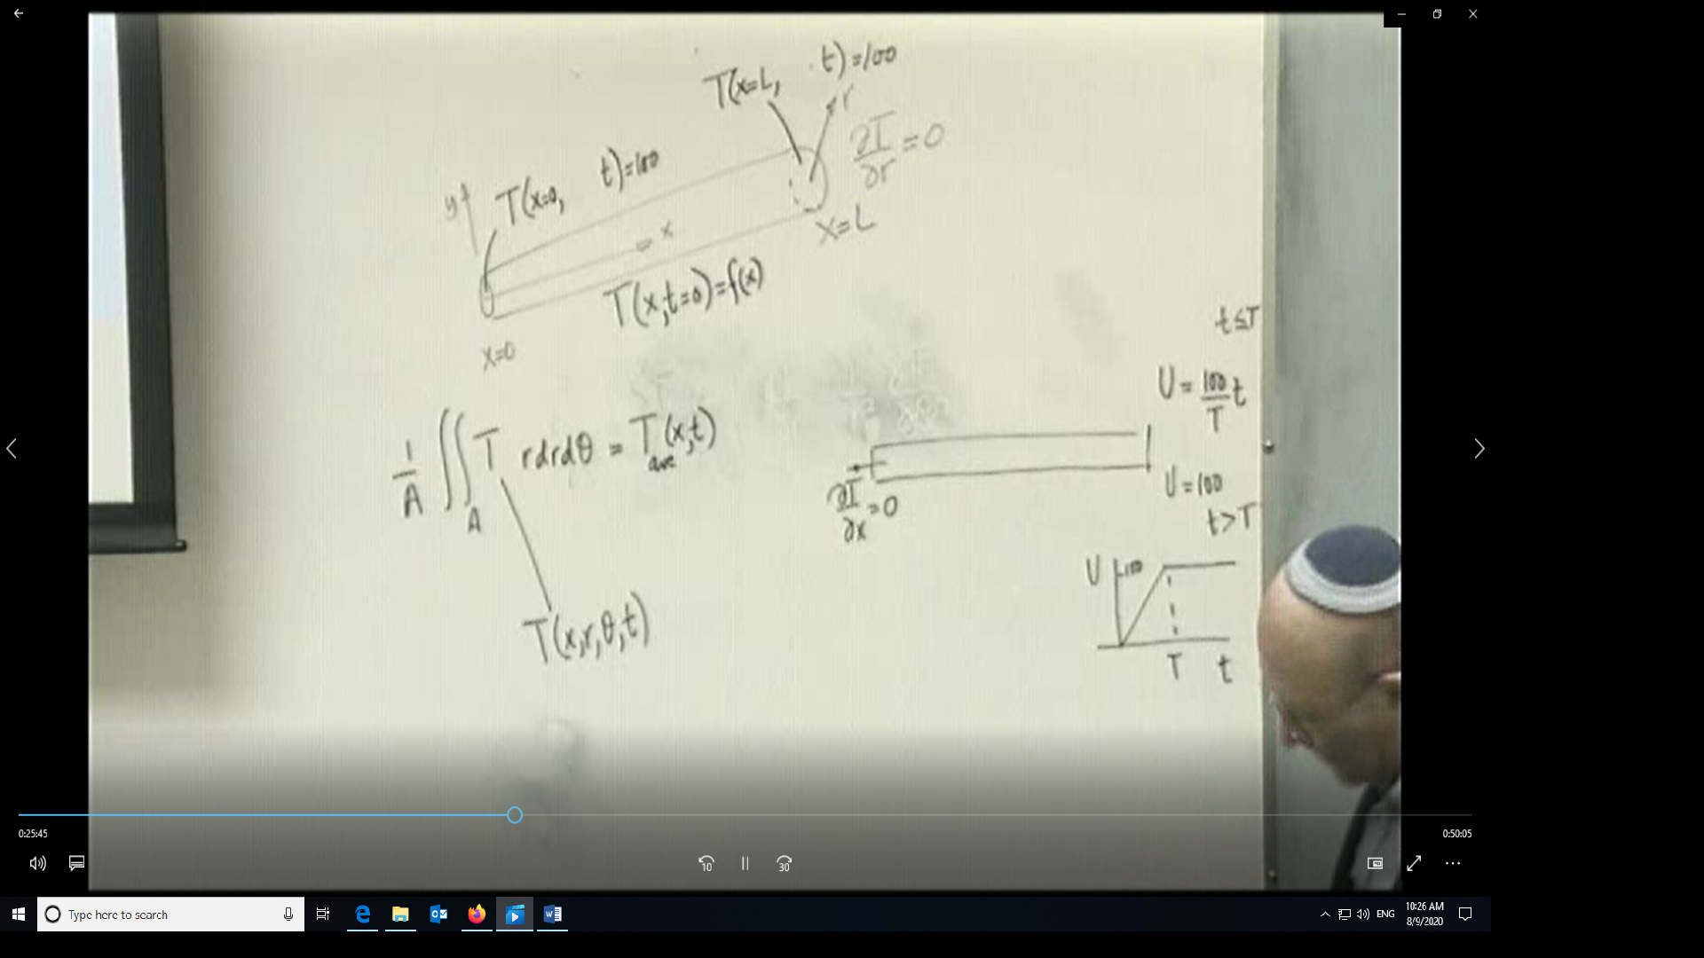
In the case where you have two different types of BCs, you may have to determine a particular (steady state) solution
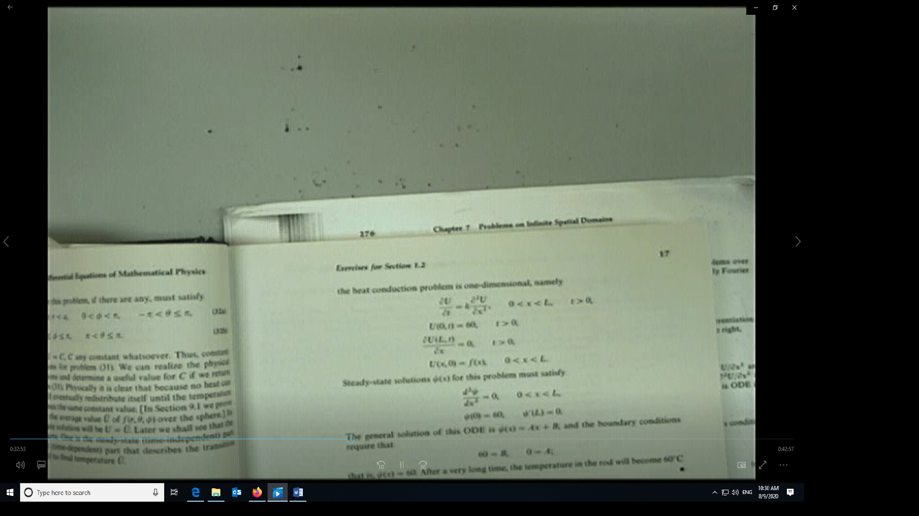
We begin the separation of variables solution methodology 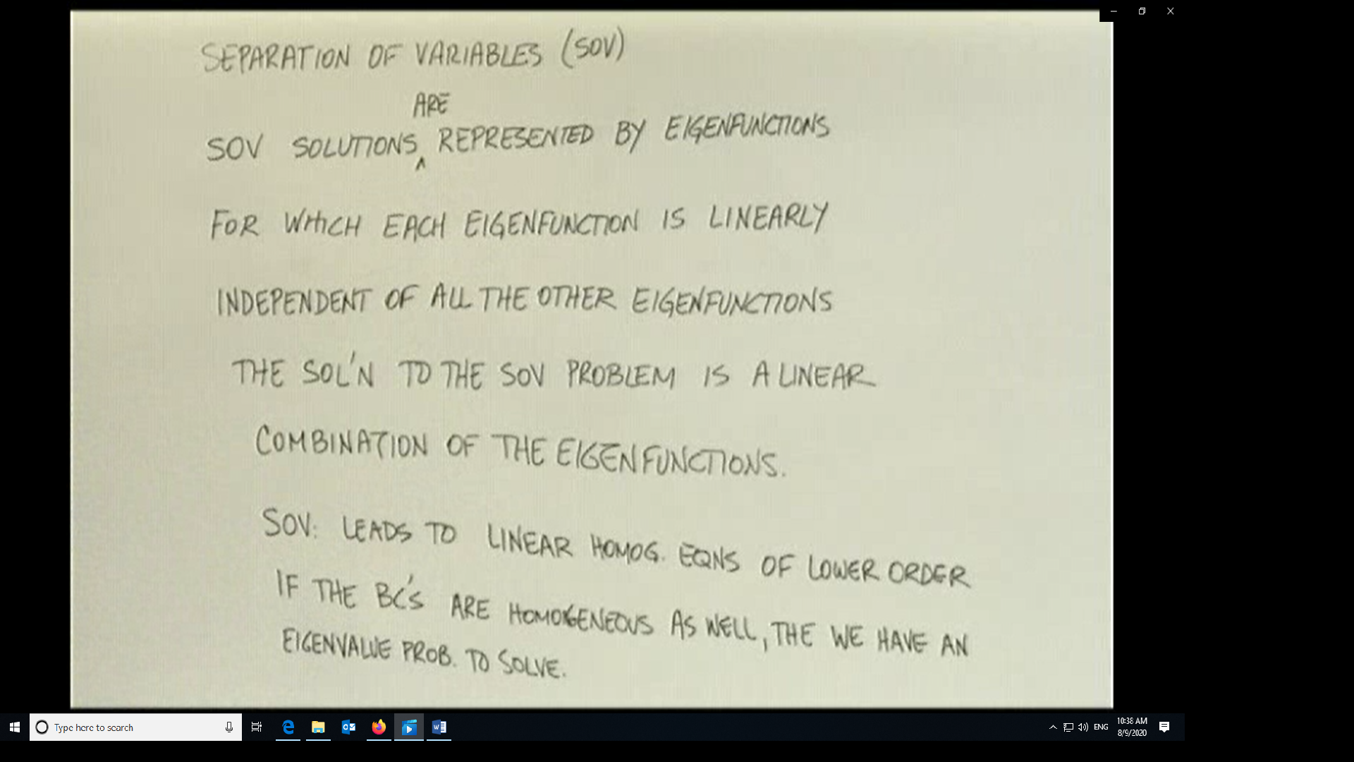
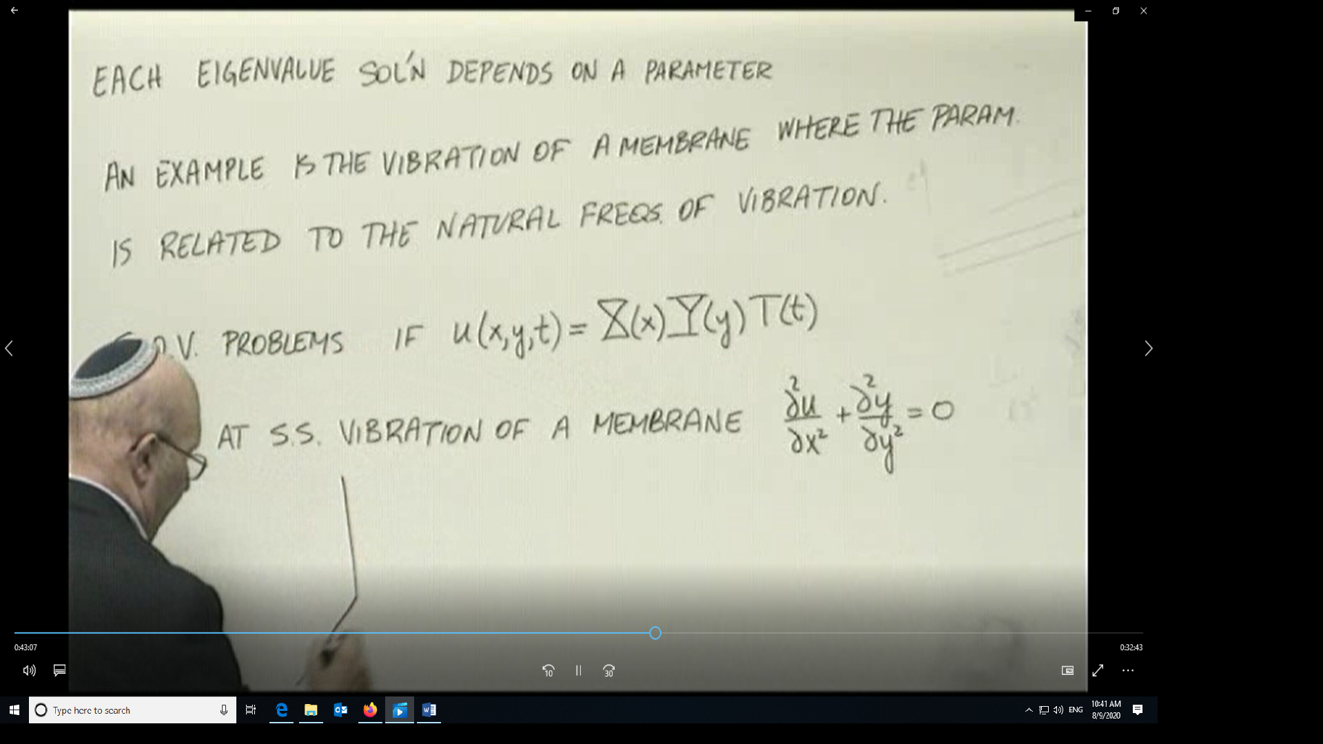
The equation on the bottom right is in error and it should be the Laplacian of u(x,y) =0
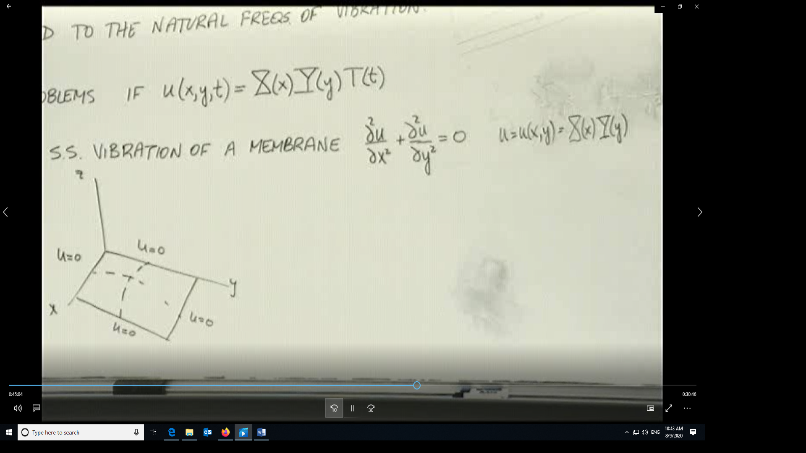
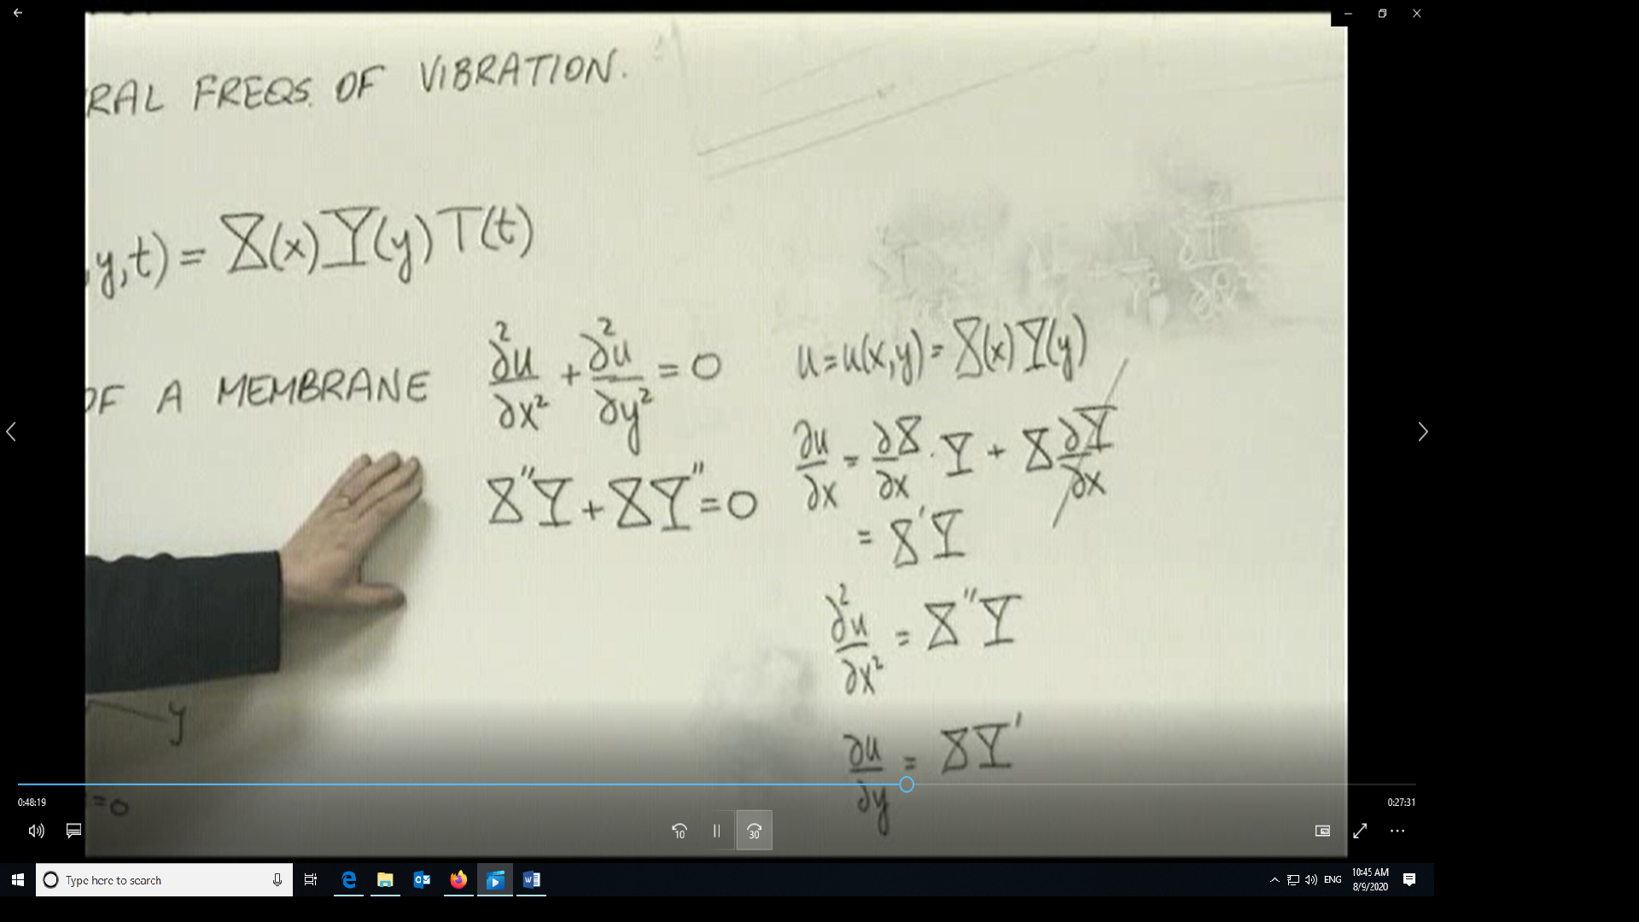
Application of SOV to determine derivatives with respect to x and y 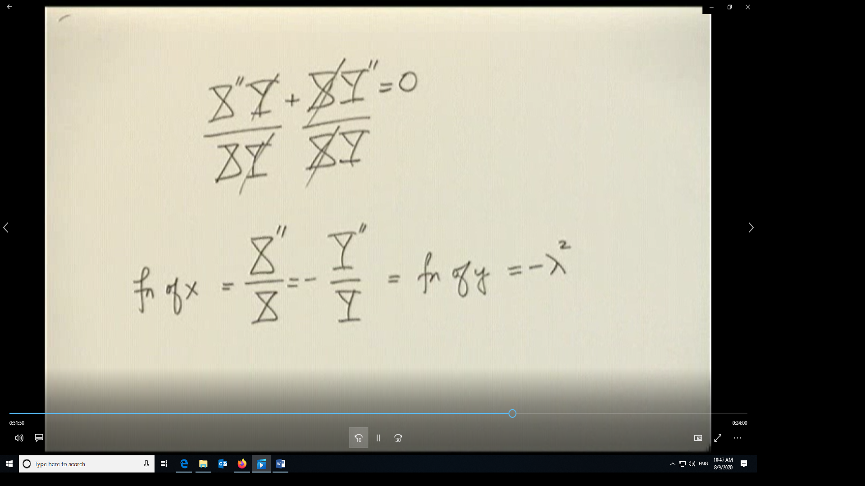
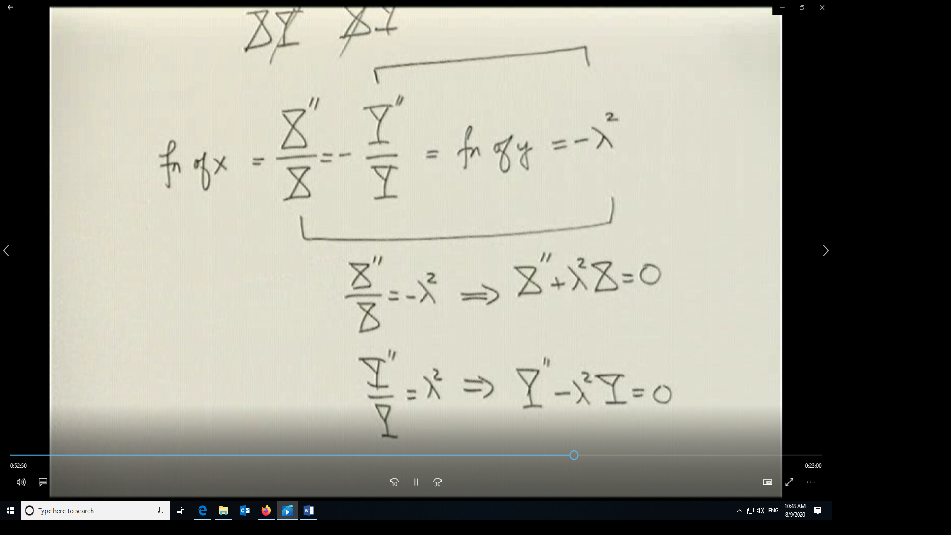
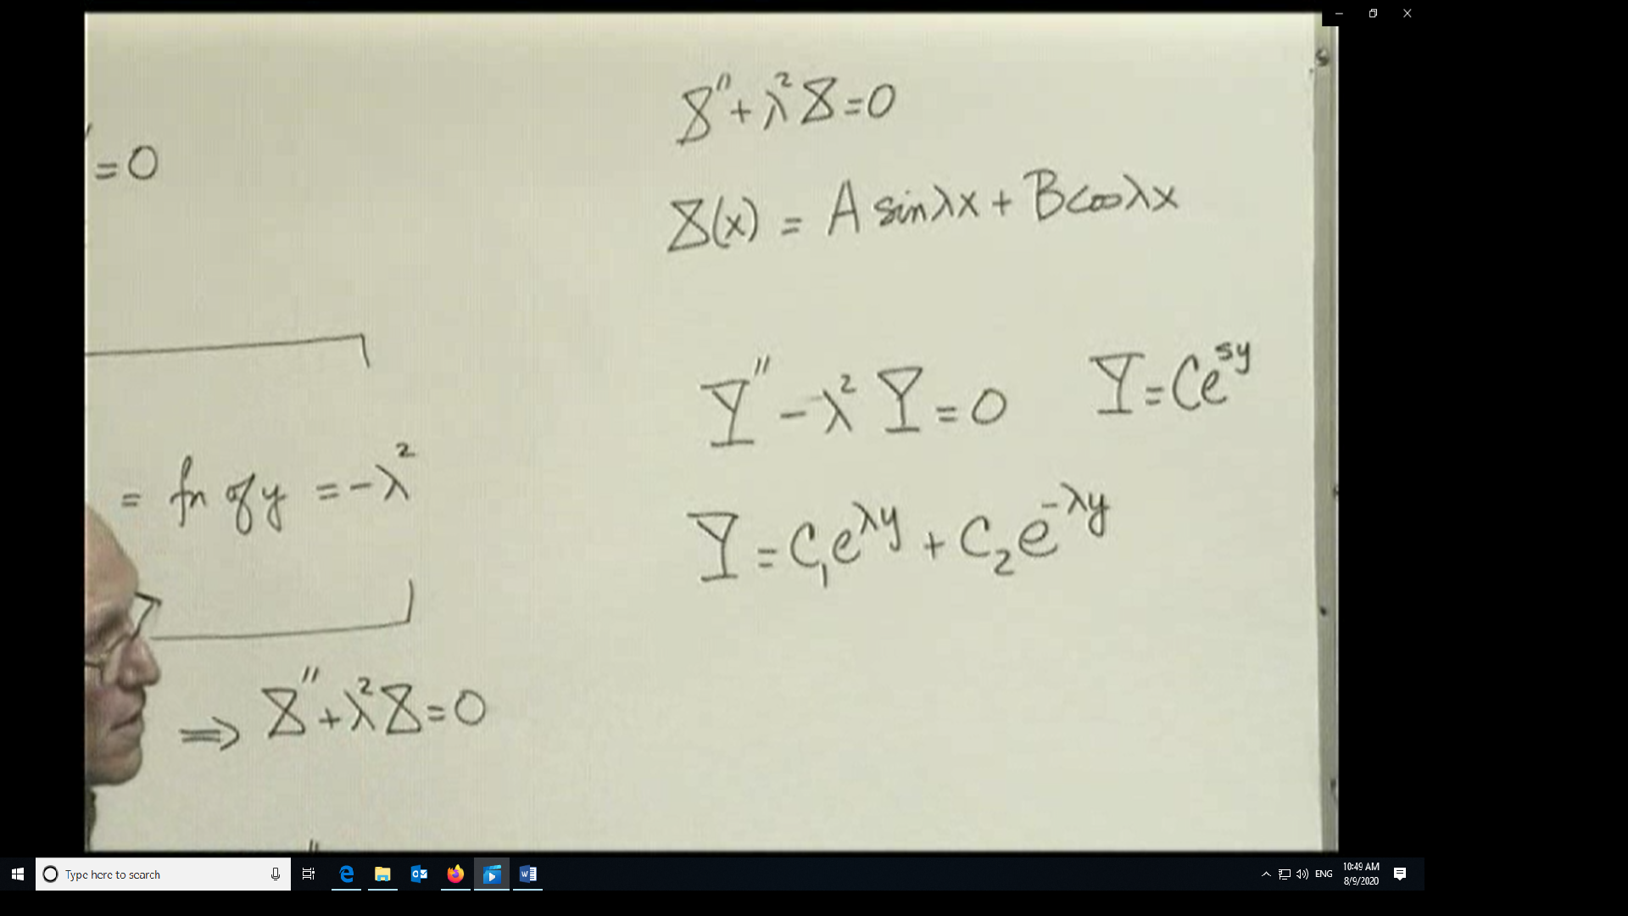
In the case of a simply supported membrane where u=0 all around
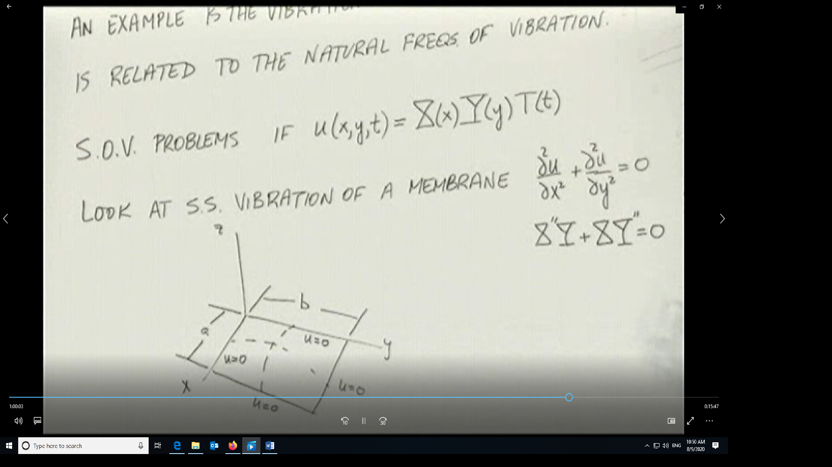
These boundary conditions translate to
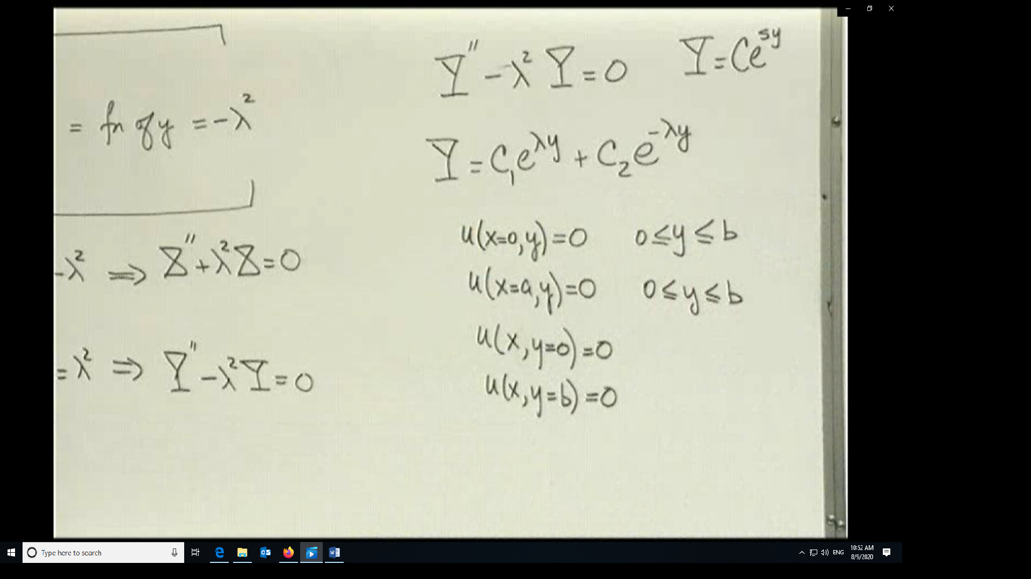
Since u(x,y)=X(x)Y(y) then these boundary conditions translate to
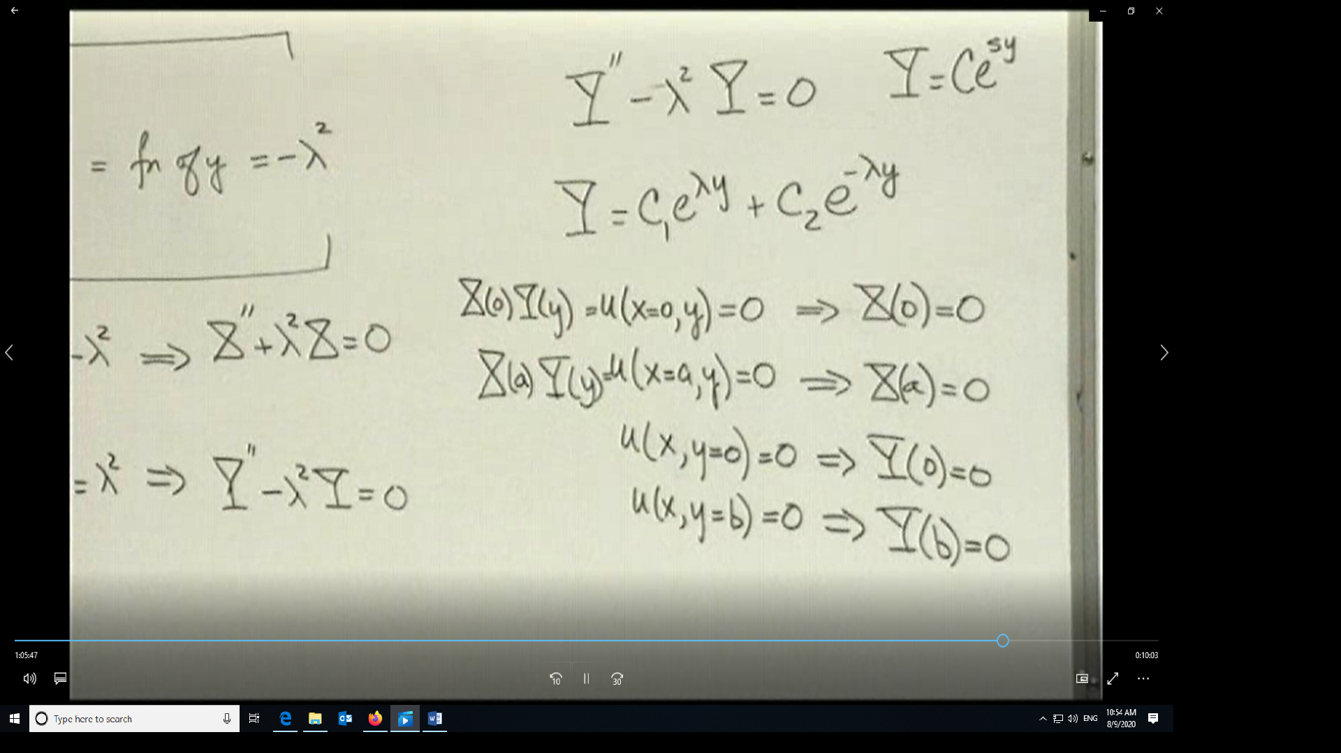
Since X(0)Y(y)=0 for all y, then that can only happen when X(0)=0.
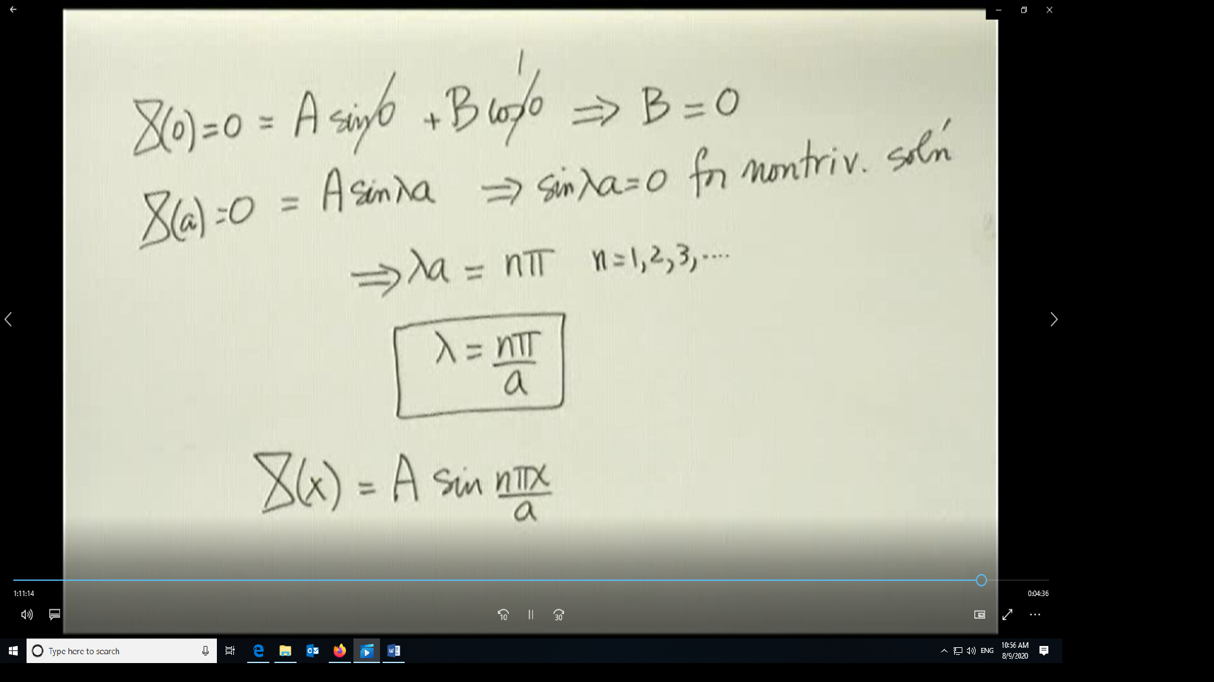
Since λ depends on n, then X(x) also depends on n and so must u(x,y). Since there are an infinite number of solutions and this is a linear problem, then adding the individual solutions is also a solution to the problem.
