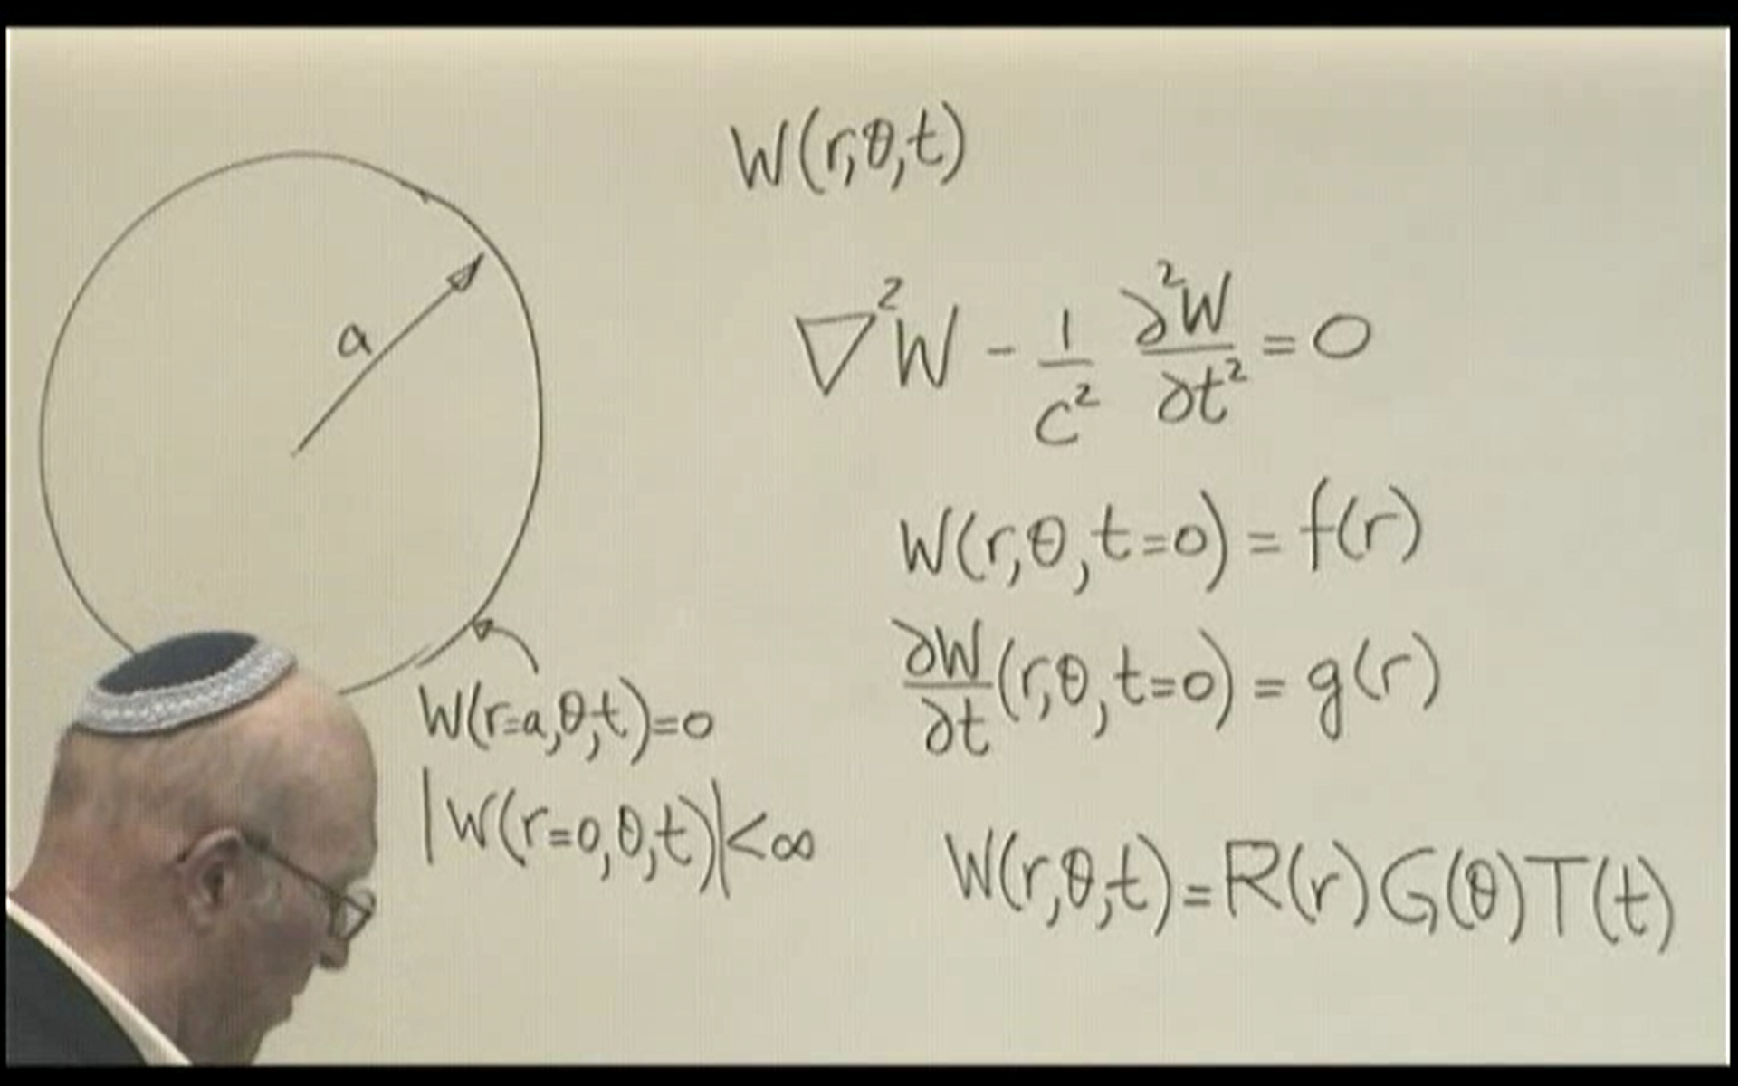

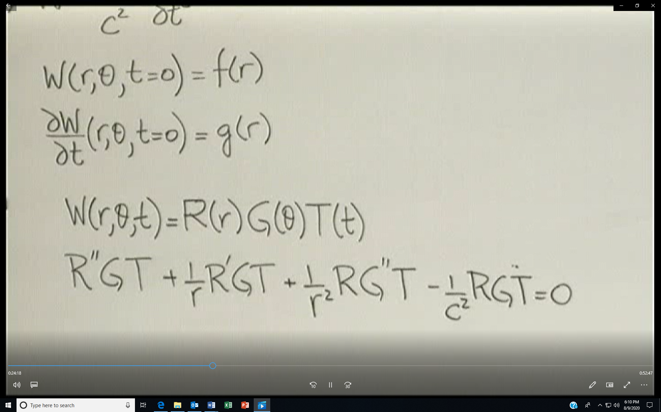
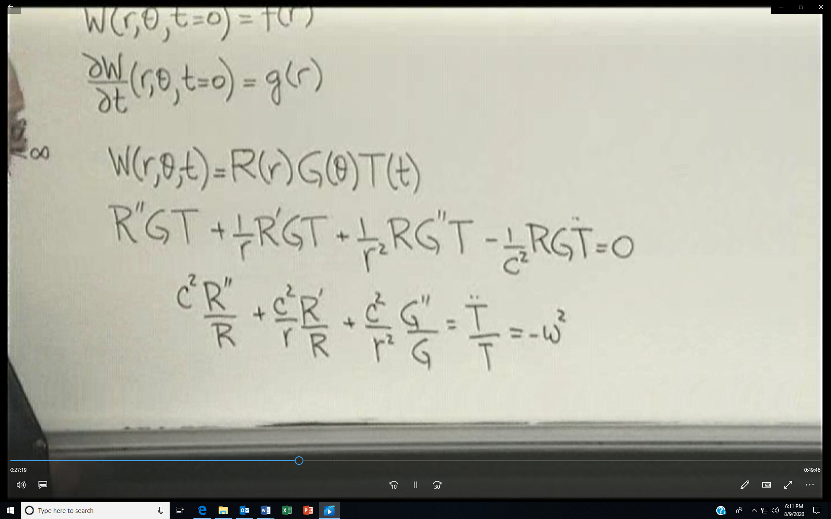
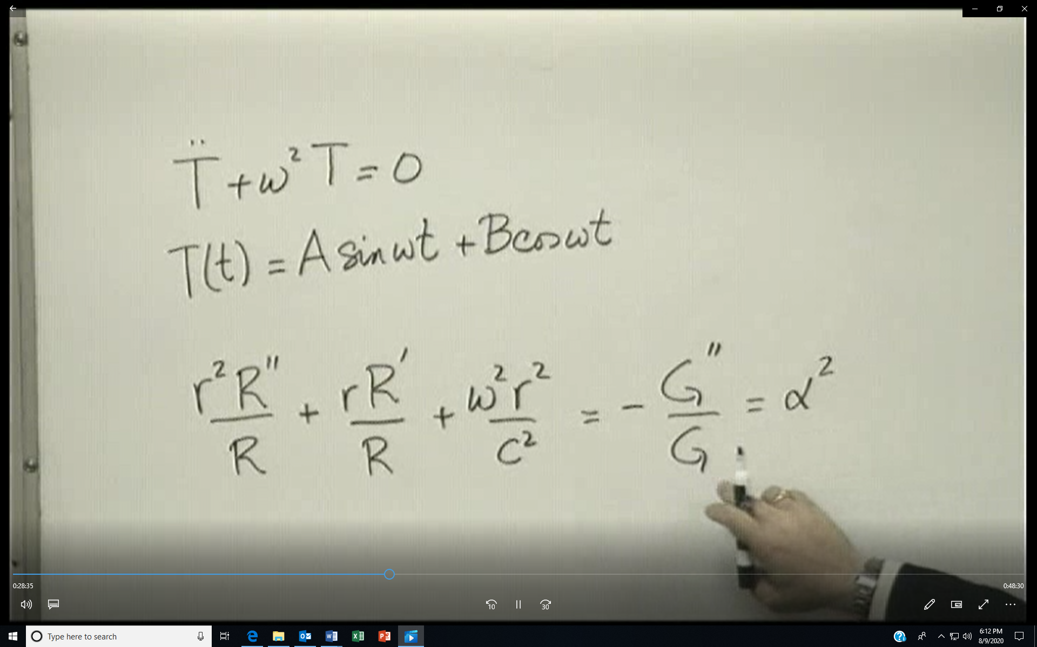

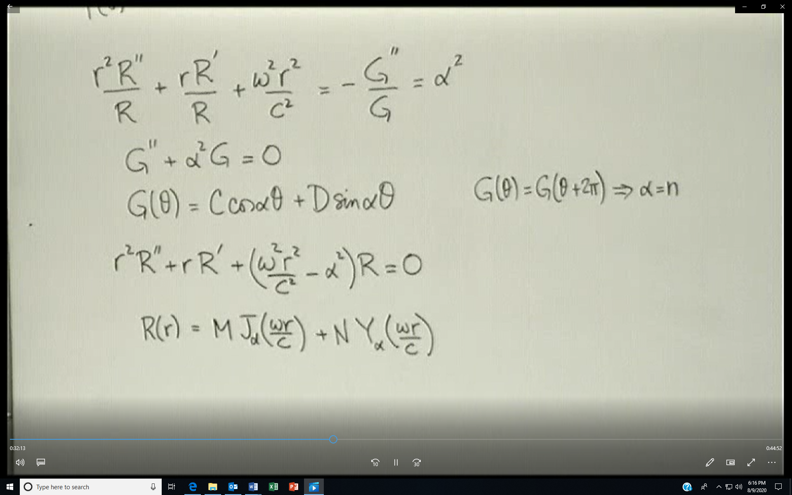
Every time you go around origin, your angle changes by 2*pi, but the value of W is the same. Hence periodicity requires the above requirements on G
Since the origin is included the Y Bessel function cannot be part of the solution
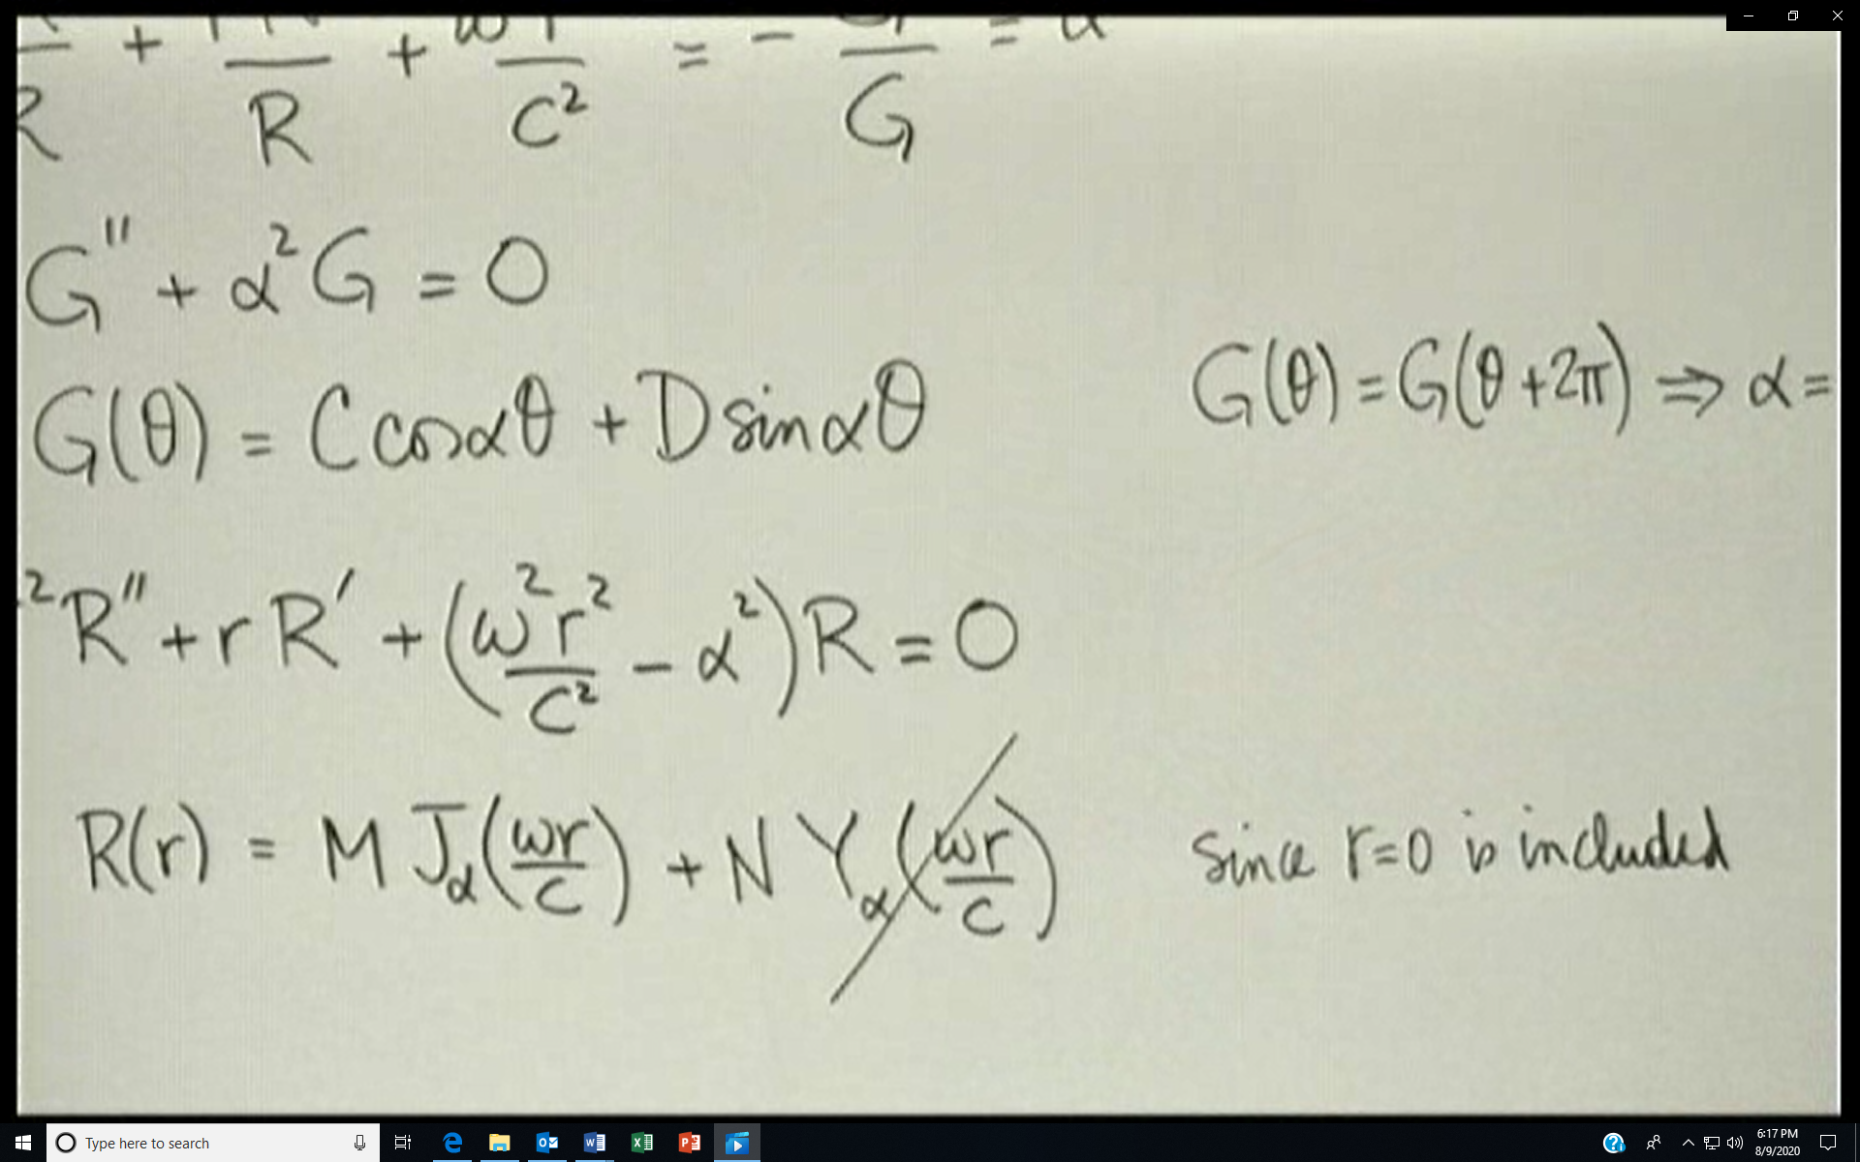

Application of the W(r=a,…)=0 boundary condition produces
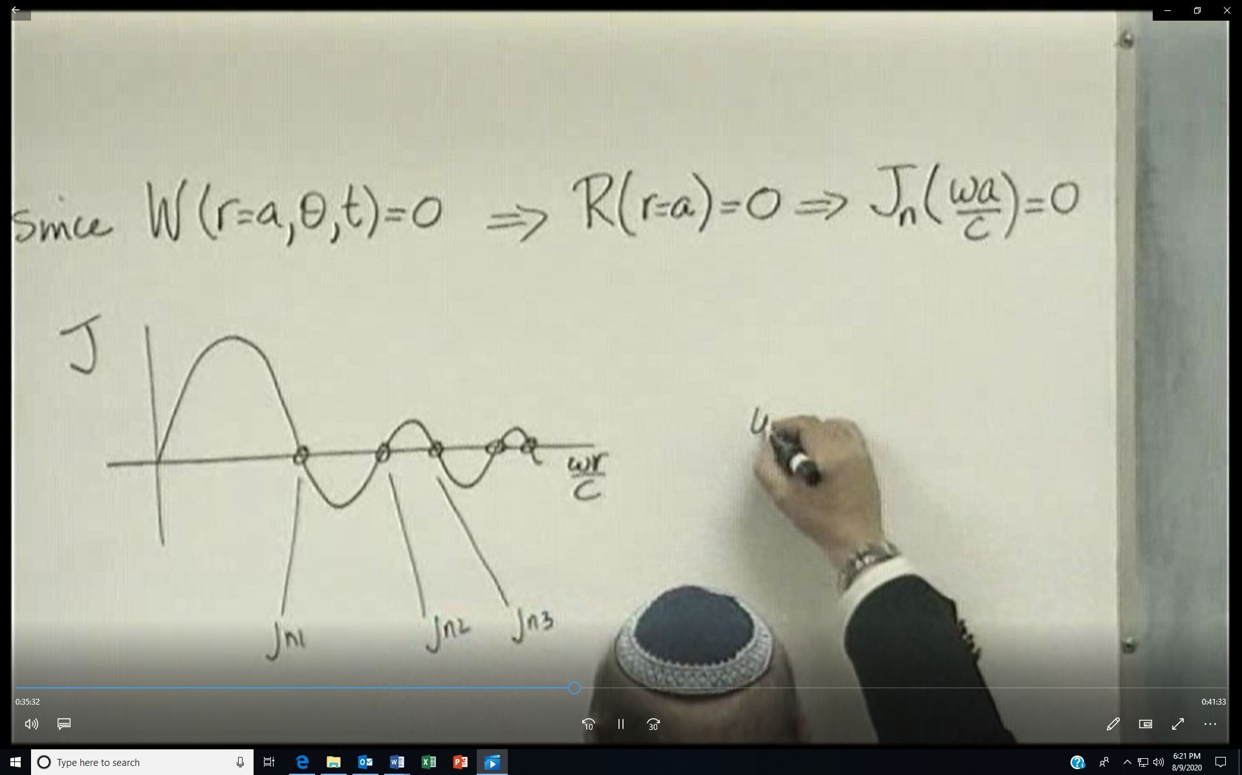
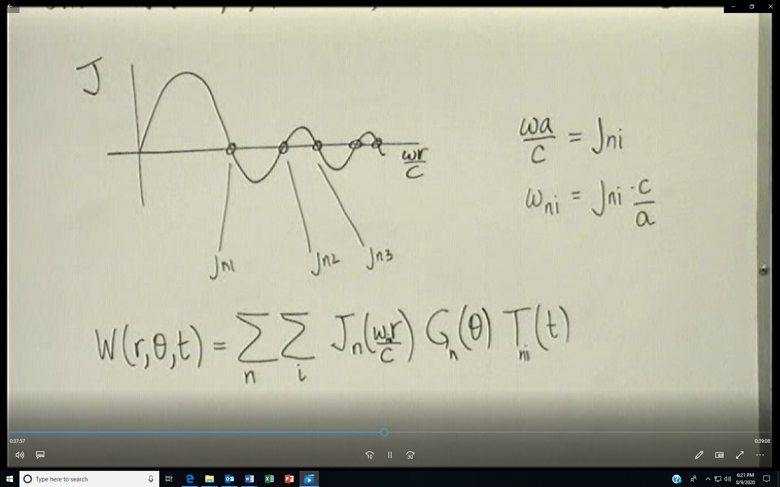
Applying the first initial condition at t=0
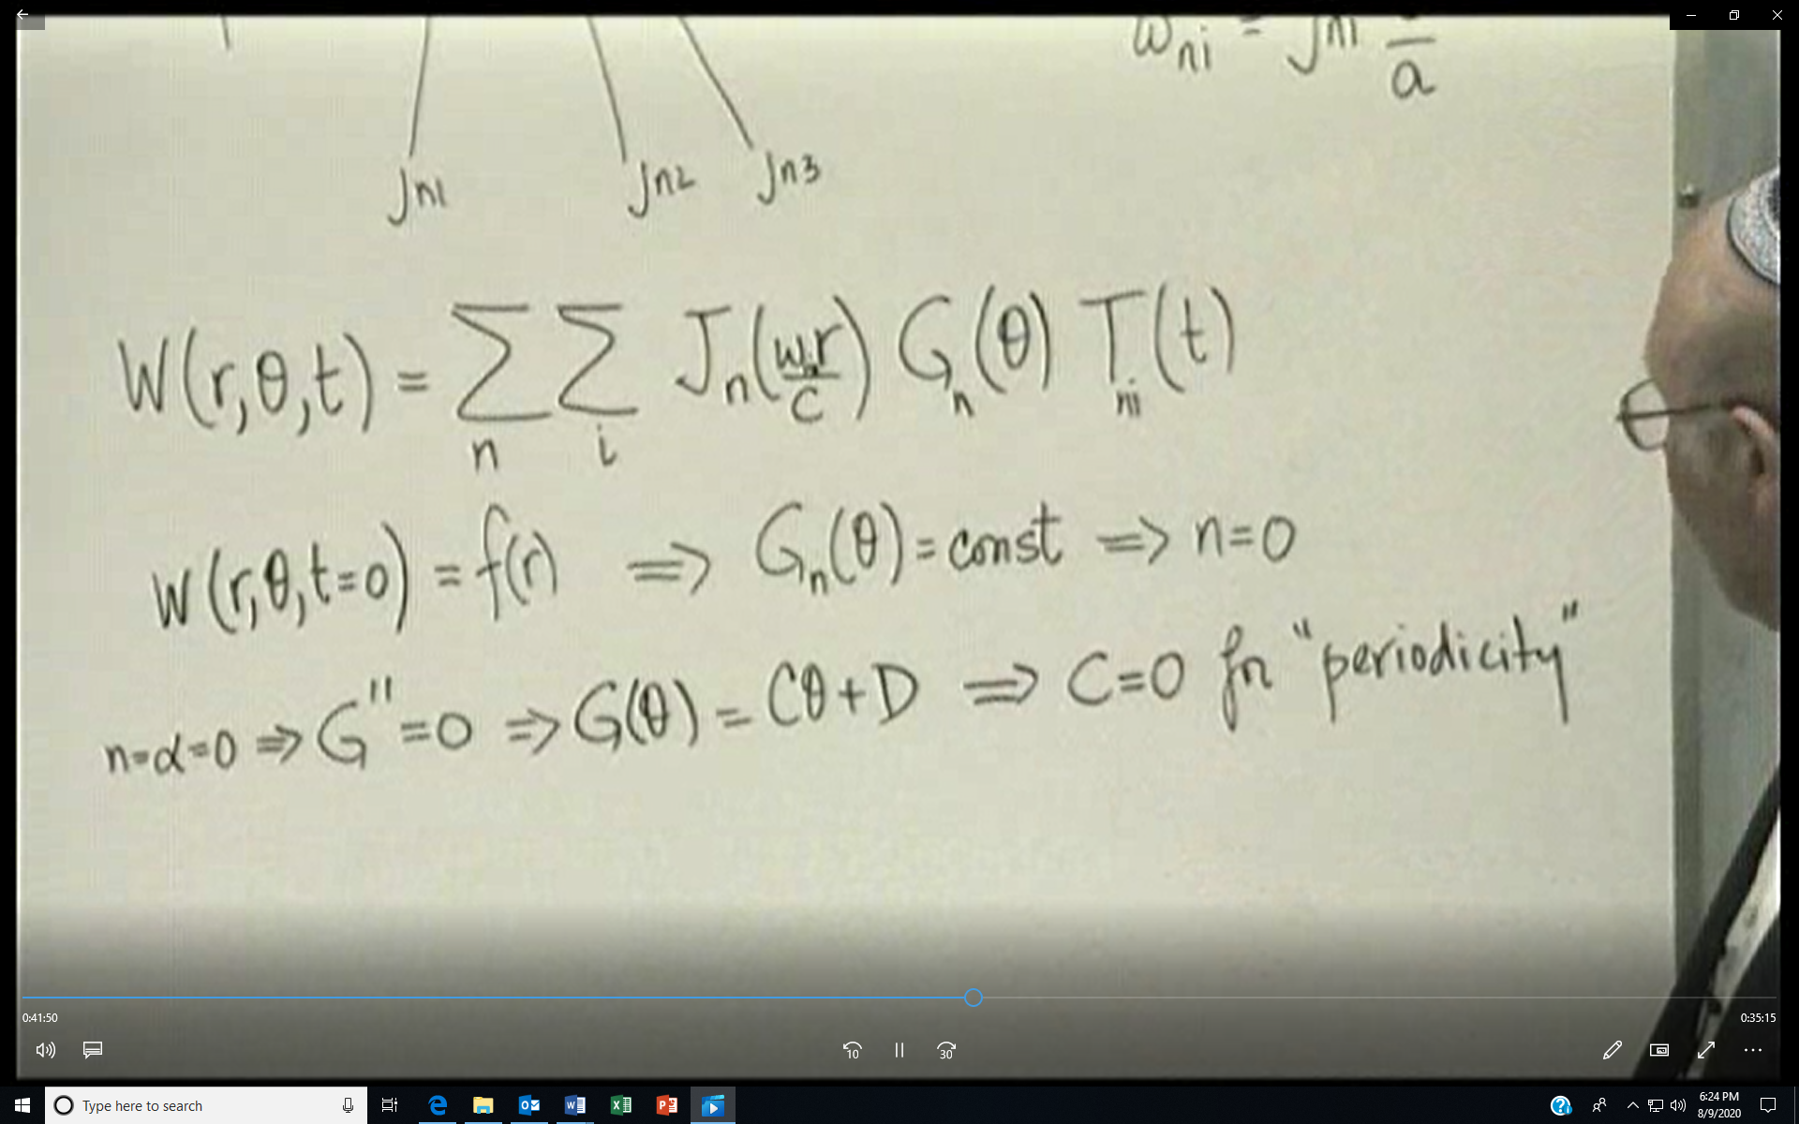
So the solution looks like below and by applying the first and second initial conditions we get series for the Bi’s and Ai’s
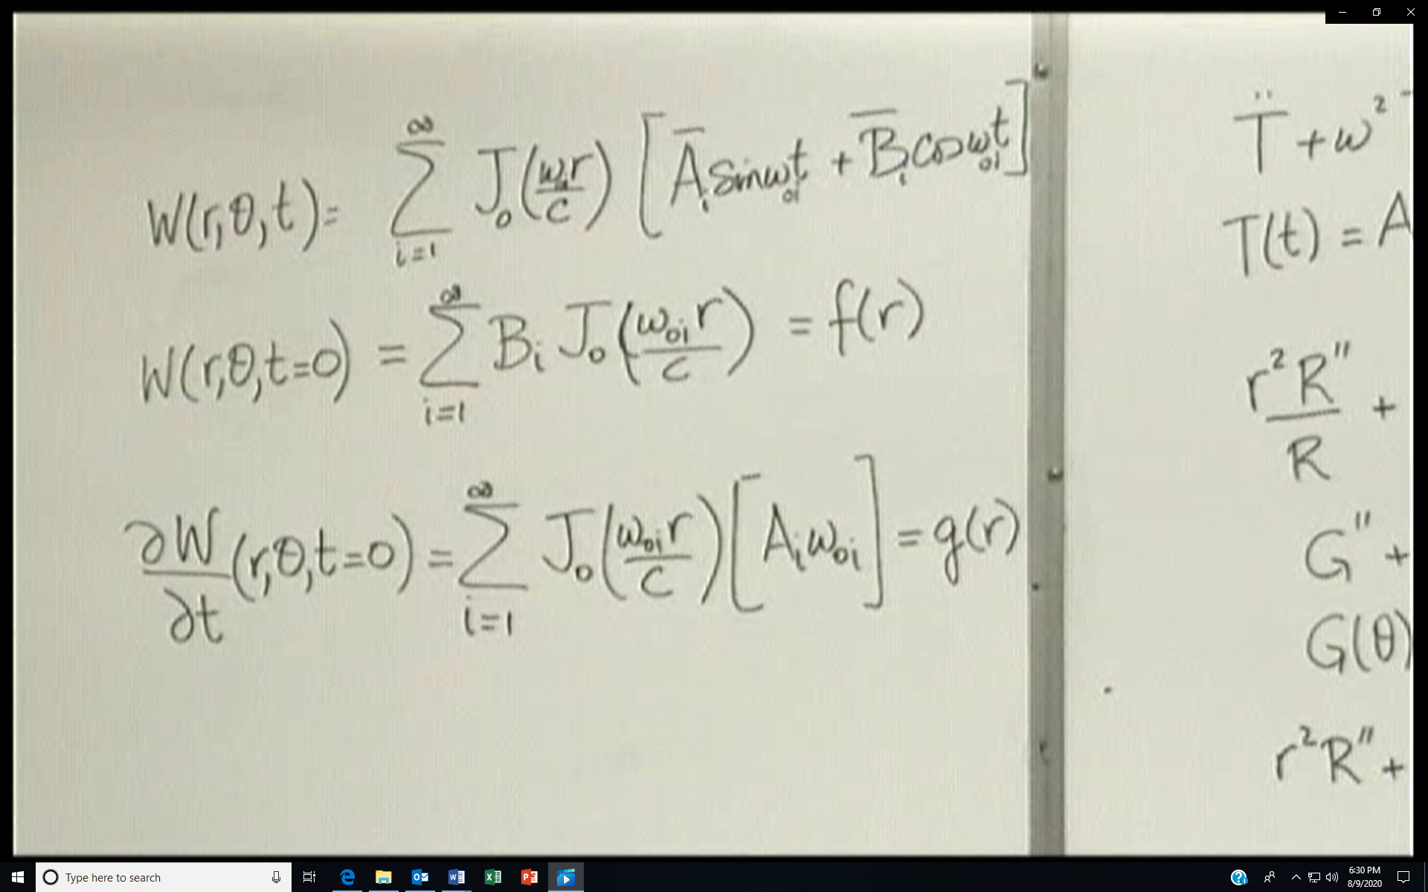
Solution comes from understanding the sturm-liouville problem.
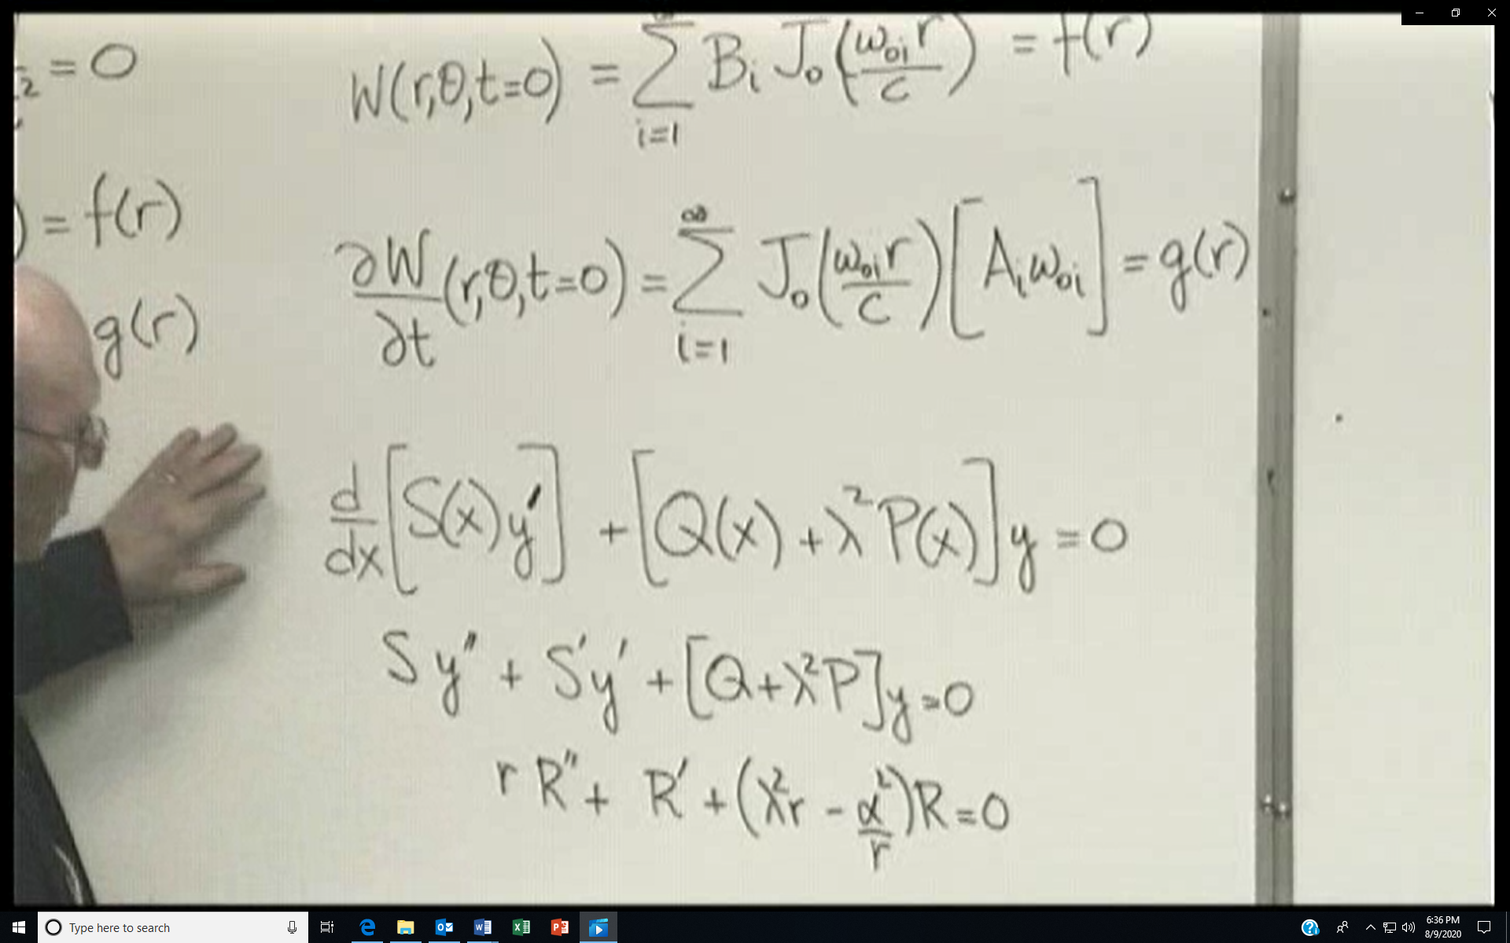
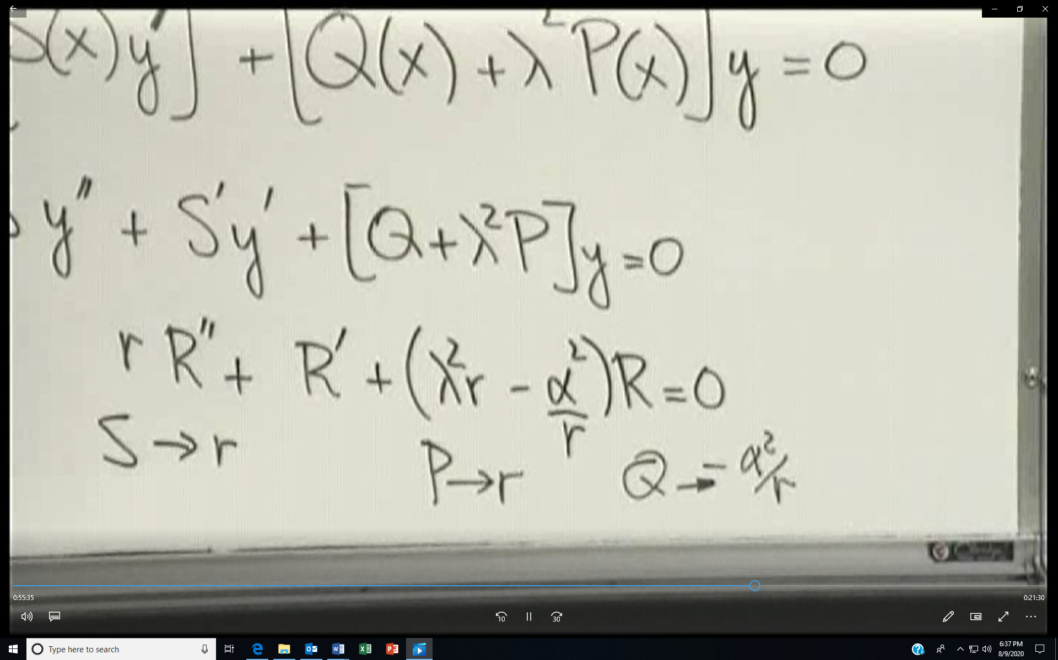
By dividing the bessel’s equation by r, you put the bessel’s equation in sturm-liouville form. The sturm-liouville problem:
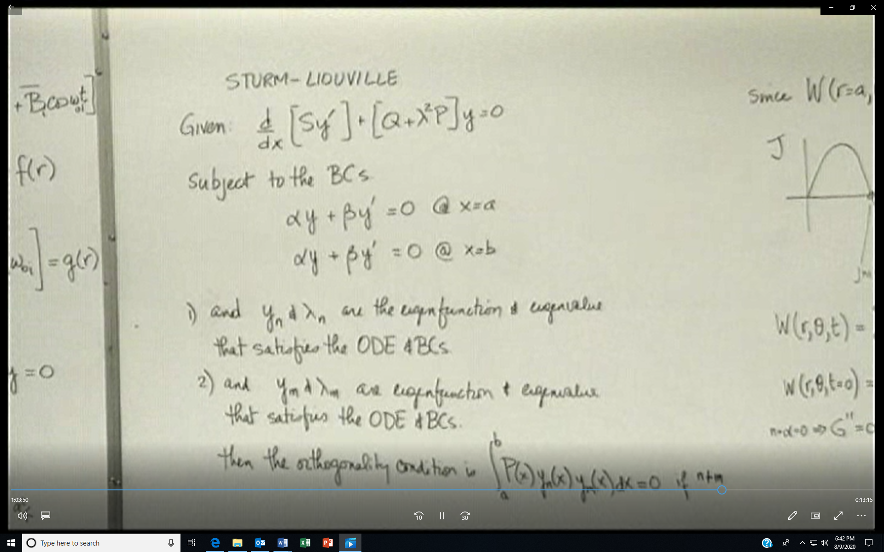
For the differential equation for time
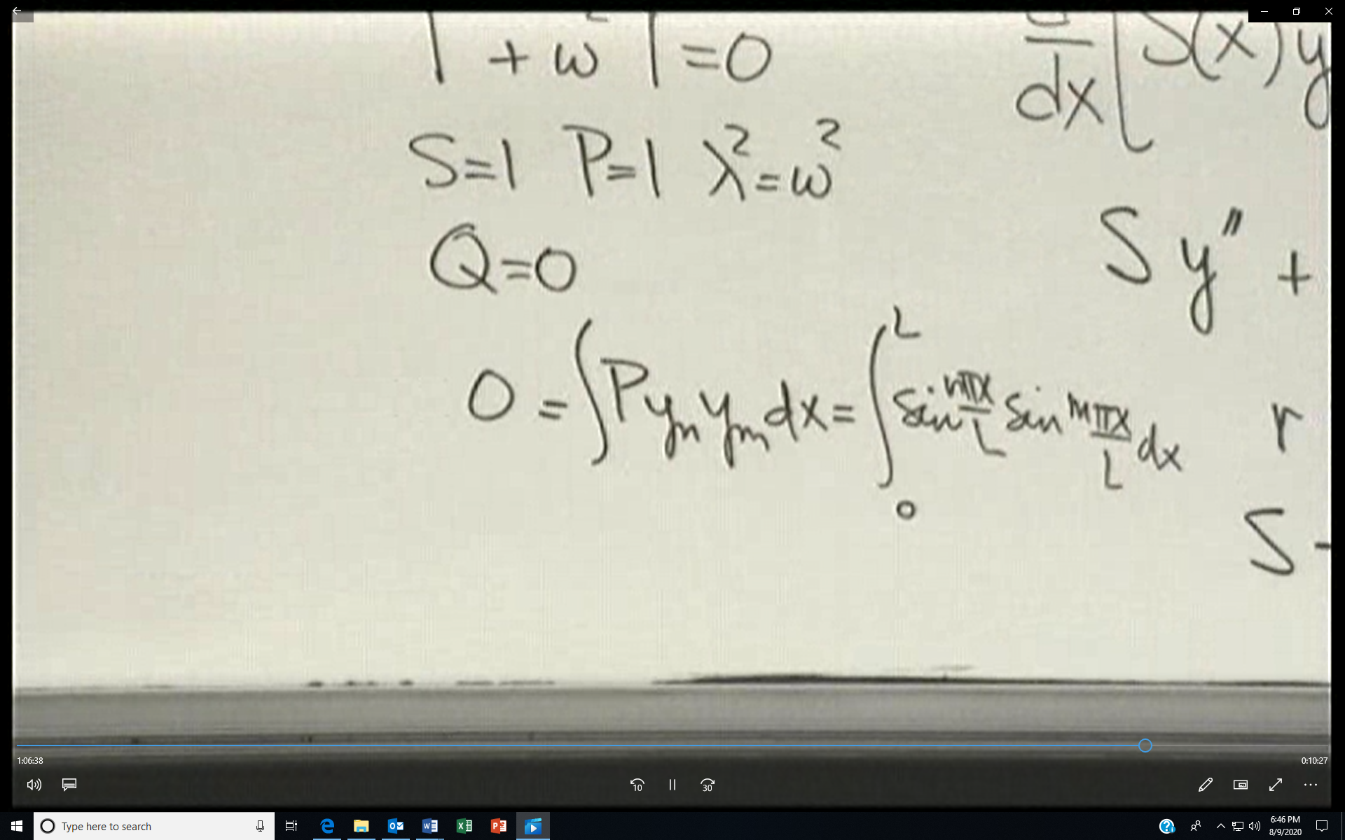
In our case the orthogonality condition leads to
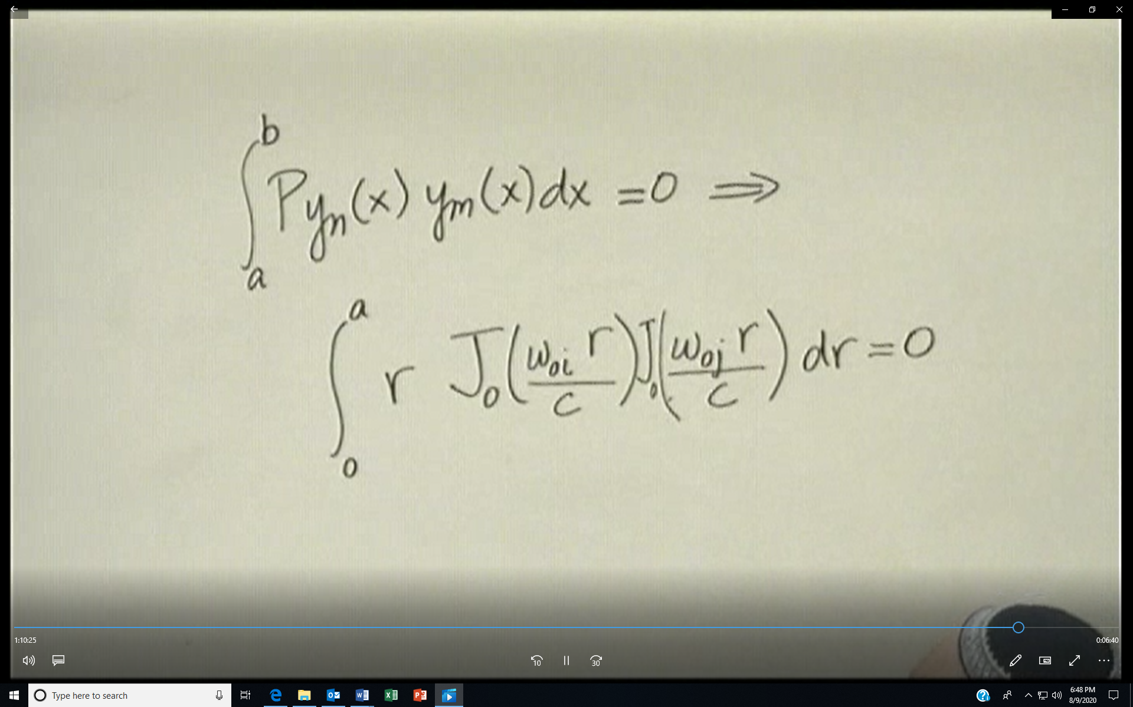
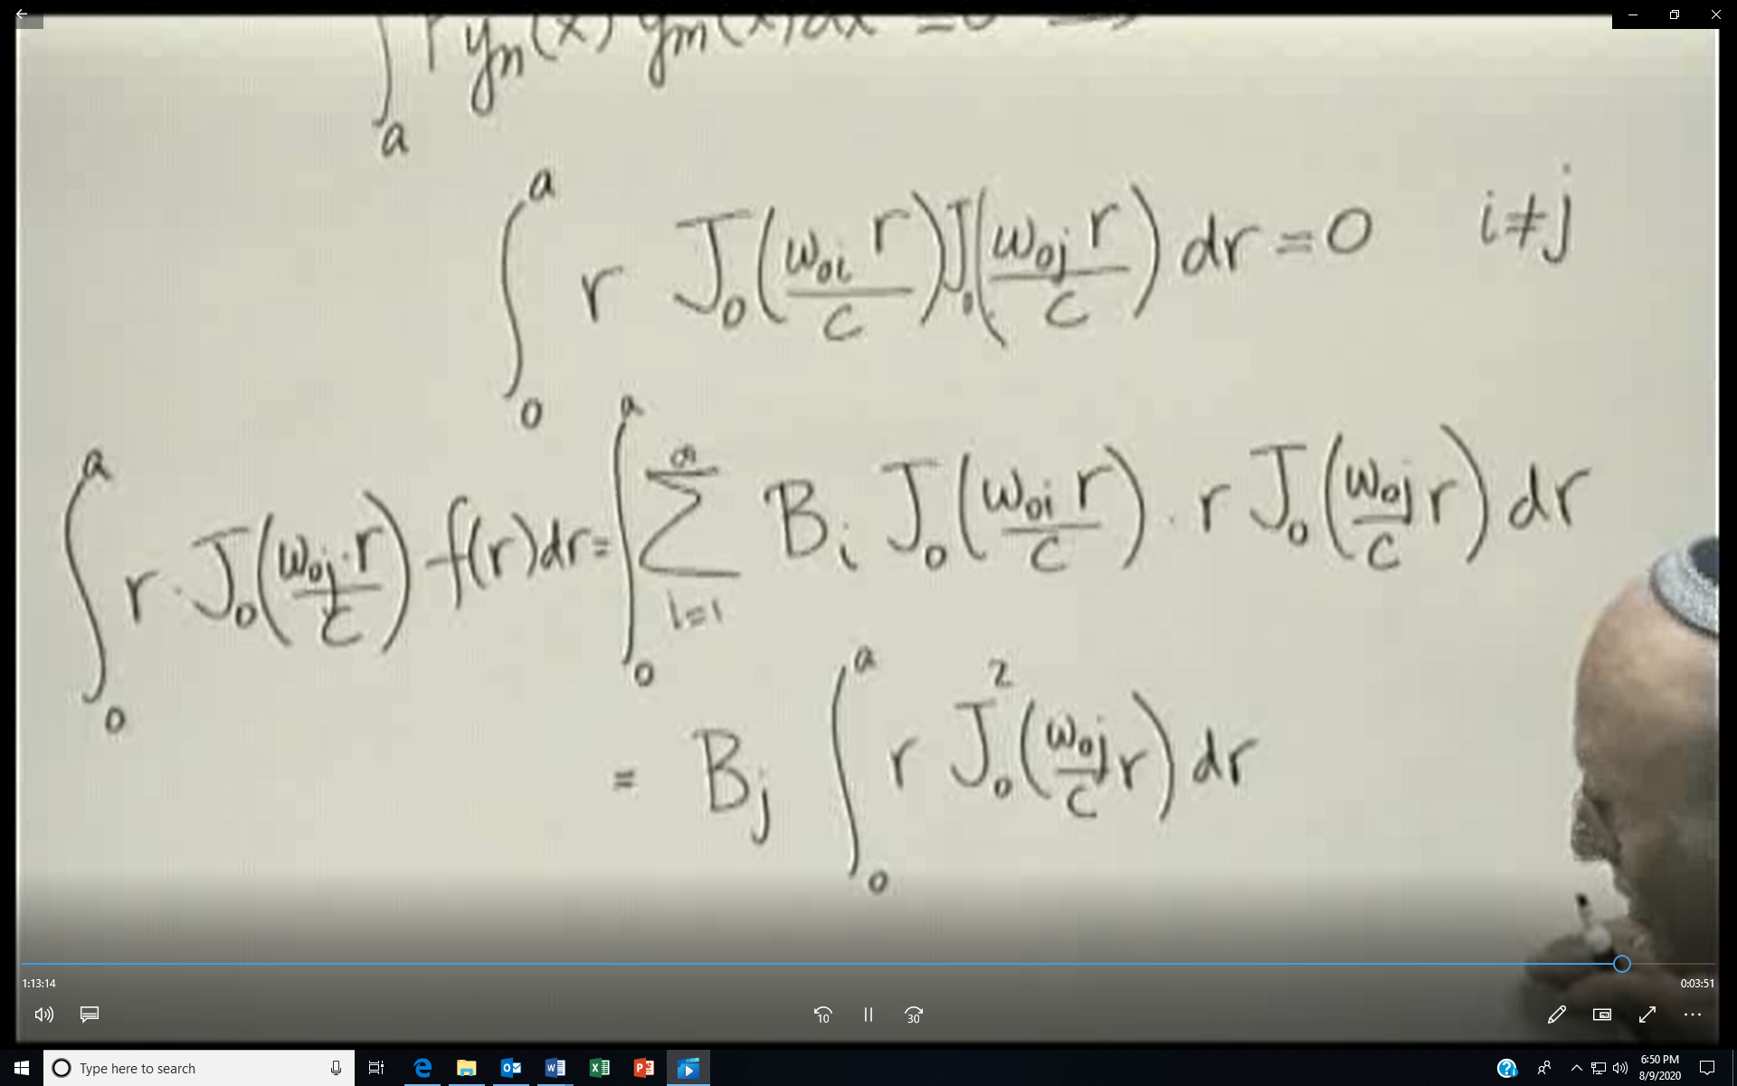
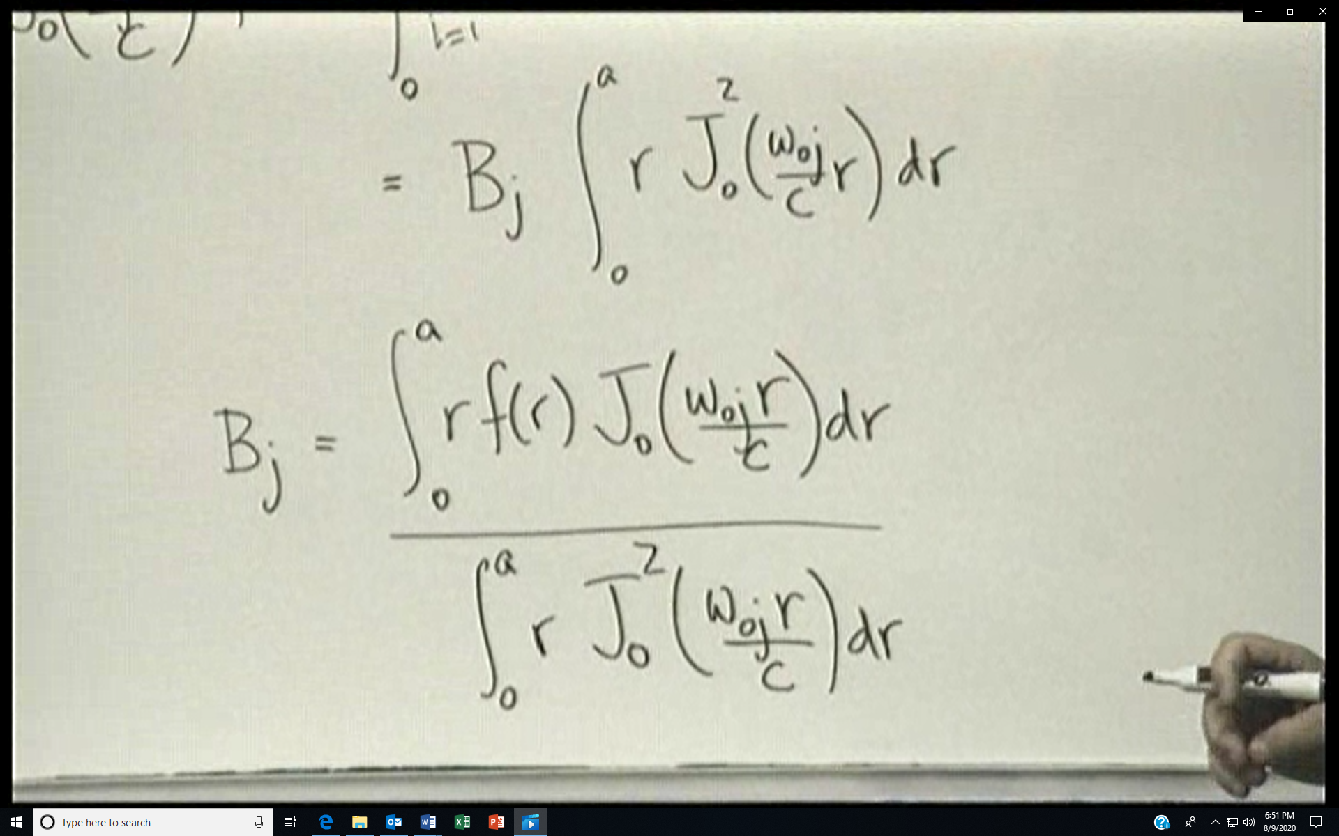
We can do this as well to the second initial condition
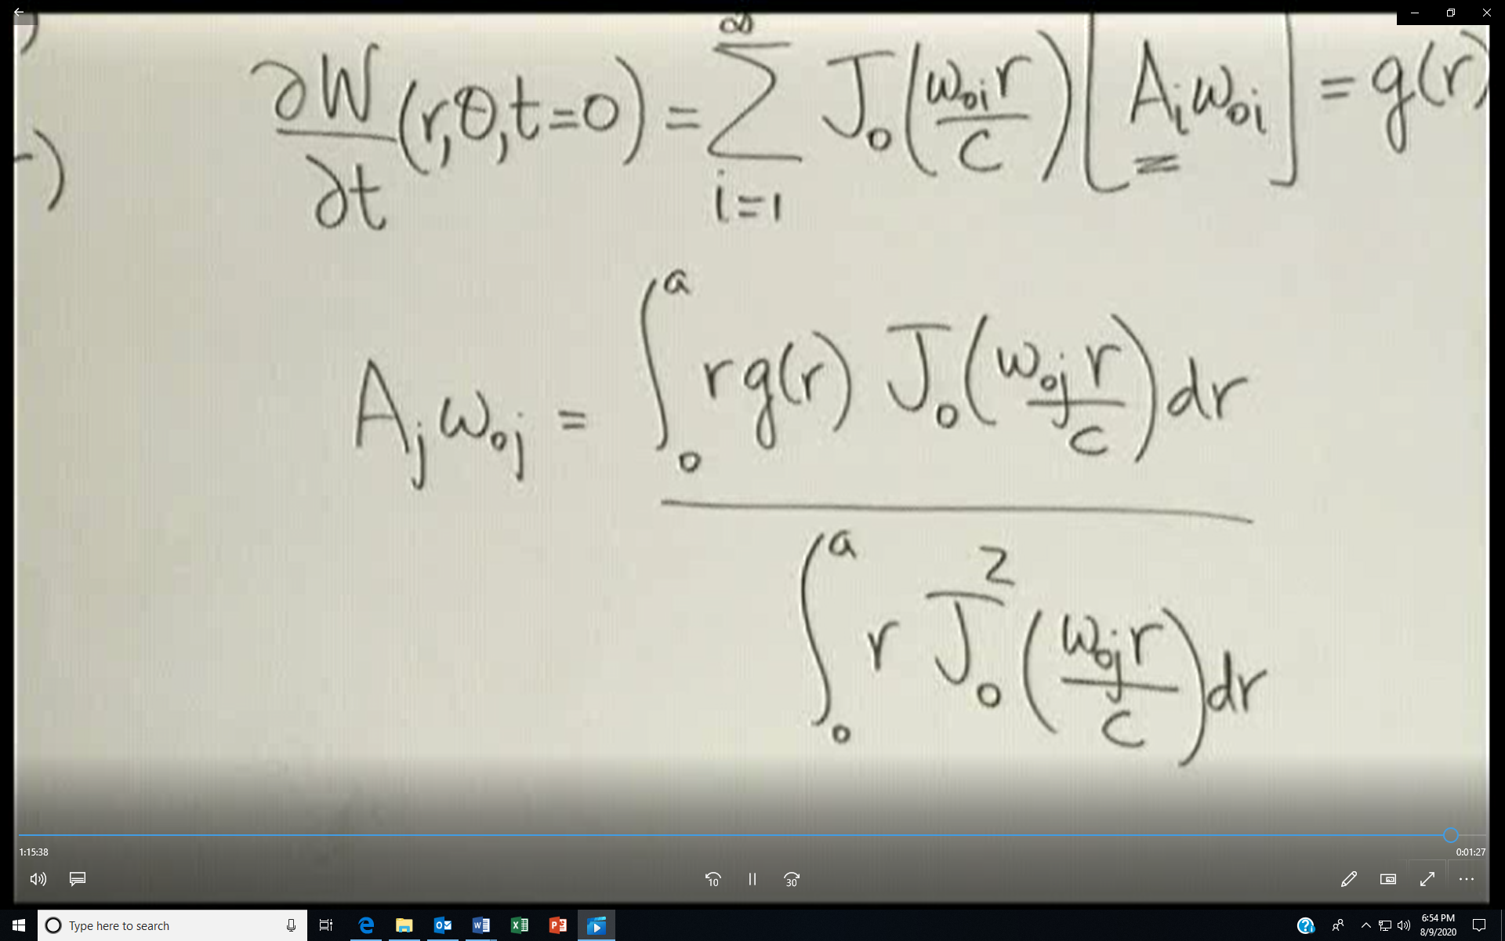
So now comes the question, what is the integral of rJo ² which appears in the denominator of Bj and Aj.

