The derivation of the wave equation. Let u(x,t) represent the displacement of a cross-section of the bar at x
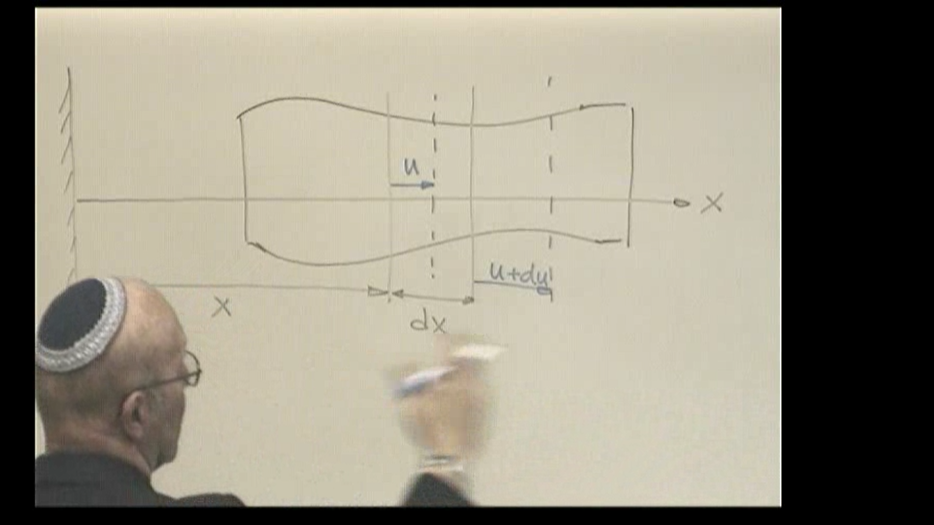
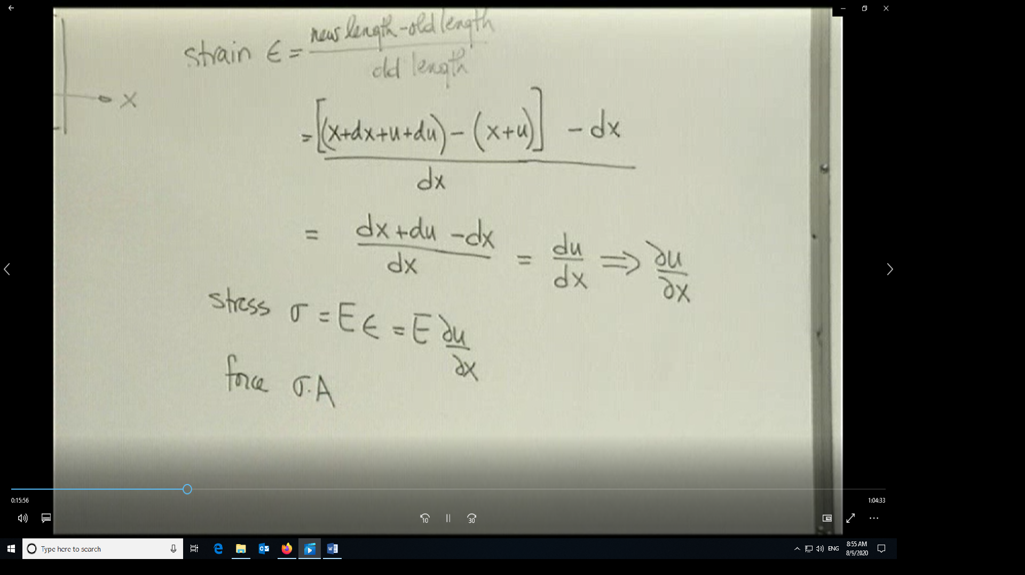
Force at any cross-section is σ•A (A the cross-sectional area)=P. In 1-D we assume stress is the average across the cross-section.
Now application of the ∑ F = mass x acceleration gives
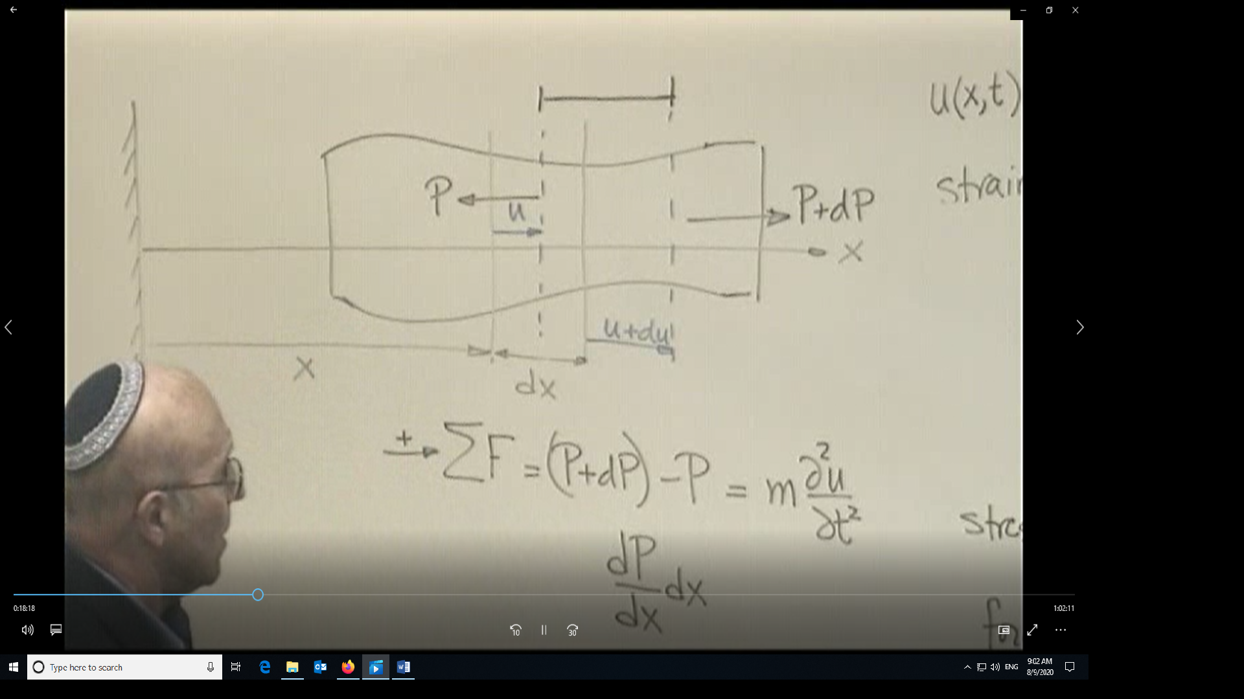
Since P depends on stress and stress depends on variation of u with respect to x, then P is a function of x
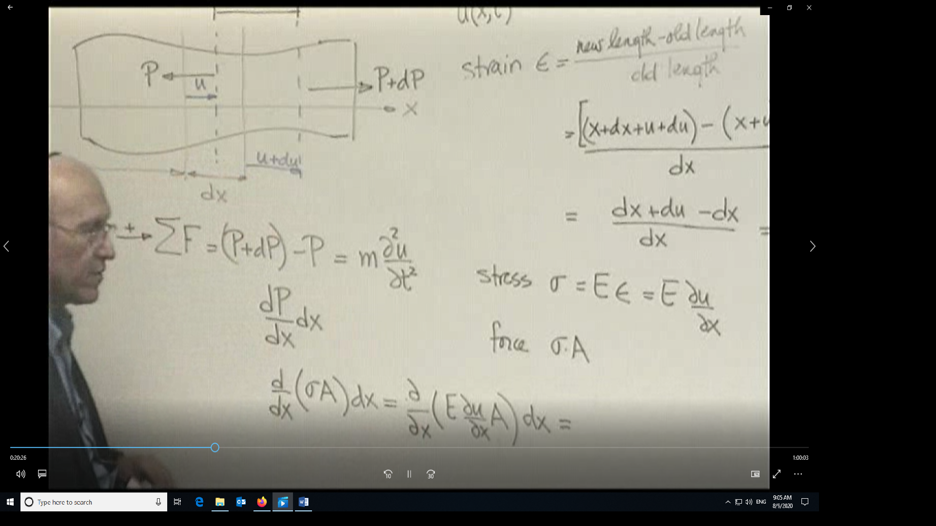
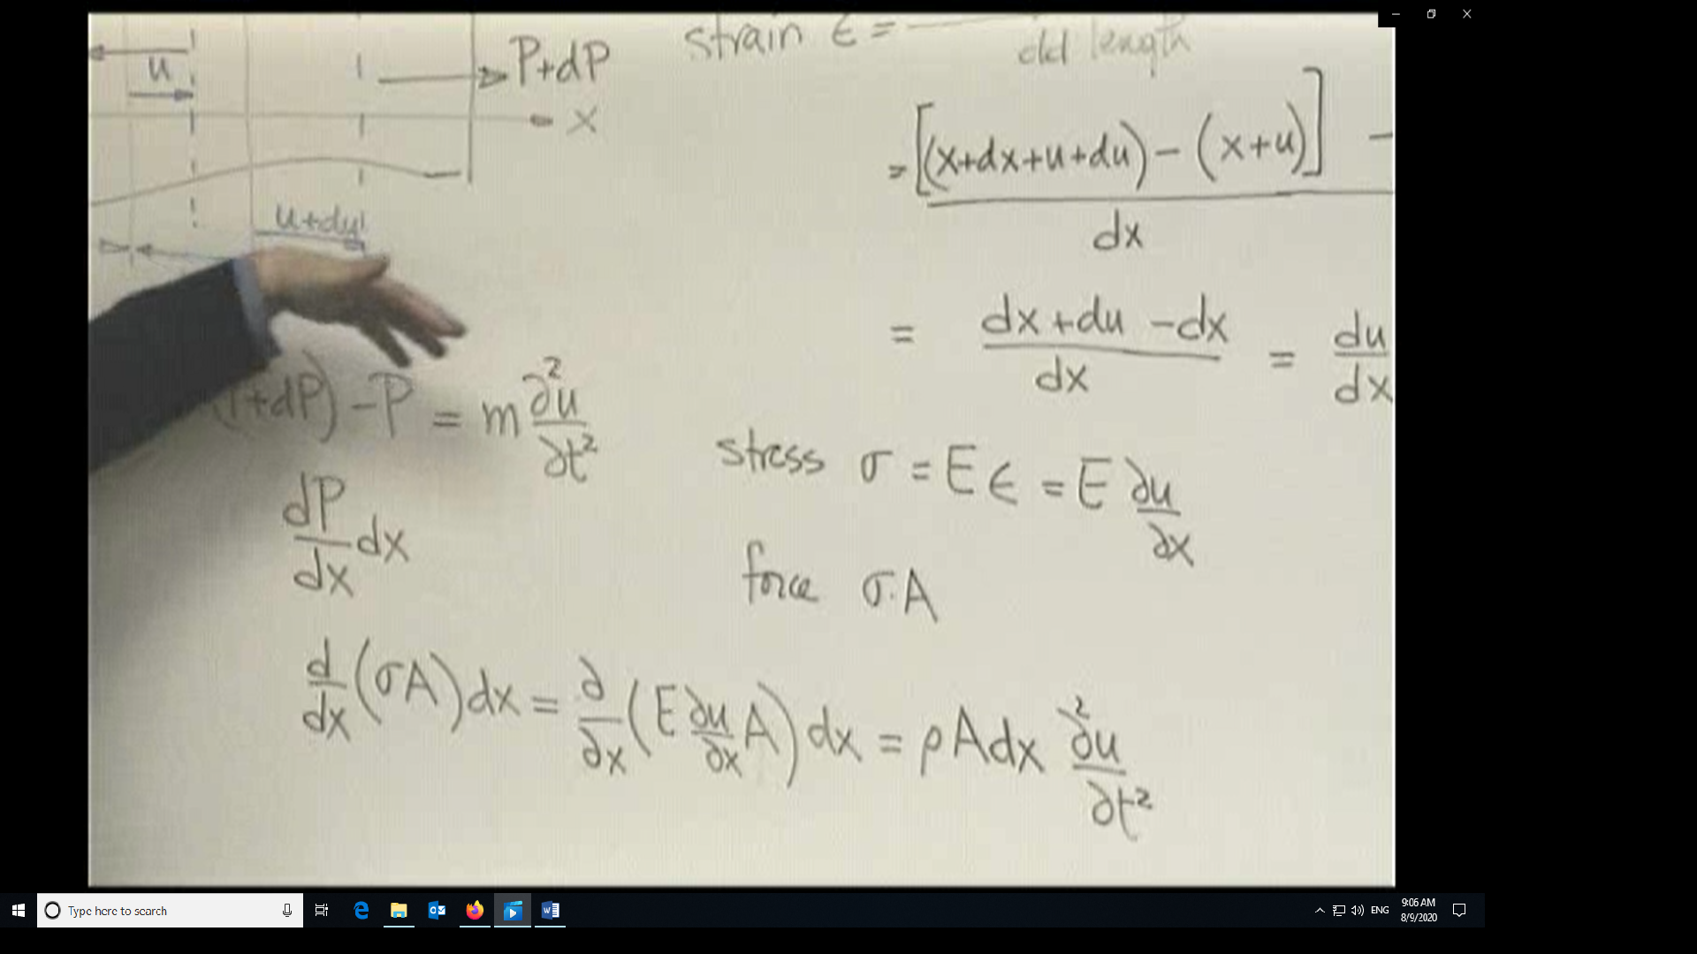
In the case where the extensional stiffness EA is a constant, each can change at every cross-section but their product is constant, then
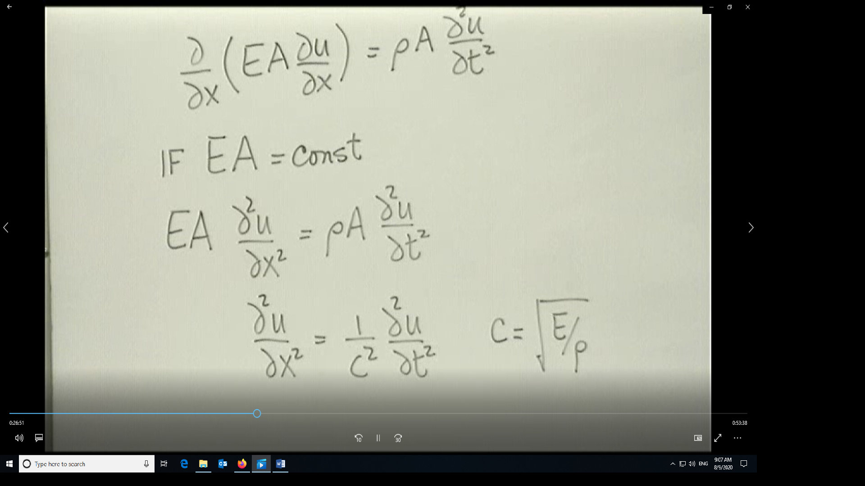
Here c is the bar speed. ρ is the density, in this case mass/unit length. E has units of load/unit area.
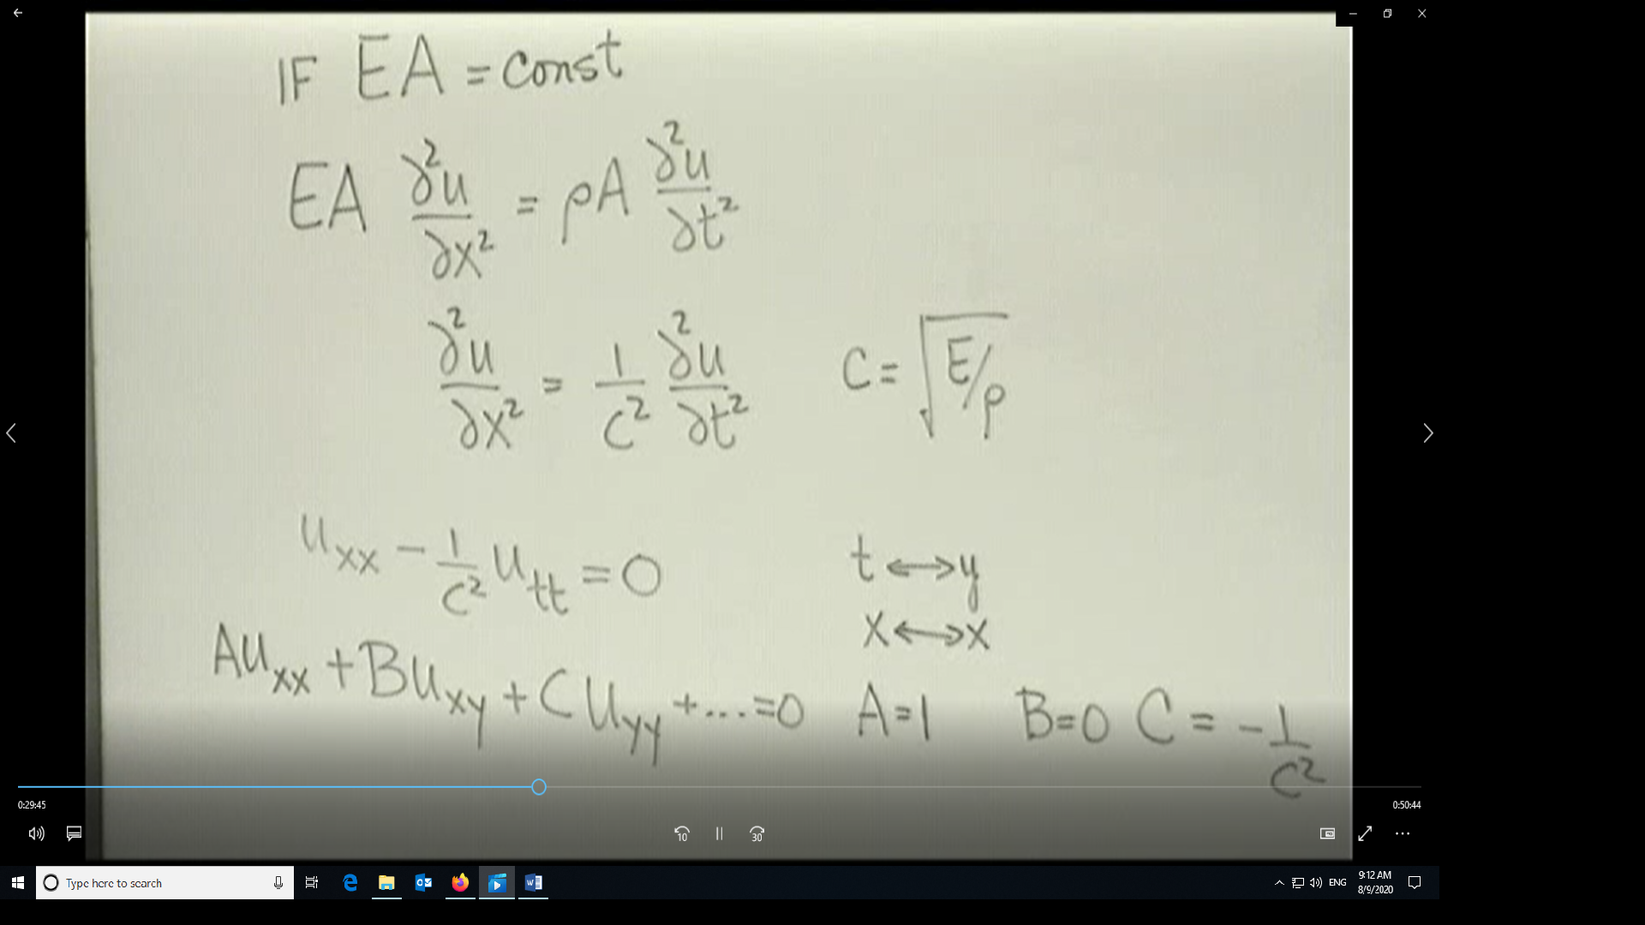
To characterize this equation to what we have learned previously
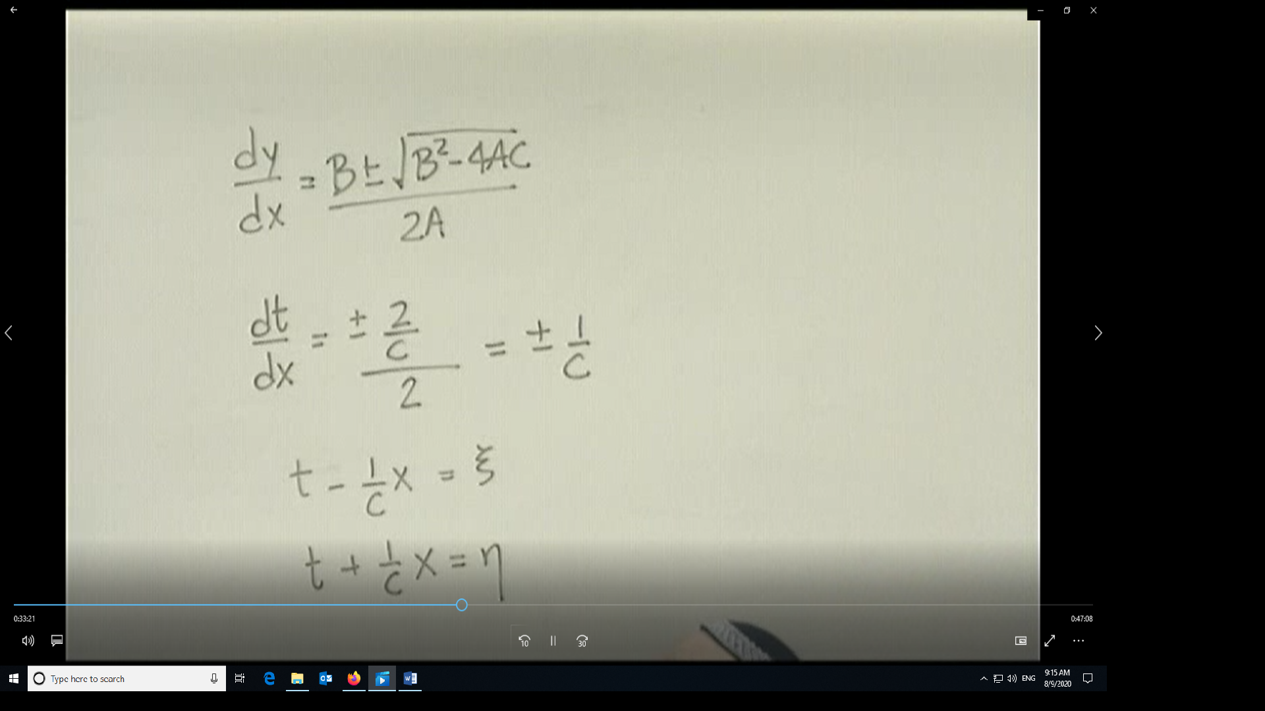

Now let us look at the 1-D heat equation and characterize it using the information we have previously learned
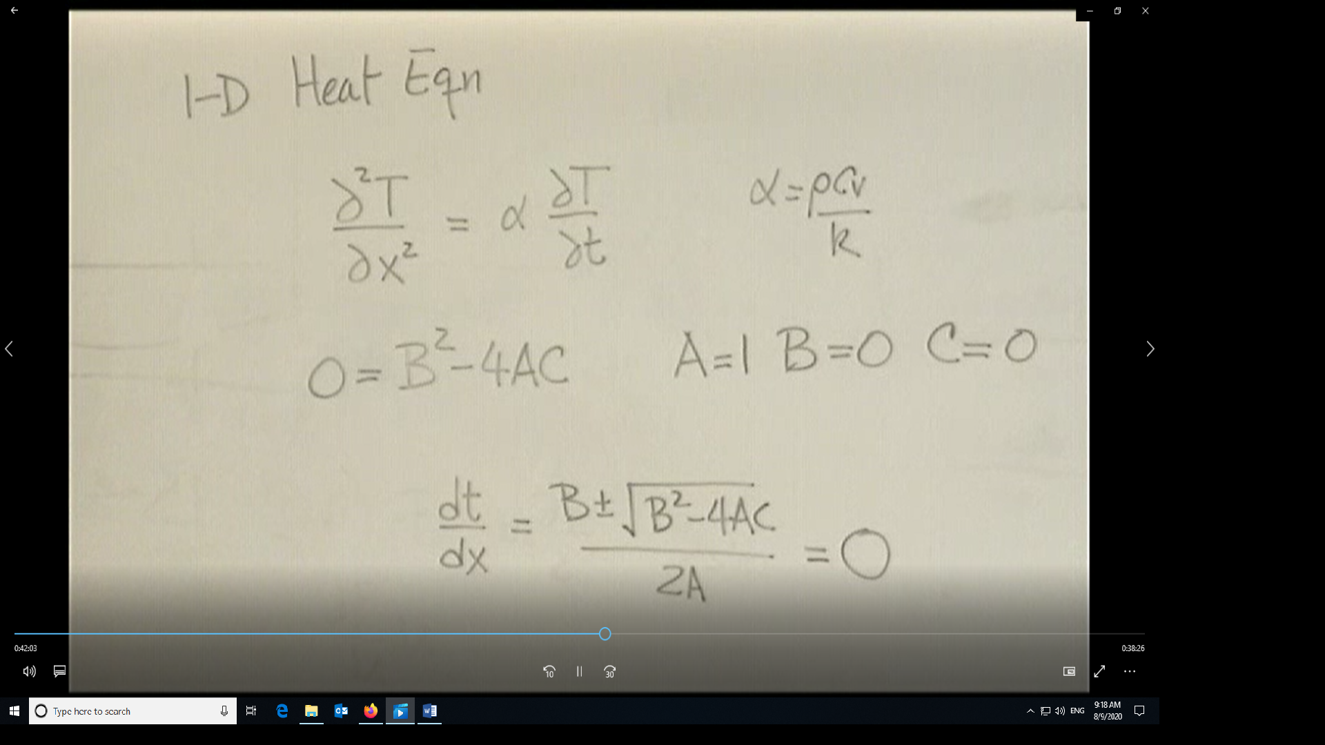
Since dt/dx=0, then t=constant, let’s call it ξ and the other characteristic is any line that crosses it like η=constant=x. Hence, the 1-D Heat equation is an example of a parabolic PDE.
Now look at the steady state 2-D heat equation
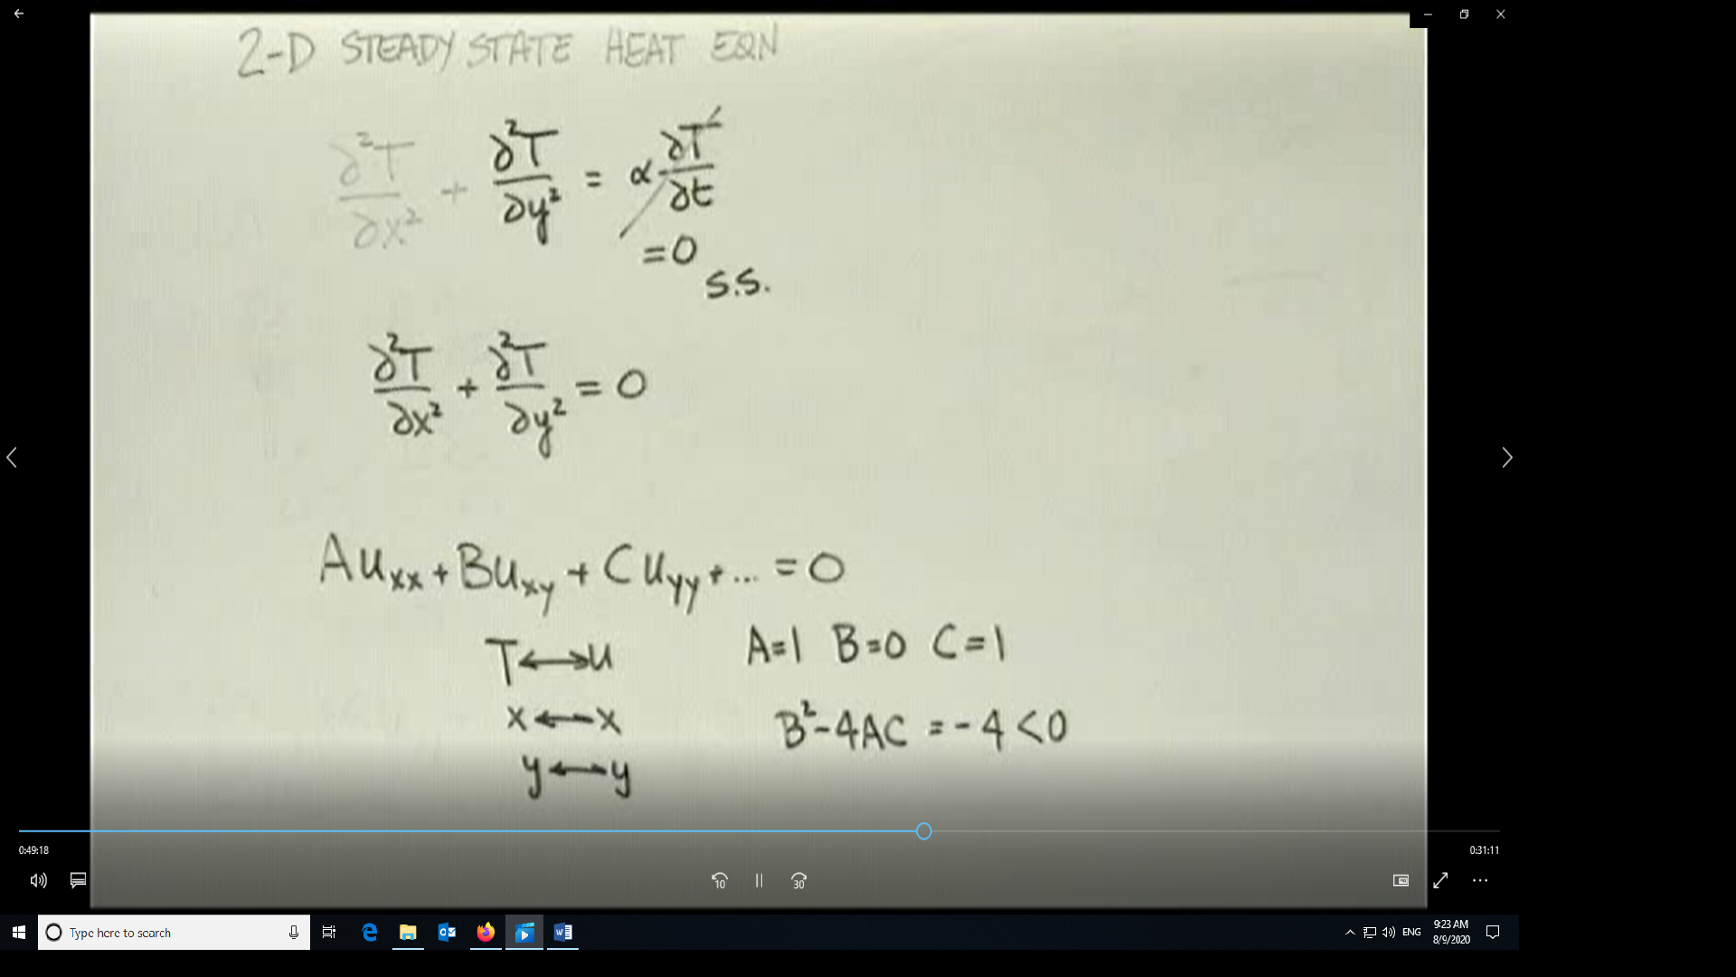
Since the discriminant is less than zero, this is an example of an elliptic PDE
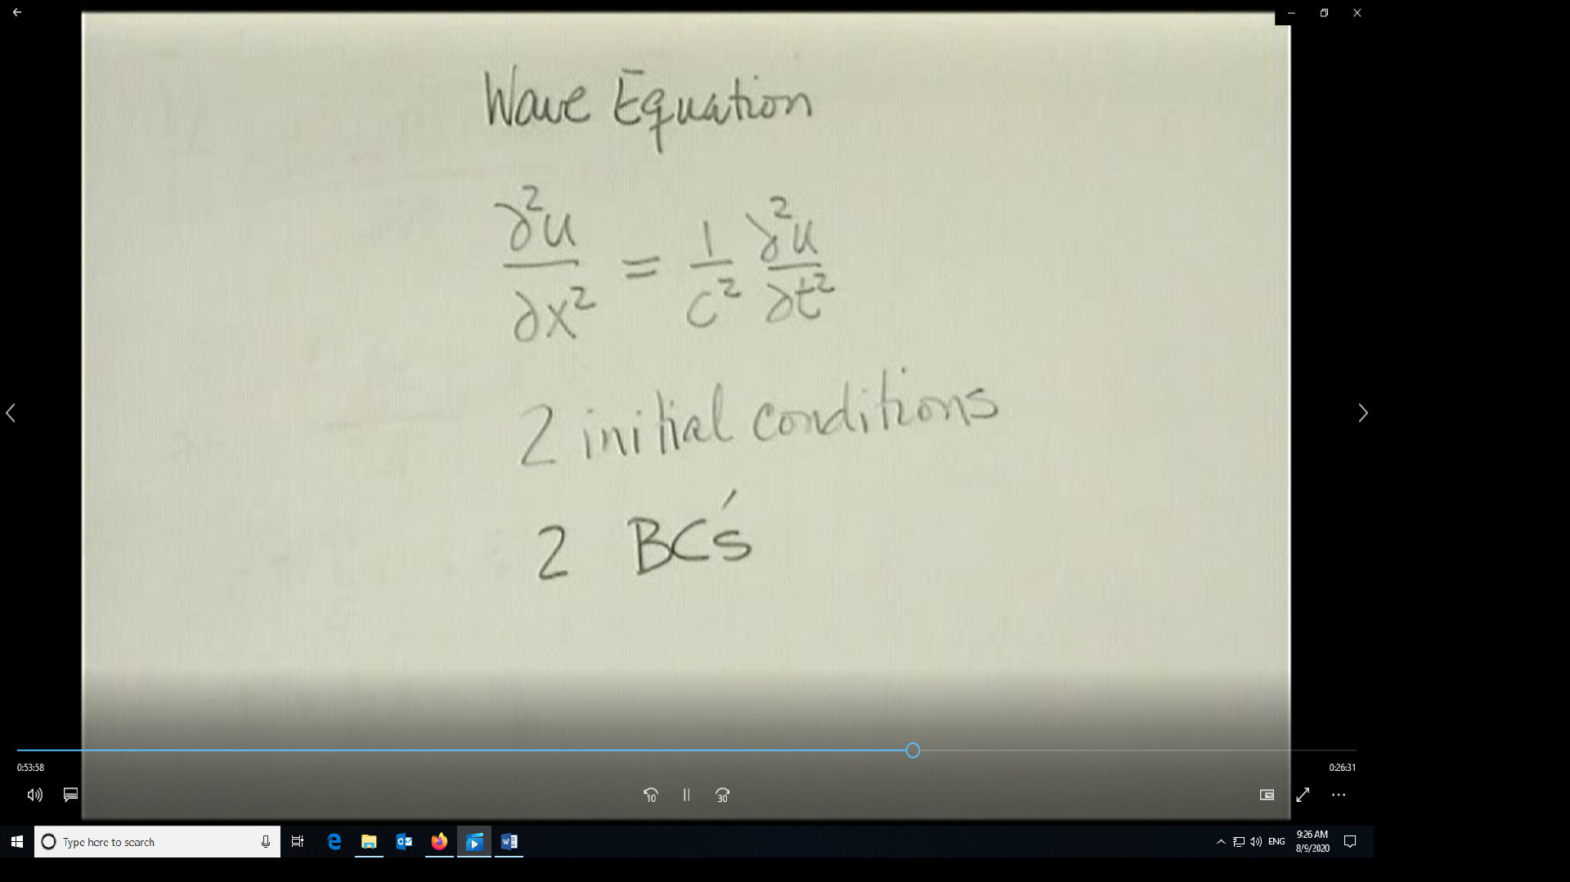
For a well posed wave-equation type problem, these are the basic requirements
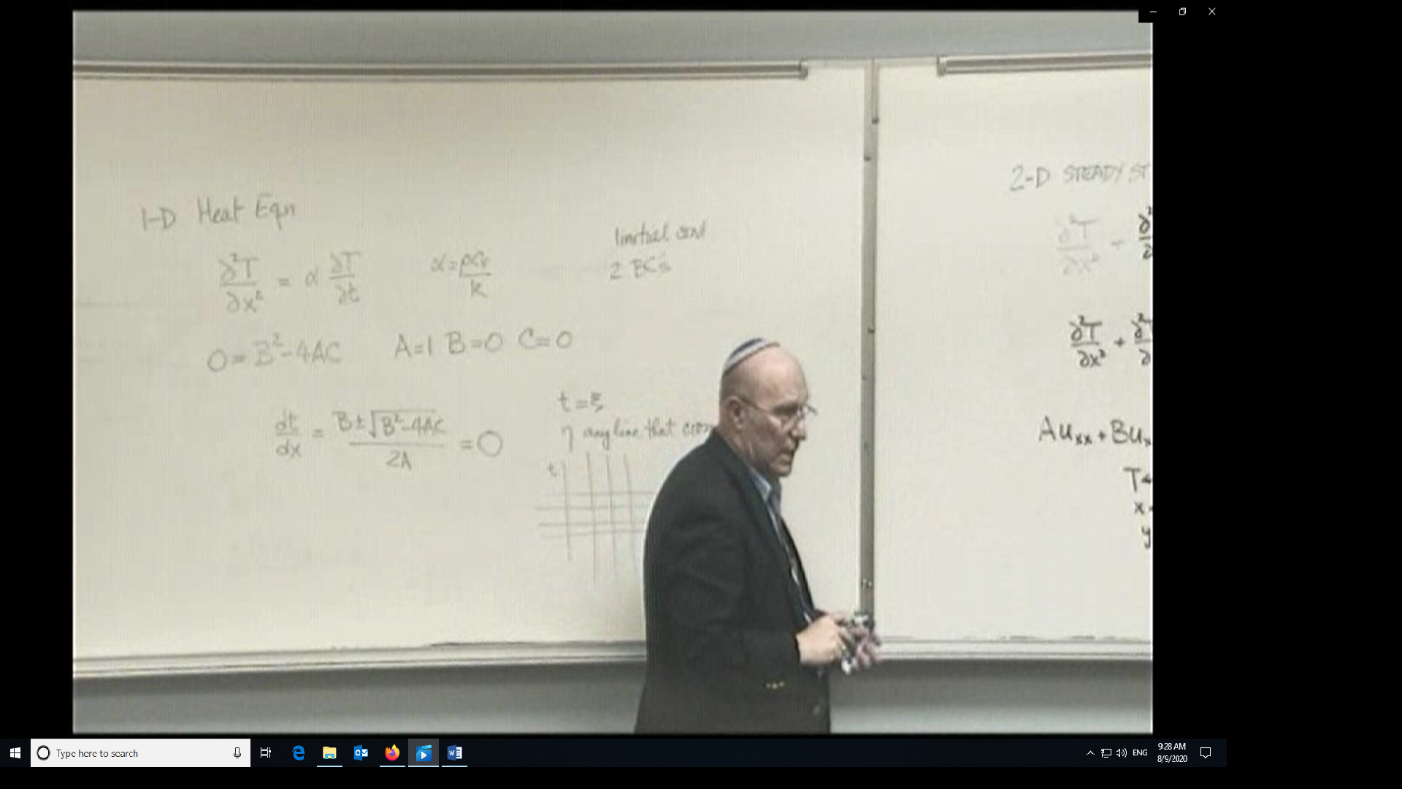
For a well posed parabolic PDE, you need 1 IC and 2 BCs
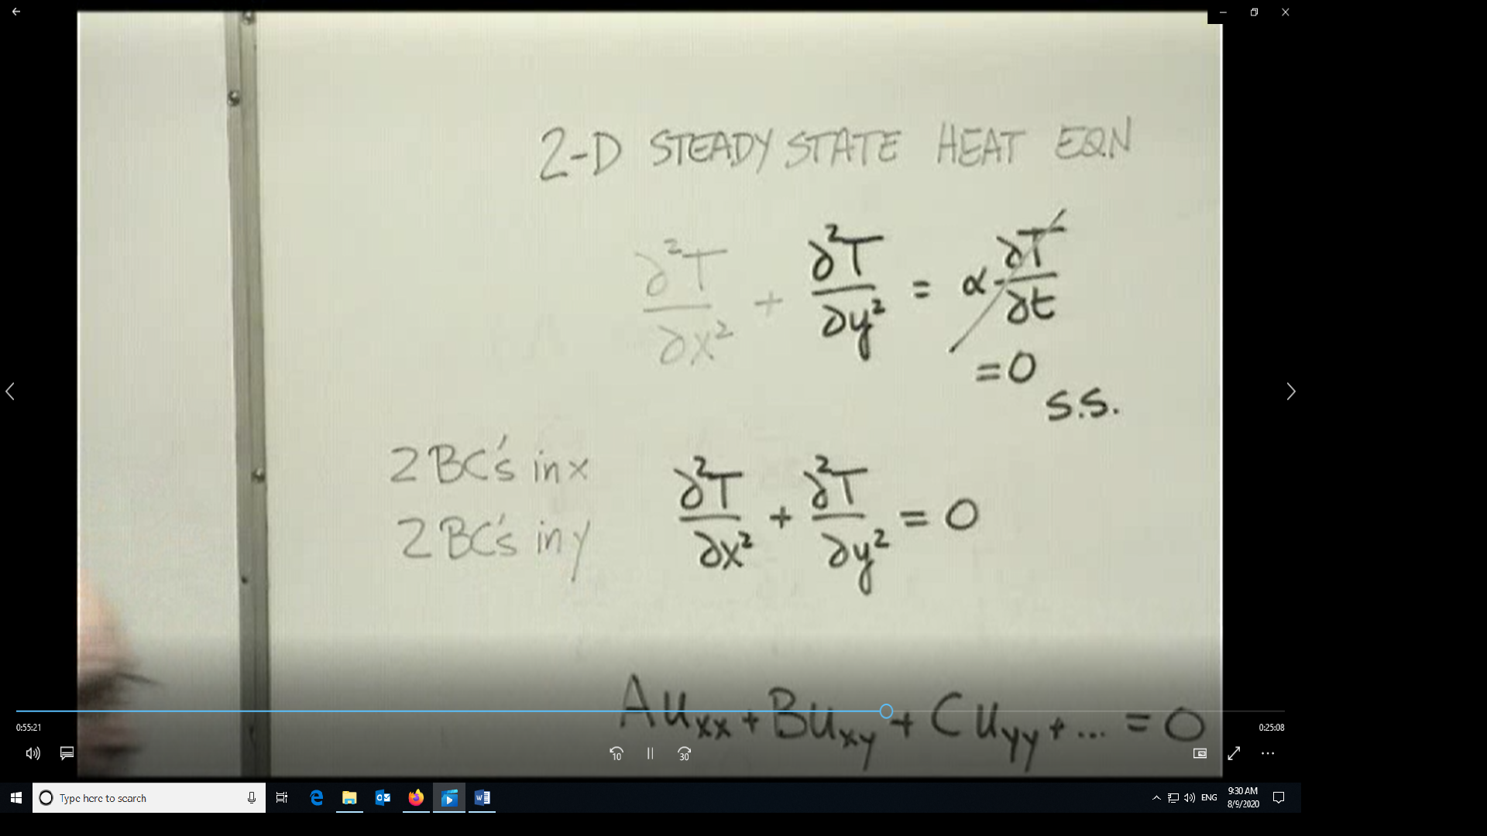
For elliptic conditions you need 4 BCs, in this case 2 in x and 2 in y
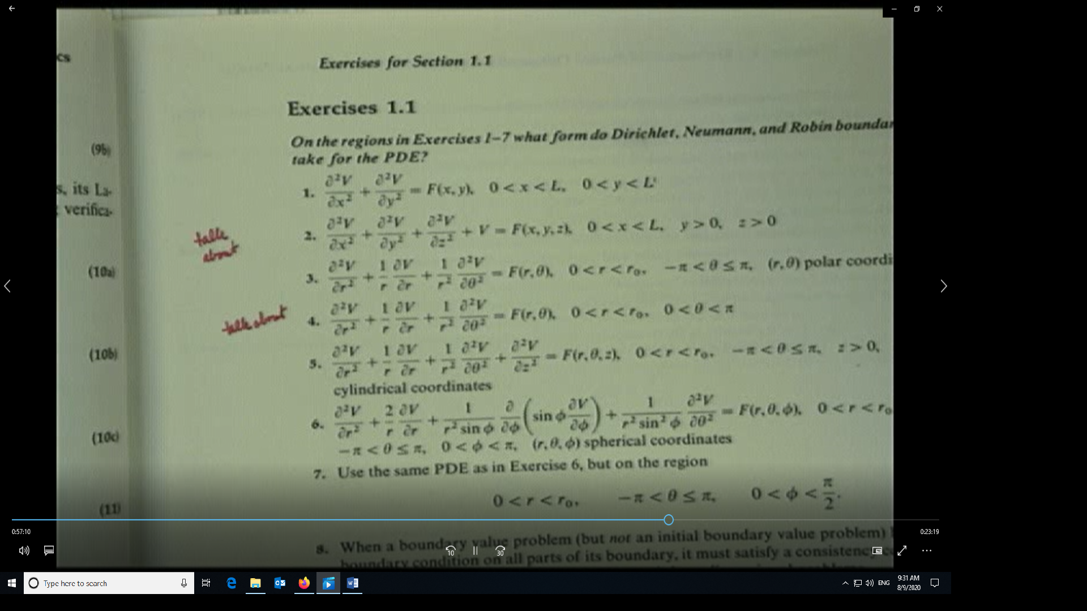
From Trim’s book, Section 1.1 Exercise 1.1. Look at the 2-D equivalent of problem 2
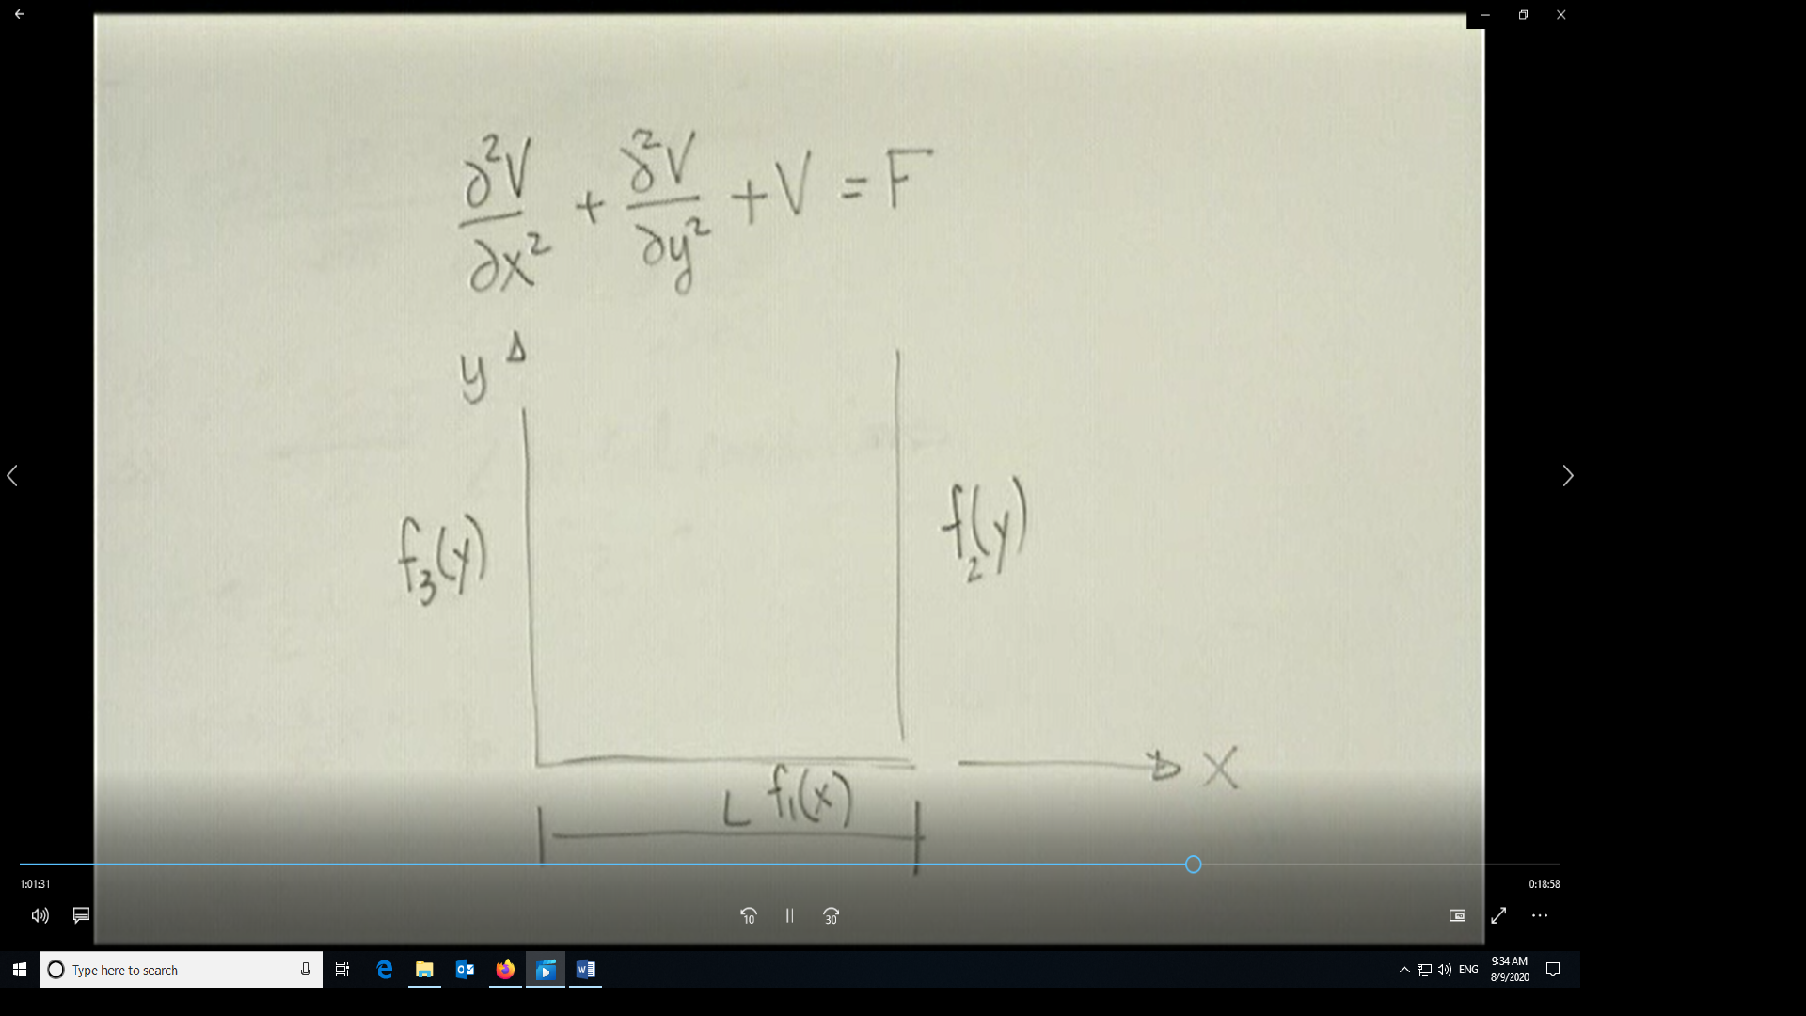
In this semi-infinite problem, at y=ꝏ the solution BC is that it must remain bounded. On the x=constant, the BCs can at most be functions of y, since x is fixed. On the y=constant line the BC can be at most a function of x.
Now looking at problem 4
This is a semi circular region. The four boundaries are at θ=0, θ=π, r=ro and at r=0
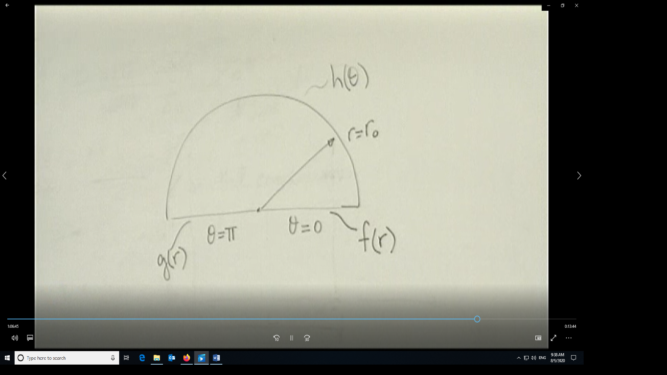
r=0 is a limiting case of r=ε where epsilon is a small quantity which is made smaller and smaller until it reaches zero. Namely, the semi-circle is a limiting case of a thick-walled cylinder where the inner radius is made so small as to collapse to a point.
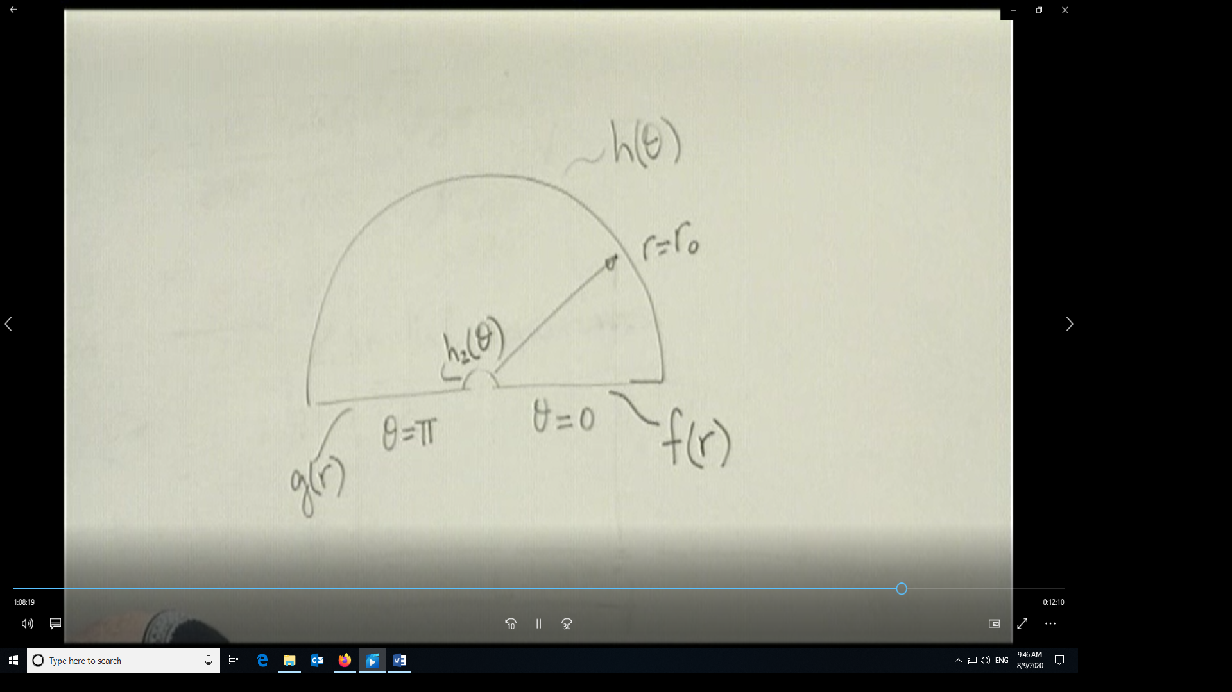
In the above, for θ=constant lines, the BCs can be at most functions of r; similarly, on constant r lines, the BCs can be at most functions of theta.
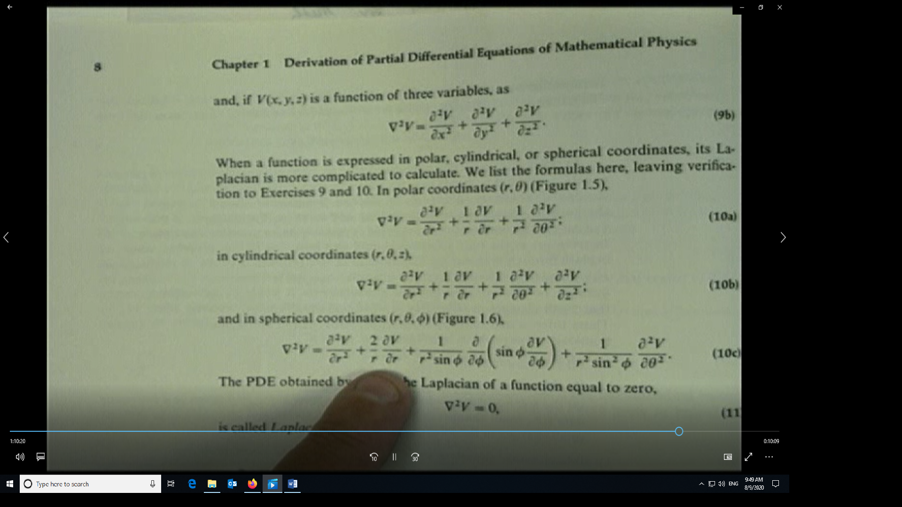
Here we show the definition of the Laplacian in different coordinate systems, Cartesian, cylindrical and spherical.
Examples of types of BCs: first type of Dirichlet (on u), second type or Neumann (on derivative of u), third type or mixed/Robin (on combination of u and its derivative)

