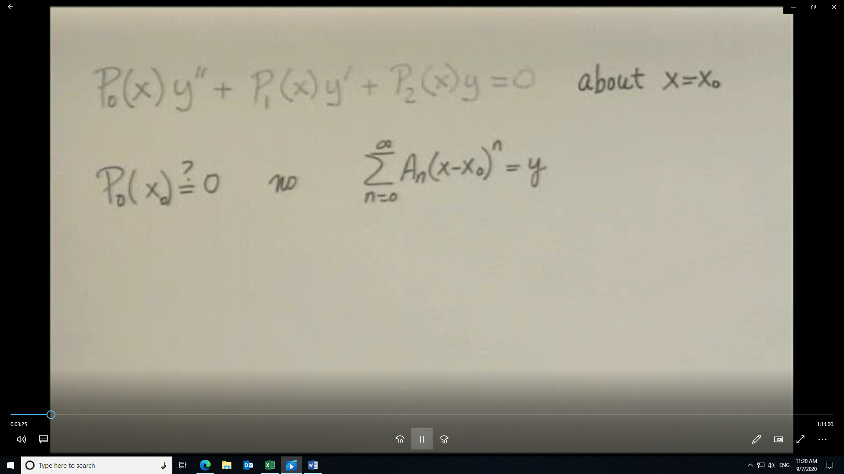
Tests used when Po(xo)=0
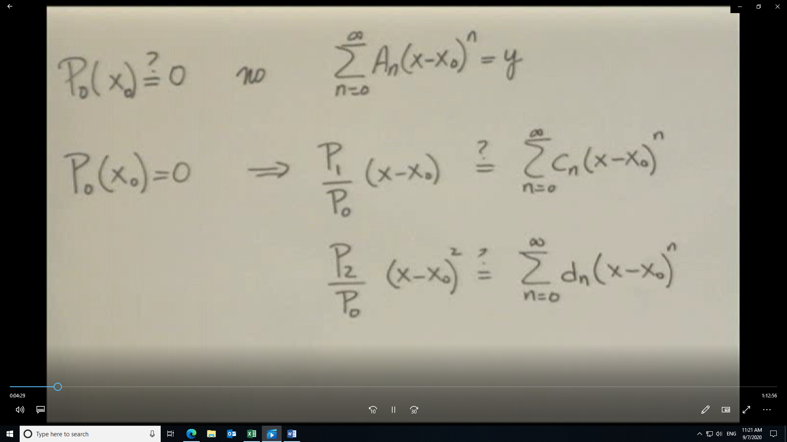
Note that if either test fails then xo is an irregular singular point and the solution may or may not be in the form of a series as shown in the next view.
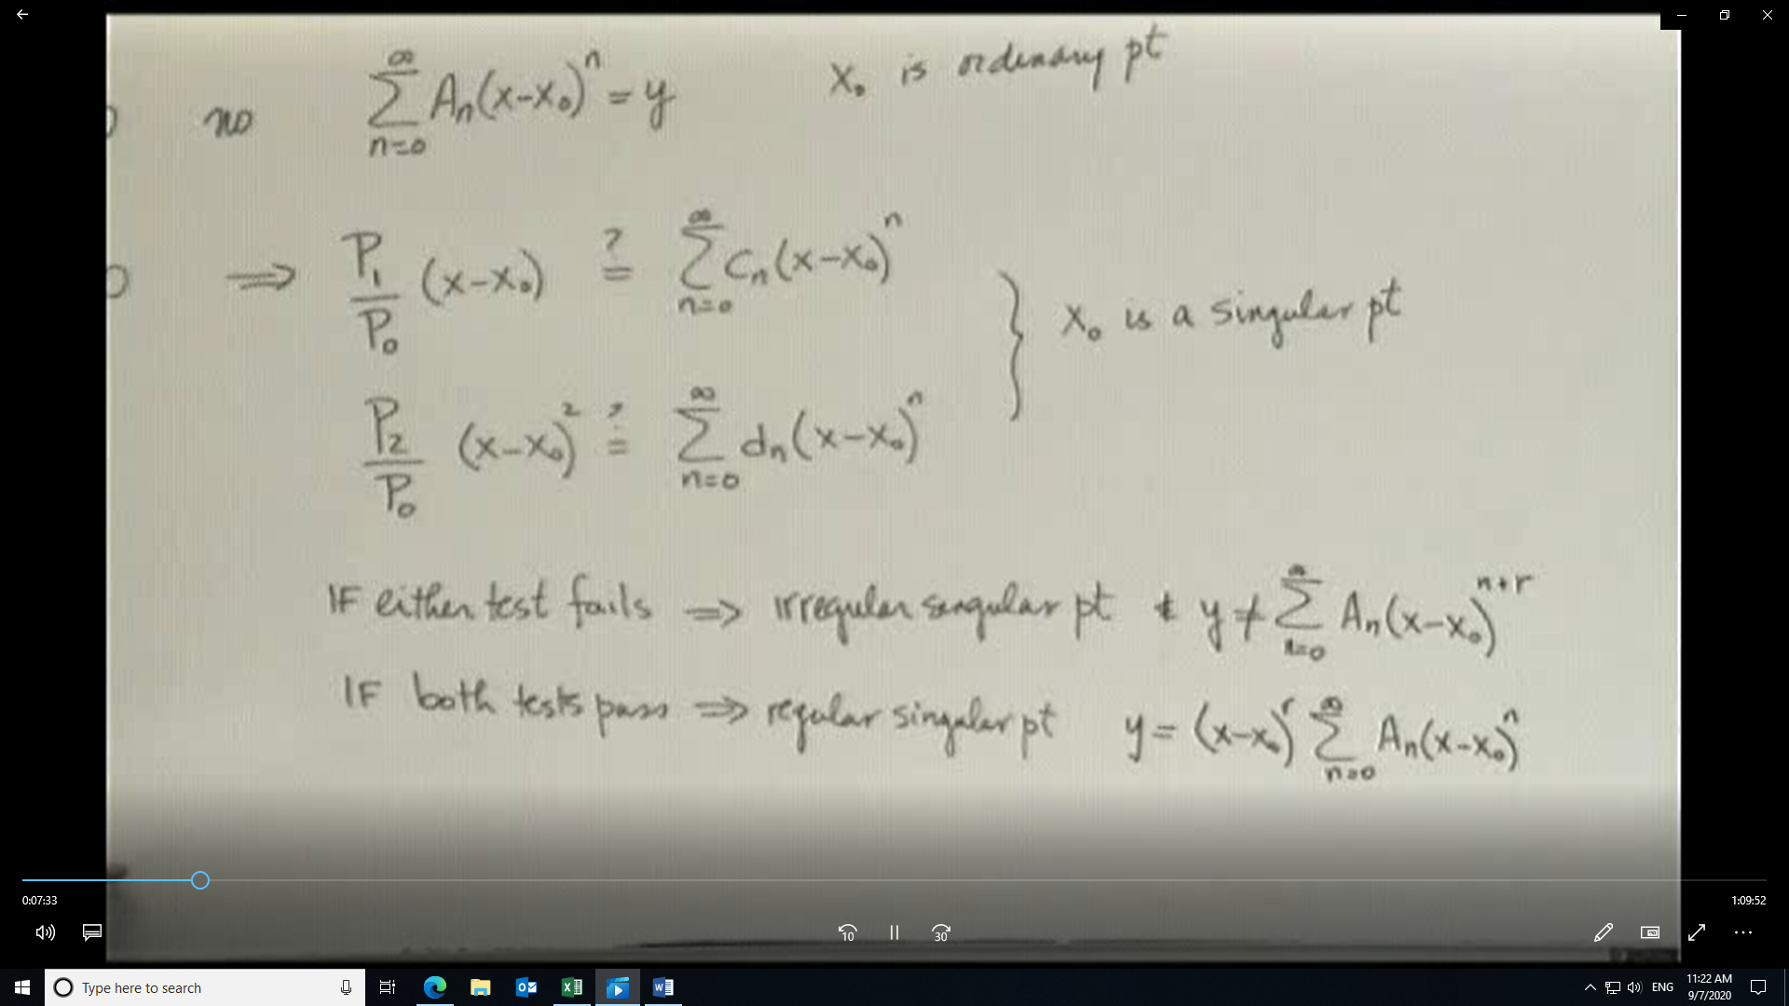
Coefficient of Lowest power of (x-xo)^{r} gives the indicial equation. Allows for solution for r.
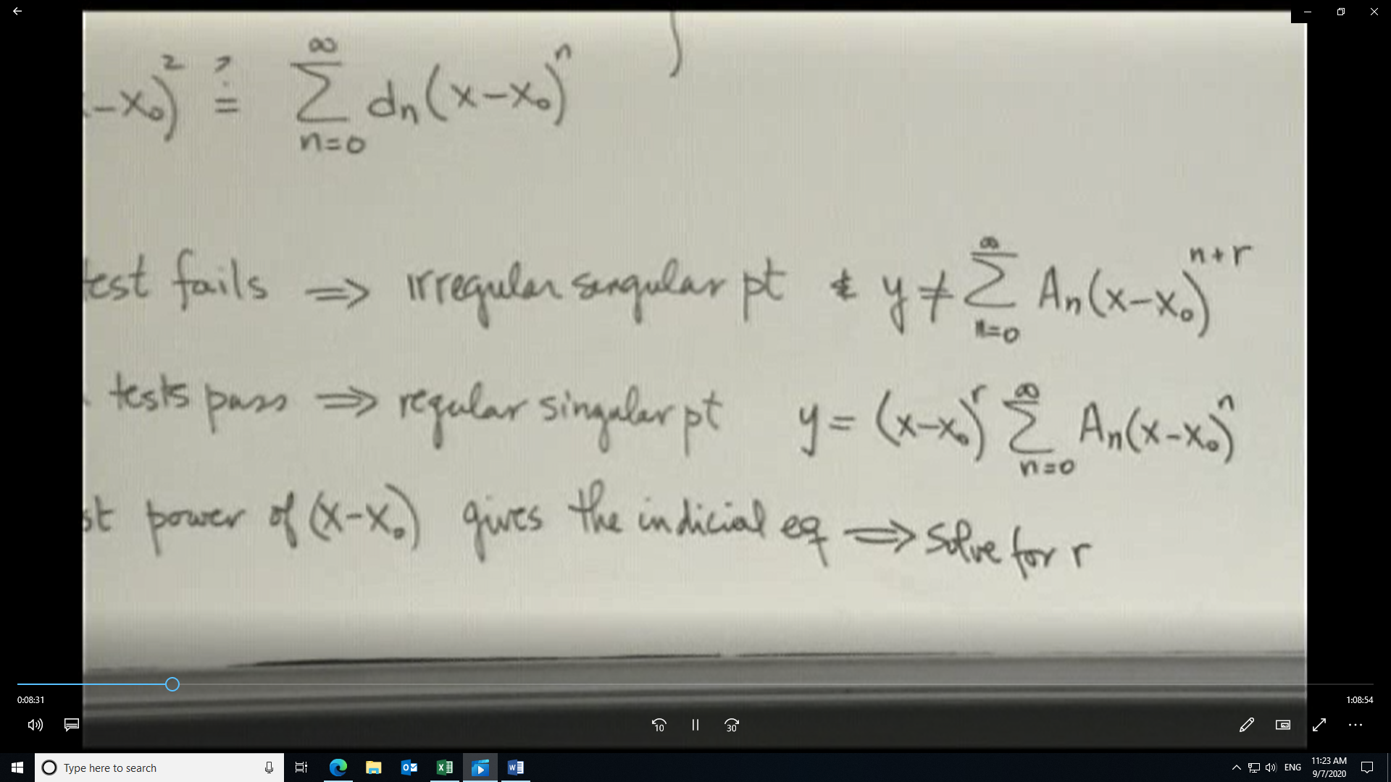
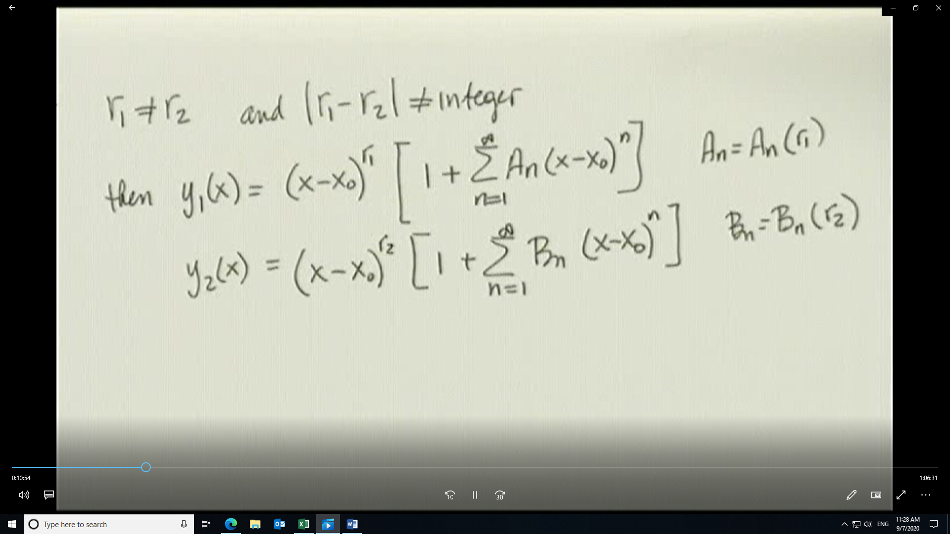

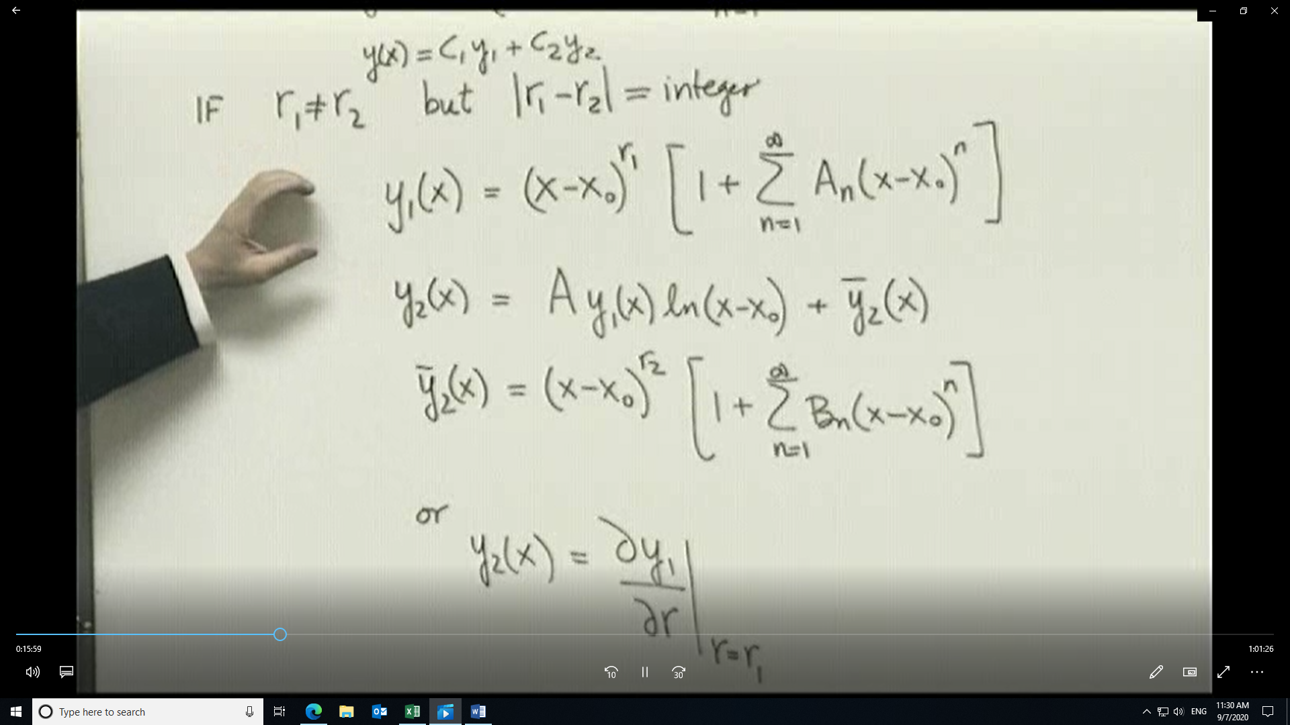
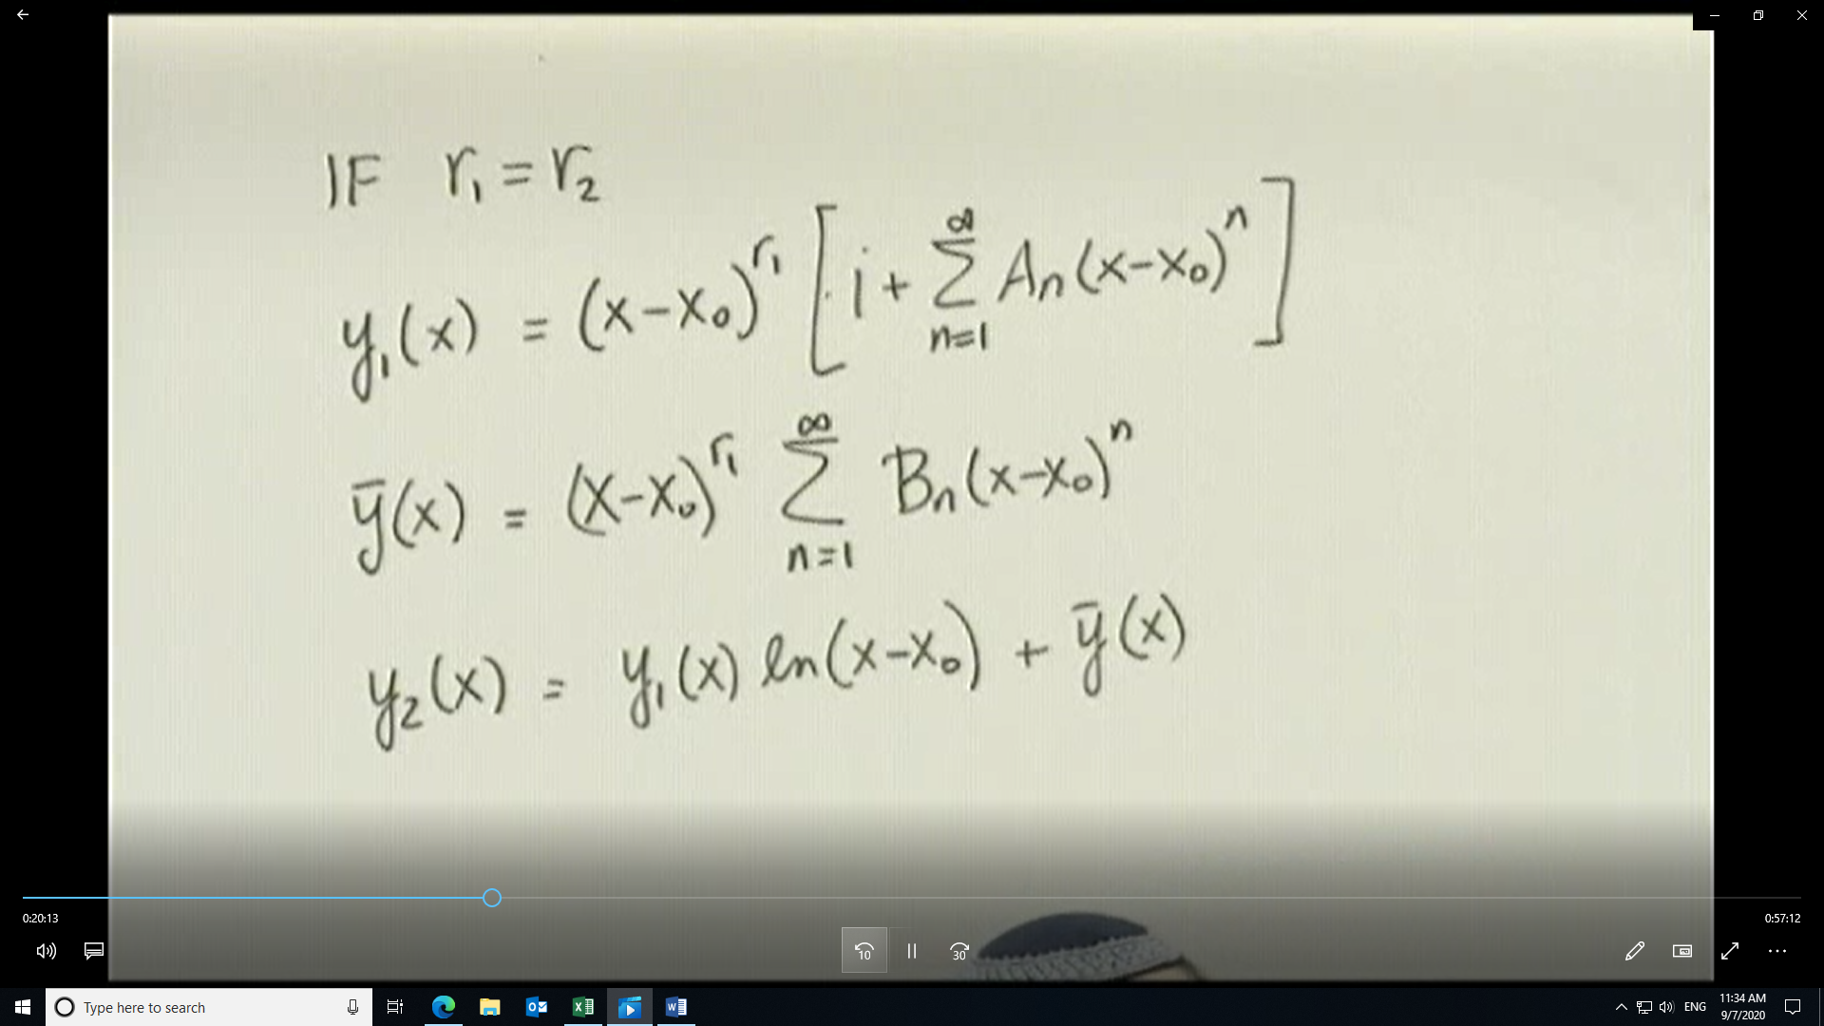
Because of the structure of y2 you can use the partial derivative of y1 with respect to r1 to find y2 as in the previous case.
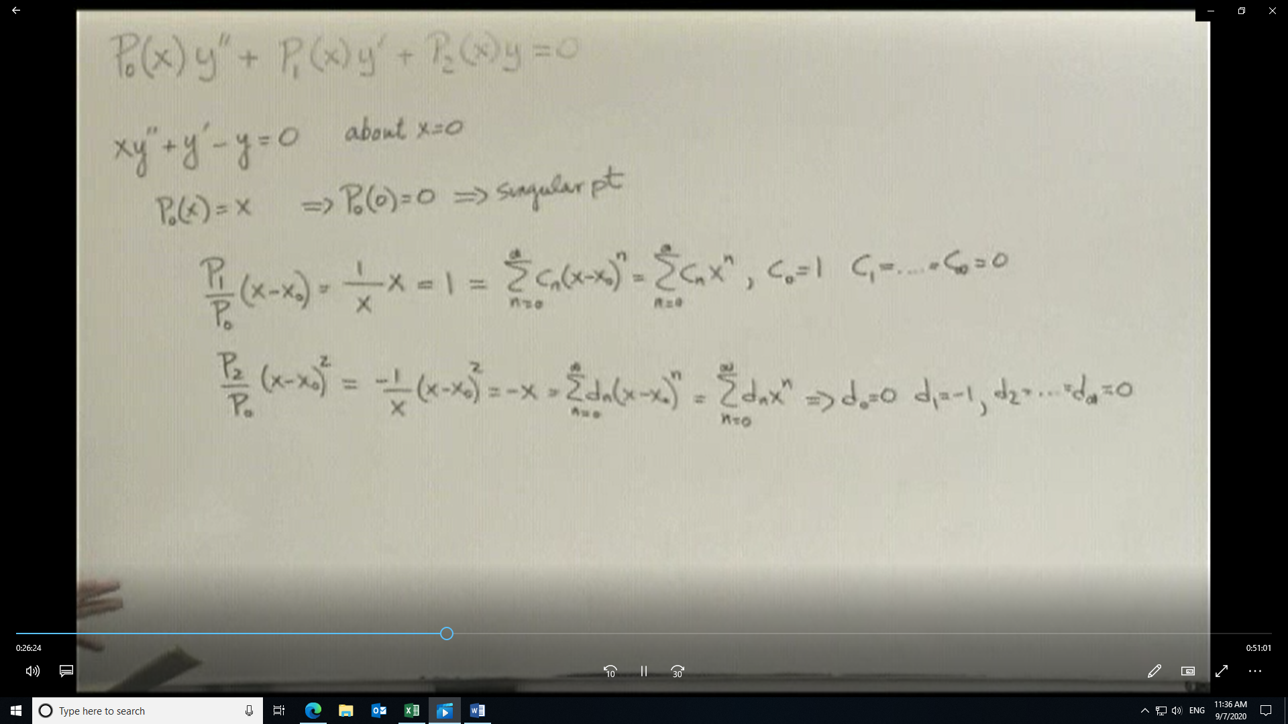
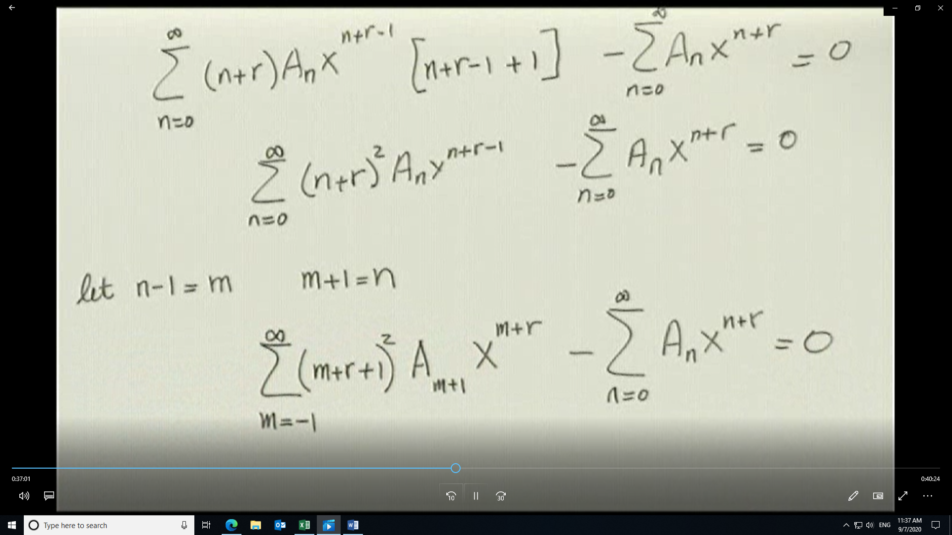
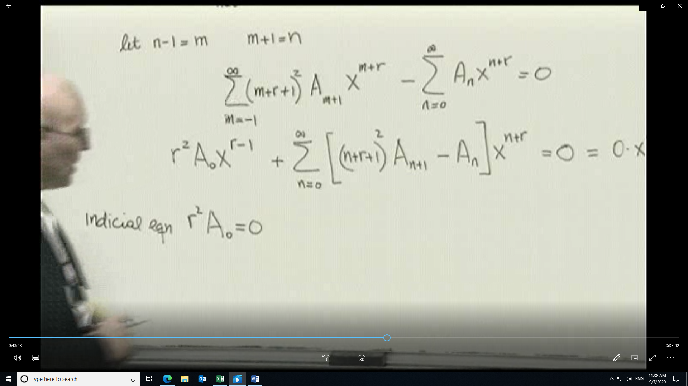
Recursion formula comes from the coefficient of the general term being zero.
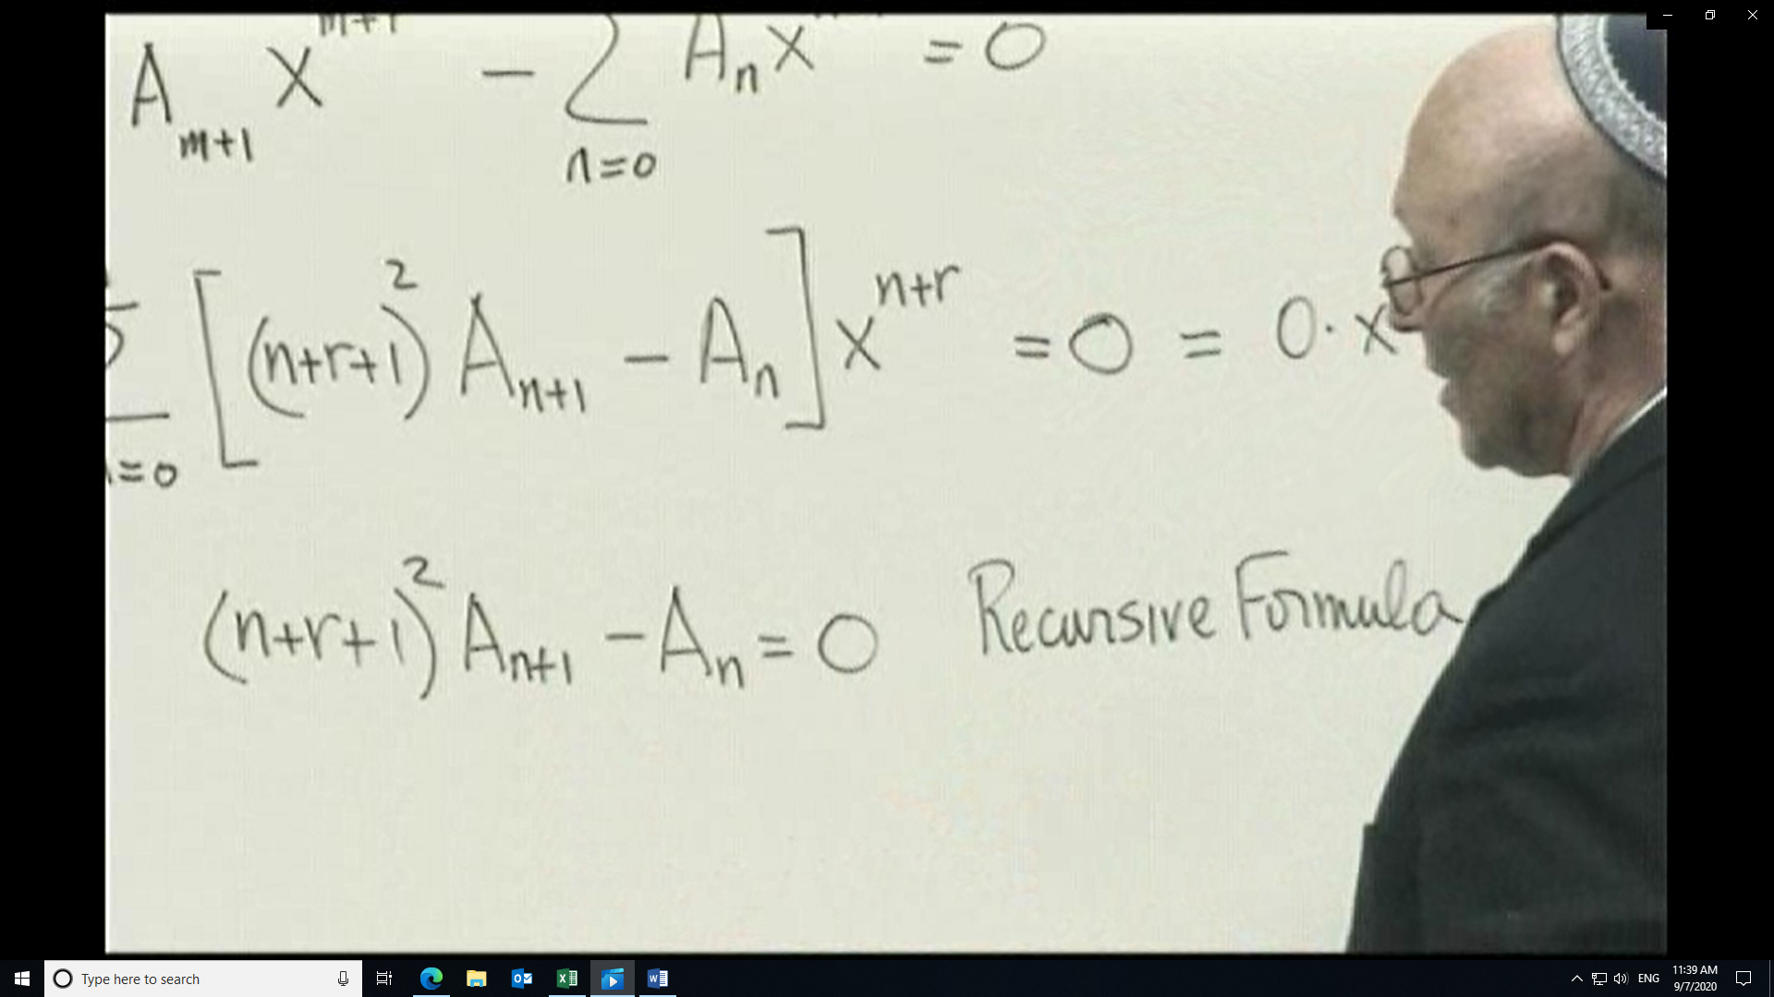
Rewrite terms for An+1 in terms of An and then use the formula to regress the result back to an expression involving Ao. Now write solution in terms of the general value r using the information from the recursion formula
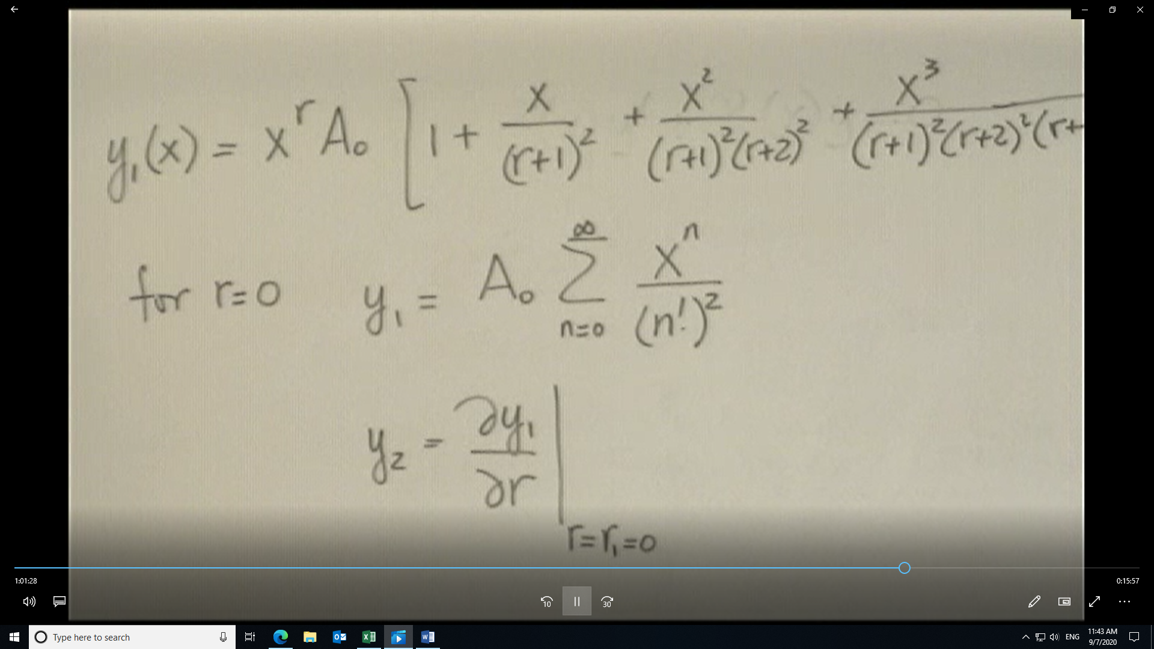
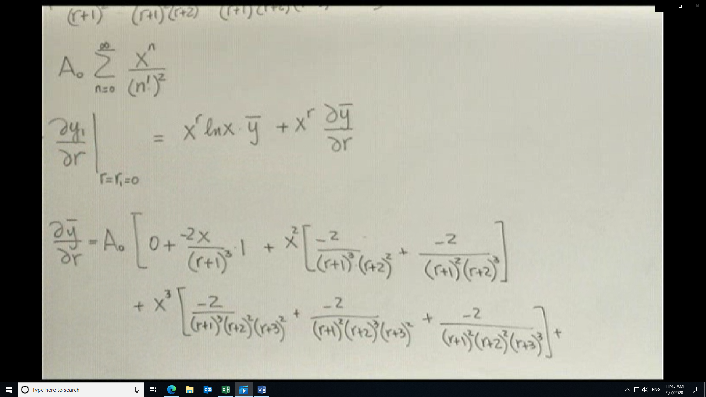
Having found the form, now let r=0, in this case, to find ∂y̅/∂r.
If xo is not zero then the form of y₂(x) would be (x-xo)^{r} ln (x-xo) y̅ + (x-xo)^{r} ∂y̅/∂r

