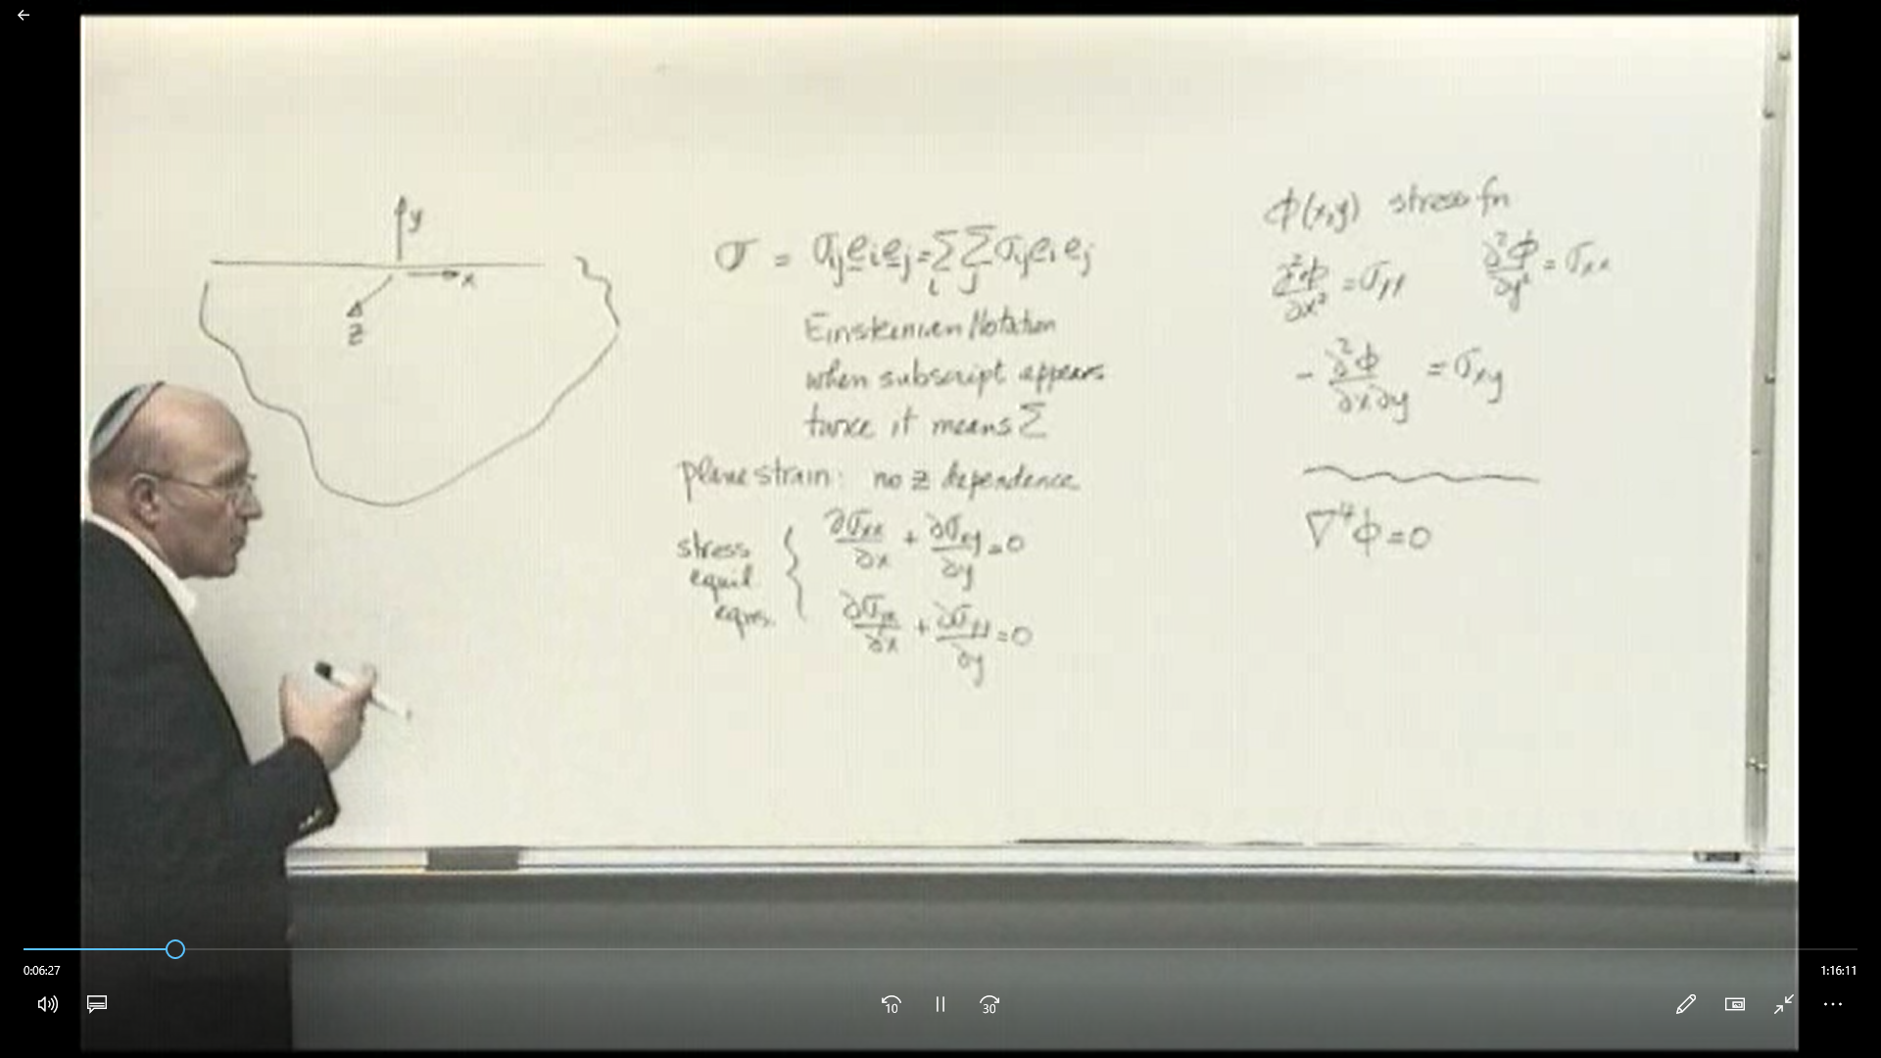
Look at problems with no z dependence
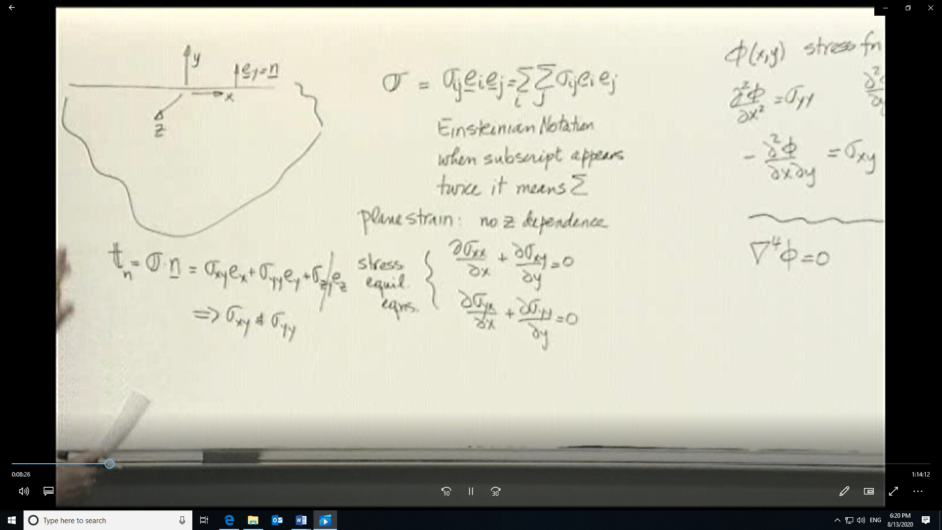
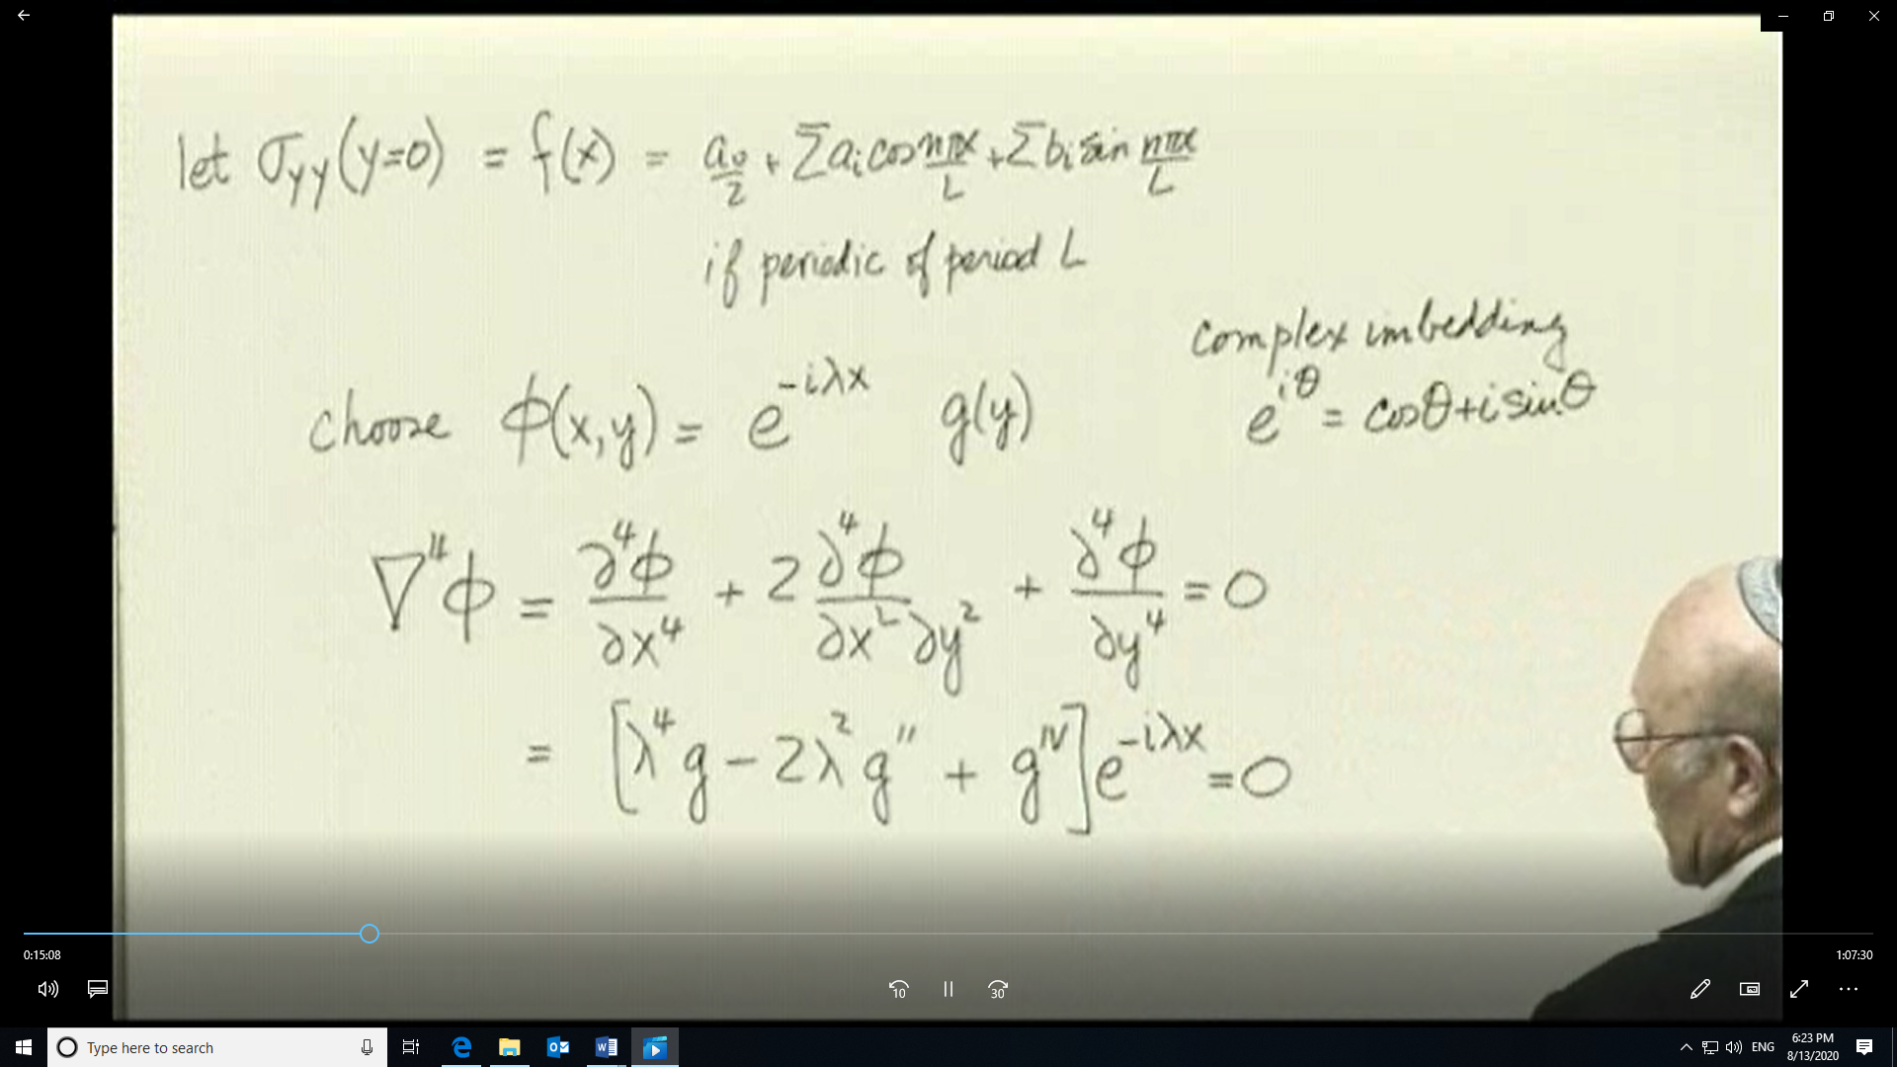

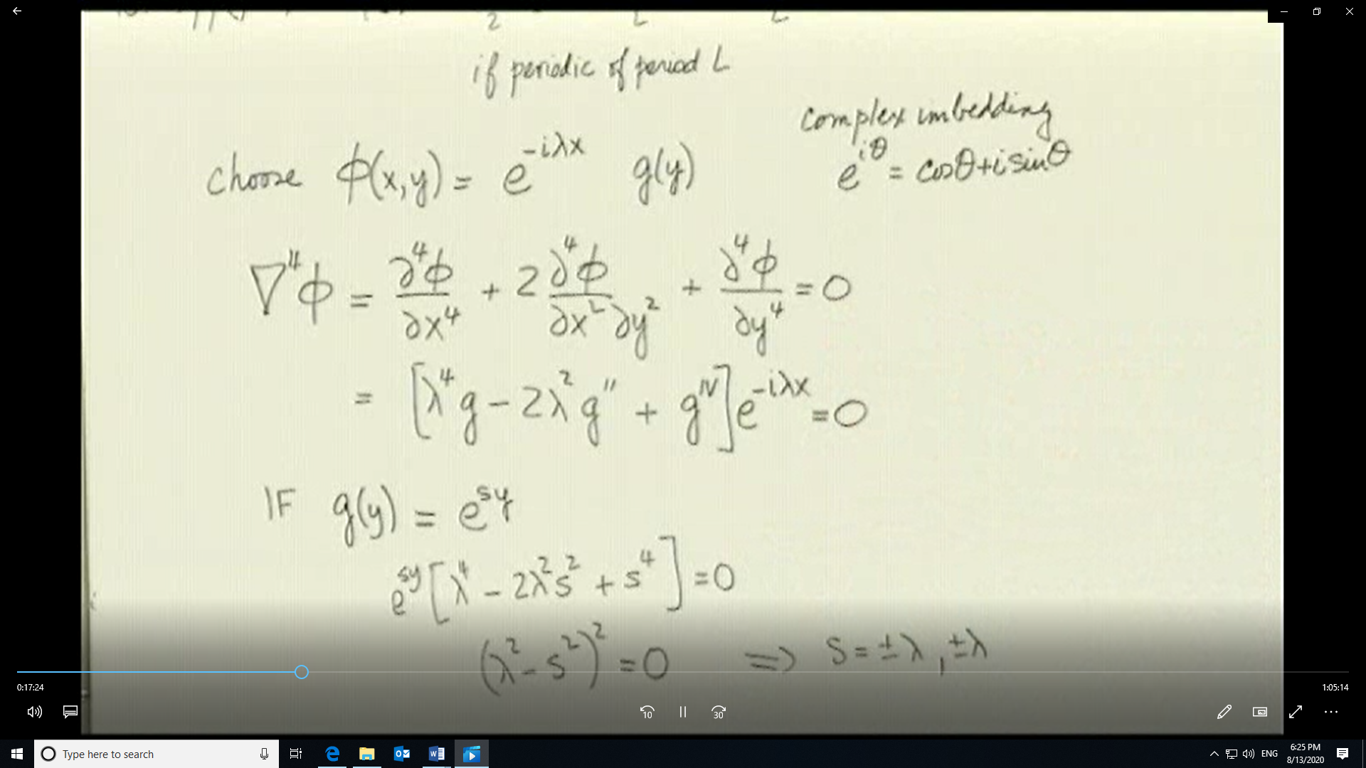

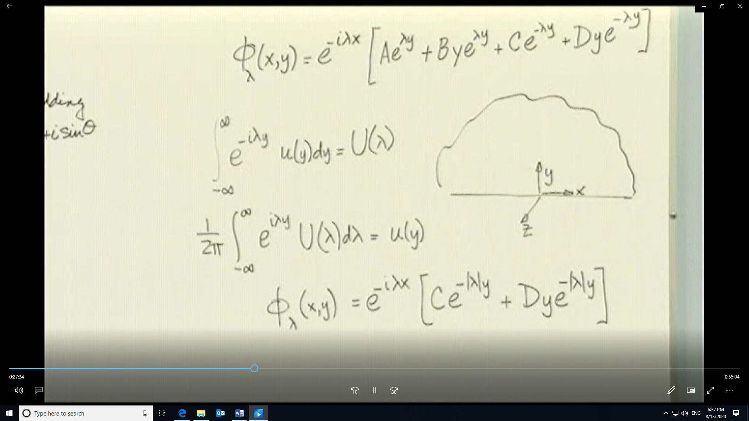

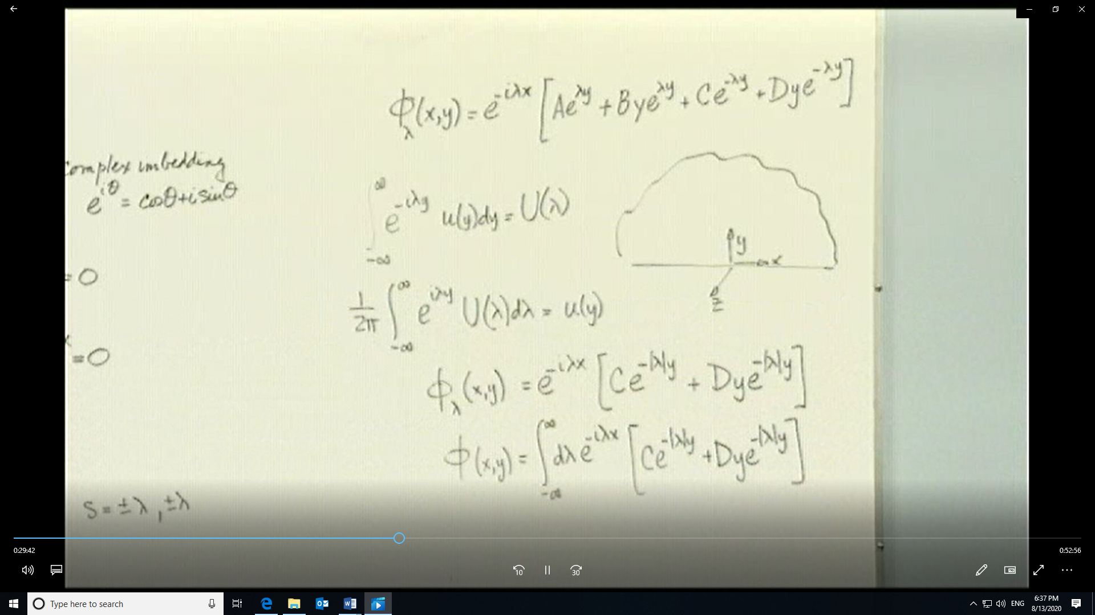

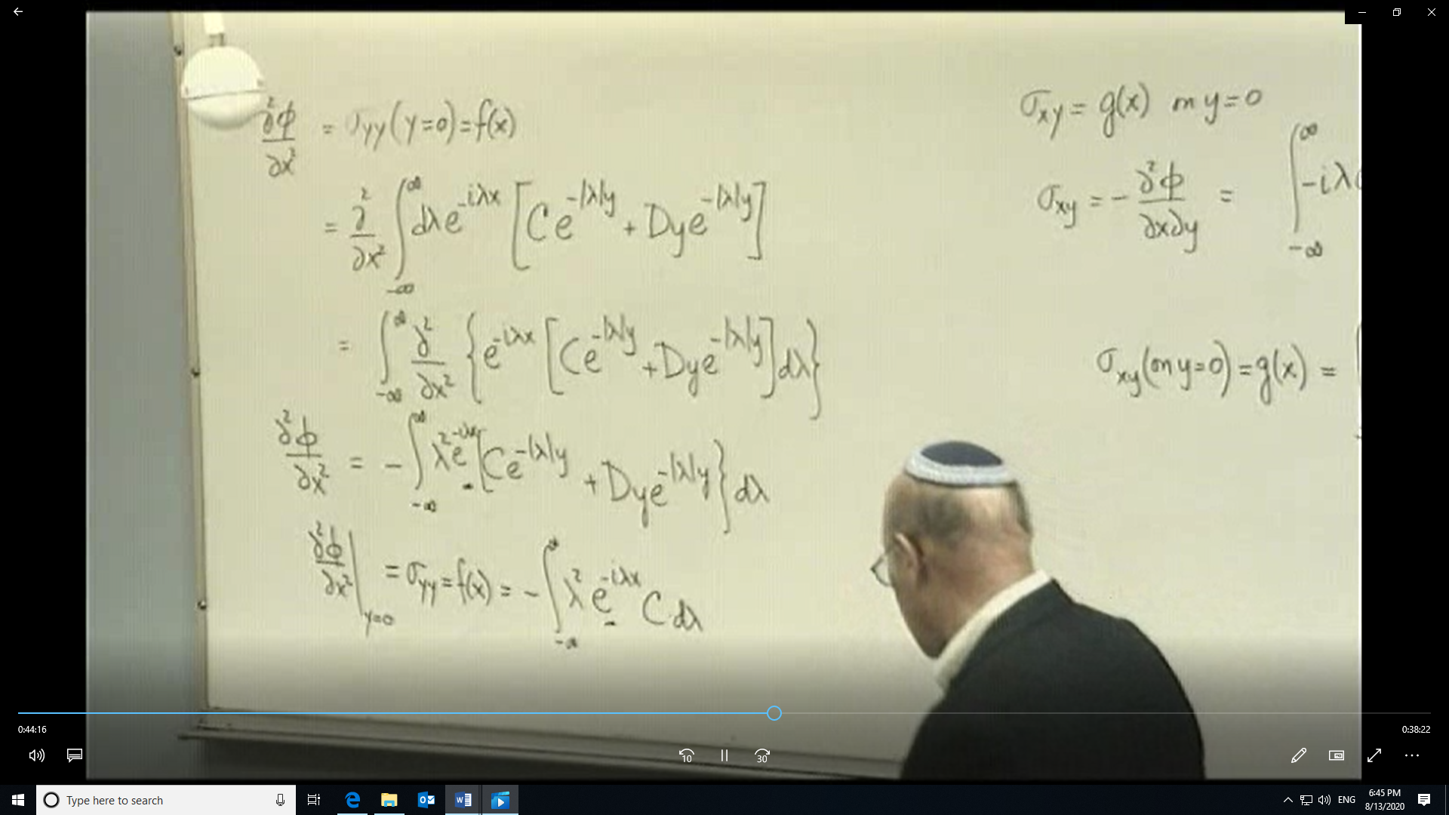

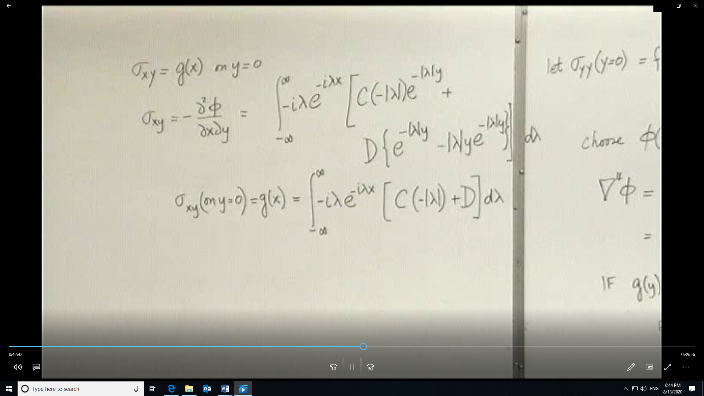
Transform of the delta function. First we speak of properties of delta function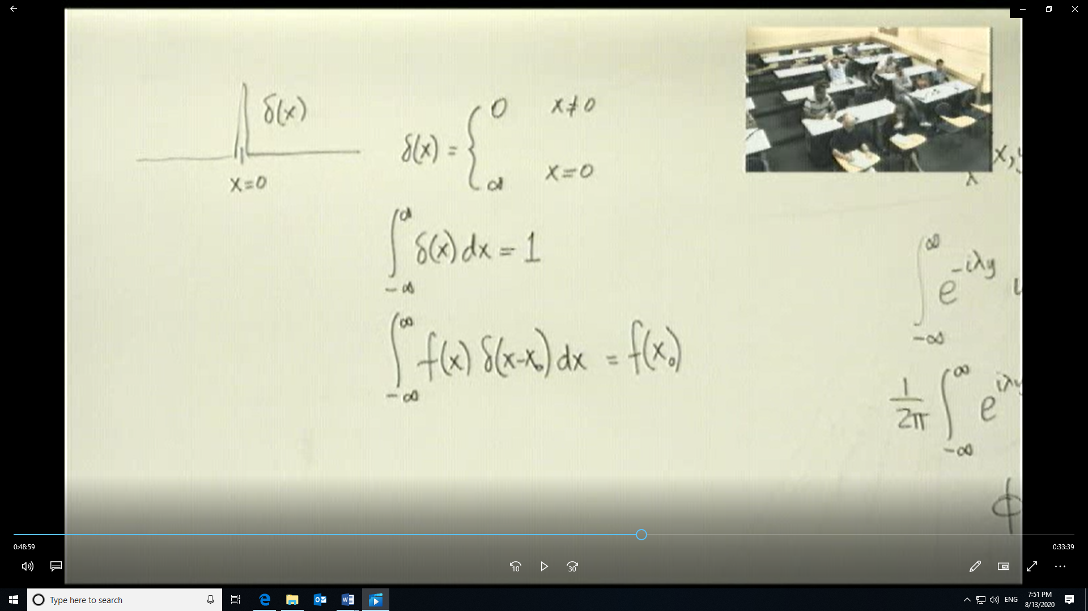
Normal to surface is in –y direction=-e_{y}. So stress tensor• n = -σ_{yy}=-f(x) = -δ(x)
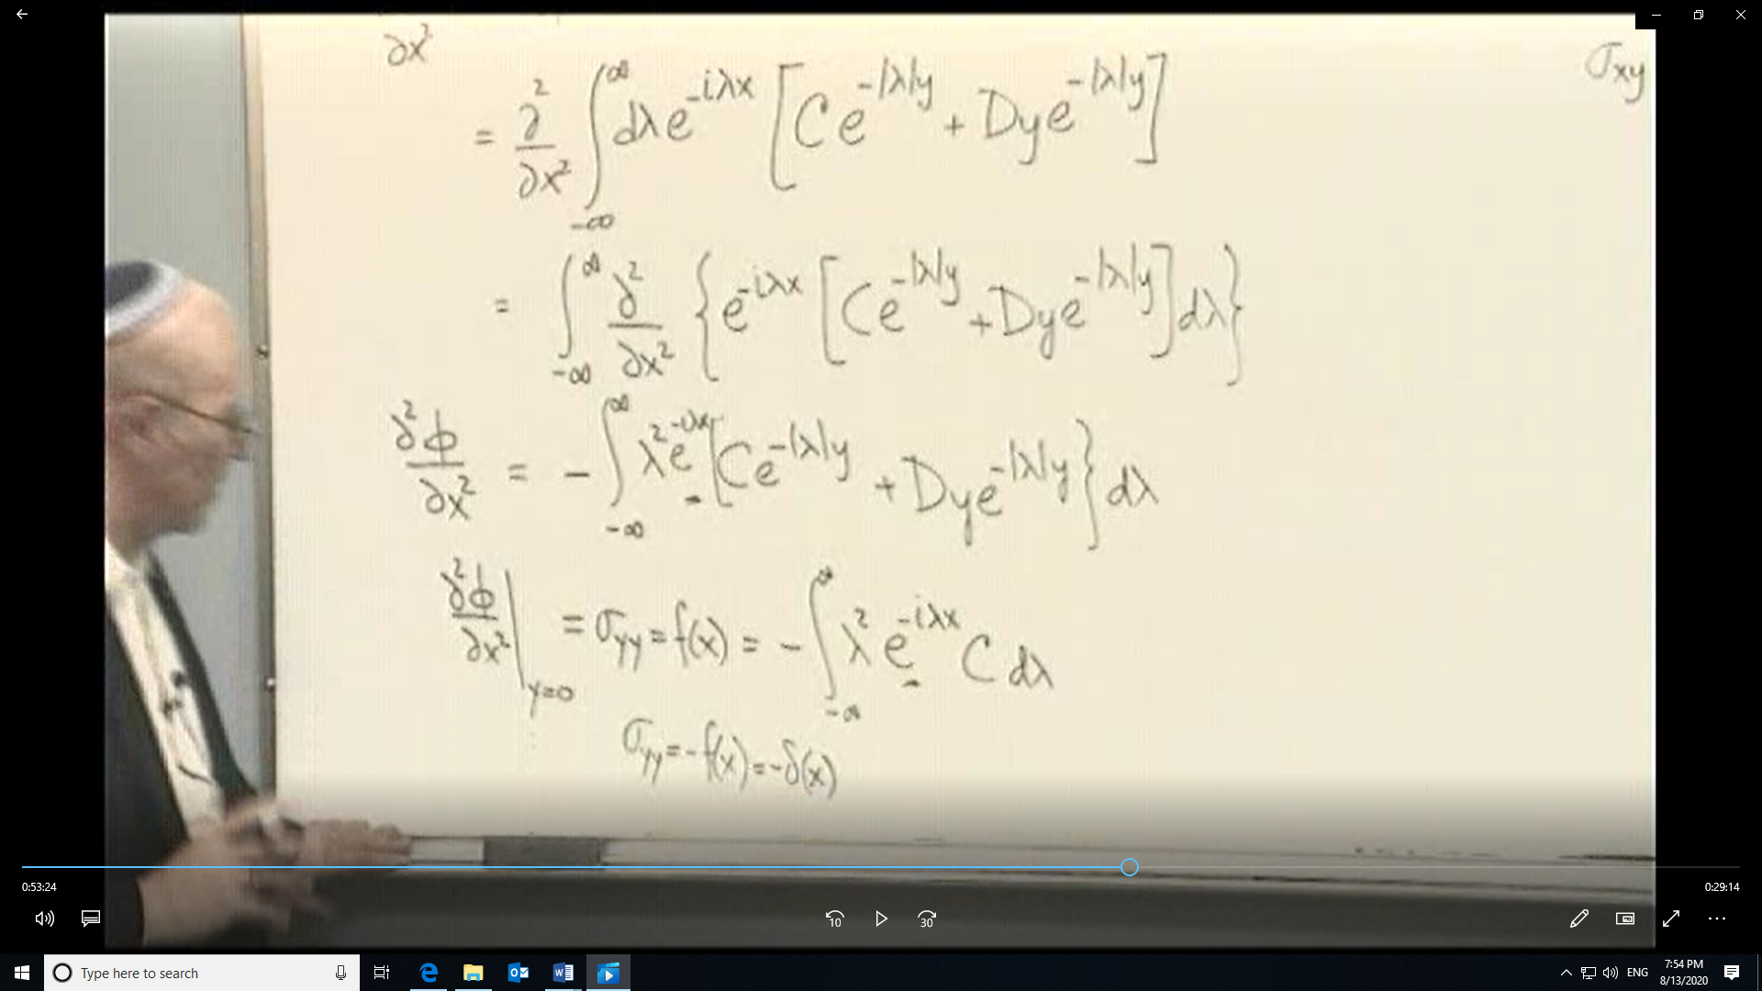
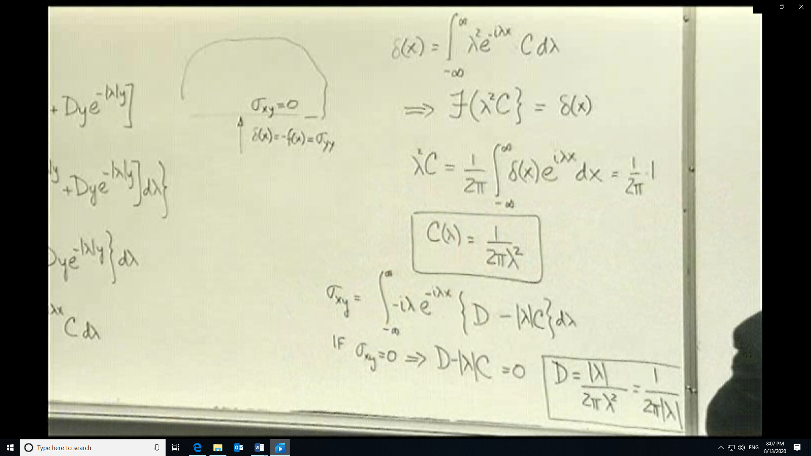
With the definitions of C and D which are functions of λ, we can get expressions for all the stresses. Also λ²/|λ|=|λ|
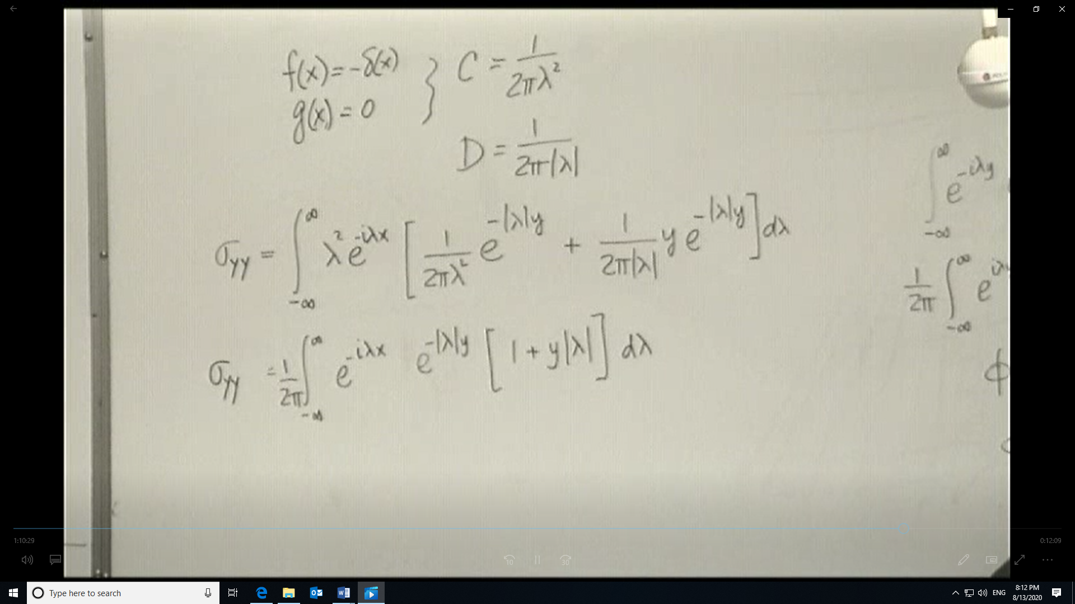
Since the integral of an even function produces an odd function. Evaluation of an odd function between +c and –c gives twice the value of the function between 0 and +c. The expression involving the cosine should have a “2” in the numerator.

Now look at the first of the cosine integrals and use the laplace transform definition of the cosine function.
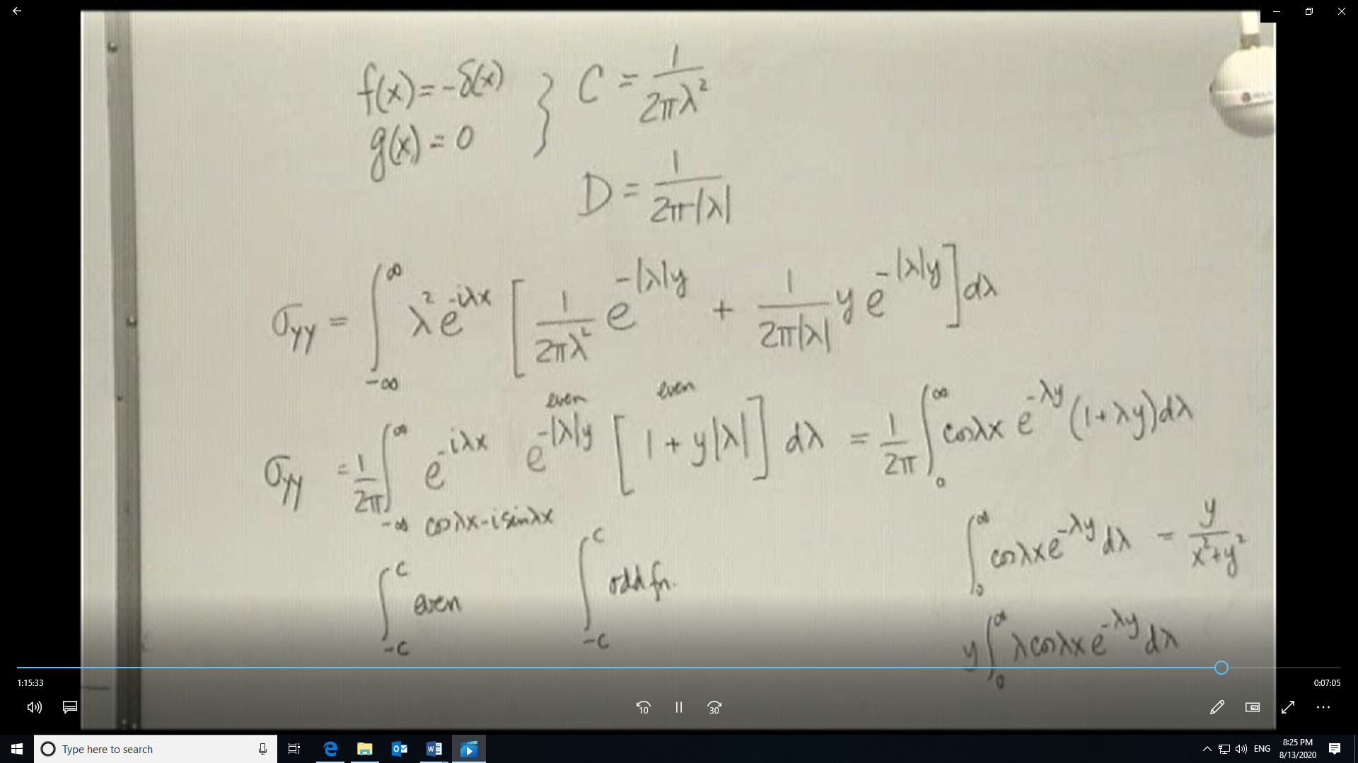
Now for the second cosine integral and realize that since we are integrating with respect to λ, y acts like a constant
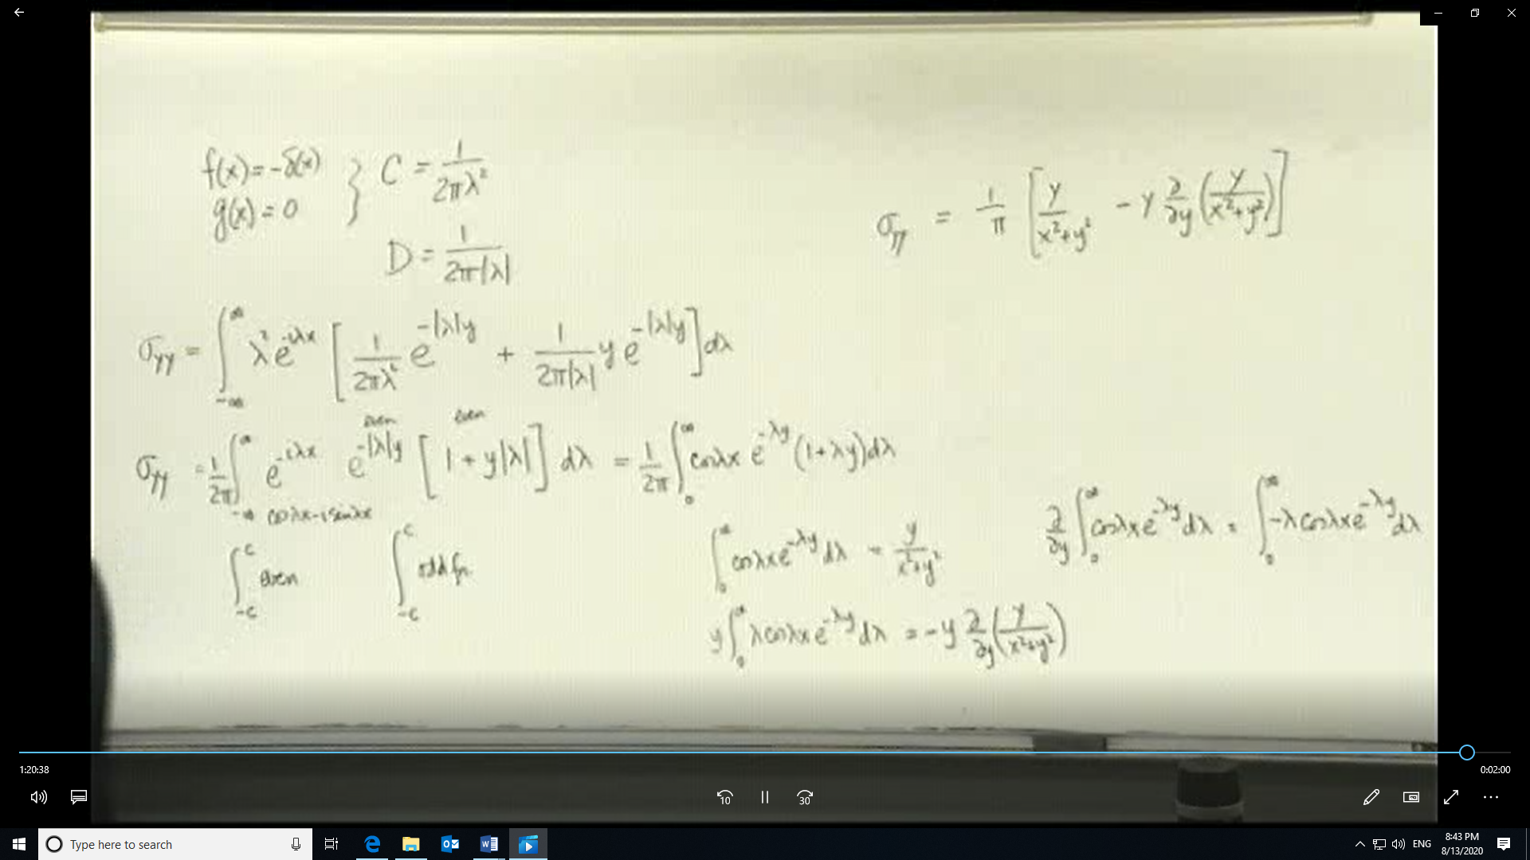
The y derivative of the first cosine integral will give you the methodology to get the second cosine integral. σ_{yy} as shown above is correct.
- As an exercise find the remaining two stresses σ_{xx} and σ_{xy} for this problem.
- and then try the case where on the boundary y=0 σ_{yy} = f(x) = 0 and the delta function δ(x) is pointing to the right as mentioned in the video.
Use the same ideas we developed in class with the traction t_{n} to determine σ_{xy} in terms of δ(x).
- Now determine the complete expression for σ_{xy} for this new problem in the same way as we did for σ_{yy} during the class.

