Preliminaries to using Fourier transform. Understanding definitions of stresses
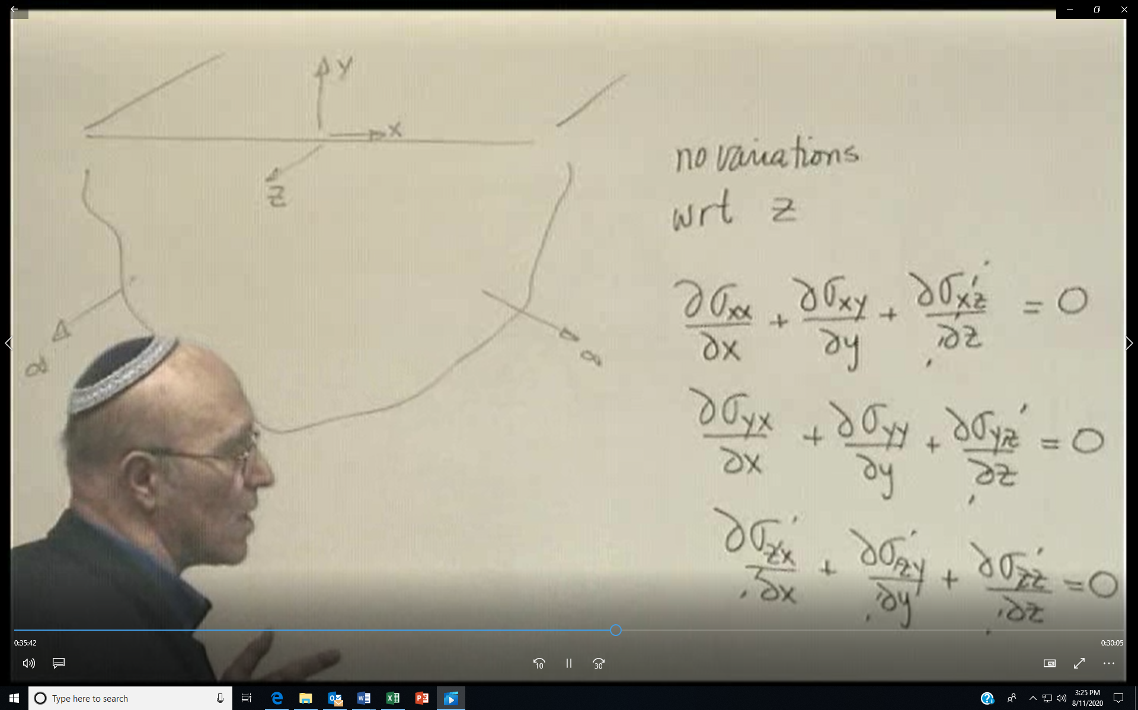
The equation that the stresses satisfy if we define a stress function is the biharmonic equation ∇⁴φ =0
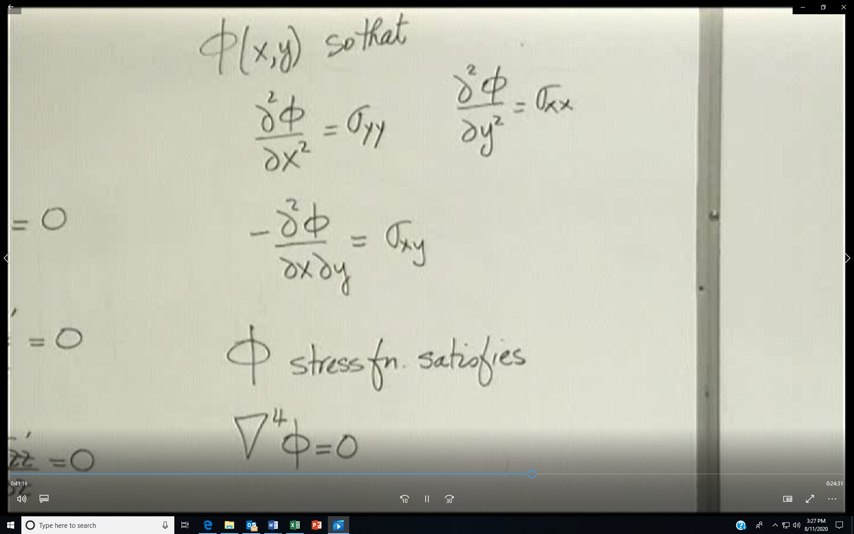

Stress tensor has two unit vectors: one for direction of force component/one perpendicular to surface
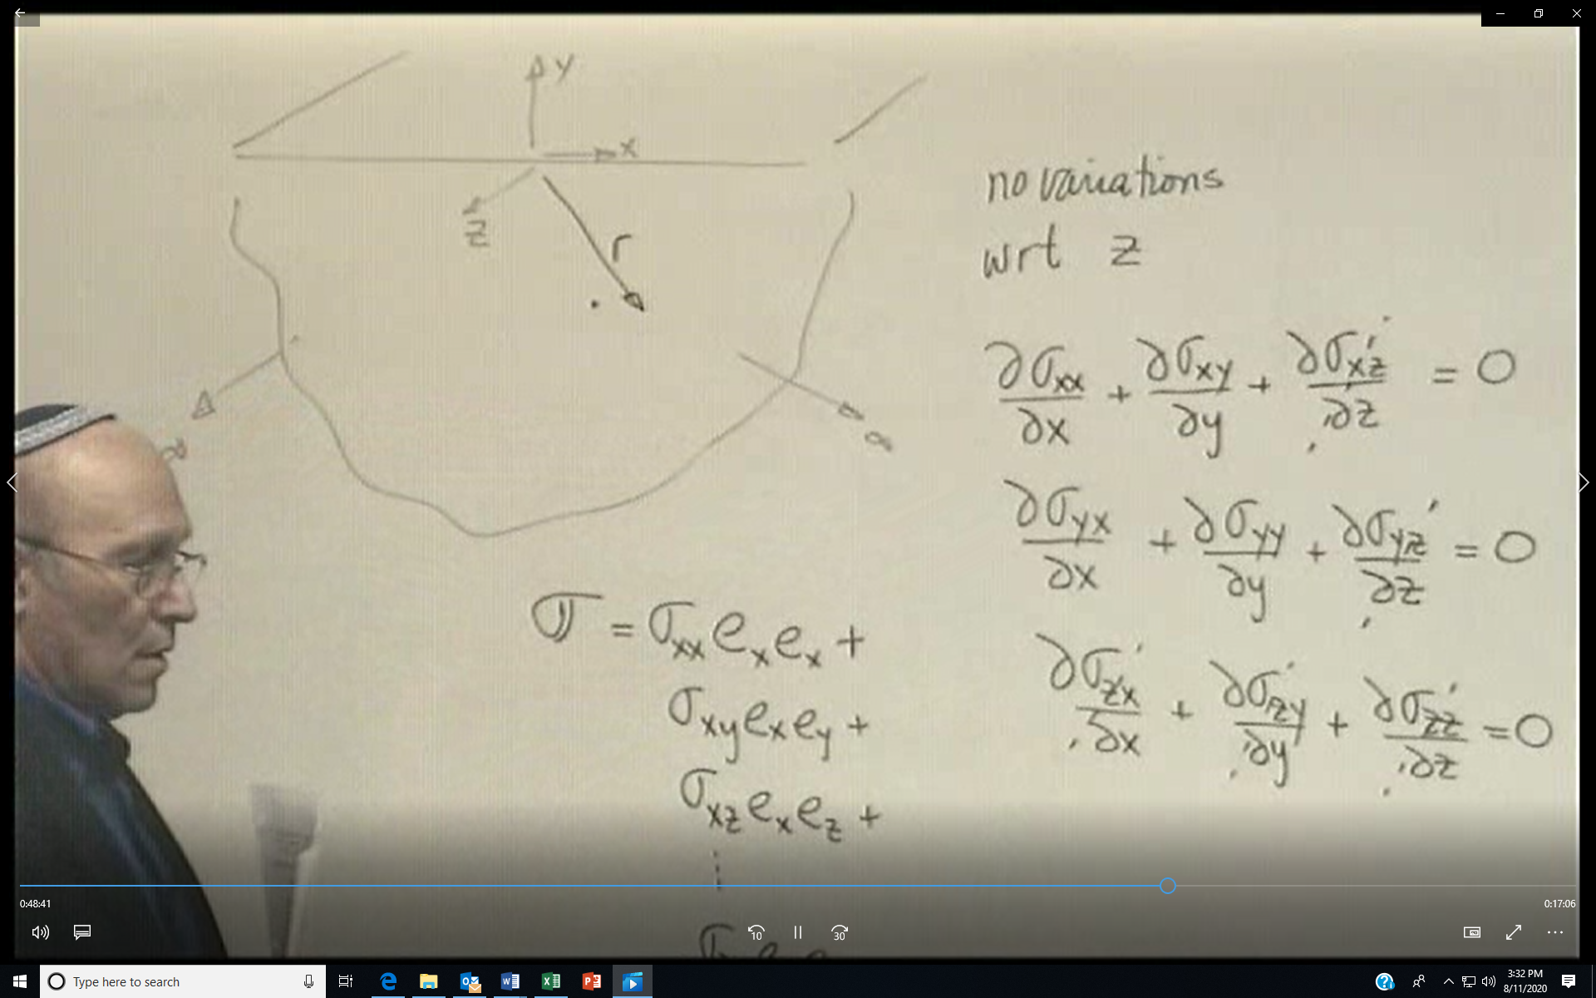
If we speak of a traction vector on a surface, t_{y}, take dot product of stress tensor with normal to that surface.
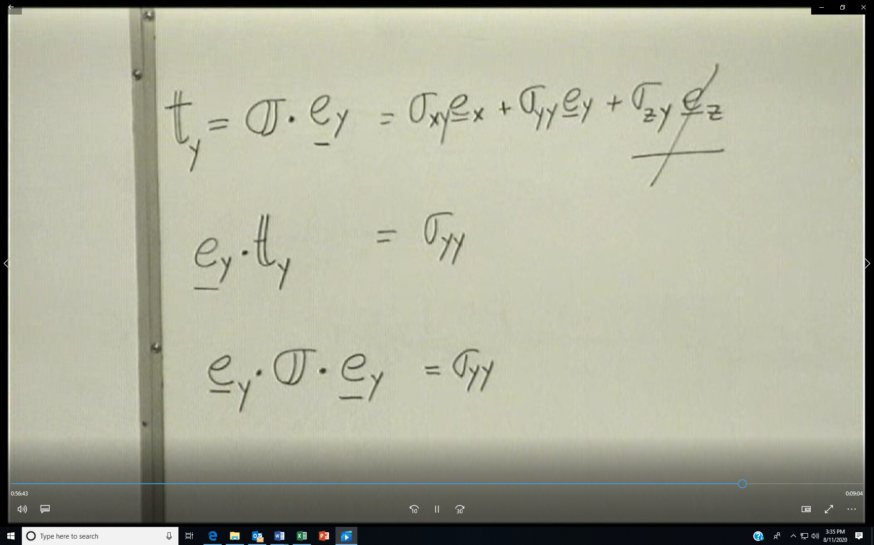
On a surface there are 3 stresses. For problems in plane stress, where no variations with z, σ_{yz} =0. To find a particular stress, e.g., σ_{yz} , take the dot product of the stress tensor with the unit vectors e_{y} and e_{z}
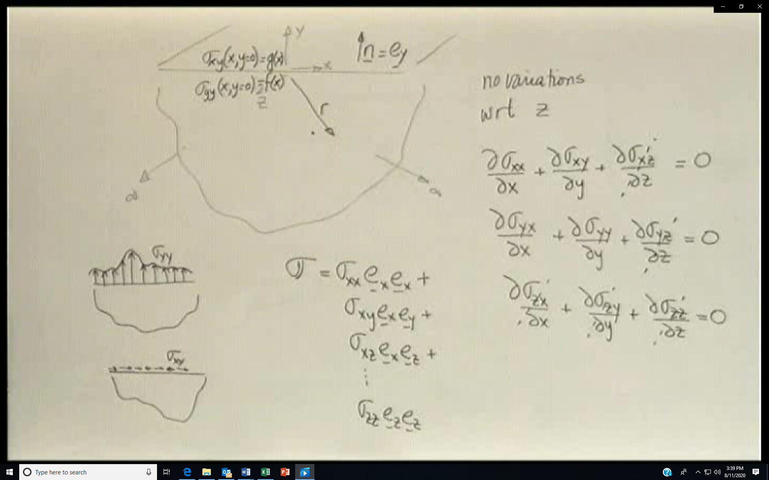
Einsteinian notation says that if two elements have the same subscript, it represents a summation
