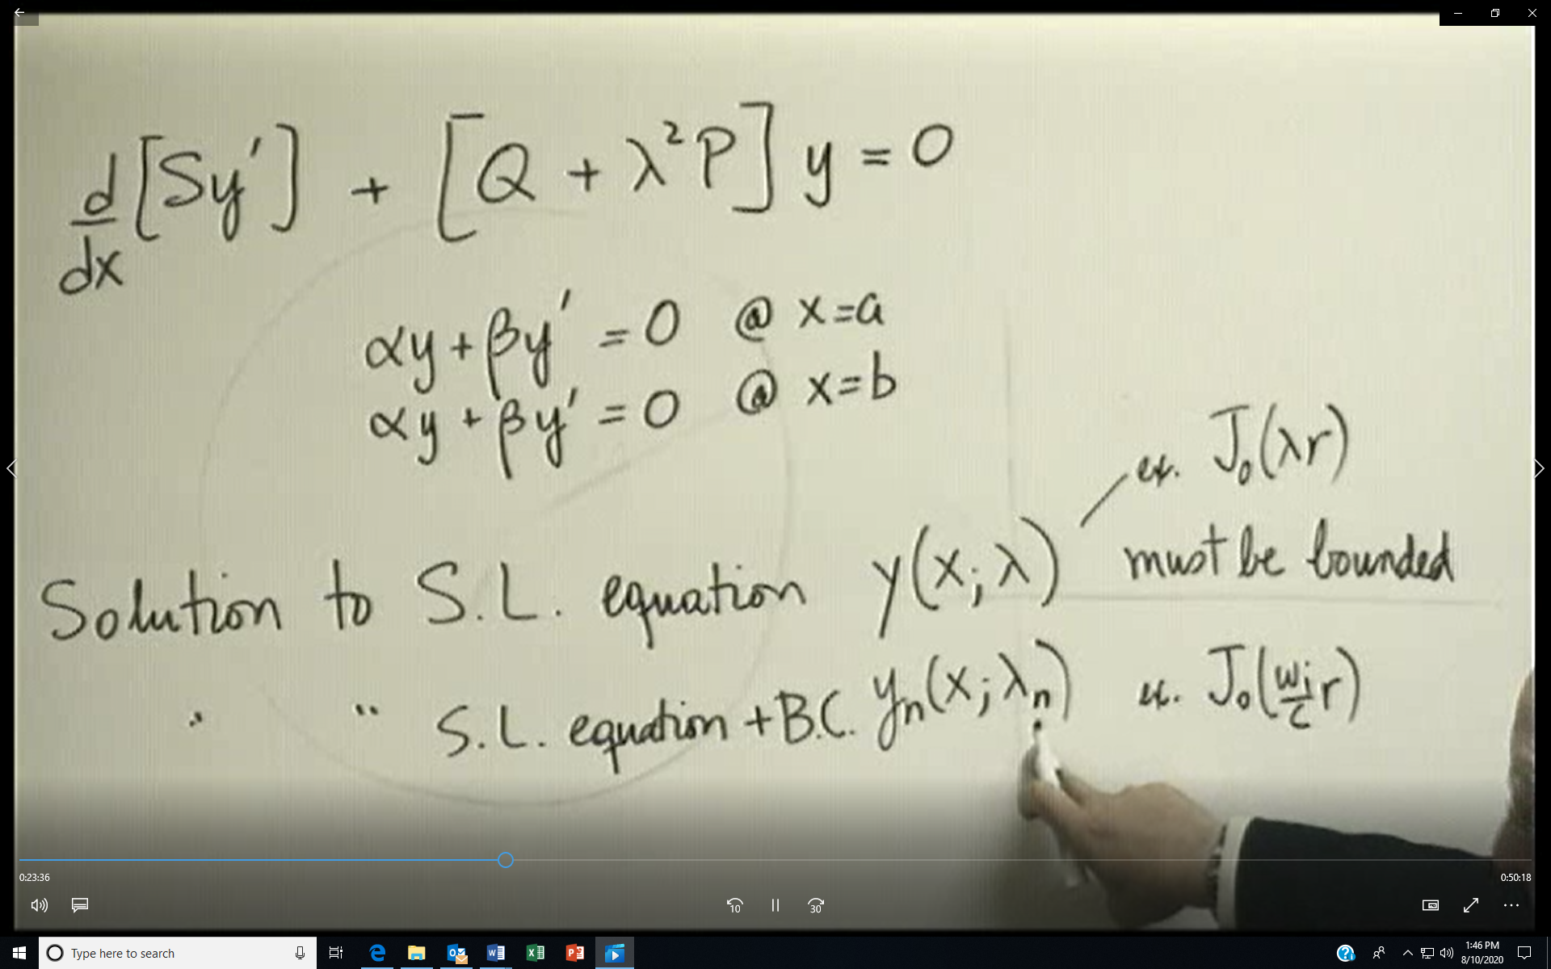
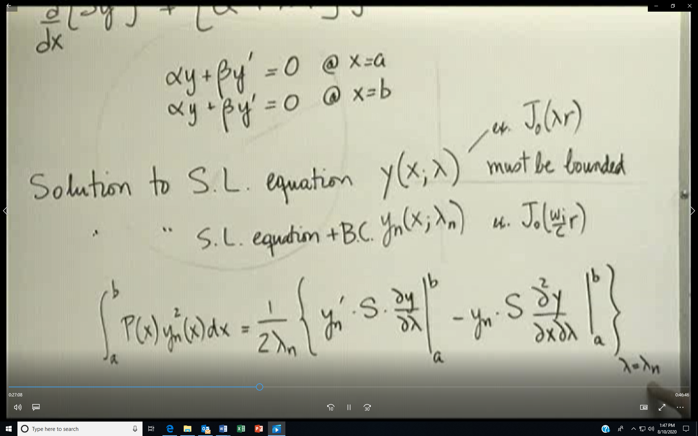
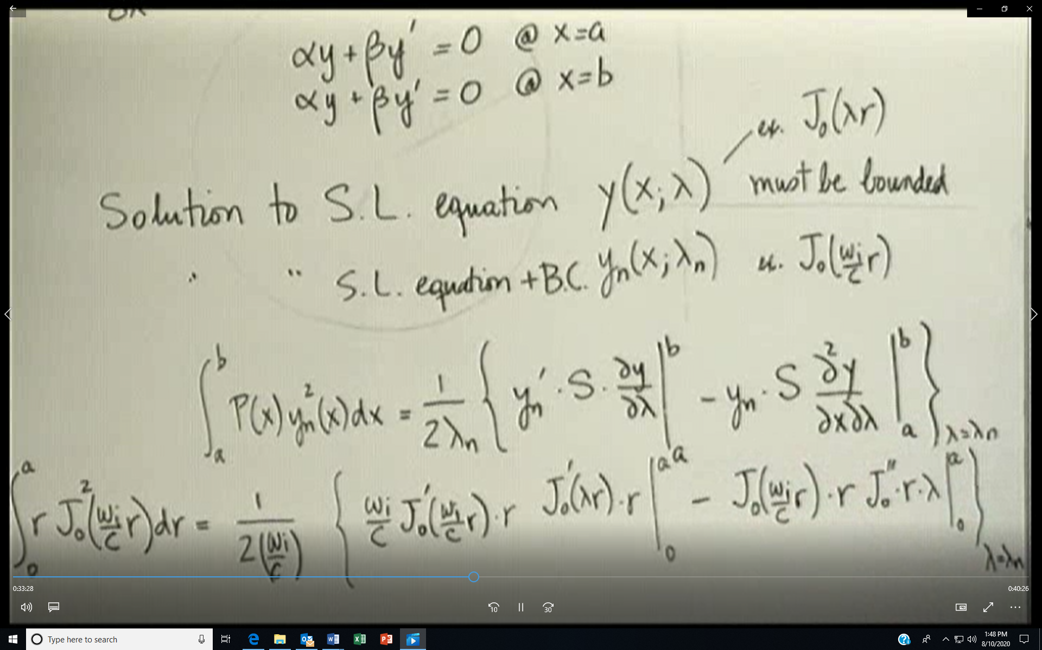
THERE IS A MISSING TERM IN THE PREVIOUS SLIDE. tHE LAST TERM SHOULD BE Jo(wir/c)*r*[Jo”(λr) *r*λ+Jo’(λr)*1]. When evaluated, that term gives zero. That term is in the next slide.
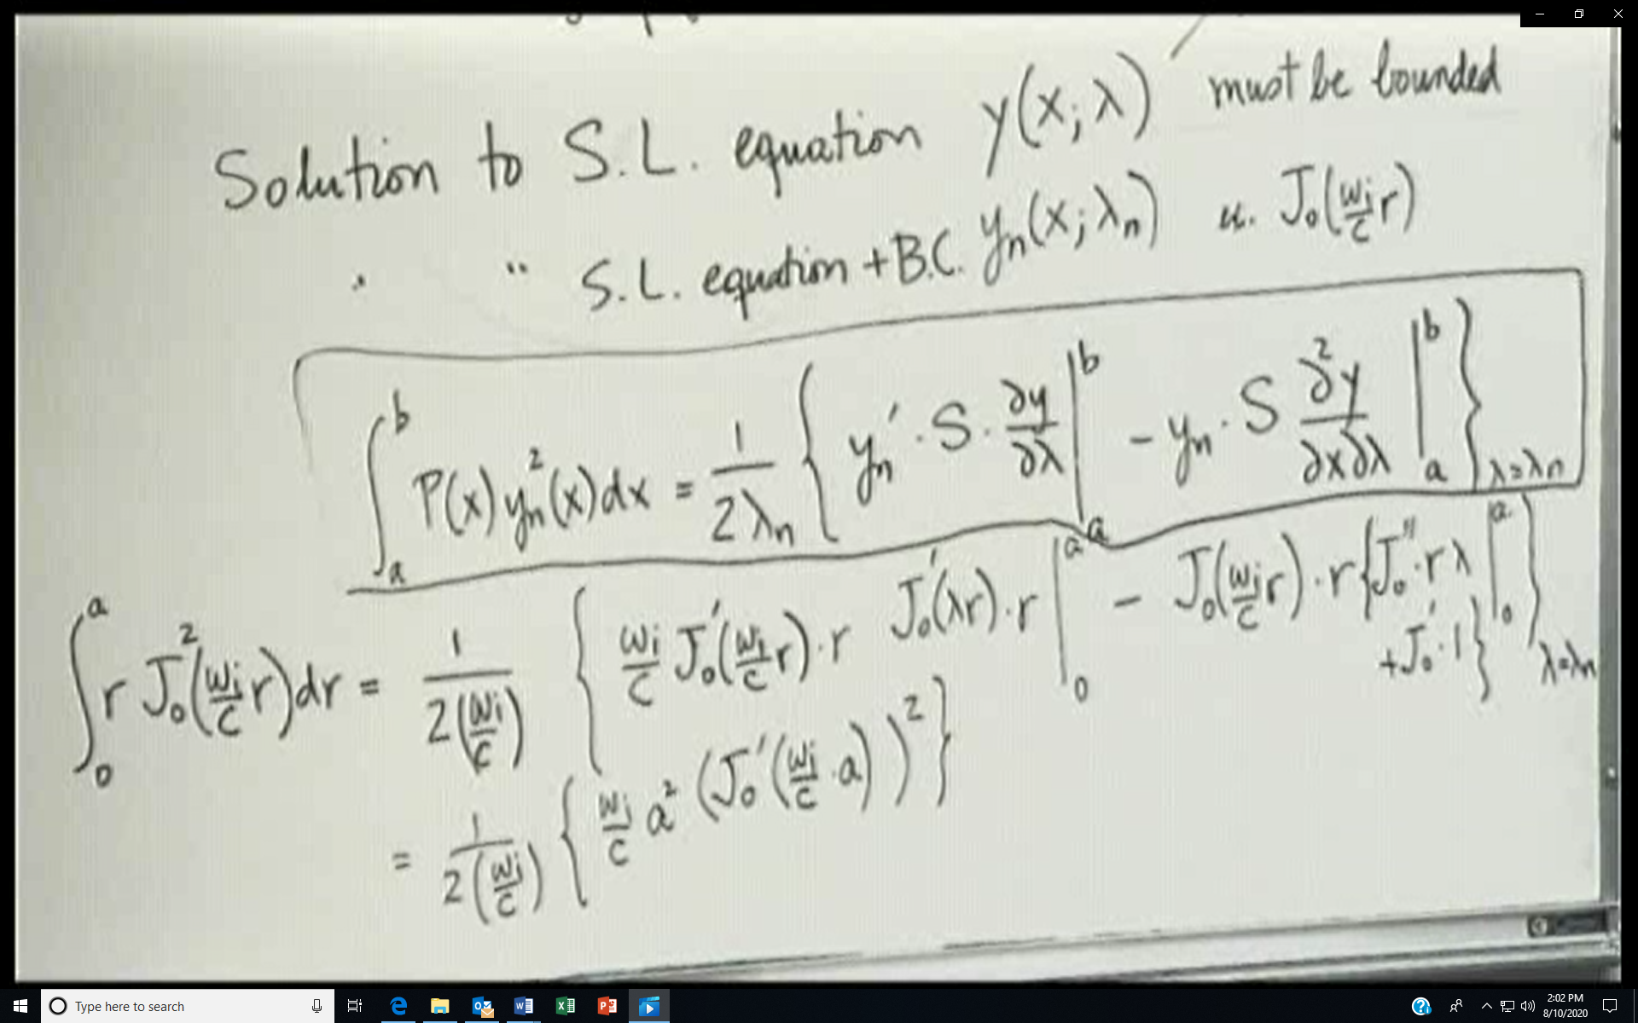
An inhomogeneous PDE with inhomogeneous BCs can be split into several problems in which only one of the BCs is non-zero
