College of Engineering and Computing
Department of Civil and Environmental Engineering
CGN 2420 - Computer Tools for Engineers

HOMEWORK 1:
1.- a) The values shown in the following table relate the height of material in a cylindrical tank and the corresponding mass of solids. Find the best curve(s) to fit this data (linear and/or polynomial). Then use these functions to predict the height of solids in the tank given the mass of solids. Calculate the height of material for mass = 3200 Kg, and mass = 20000 Kg.
h (ft) | m(lb)
0 | 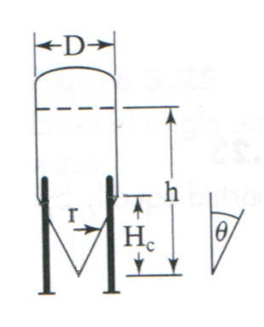  0
2 | 56
4 | 447
6 | 1508
8 | 3574
10 | 6981
12 | 11470
14 | 16000
16 | 20520
18 | 25040
20 | 29570
22 | 34090
24 | 38620

b) Dimensions of this tank are θ = 30º, D = 12 ft, and density of solids in the tank is 20 lb/ft³. Perform the calculations in Excel to obtain the mass values given in the table.

2.- The data given in file HW_Rainfall_Data.xls shows the amount of precipitation, measured in inches, per month and per year from 1914 to 1997.
a.- Determine mean value of total rainfall per month and the corresponding standard deviation for these 84 years.
b.- Plot the previous results (Mean rainfall vs. months of the year) in a column graph and predict during which month of the year we can expect the largest precipitation.
c.- Create a histogram to show the frequency distribution of total amount of rainfall/year. Use intervals (bins) of 2 inches, starting with 39.5 and finishing with 83.5 inches.
d.- Plot the cumulative frequency corresponding with this histogram, and determine the probability of having a total rainfall per year between 60 and 70 inches.

3.- The nodal displacements of a crane can be found by solving the equilibrium equations:
170.4105 | 37.9473 | --113.8420 | -37.9473 |  | u1 |  | P1
37.9473 | 69.2176 | -37.9473 | -12.6491 |  | u2 | = | P2
-113.8420 | -37.9473 | 120.9131 | 45.0184 |  | u3 |  | P3
-37.9473 | -12.6491 | 45.0184 | 19.7202 |  | u4 |  | P4

where the u_{i} ’s are the nodal displacements (inch) and P_{i} the load applied (lb) along the direction of u_{i} . Find the nodal displacements for P₁ = P₂ = 0, P₃ = 100 and P₄ =50.
Use matrices to find your answer.

Due date: Tuesday July 19, 2011

Please submit your Homework on time to the following gmail account:
egn1100.section1@gmail.com
Use only ONE Excel file, with each problem in a different spreadsheet. Save the file with your NAME and LASTNAME.
Homework that has not been submitted in this way will not be graded.

