Why Drugs Cost So Much
By PETER B. BACHJAN. 2015
Inside
Supported by
Photo
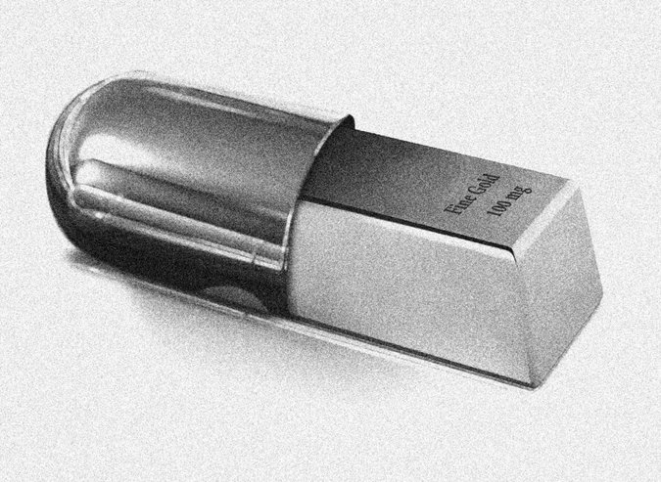
Credit Mark Pernice

ELI LILLY charges more than $13,000 a month for Cyramza, the newest drug to treat stomach cancer. The latest medicine for lung cancer, Novartis’s Zykadia, costs almost $14,000 a month. Amgen’s Blincyto, for leukemia, will cost $64,000 a month.
Why? Drug manufacturers blame high prices on the complexity of biology, government regulations and shareholder expectations for high profit margins. In other words, they say, they are hamstrung. But there’s a simpler explanation.
Companies are taking advantage of a mix of laws that force insurers to include essentially all expensive drugs in their policies, and a philosophy that demands that every new health care product be available to everyone, no matter how little it helps or how much it costs. Anything else and we’re talking death panels.
Examples of companies exploiting these fault lines abound. An article in The New England Journal of Medicine last fall focused on how companies buy up the rights to old, inexpensive generic drugs, lock out competitors and raise prices. For instance, albendazole, a drug for certain kinds of parasitic infection, was approved back in 1996. As recently as 2010, its average wholesale cost was $5.92 per day. By 2013, it had risen to $119.58.
Novartis, the company that makes the leukemia drug Gleevec, keeps raising the drug’s price, even though the drug has already delivered billions in profit to the company. In 2001 Novartis charged $4,540, in 2014 dollars, for a month of treatment; now it charges $8,488. In its pricing, Novartis is just keeping up with other companies as they charge more and more for their drugs. They know we can’t say no.
But what if we didn’t require insurance companies to cover all drugs? We can see the answer in Europe. Many European countries say no to a handful of drugs each year, usually those that are both pretty ineffective and highly costly. Because they can say no, yes is not a guarantee. So companies have to offer their drugs at prices that make them attractive to these health care systems. A recent survey of cancer drug policies revealed you don’t have to say no very often to get discounts for saying yes. Of the 29 major cancer drugs included in the study that are available in the United States, an estimated 97 percent and 86 percent are also available in Germany and France, respectively.
As a consequence of the stand taken by those countries, prices in Europe for prescription drugs are 50 percent below what we pay, according to a McKinsey study from 2008. Gleevec costs $4,500 per month in Germany today, and $3,300 per month in France, less than what Americans paid in 2001.
Saying no, or even the threat, works to lower prices in the United States, too. But it’s rare. In 2012, my hospital said we wouldn’t give the colon cancer drug Zaltrap to our patients because it cost twice as much as another drug (Genentech’s Avastin) that was just as good. When we refused to use it, the company realized that other cancer hospitals and doctors might follow, and halved its price nationwide.
More recently, Express Scripts, a company that manages pharmacy benefits, showed that approval was no guarantee. It was therefore able to play two makers of treatments for hepatitis C off against each other. Express Scripts said yes to AbbVie’s Viekira Pak (for the most common subtype, genotype 1 disease), and said no to Gilead’s Sovaldi and Harvoni. Another pharmacy benefit program, CVS Caremark, played it the other way, closing out AbbVie and choosing Gilead.
Either way, the lesson is that Express Scripts, once it showed it could say no, got AbbVie to discount its product. It isn’t saying how much, but Steve Miller, a senior executive, said it had “significantly narrowed the gap between prices charged in the United States and Western Europe.” Sounds like the kind of progress we need
You might worry about patients being harmed through these moves. But we rejected Zaltrap knowing it was no better than the alternative. Express Scripts and CVS Caremark played the two drug manufacturers off against each other because both manufacture effective treatments.
The industry might argue that drug spending is only 10 percent of all health care spending, but that 10 percent equals around $300 billion per year. More important, the costs of high-priced drugs are being passed on to patients. Lilly’s drug Cyramza will cost the average Medicare patient $2,600 per month without supplemental insurance. That’s more than most Medicare-age people earn each month, before taxes. Actually, high prices get passed on to us all, either through individual costs or insurance.
That leaves us with two options. We can free insurers and government programs from the requirement to include all expensive drugs in their plans as we explain to the public that some drugs are not effective enough to justify their price. If we do this, we can be confident that manufacturers will lower their prices to ensure their ability to sell their products. Or we can piggyback on the gumption of bolder countries, and demand that policy makers set drug prices in the United States equal to those of Western Europe. Either approach would be vastly superior to the situation we have today.
Peter B. Bach is a physician and director of the Center for Health Policy and Outcomes at Memorial Sloan Kettering Cancer Center.

