How your body beats the heat: Why do those first hot days of the year feel so bad? Because our bodies' best methods of coping with heat haven’t been tested in three seasons. But if you’re slogging though your work or workout now, you are already starting the process of acclimatization, which will make you better able to withstand heat all summer. These changes can happen in as little as two weeks, according to Lawrence Armstrong, a bioenergetics expert who has studied heat’s effect on the body since 1982.

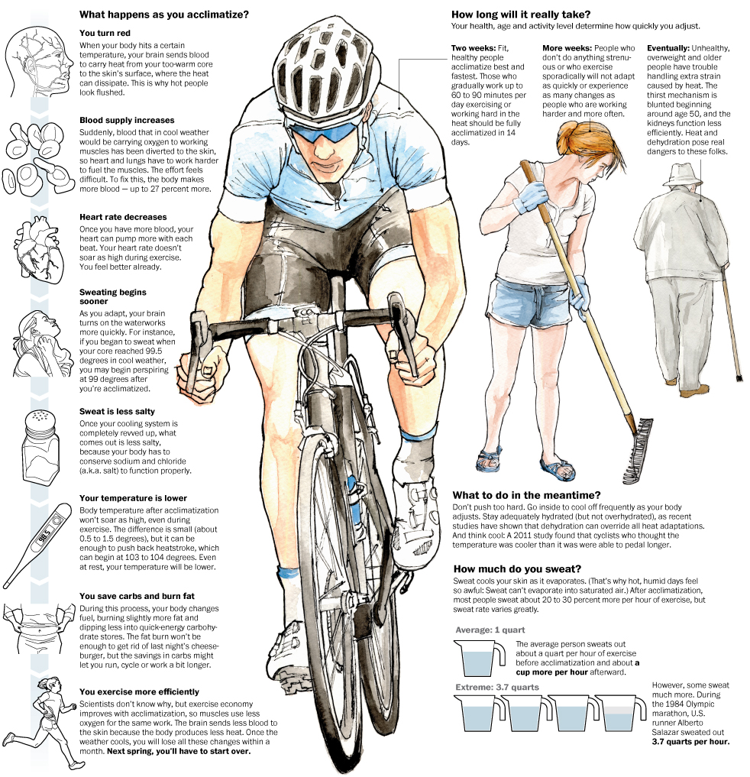

Lawrence Armstrong of the Human Performance Laboratory at the University of Connecticut; Paul Castle of the Department of Sport and Exercise Science at the University of Bedfordshire in the United Kingdom; National Institutes of Health; Journal of Applied Physiology. Bonnie Berkowitz and Alberto Cuadra / The Washington Post. Published on May 25, 2012, 3:02 p.m.

