Could CONDOMS boost vaginal health? Study finds they increase levels of friendly bacteria and prevent minor infections
- Lactobacillus are bacteria that dominate the natural flora of the vagina
- They prevent itchiness and even infection, including of the HIV virus
- It is thought condoms boost levels because they prevent alkaline sperm disrupting a vagina's acidic 'ecosystem' where bacteria thrive
By Rachel Reilly
PUBLISHED: 06:23 EST, 30 July 2013 | UPDATED: 06:26 EST, 30 July 2013
It’s not just the gut that benefits from friendly bacteria, a person’s more intimate regions do too - and condoms have been found to boost levels in women’s vaginas.
A study has revealed that sexually active women who used condoms have greater quantities of beneficial bacteria called Lactobacillus compared to other forms of contraception.
Possessing healthy levels of the bacteria in that part of the body is associated with a lower incidence of itchiness and even a lower chance of being infected with HIV.
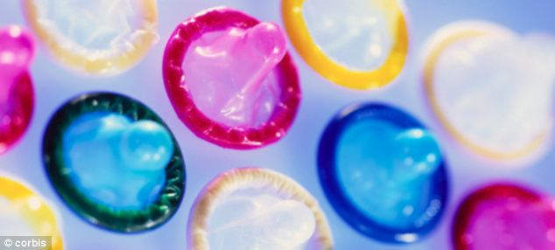
A study has revealed that sexually active women who used condoms have greater quantities of beneficial bacteria called lactobacillus compared to other forms of contraception. Possessing healthy levels is associated with a lower incidence of itchiness and even a smaller chance of being infected with HIV
Researchers at Beijing Friendship Hospital studied 164 healthy, married women in China, aged between 18 and 45 who were not using a hormonal form of birth control, according to a report by LiveScience.
Among the participants, 72 were using condoms, 57 were using an intrauterine device (IUD), and 35 were using the 'rhythm method', in which a couple abstains from sex on the days pregnancy is mostly likely.
The scientists focused on lactobacillus, a group of bacteria that dominates the natural flora of the vagina for many women.

The microbes, which produce lactic acid and hydrogen peroxide, help the vagina maintain an average pH of 4.5, similarto the acidity of beer or tomato juice.
This 'acidic buffer system', as the researchers called it, is thought to block harmful bacteria from taking up residence and causing infections.
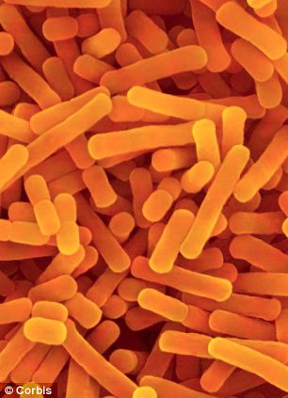
Lactobacillus (pictured) produce lactic acid and hydrogen peroxide, help the vagina maintain an average pH of 4.5, comparable to the acidity of beer or tomato juice
Though there may not be a 'normal' microbiome for a healthy vagina, the presence of lactobacillus is thought to help prevent bacterial vaginosis, which is an imbalance of vaginal bacteria that causes itching, unusual discharge and unpleasant smell.
Beneficial bacteria have even been linked to a decreased risk of HIV infection.
The researchers found that the population of lactobacillus was significantly higher in the condom group.
Sexual activity can disrupt the balance of the vagina's ecosystem, especially when semen (which has a pH of 7.0 to 8.0) enters the mix, the researchers said.
The results suggest that condoms can help the vagina maintain its natural acidic defenses, the researchers said.
However, the researchers warned that condoms might not be the best way to prevent unwanted pregnancy for everyone.
Condoms have a failure rate of 15 per cent with 'average use', which takes into account human errors in using them.
In contrast, IUDs have a failure rate of 0.6 percent to 0.8 percent in the first year, and can be effective for more than a decade after insertion, the researchers said.
The new study was published in the journal PLOS One.

