July 15, 2013, 12:01 am 93 Comments

Kidney Disease, an Underestimated Killer
By JANE E. BRODY
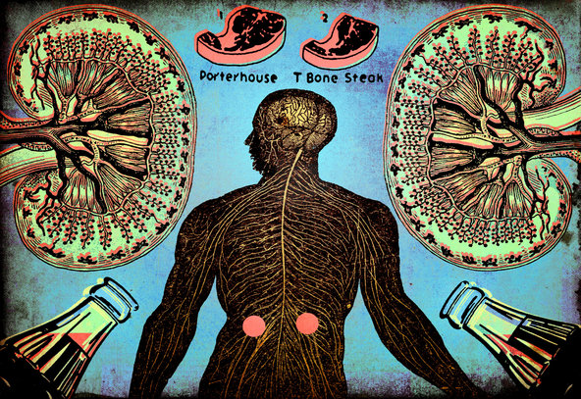
Kidney disease doesn’t get the attention, funding or concern associated with cancers of the breast or prostate. But it actually kills more Americans — 90,000 a year — than both malignancies combined.
Even when it is not fatal, the cost of treating end-stage kidney disease through dialysis or a kidney transplant is astronomical, more than fivefold what Medicare pays annually for the average patient over age 65. The charges do not include the inestimable costs to quality of life among patients with advanced kidney disease.
Much is known about who faces the greatest risks of developing chronic kidney disease and how it can be prevented, detected in its early stages, and treated to slow or halt its progression. But unless people at risk are tested, they are unlikely to know they have kidney disease; it produces no symptoms until it is quite advanced.
Perhaps no one knows this better than Duane Sunwold, 55, a culinary arts instructor at Spokane Community College in Spokane, Wash., whose compromised kidney function was not uncovered until a blood pressure crisis landed him in the hospital. A physician assistant found that abnormal amounts of protein were spilling out in his urine.
Mr. Sunwold, then only 43, was referred to a nephrologist, who diagnosed a condition called minimal-change disease: damage to the tiny blood vessels within the kidney that filter wastes from the blood to make urine. Protein is not supposed to be among those wastes. Although Mr. Sunwold’s personal physician was treating him for high blood pressure, a leading cause of kidney failure, the doctor never checked to see how well his vital organs were functioning.
Such a lapse is hardly uncommon. Kidney disease often is not on the medical radar, and in as many as three-fourths of patients with risk factors for poor kidney function, physicians fail to use a simple, inexpensive test to check for urinary protein.
This fact has turned Mr. Sunwold into a proselytizer with a potentially lifesaving message for 26 million Americans who have kidney disease (many of whom don’t yet know it) and an additional 76 million at high risk of developing it: Make sure your doctor checks the amount of protein in your urine at least once a year.
After his diagnosis, Mr. Sunwold brought all his risk factors under control and succeeded in improving his kidney function. He offers tips online and recipes for good kidney health, which are also good for the heart, diabetes and weight control.
A study published in April online in The American Journal of Kidney Disease demonstrated how common lifestyle factors can harm the kidneys. Researchers led by Dr. Alex Chang of Johns Hopkins University followed more than 2,300 young adults for 15 years. Participants were more likely to develop kidney disease if they smoked, were obese or had diets high in red and processed meats, sugar-sweetened drinks and sodium, but low in fruit, legumes, nuts, whole grains and low-fat dairy.
Only 1 percent of participants with no lifestyle-related risk factors developed protein in their urine, an early indicator of kidney damage, while 13 percent of those with three unhealthy factors developed the condition, known medically as proteinuria. Obesity alone doubled a person’s risk of developing kidney disease; an unhealthy diet raised the risk even when weight and other lifestyle factors were taken into account.
Overall, the risk was highest among African-Americans; those with diabetes, high blood pressure or a family history of kidney disease; and those who consumed more soft drinks, red meat and fast food.
In commenting on the study, Dr. Beth Piraino, president of the National Kidney Foundation, said, “We need to shift the focus from managing chronic kidney disease to preventing it in the first place.”
Which is exactly the approach Mr. Sunwold has adopted. “I had been feeling like I had the flu — bone-tired, exhausted all the time,” he said. “I’m now a wannabe vegan. Meat makes up less than 5 percent of my diet. In just two weeks after changing my diet to one that is plant-based, I really felt much better.”
He also swims laps every day and maintains his 6-foot frame at 180 pounds. His kidney function, which is now normal, is checked every three months, and he religiously takes medication to control his blood pressure.
Dr. Leslie Spry, director of the Dialysis Center of Lincoln in Nebraska and another online proselytizer for a kidney-healthy lifestyle, noted that people with high blood pressure, Type 2 diabetes or obesity who manage to avoid a heart attack or stroke remain at risk for kidney disease, which he likened to the third rail.
Having just one risk factor raises the chances of developing kidney disease from one in 10 to one in three, Dr. Spry said.
A family history of kidney disease is not the only genetic risk. In addition to African-Americans, Hispanic Americans, Asian-Americans and American Indians are more likely than white Americans to develop kidney disease.
“People can’t change their genetics,” Dr. Spry said in an interview. “But I wouldn’t have to work so hard if they didn’t smoke, reduced their salt intake, ate more fresh fruits and vegetables, and increased their physical activity. These are things people can do for themselves. They involve no medication.”
He also urges everyone with any risk factor for kidney disease to be screened annually with inexpensive urine and blood tests. That includes everyone 65 and older, for whom the cost is covered by Medicare. Free testing is also provided by the National Kidney Foundation for people with diabetes.
The urine test can pick up abnormal levels of protein, which is supposed to stay in the body, compared with the amount of creatinine, a waste product that should be excreted. The blood test, called an eGFR (for estimated glomerular filtration rate), measures how much blood the kidneys filter each minute, indicating how effectively they are functioning.
Anyone found to have kidney disease should be referred to a nephrologist, a specialist who can work with the family physician to control the disease.
Two medications commonly used to treat high blood pressure can often halt or delay the progression of kidney disease in people with diabetes: angiotensin-converting enzyme (ACE) inhibitors and angiotensin receptor blockers (ARBs). Careful control of blood sugar levels also protects the kidneys from further damage.

