From satisfaction - to bloating and blood clots: Nutritionist details what REALLY happens to your body after eating one slice of pizza and reveals which restaurants offer the most calorific portions
- Sonya Angelone, a spokeswoman for the Academy of Nutrition and Dietetics, broke down the process from ingestion to four hours after eating
- The first bite activates the brain's pleasure center, and salvation releases digestive enzymes in the body
- After 15 minutes, glucose enters the bloodstream and the body receives energy from the food
- She also revealed that Papa John’s pizza has the highest calories-per-slice while Little Caesars has the lowest
By EMILY JAMES FOR DAILYMAIL.COM
PUBLISHED: 11:12 EST, 21 October 2015 | UPDATED: 13:05 EST, 21 October 2015

It's a go-to indulgence that nearly everyone enjoys, however most people intentionally try not to think about the effects that pizza has on their body.
But a detailed report on Cosmopolitan.com from nutritionist Sonya Angelone, a spokeswoman for the Academy of Nutrition and Dietetics, is showing exactly what happens to a person's body when they eat a slice of the cheesy delicacy.
Sonya broke down the process of eating one large slice of pepperoni pizza - which typically contains 311 calories, 13.5 grams of fat, and 720 milligrams of sodium - into time increments, revealing specifically how the Italian favorite affects one's brain, bloodstream, and digestive system.
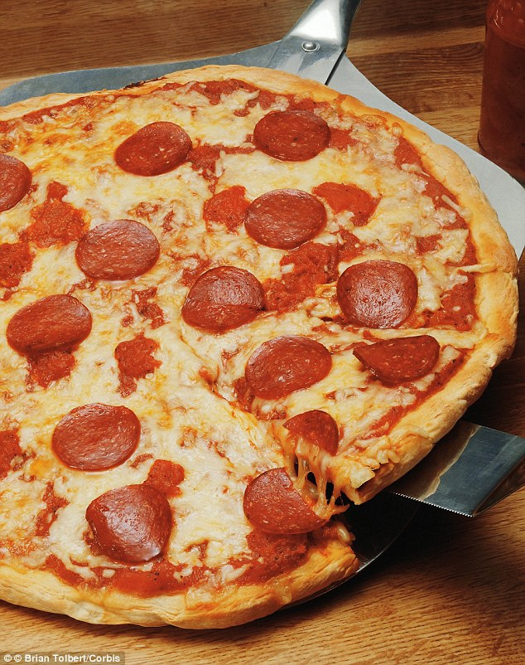
+6
The truth: Nutritionist Sonya Angelone, a spokeswoman for the Academy of Nutrition and Dietetics, has revealed exactly what happens to the body when one eats a slice of pepperoni pizza
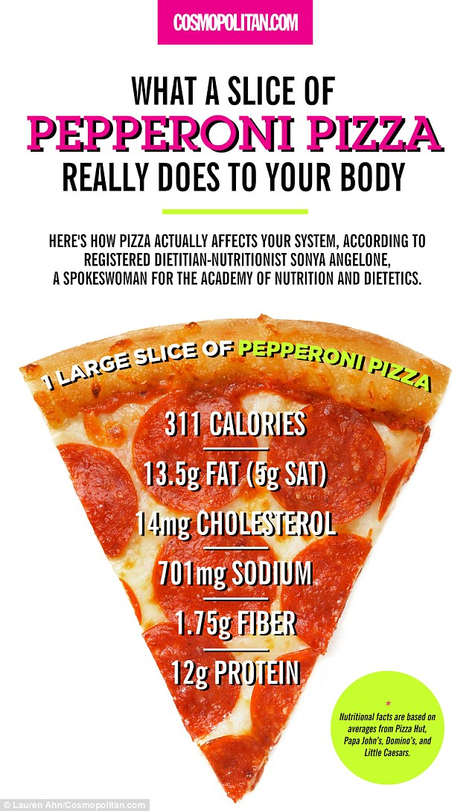
+6
Breaking it down: An average slice of peperonni pizza contains 311 calories, 13.5 grams of fat, and 720 milligrams of sodium
The first bite activates the brain's pleasure center, and salivating over a slice triggers the release of digestive enzymes in the body, which break down the carbs into simple sugars that the body can later use as fuel.
About 15 minutes after eating the slice, glucose begins to enter the bloodstream, but the the fat and protein from the pepperoni and cheese slows this process down, making the energy you received from eating the pizza last longer.
However, if a person eats quickly, overeats, or has a sensitivity to lactose or gluten, they might become bloated as their body digests the pizza and releases residual gasses.
Around 20 minutes after ingesting the pizza, levels of leptin - the hormone that tells one to stop eating - rises and communicates to the body that it is full. Meanwhile, the pancreas secretes the hormone insulin to help the cells convert the sugar into fuel.
If one continues to eat past this point, the cells will reject the fuel and send it to the liver to be turned into fat.

RELATED ARTICLES
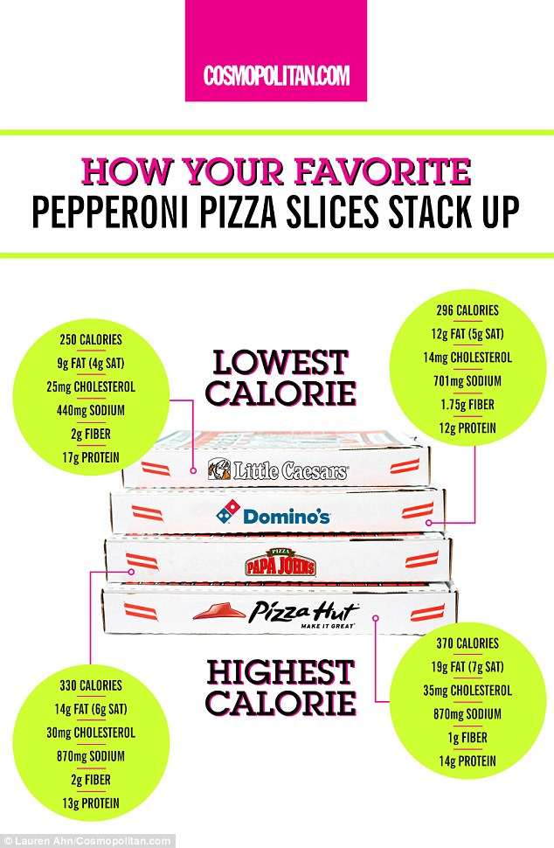
+6
The low-down: Little Ceasars pepperoni pizza is the best fast food option, at 250 calories a slice, while Pizza Hut is the worst, at 370 calories a slice. Domino's and Papa Johns are in the middle at 296 and 330 calories
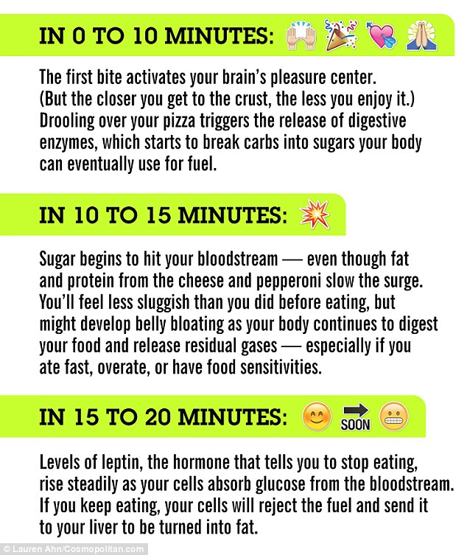
+6
What happens: In the first 15 minutes after one eats a slice of pizza, sugar enters the bloodstream and one feels energized. After 20 minutes, the hormone leptin tells the body to stop eating
After 30 minutes, the body will feel fueled up and satisfied - unless one has overeaten, which causes sluggishness.
The body then digests the fat and protein from the pepperoni and cheese and injects it into the bloodstream. If the muscles already have enough fuel, the fat will be re-routed to one's liver, where it will be stored for later use.
This process causes the levels of triglycerides (fat in the blood) to rise, which could result in clogged arteries for people who have unhealthy diets or a family history of circulatory disease.
However, if one is relatively healthy, the triglycerides will taper off after about six hours.
About an hour after eating, one's blood pressure temporarily rises due to lack of space in the blood vessels from the fatty meal, which could cause blot clots for someone with a family history of heart disease.
On the plus side, the body feels full and energized due to the fact that the fat and protein from the pizza have ebbed the production of serotonin, a hormone that causes tiredness.
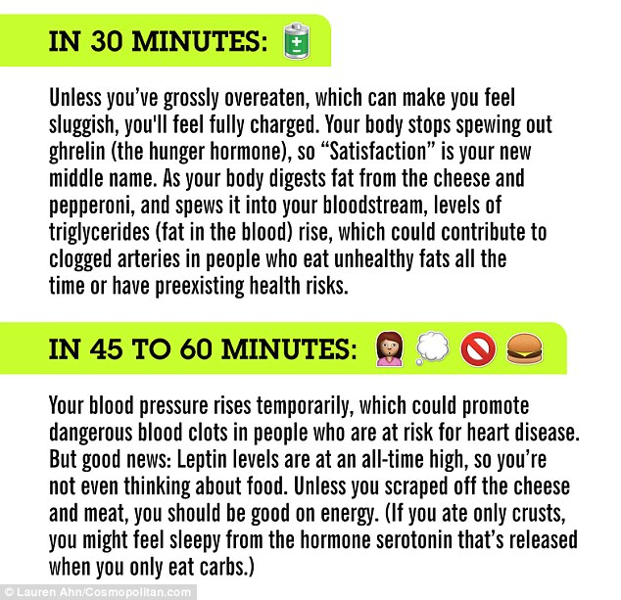
+6
Next: The body feels satisfied after it stops releasing the hunger hormone ghrelin. Then, levels of fat in the blood rise and one's blood pressure also rises temporaily
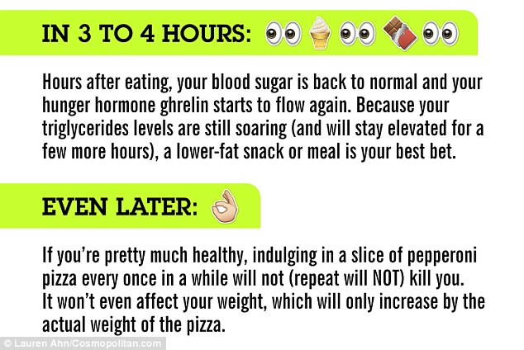
+6
After: Four hours later, the body's blood sugar is back to normal and one starts to feel hungry again. In the long-term, eating a slice of pizza won't affect a person, but it could cause problems if they are unhealthy
Around three to four hours after eating, the body's blood sugar returns to its normal levels and the food has left the stomach.
The hunger hormone ghrelin is released, but it's best to satisfy your cravings with a low-fat snack at this time, since triglyceride levels are still soaring.
If one is typically healthy, eating a slice of pepperoni pizza will not affect one's long-term health, and the body's weight will only increase by the weight of the actual slice.
But if one has high blood pressure, diabetes, heart disease, is overweight, or smokes, eating a slice of pizza can exacerbate the body's current state and cause health problems.
Cosmopolitan.com also rated the top fast food pizza options, with Little Ceasars having the lowest calorie slices at 250 calories, and Pizza Hut having the highest at 370 calories per slice.
In the middle were Domino's, at 296 calories per slice, followed by Papa John's, at 330 calories per slice.

