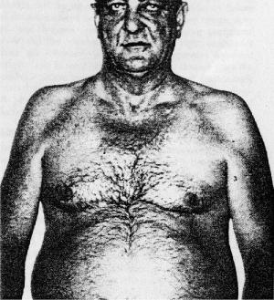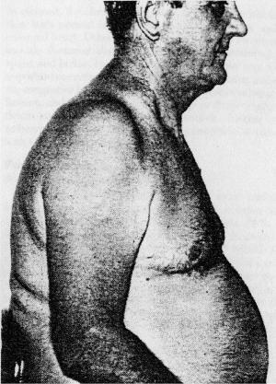
Figure 1. Blue Bloater - chronic bronchitis.

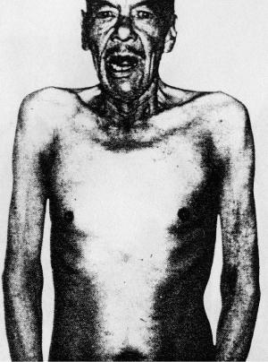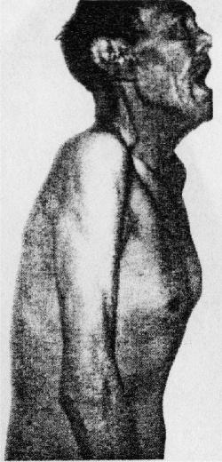
Figure 2. Pink Puffer – emphysema

Medical references to pink puffer and blue bloater
Doctors and scientists have written many research papers on the subject of Chronic Obstructive Airways Disease (COAD) which over time has been known by a number of other names, including Chronic Obstructive Pulmonary Disease (COPD), Chronic Airflow Limitation (CAL), Chronic Airways Disease (CAD) and Obstructive Airways Disease (OAD).
Medical patients with COAD clinically cover a wide spectrum and those extremes have become known as pink puffers and blue bloaters. Two components of COAD are emphysema¹ and chronic bronchitis². When these diseases are examined in their relatively pure form, each has its own striking patient characteristics of body build, general appearance and underlying disordered physiologic condition. That is, pink puffers are emphysema patients and blue bloaters are chronic bronchitis patients (Mandavia and Dailey 1993). However, Voelkel (2000) stresses that “while COPD patients are viewed traditionally as being either blue bloaters or pink puffers, guidelines have made efforts to stress that many patients will fall into neither group”.

Medical papers often quote significantly different figures as to the proportion of COAD sufferers in a given population. For example, Duffy (2000) quotes about 5% of the United States population are COAD sufferers, while Hunter et al (2001) quote approximately 20%. Mandavia and Dailey (1993) quote COPD as effecting more than 25% of all adults in the USA. These vastly different figures reflect the conflicts of definition between doctors and authorities.

Pink puffers and blue bloaters from a medical perspective
Pink puffers are patients with COPD where the pathology is widespread emphysema¹. Their main symptom is breathlessness which is progressive, because their blood gases are relatively normal, their skin is of good colour and in the case of Caucasians, has a pink colour. They are of thin build and have evidence of airways obstruction with a reduced exhaling capacity - forced expired volume in one second (FEV₁). Their chests are over inflated (hyperinflated) due to air trapping and the diffusing capacity of the lungs for carbon monoxide (DL_{co})³ is reduced. A disease of the heart (cor pulmonale)⁴ is unusual and when it occurs is usually late in the disease. (West 1977, DeMarco et al 1981).
On the other hand, blue bloaters have mostly a severe bronchitis² with some emphysema¹. They are overweight and have a chronic cough with sputum (sometimes purulent). They have an elevated carbon dioxide and low oxygen in the blood. There is severe airway obstruction with a reduced FEV₁. Lung volumes and DL_{co} may be normal. The patients have a plethoric⁵ appearance due to polycythaemia (an increase in the number of red cells due to chronic hypoxia⁶), and are cyanosed (blue) because of low blood oxygen. Chronic hypoxia causes the pulmonary blood vessels in these patients to constrict so that the right side of the heart has to pump much harder. This is worsened by the thickening of the blood (polycythaemia) and leads to thickening of the muscle in the right side of the heart (cor pulmonale) with subsequent failure and fluid retention. These changes occur relatively early in the disease and give the blue bloater appearance. Patients usually respond very well to correcting the hypoxia with long term oxygen therapy (West 1977).

I know that pink puffer goes with emphysema and blue bloater with bronchitis.
Can anyone explain?
pink puffer because of the reddish complexion and the patient hyperventilates .....these pts have less hypoxemia compared to chronic bronchitis ( blue bloaters) ....and so in emphysema u will have less carbon dioxide retention.
blue bloaters is when patients will be cyanotic hence blue color of lip and skin ...because its chronic bronchitis and they will have co2 retention and more severe hypoxemia .....

In Chronic bronchitis there is a lot of ateriovenous anastomosis leading to right to left shunt .As a consequence
There is marked
hypoxemia -------------> Cyanosis Blue) and pulmonory vasoconscrition (Pulmonary vessesl are only vessels in the body which constrict in response to hypoxia)
Pulmonary vasoconstriction ----------> Pulmonary HTN -----------> Corpulmonal (Rt ventricular hypertrophy) ------------> RVF --------------> Generlaized edema (Bloaters)
Hypercapnia due to this marked shunting of blood ----------> warm bounding pulse and papilledema (raised ICP)
But in emphesema there is avleolar septal damage which reduces vascular bed which leads to slight hypoxia (comparatively pink ). In addition there is marked elastic tissue damage ---------> lack radial traction on the brochioles which leads to marked tendency to collapse during expiration because of positive expiratory pleural pressure. So this patient breaths through mouth with gradual release of pressure so that there is more intra bronchial pressure to prevent air way collapse (Purse lip breathing ) .In other words this patient puffs the breathing.
So PINK PUFFER

