The 29-point DEATH test: From slow walking speed to exhaustion, doctors' check list spots patients most at risk of dying within 30 days
- Test creates a percentage chance of death within one month and 12 weeks
- Doctors say the test will prevent futile and costly treatments for the elderly
- Aims to prompt frank talks about death and stop prolonging suffering
- Many patients currently die in hospital against their preference
- The test will allow them to choose to go home and say goodbye to family
By Madlen Davies for MailOnline
Published: 06:03 EST, 23 January 2015 | Updated: 07:19 EST, 23 January 2015
A test to identify those elderly patients most at risk of dying within 30 days has been developed by doctors.
They say the test will give people the chance to go home and spend time saying goodbye to loved ones, preventing them from enduring their last days in hospital.
The 29-point checklist will prevent futile and costly treatments that prolong the patient's suffering and frustrate doctors, the researchers said.
The test comprises a checklist of 29 predictors of health including age, frailty, the severity of their illness and mental impairment.
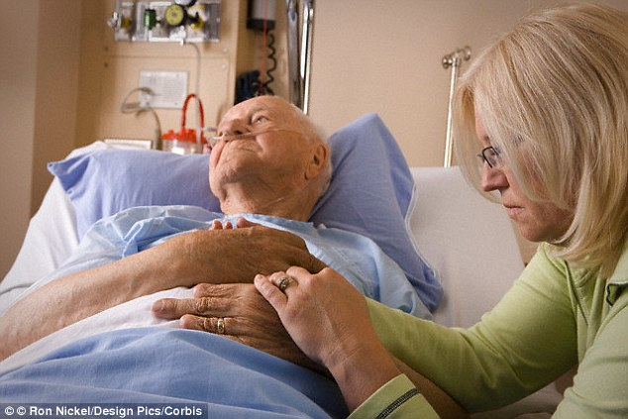
A test to identify elderly patients who will die within 30 days has been developed by doctors. They say the test will prevent futile and costly treatments that prolong the patient's suffering
It also includes previous emergency admissions, treatment in the intensive care department, heart rate and protein in the urine (which is often a sign of kidney disease).
From looking at these indicators doctors can produce a percentage chance of death between one month and 12 weeks.
Researchers say the aim of Critera for Screening and Triaging to Appropriate aLternative care - or CriSTAL for short - is to kick-start frank discussions about end of life care and prevent ineffective treatment.
Dr Magnolia Cardona-Morrel, of the University of New South Wales, and the study's lead author said: 'Delaying unavoidable death contributes to unsustainable and escalating healthcare costs, despite aggressive and expensive interventions.
'These interventions may not influence patient outcome; often do not improve the patient's quality of life; may compromise bereavement outcomes for families; and cause frustration for health professionals.
'Current hospital systems often fail to recognise or cater to the needs of people for whom death is imminent and unavoidable.

THE 29-POINT DEATH TEST

For patients with an age of 65 or over who have been admitted to hospital this time in an emergency:
1. Altered level of consciousness (Glasgow Coma Score change >2 or AVPU=P or U)
2. Blood pressure (a systolic blood pressure of less than 90 mm Hg)
3. Respiratory rate of less than five and more than 30
4. Pulse rate of less than 40 or more than 140
5. Need for oxygen therapy, or known oxygen saturation of less than 90 per cent
6. Hypoglycemia blood glucose level (less sugar in the blood than normal)
7. Repeat or prolonged seizures
8. Low output of urine (less than 15 mL/h or less than 0.5 mL/kg/h) or a MEW or SEWS score of more than 4
9. Previous history of disease, including:
10. Advanced cancer
11. Kidney disease
12. Heart failure
13. Various types of lung diseases
14. Strokes and vascular dementia
15. Heart attack
16. Moderate to severe liver disease
17. Mental impairment such as dementia or disability from a stroke
18. Length of stay before this RRT call (>5 days predicts 1-year mortality)
19. Repeat hospitalizations in the past year
20. Repeat admission to the intensive care department of the hospital
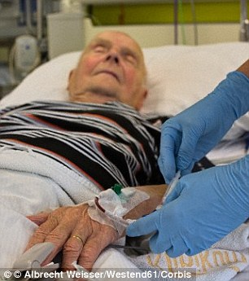
21. Frailty
22. Unexplained weight loss
23. Self-reported exhaustion
24. Weakness (being unable to grip objects, being unable to handle objects or lift heavy objects of less than or equal to 4.5kg,
25. Slow walking speed (walks 4.5m in more than 7 seconds) or is
26. Inability to do physical exercise or stand
27. Is a nursing home resident or lives in supported accommodation
28. Having urine in their blood (more than 30mg albumin/g creatinine
29. Abnormal ECG (irregular heartbeat, fast heartbeat and any other abnormal rhythm or more than or equal to 5 ectopics/min and changes to Q or ST waves)
'They are geared for aggressive treatment and emergency resuscitation, not peaceful, harm-free transitions.
'Elderly people who are dying need to be protected from heroic but intrusive live-saving hospital interventions that often only prolong suffering rather than enhance quality of remaining life.'
She added the checklist is not intended to substitute healthcare for the elderly who are terminally ill.
Instead, it is meant to 'provide an objective assessment and definition of the dying patient'.
She said: 'It's about coming to terms with the fact that death from old age and multiple chronic conditions is part of a natural process and that medicine cannot work miracles.
'And it's about ensuring that people at the end of their lives have the best possible care and support, in line with their wishes.'
Many patients die in hospital even thought this would not be their preference, the researchers say. The test would allow them to choose go home and say goodbye to their loved ones
The test could also help healthcare professionals, many of whom are under pressure to continue prolonging the life of a patient against all the odds.
While there are policies for stopping treatment in terminally ill patients, there are societal pressures on healthcare professions to continue prolonging life even in 'plainly futile' situations, she said.
The test would give doctors more concrete information about the inevitability of death which could help them to say no to further invasive treatment.
The researchers said most patients end up dying in hospital, even though that is not their stated preference, when asked.
The CriSTAL test would give families and patients options about their preferred place of death, and could prompt hospitals to develop more appropriate services than hospitals for managing patients at the end of their life.
A shortened version of the test could even be used for every hospital admission, the researchers concluded.
The research was published in the journal BMJ Supportive & Palliative Care.

Read more: http://www.dailymail.co.uk/health/article-2923173/The-29-point-DEATH-test-slow-walking-speed-exhaustion-doctors-check-list-spots-patients-risk-dying-30-days.html#ixzz3Pg1Y6XQI
Follow us: @MailOnline on Twitter | DailyMail on Facebook

