Posted on Tue, Jun. 25, 2013
Sudden cardiac deaths like those that fell ‘Sopranos’ star James Gandolfini can be prevented
By Howard Cohen
hcohen@MiamiHerald.com
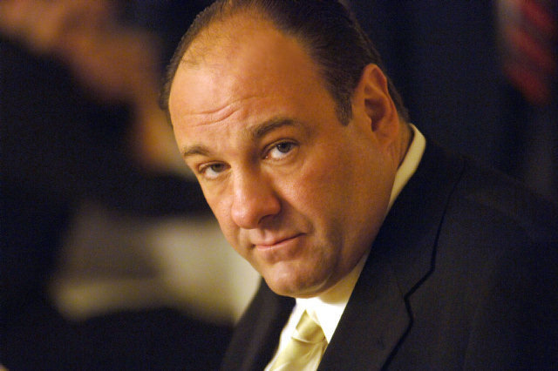

BARRY WETCHER / AP
This undated publicity photo, released by HBO, shows actor James Gandolfini in his role as Tony Soprano, head of the New Jersey crime family portrayed in HBO's "The Sopranos."Gandolfini died Wednesday, June 19, 2013, in Italy. He was 51. The autopsy said his death was caused by a heart attack. James Gandolfini and Michael Gale couldn’t be more different.
Gandolfini’s performance as Tony Soprano, a mobster with heart on the HBO drama, The Sopranos, created an iconic television character. His larger than life persona was matched by the large frame Gandolfini, 51, carried.
The final scene in the last episode of The Sopranos was set inside an ice cream parlor. One could safely assume the actor was familiar with most of the flavors.
Gale, 61, works in the healthcare industry, is an avid cyclist, eats a lean diet, and, by all accounts, would not be familiar to HBO’s viewership.
Both men suffered massive heart attacks. And here they share a kinship: There was no early warning to indicate something was wrong.
Gandolfini was in Rome on vacation celebrating his son’s graduation from junior high school and was also scheduled to appear at the Taormina Film Festival in Sicily. He collapsed inside his hotel room. Gale was dining with his girlfriend at Duffy’s Sports Grill in Fort Lauderdale discussing a planned 100-mile bike ride in hilly Mount Dora when he collapsed at the table.
Gale is en route to Jupiter Island to meet his cycling friends for a 200k bike ride.
Gandolfini’s funeral is scheduled for Thursday at the Cathedral of St. John the Divine in New York City.
The overall risk for individuals over 35 is one in a thousand will die suddenly. About one-half of the 300,000 Americans who die from sudden cardiac arrest annually exhibit no previous warning signs. And 50 percent of cardiac arrests are first events.
In such case, “Death is the presenting event of underlying disease,” said Dr. Robert Myerburg, professor of medicine and physiology at the University of Miami Miller School of Medicine. Myerburg did not treat the actor. An autopsy last week confirmed that Gandolfini, who also starred on Broadway and in the crime movie, True Romance, died of a heart attack, “natural causes,” although the exact cause for the cardiac arrest was not immediately known.
The risk for females is lower pre-menopausal because of estrogen’s protective traits during the child-bearing years, but once past menopause, women quickly catch up to the men in their 50s.
“It’s quite interesting,” Dr. Adam Splaver, clinical cardiologist and director of echocardiography for the Memorial Health Care System in Hollywood, said of the attention sparked by Gandolfini’s sudden death. “The incidence is on the rise. Over two million people are expected to have an event. People at increased risk are those with a previous heart attack or with a weak heart and other risk factors such as being overweight, having that central beer belly. Cholesterol problems, in addition to being out of shape, all can increase the risk of cardiac disease.”
The take-home message from Gandolfini’s high-profile death at age 51: eat a healthy diet with a concentration on vegetables and fruits and exercise regularly.
“Don’t put yourself in the position to increase your risk,” Myerburg said.
Reducing body fat, especially if you are obese, and engaging in some form of exercise, which can include simple walking to getting your heart rate up, can make a big difference.
“You are shifting the odds in your favor by what you are doing,” Myerburg said.
If you smoke, stop now. Gandolfini smoked.
“Smoking increases the risk of sudden death and other cardiovascular deaths. The good side is cessation of smoking reduces the risk… within weeks … that positive action shifts the odds in your favor,” Myerburg said.
“Sudden cardiac arrest is something that is quite preventable,” Splaver added. “This is something we can screen for. If we can identify who has a weak heart by doing a simple test like an EKG we can identify patients at risk. Patients with dizziness, lightheadedness, blacking-out, fainting, should be evaluated.”
Sleep apnea can also lead to rhythm disturbances of the heart muscle. Those who are overweight are at greatest risk for sleep apnea — an interruption of the breathing while sleeping — although even fit, thin people can suffer from sleep apnea.
Gale remembers few details of that evening in September 2010 that changed his life.
“I was sitting at a high-top table. There was wine in front of me and my girlfriend on the other side of me. The rest is what they told me happened,” he said Friday. “My chin dropped to my chest and I was out. The woman sitting close by noticed — she was a nurse and she gave me CPR until the EMTs came.”
Gale was rushed to Westside Regional Medical Center in Plantation. The determination: silent ischemia, a lack of blood flow and oxygen to the heart due to a blocked artery.
“I had not a sign, not a pain, not a symptom and that is called silent ischemia. You don’t want that. Pain is good. You want to know so you can take proactive measures,” Gale said.
He eventually found his way to the University of Miami Hospital where he has been under the care of Myerburg. He has since undergone the placement of stents to open blood flow, underwent triple bypass surgery and had an implanted defibrillator. In his case, electrocardiogram (EKG) tests of his heart couldn’t determine why he kept having problems because the electrical system of the organ wasn’t compromised. Rather, an inherited tendency to build up artery clogging cholesterol led to a diagnosis of hypercholesterolemia. This syndrome can be detected when a patient undergoes stress testing, thus pointing out the importance of having your doctor perform that test, especially if a first-degree family member, like a parent, grandparent or sibling, suffered from early cardiac arrest. Gale’s father and grandfather died in their 40s and 50s from cardiac arrest. High cholesterol runs in his family.
The greatest challenge in cardiology is identifying patients who might be at risk, Myerburg said. The University of Miami Hospital has established a monthly clinic to focus on hypertrophic cardiomyopathy and other inherited and acquired causes of heart rhythm disturbances through screenings, physical evaluations, family histories and genetic testing.
Of Gale’s initial attack: “He had cardiac arrest and there was someone around to give CPR,’ Myerburg said. “He’s the parallel of Gandolfini and, in other ways, he’s the antithesis. It was probably the same kind of event, but on the other hand, he had somebody around to give CPR and that got him resuscitated. And he’s a recreational athlete and he’s got his whole life back. He’s the counter of that story.”

Read more here: http://www.miamiherald.com/2013/06/25/v-print/3468137/sudden-cardiac-deaths-like-those.html#storylink=cpy

