Compliance
Compliance refers to the distensibility of an elastic structure (such as the lung) and is defined as the change in volume of that structure produced by a change in pressure across the structure. It is important to understand that the lung (or any other elastic structure) will not increase in size if the pressure within it and around it are increased equally at the same time.
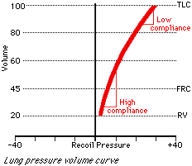
In a normal healthy lung at low volume, relatively little negative pressure outside (or positive pressure inside) needs to be applied to blow up the lung quite a bit. However lung compliance decreases with increasing volume. Thereforeas the lung increases in size, more pressure must be applied to get the same increase in volume. This can be seen from the following pressure-volume curve of the lung: Lung compliance and the slope are the same:

Compliance can also change in various disease states. For example, in fibrosis the lungs become stiff, making a large pressure necessary to maintain a moderate volume. Such lungs would be considered poorly compliant. However, in emphysema, where many alveolar walls are lost, the lungs become so loose and floppy that onlya small pressure difference is necessary to maintain a large volume. Thus, the lungs in emphysema would be considered highly compliant.
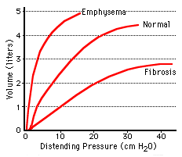

Obstructive Ventilatory Defect
This is a respiratory abnormality characterized by a slow rate of forced expiration (low FEV1/FVC). In those with active asthma or emphysema, a high residual volume and functional residual capacity and a low vital capacity are usually seen as well. In individuals with bronchitis these lung volumes are more likely to be normal.
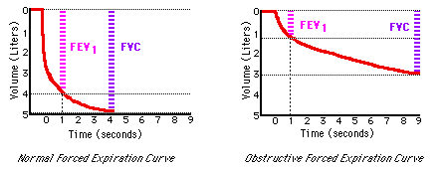
Asthma, bronchitis, and emphysema are all considered obstructive conditions, but the way each results in an obstructive defect is quite different. More information about any of these diseases can be found in the appropriate encyclopedia entry.
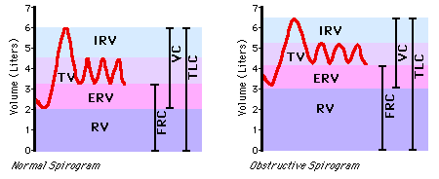

Emphysema
Emphysema is a disease characterized by dilation of the alveolar spaces and destruction of the alveolar walls. With their loss, much of the elastic recoil of the lung is also lost.
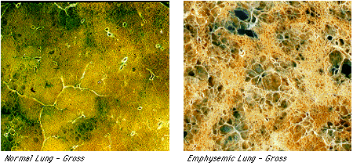
Compliance of the lung in emphysema is significantly above normal; the lung becomes easy to distend but empties slowly. This results in a chronically overinflated lung (high total lung capacity, functional residual capacity, and residual volume), which lessens the curvature of the diaphragm, making it less efficient in generating even the small swings in pleural pressure necessary for breathing. Pulmonary function tests on a patient with emphysema will reveal a compromised expiratory flow (due to their low lung recoil), including a low FEV1, FVC, and FEV1/FVC ratio.
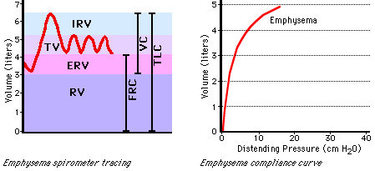

Asthma
Asthma is a condition characterized by airway hyperresponsiveness, which results in reversible increases in bronchial smooth muscle tone, and variable amounts of inflammation of the bronchial mucosa.During an acute asthma attack, the already inflamed airways narrow further due to bronchospasm, which leads to increased airway resistance. Because of the increased smooth muscle tone during an asthma attack, the airways also tend to close at abnormally high lung volumes, trapping air behind occluded or narrowed small airways.Thus the acute asthmatic will breathe at high lung volumes, his functional residual capacity will be elevated, and he will inspire close to total lung capacity. The accessory muscles of respiration are often used to maintain the lungs in a hyperinflated state.
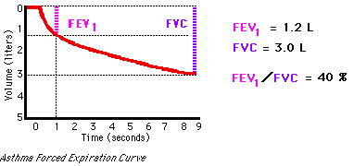
During episodes of acute asthma, pulmonary function tests reveal an obstructive pattern. This includes a decrease in the rate of maximal expiratory air flow (a decrease in FEV1 and the FEV1/FVC ratio) due to the increased resistance, and a reduction in forced vital capacity (FVC) correlating with the level of hyperinflation of the lungs. Because these patients breathe at such high lung volumes (near the top of the pressure-volume curve, where lung compliance greatly decreases), they must exert significant effort to create an extremely negative pleural pressure, and consequently fatigue easily. Overinflation also reduces the curvature of the diaphragm, making it less efficient in generating further negative pleural pressure.
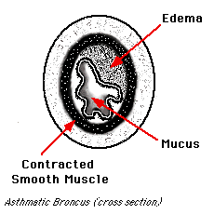
The level of airway hyperresponsiveness can be measured in the laboratory by a methacholine (similar to acetylcholine) inhalation challenge test, which produces dramatic bronchconstriction in the airways of an asthmatic.

Bronchitis
Bronchitis is a condition which is clinically defined as a chronic cough with mucus production most months of the year. The mucus secretions and inflammation in the bronchi tend to narrow the airways and provide an obstacle to airflow, thus increasing the resistance of the airways. In this manner bronchitis may cause obstructive pulmonary symptoms.
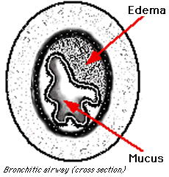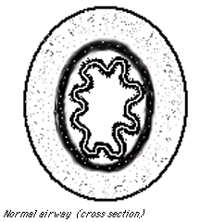
On pulmonary tests, a bronchitic may present a decreased FEV1 and FEV1/FVC. However, unlike the other common obstructive disorders, asthma and emphysema, bronchitis rarely causes a high residual volume. This is because the air flow obstruction found in bronchitis is due to increased resistance, which does not generally cause the airways to collapse prematurely and trap air in the lungs.
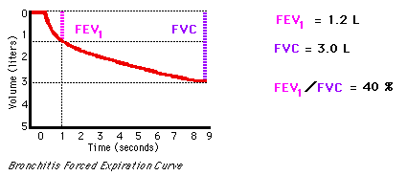

Forced Expiration
Forced expiration is a simple but extremely useful pulmonary function test. A spirometry tracing is obtained by having a person inhale to total lung capacity and then exhaling as hard and as completely as possible. These tracings are a very effective way of separating normal ventilatory states from obstructive and restrictive states.
In a normal forced expiration curve, the volume that the subject can expire in one second (referred to as FEV1) is usually about 80% of the total forced vital capacity (FVC), or something like four liters out of five.
In an obstructive condition, however, such as asthma, bronchitis or emphysema, the forced vital capacity is not only reduced, but therate of expiratory flow is also reduced. Thus, an individual with an obstructive defect might have a forced vital capacity of only 3.0 liters, and in the first second of forced expiration, exhale only 1.5 liters, giving a FEV1/FVC of 50%. With a restrictive disease, such as fibrosis, forced vital capacity is also compromised. However, due to the low compliance of the lung in such conditions, and the high recoil, the FEV1/FVC ratio may be normal or even greater than normal. For example, a patient with a restrictive condition might have a FVC of 3.0 liters, as was seen in the obstructive cases, but the FEV1 might be as high as 2.7 liters, giving a FEV1/FVC ratio of 90%.
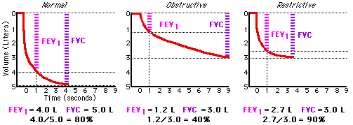
Forced expiration curves are particularly useful because they are so reproducible. At every lung volume there exists a maximal rate of flow which cannot be exceeded. When an individual tries to exceed his maximal flow rate, he forcefully contracts his abdominal muscles to increase his already positive pleural pressure. This increases the driving pressure for air flow from the alveoli to the mouth but also causes the bronchi (whose pressure lies somewhere between that in the alveoli and that at the mouth, but is less than pleural pressure) to collapse. Thus the airways become occluded and flow is slowed until the pressure difference across the airways

Gas Dilution
Gas dilution is a method of determining those lung volumes that cannot be determined from simplespirometry. These include functional residual capacity, which is computed directly, and residualvolume and total lung capacity, which are computed from FRC. The subject is connected to aspirometer containing a known concentration of helium, or some other inert and insoluble gas.
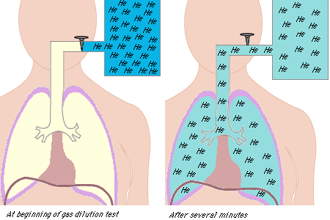
After several minutes of breathing, the helium concentrations in the spirometer and lung becomethe same. From the law of conservation of matter, we know that the total amount of helium beforeand after is the same. Therefore we can set the fractional concentration times the volume beforeequal to the fractional concentration times the volume, because of the conservation law of matter.

We solve for the volume after (the volume of the lung and spirometer), subtract out the volume ofthe spirometer, and we get the volume of the lung.

Restrictive Ventilatory Defect
Restrictive disease is a condition marked most obviously by a reduction in total lung capacity. A restrictive ventilatory defect may be caused by a pulmonary deficit, such as pulmonary fibrosis (abnormally stiff, non-compliant lungs), or by non-pulmonary deficits, including respiratory muscle weakness, paralysis, and deformity or rigidity of the chest wall.
In pulmonary tests, an individual with a restrictive ventilatory defect demonstrates a low total lung capacity, a low functional residual capacity, and a low residual volume. While his forced vital capacity (FVC) may be quite low, his forced expiratory volume in one second divided by the forced vital capacity (FEV1/FVC) is often normal or greater than normal due to the increased elastic recoil pressure of the lung.
Because large drops in pleural pressure are required to inflate the lungs, deep breaths are difficult for individuals with restrictive defects, and they tend to breathe shallowly and rapidly.
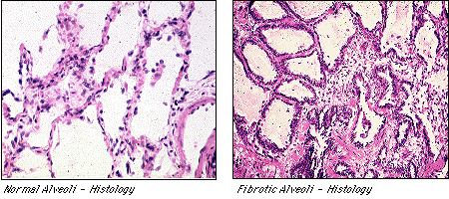
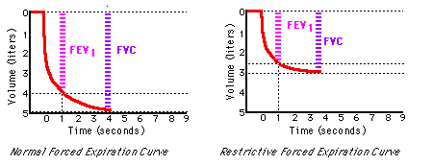

Surfactant
Surfactant is a complex substance containing phospholipids and a number of apoproteins. This essential fluid is produced by the Type II alveolar cells, and lines the alveoli and smallest bronchioles. Surfactant reduces surface tension throughout the lung, thereby contributing to its general compliance. It is also important because it stabilizes the alveoli. LaplaceÕs Law tells us that the pressure within a spherical structure with surface tension, such as the alveolus, is inversely proportional to the radius of the sphere (P=4T/r for a sphere with two liquid-gas interfaces, like a soap bubble, and P=2T/r for a sphere with one liquid-gas interface, like an alveolus: P=pressure, T=surface tension, and r=radius). That is, at a constant surface tension, small alveoli will generate bigger pressures within them than will large alveoli. Smaller alveoli would therefore be expected to empty into larger alveoli as lung volume decreases. This does not occur, however, because surfactant differentiallyreduces surface tension, more at lower volumes and less at higher volumes, leading to alveolar stability and reducing the likelihood of alveolar collapse.
Surfactant is formed relatively late in fetal life; thus premature infants born without adequate amounts experience respiratory distress and may die. 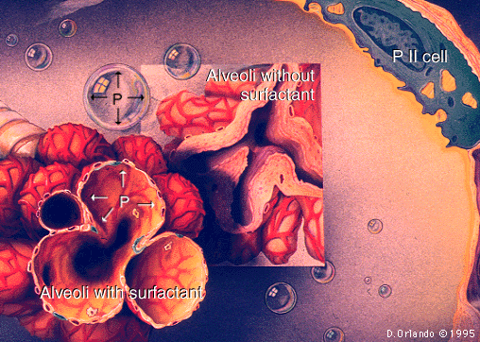

Dead Space
Dead space is the portion of each tidal volume that does not take part in gas exchange.
There are two different ways to define dead space-- anatomic and physiologic. Anatomic dead space is the total volume of the conducting airways from the nose or mouth down to the level of the terminal bronchioles, and is about 150 ml on the average in humans. The anatomic dead space fills with inspired air at the end of each inspiration, but this air is exhaled unchanged. Thus, assuming a normal tidal volume of 500 ml, about 30% of this air is "wasted" in the sense that it does not participate in gas exchange.
Physiologic dead space includes all the non-respiratory parts of the bronchial tree included in anatomic dead space, but also factors in alveoli which are well-ventilated but poorly perfused and are therefore less efficient at exchanging gas with the blood. Because atmospheric PCO2 is practically zero, all the CO2 expiredin a breath can be assumed to come from the communicating alveoli and none from the dead space. By measuring the PCO2 in the communicating alveoli (which is the same as that in the arterial blood) and the PCO2 in the expired air, one can use the Bohr Equation to compute the "diluting," non-CO2 containing volume, the physiologic dead space.

In healthy individuals, the anatomic and physiologic dead spaces are roughly equivalent, since all areas of the lung are well perfused. However, in disease states where portions of the lung are poorly perfused, the physiologic dead space may be considerably larger than the anatomic dead space. Hence, physiologic dead space is a more clinically useful concept than is anatomic dead space.
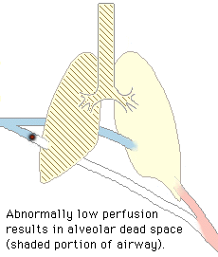

Body Plethysmography
Spirometry is the standard method for measuring most relative lung volumes; however, it isincapable of providing information about absolute volumes of air in the lung. Thus a differentapproach is required to measure residual volume, functional residual capacity, and total lungcapacity. Two of the most common methods of obtaining information about these volumes are gasdilution tests and body plethysmography.
In body plethysmography, the patient sits inside an airtight box, inhales or exhales to aparticular volume (usually FRC), and then a shutter drops across their breathing tube. Thesubject makes respiratory efforts against the closed shutter (this looks, and feels, likepanting), causing their chest volume to expand and decompressing the air in their lungs. Theincrease in their chest volume slightly reduces the box volume (the non-person volume of the box)and thus slightly increases the pressure in the box.
Using the data from the plethysmography requires use of Boyles Law.
To compute the original volume of air in thelungs, we first compute the change in volume of the chest.Using Boyle's Law (P1V1=P2V2, atconstant temperature), we set the initial pressure in the box times the initial volume of the box(both of which we know), equal to the pressure times volume of the box at the end of a chestexpansion (of which we know only the pressure).
We solve for the volume of the box during the respiratory effort. The difference between thisvolume and the initial volume of the box, is the change in volume of the box, which is the same asthe change in volume of the chest. Armed with this piece of information, we use Boyle's Lawagain, this time on the fixed amount of gas in the chest before and at the end of a respiratoryeffort. We set the initial volume of the chest (unknown) times the initial pressure at the mouth(known), equal to the inspiratory volume of the chest (the same unknown volume plus the change inthe volume of the chest, which we have just computed) times the pressure at the mouth during theinspiratory effort (known). Now we solve for the unknown volume, which will be the original volumeof gas present in the lungs when the shutter was closed. As mentioned before, the shutter isusually closed at the end of a normal exhalation, or at FRC.
Body plethysmography is particularly appropriate for patients who have air spaces within the lungthat do not communicate with the bronchial tree. In these individules, gas dilution methods ofmeasurement would give an erroneously low volume reading.

Pleural Pressure
Pleural pressure, or Ppl, is the pressure surrounding the lung, within the pleural space. During quiet breathing, the pleural pressure is negative; that is, it is below atmospheric pressure.
The pleura is a thin membrane which invests the lungs and lines the walls of the thoracic cavity. During development the lungs grow into the pleural sacs until they are completely surrounded by them. The side of the pleura that covers the lung is referred to as the visceral pleura and the side of the pleura which covers the chest wall is called the parietal pleura. These two sides are continuous and meet at the hilum of the lung. The two faces of the pleural membranes are directly opposed to one another, and the entire potential space within the pleura contains only a few milliliters of serous pleural fluid.
The size of the lung is determined by the difference between the alveolar pressure and the pleural pressure, or the transpulmonary pressure. The bigger the difference, the bigger the lung. As a result of gravity, in an upright individual the pleural pressure at the base of the lung base is greater (less negative) than at its apex; when the individual lies on his back, the pleural pressure becomes greatest along his back. Since alveolar pressure is uniform throughout the lung, the top of the lung generally experiences a greater transpulmonary pressure and is therefore more expanded and less compliant than the bottom of the lung.
During active expiration, the abdominal muscles are contracted to force up the diaphragm and the resulting pleural pressure can become positive. Positive pleural pressure may temporarily collapse the bronchi and cause limitation of air flow.
Pleural pressure is estimated in human subjects using an esophageal balloon.

Pneumothorax
A pneumothorax is a condition in which air has entered and expanded the normally closed pleural space, driving pleural pressure up toward atmospheric pressure, and resulting in partial or complete collapse of the lung. When pleural pressure approaches zero, the lung and chest wall both move toward the equilibrium positions they would assume in the absence of any external pressures-- the lung collapses and the chest wall springs out.
A pneumothorax may be induced by a break in either the parietal pleura (e.g., from trauma, needle or catheter insertion) or in the visceral pleura (e.g., from rupture of a subpleural air pocket or necrosis of lung adjacent to the pleura).
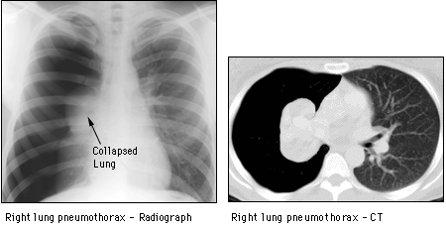
The right side of this patient's thoracic cavity (viewer's left) shows a darker area where the lung should be. Note the expanded chest wall and the collapsed lung.

Recoil Pressure
Recoil pressure is the difference in pressure between two sides of an elastic structure. To get any hollow elastic structure to move from its resting volume, one side of the structure must be exposed to a higher pressure than the other. In respiratory physiology, recoil pressure is used with respect to the lung and the chest wall. It is always the pressure inside minus the pressure outside.
The recoil pressure of the lung is the alveolar pressure minus thepleural pressure (inside pressure minus outside pressure). Other terms which refer to the exact same quantity are the distending pressure of the lung, the transpulmonary pressure, PL, and Palv - Ppl. While Palv and Ppl can be positive or negative, the recoil pressure of the lung is always be positive; that is, the alveolar pressure must always be greater than the pleural pressure. The greater the difference, the greater the recoil pressure, and the bigger the lung will be.
The recoil pressure of the chest wall, which can be measured only when the muscles that make up the chest wall are relaxed, is the same as the distending pressure of the chest wall, which is the same as PW, which is the same as Ppl - Pbs. All refer to the difference between the pleural pressure and the pressure at the body surface, which is atmospheric, and therefore zero.
The recoil of the respiratory system, or PRS, is simply the recoil pressure of the lung plus the recoil pressure of the chest wall, which is Palv-Pbs.
