Membrane that can keep your heart pumping forever and possibly prevent heart attacks
- The membrane has been proven to work on a rabbit heart
- Researchers say it should be available for humans in the next 10-15 years
By Ryan Gorman
PUBLISHED: 01:04 EST, 3 March 2014 | UPDATED: 07:39 EST, 3 March 2014

Scientists have created an external membrane using a 3-D printer than can keep a heart beating virtually forever.
The thin membrane is elastic, designed to stretch over a heart like a glove, and is outfitted with tiny electrodes that monitor cardiac function – it was first demonstrated as a proof of concept on a rabbit heart.
Researchers at both the University of Illinois at Urbana-Champaign and Washington University published the astonishing breakthrough in Nature, and hope it will someday help prevent heart attacks in humans.
SCROLL DOWN FOR VIDEO
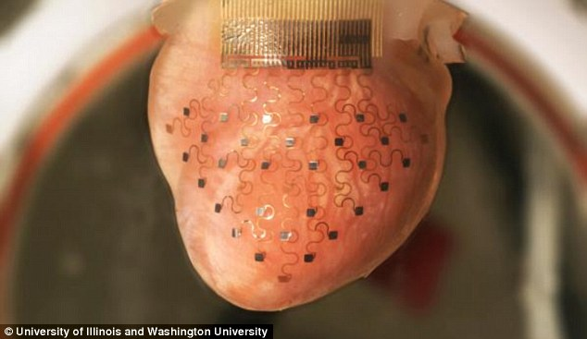
The future of medicine: This custom-fit membrane is woven with a network of electrodes that sense body movement and regulate blood flow - it might one day prevent heart attacks in humans
It is about 10-15 years away from being made available to humans, but the revolutionary device might be a long-term solution to these normally catastrophic events.
The team told Gizmodo’s Sploid that they were able to custom fit it to the rabbit’s heart by using computers to scan it’s surface area and put together a mold for the membrane.
They then put it together and wove it with a spider web-like network of electrodes that interact with the rest of the body to regulate heart beat – it’s light years ahead of a pacemaker.
‘This artificial pericardium is instrumented with high quality, man-made devices that can sense and interact with the heart in different ways that are relevant to clinical cardiology,’ researcher John Rorgers said.
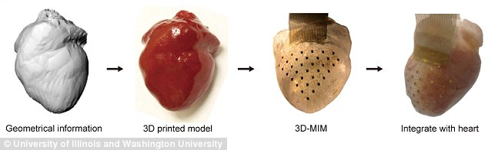
From concept to reality: Scientists first mapped the heart using 3D imagery, they then 3D printed a model for the membrane, created the membrane and then fitted it to the heart - which it now is able to keep beating despite it being outside of the rabbit
Those sensors track tissue movement and use the signals the nervous system, would normally send to the heart to regulate pulse.
This methodology allows the device to keep the heart beating even when a heart attack or arrhythmia occurs.

More...
- Ears and noses to be grown in lab from stem cells for human transplants thanks to revolutionary technique
- They're already called 'vertically challenged' - but are short people intellectually challenged too?
‘When it senses such a catastrophic event as a heart attack or arrhythmia, it can also apply a high definition therapy,’ biomedical engineer Igor Efimov told St. Louis Public Radio.
‘It can apply stimuli, electrical stimuli, from different locations on the device in an optimal fashion to stop this arrhythmia and prevent sudden cardiac death.’
The electrical stimuli regulate the heart’s movement, which means blood will keep flowing and more people will keep living.
Read more: http://www.dailymail.co.uk/news/article-2571917/Membrane-heart-pumping-forever-possibly-prevent-heart-attacks.html#ixzz2v0u4cBMG
Follow us: @MailOnline on Twitter | DailyMail on Facebook

