Can A Broken Heart Kill You?
ELLE
Maia Szalavitz
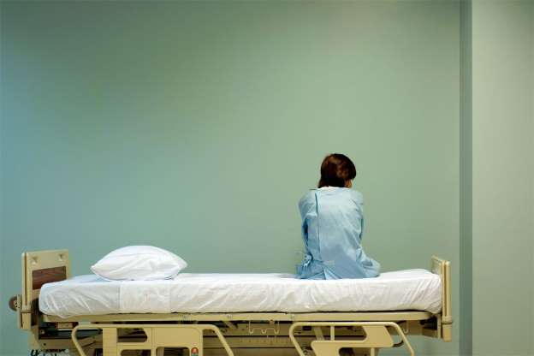© Provided by Elle
Annette Sciberras' heart broke—figuratively and literally—when she first saw her mother's lifeless body in the hospital. As a cardiac nurse, she'd known that her mom was nearing the end, but that didn't prepare her for the reality: "It was a surreal feeling, hard to explain, but as soon as I walked into the room and saw her, I became very weak and collapsed on her."
Sciberras assured the internist who came to check on her that she was fine, probably just a bit of heartburn, though she'd been having occasional chest pain for weeks. Her daughter was having none of it, however: "'Mom, I just lost Grandma, I don't want to lose you, too.'" Sciberras agreed to go to the ER. There, she was soon found to be suffering from stress cardiomyopathy—or, informally, broken heart syndrome—a condition that may account for at least six percent of what are initially diagnosed as heart attacks in women.
Broken heart syndrome can occur when any severe physical or emotional stress—not just the loss of a loved one—overwhelms the heart's pumping ability with a flood of adrenaline. Some 6,800 Americans were hospitalized for it in 2008—according to the best available data—and for reasons that are as yet unclear, nine out of 10 sufferers are women.
Broken heart syndrome is just one of many heart conditions that affect women disproportionately, or differently from men. Though chest pain or discomfort is the most common symptom of heart attack for both sexes, half of women don't have it. Instead they may feel nauseated, dizzy, sweaty, fatigued, or short of breath, and have pain in their back or jaw. (These are also the symptoms of broken heart syndrome.) In part because only 24 percent of subjects in cardiac studies are female, much about women's hearts remains unknown. (Another mystery: how much broken heart syndrome can be blamed when someone dies within days of his or her spouse, though since men are more likely than women to do so, stress cardiomyopathy probably isn't a major contributor.)
Unlike a heart attack, broken heart syndrome doesn't involve a physical obstruction to the heart or the coronary arteries. The heart has receptors for stress hormones that allow it to beat faster in situations requiring fight or flight, but if there are too many hormones for the heart to handle, it goes into a kind of "shock," says Suzanne Steinbaum, DO, director of women's heart health at New York's Lenox Hill Hospital and a spokesperson for the American Heart Association's Go Red for Women campaign. She adds, "This is actually the first time a cardiac condition was diagnosed based on something that happens with the mind."
Debi Jones, 60, who runs a Facebook page for broken heart survivors, was afflicted with the condition after a stressful 12-hour drive that exacerbated a serious thyroid condition. She also downplayed her symptoms at first; the night before she was diagnosed, she just lay on the bathroom floor of her home in agony, too concerned about bothering her family after their long trip to seek help.
But when she finally reached the ER, Jones saw her heart struggling to beat on the monitor. "It was pretty terrifying to see three quarters of my heart beating and one quarter bulging out like a balloon and just hanging there, not doing anything at all," she says. (The disease was first discovered in Japan in 1990, and the shape the heart makes when affected reminded people of an octopus trap and led to its Japanese name: takotsubo cardiomyopathy.)
With several basic heart tests, the syndrome is fairly simple to diagnose—but as in Sciberras' and Jones' cases, women themselves may discount the warning signs, and some doctors may dismiss the symptoms too. The good news is that because the damage it causes to the heart is usually only temporary, if medical attention is given in time, complete recovery is likely. "A small percentage might get it again," Steinbaum says. "But most do well and their heart returns to normal."
Not surprisingly, learning to manage stress is an important part of getting better and preventing a repeat event, Steinbaum says. Both Jones and Sciberras found themselves terrified of facing upsetting events after the diagnosis—a fear that, ironically, can exacerbate the problem. "You need to reach out to people," Jones says. Based on talking to other broken heart survivors, she believes that those who try to handle it on their own take longer to recover. "Don't be afraid to tell someone that you are afraid," she says.
All the usual stress-reduction techniques—exercise, meditation, good diet and sleep habits—are likely to help, but they work only if you do them, of course. "It's really important for women to be sure they have some time for themselves and for their health," says Viola Vaccarino, PhD, professor of epidemiology and medicine at Emory University.
And it's especially critical to put yourself first if you have symptoms: Sciberras was a cardiac nurse who'd been born with a heart defect and had a mother dying of heart disease yet minimized her own chest pain; Jones lay on her bathroom floor rather than seek help. "Don't be afraid or embarrassed or tell yourself 'This isn't really a heart attack,'" Jones says.

