South Florida’s source for synthetic drugs: The China pipeline
Today’s drug importers use parcel shippers, not go-fast boats
Designers constantly tweak formulas to confound the cops
Local college kids seduced by profits, then busted
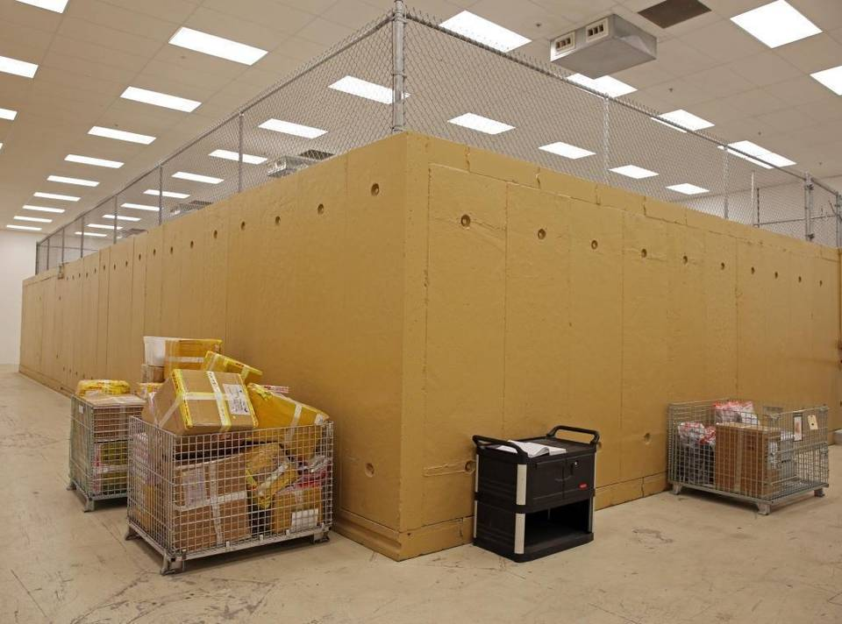
Read more here: http://www.miamiherald.com/news/local/crime/article35417625.html#storylink=cpy

BY DAVID OVALLE AND JAY WEAVER
dovalle@miamiherald.com

From Nanjing, a bustling city on the south bank of China’s Yangtze River, the packagetraveled over 8,000 miles to make its way to an unassuming barbershop along Miami’s Coral Way.
It didn’t contain hair-care products.
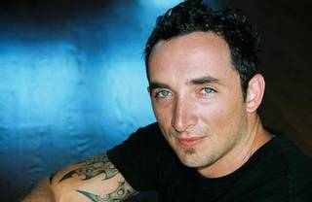
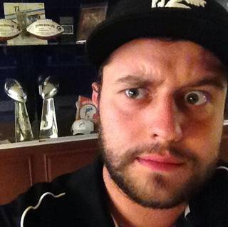
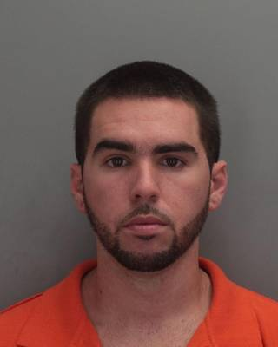

1 of 8
ANDREW POUYA: Cooperated with agents after being busted.
At a Miami Customs warehouse, suspicious federal inspectors flagged the nondescript brown paper parcel sent from someone named only Alva. Inside, they found a variant of methylone, one of a host of synthetic chemicals sold as the euphoric club drug known as Molly.
A records check revealed that in just two months, 21 similar packages from China had been mailed to the Heads Up Barbershop just outside Coral Gables. After a 20-month investigation, which included an undercover agent posing as a mail carrier, federal authorities this spring quietly arrested a 28-year-old former Florida International University honors student named David “Sway” McConnell. He was using the small shop as a drop for an illegal party-pill operation — built entirely on chemicals imported in bulk from China.
For McConnell and other dealers in South Florida and across the country, the loosely regulated pipeline of synthetic drugs from China has created a new model for doing business in the digital age. Tech-savvy dealers order from overseas suppliers with just a few mouse clicks and pay with simple money transfers. They don’t need go-fast boats or drug “mules,” long the smuggling tools of old-school narco-traffickers. Dealers in the booming synthetics trade use the trusty U.S. Postal Service or big-name parcel shippers.
“There is no typical drug dealer anymore,” South Florida’s U.S. Attorney Wifredo Ferrer said. “It’s easy to get access to this stuff. It’s less dangerous and less risky. These new drug dealers are using the Internet, and all they need is a runner to go intercept the package from overseas.”
Follow the Molly: Click here for a larger map

The drugs
Bath salts. Molly. Spice. Flakka. NBOMe. Despite their crude street names, the drugs themselves also are products of fast-evolving technology. They’re concocted by underground chemists in China constantly tweaking formulas, even just by a molecule or two, as they race to stay one step ahead of U.S. authorities and drug laws.
For instance, much of the Molly sold in South Florida has been touted for years as a purified version of the once-popular club drug ecstasy. In reality, lab tests routinely show it consists of various untested and sometimes unknown substances that can be lethal.
“They’re way ahead of us,” Kevin Stanfill, assistant special agent in charge of the Drug Enforcement Administration’s Miami Field Division, said of illicit Chinese distributors. “They watch the news; they see the reports. It’s ever changing, and we have to change with the times.”
Flakka, a psychoactive stimulant technically known as alpha-PVP, has gotten most of the attention in South Florida for good reason. In Broward County, more than 40 people have died with the drug in their system over the past year. About half were overdoses involving multiple drugs, such as cocaine and painkillers.
IN BROWARD COUNTY, MORE THAN 40 PEOPLE HAVE DIED WITH THE PSYCHOACTIVE DRUG FLAKKA IN THEIR SYSTEM OVER THE PAST YEAR.
But it’s just one of an array of dangerous, potentially deadly synthetics. Since 2011, crime labs in South Florida and statewide have reported more seizures of so-called bath salts (cathinones) and synthetic marijuana (cannabinoids). They have detected an ever-increasing — though still relatively small — number of them in the bodies of rape, homicide and overdose victims.
By far the most dangerous drug is the illegal version of the potent painkiller fentanyl, which is passed off as synthetic heroin or mixed with the real thing. Fentanyl or illicit chemical variants have been found in a staggering 52 overdose cases in Miami-Dade over the past year.
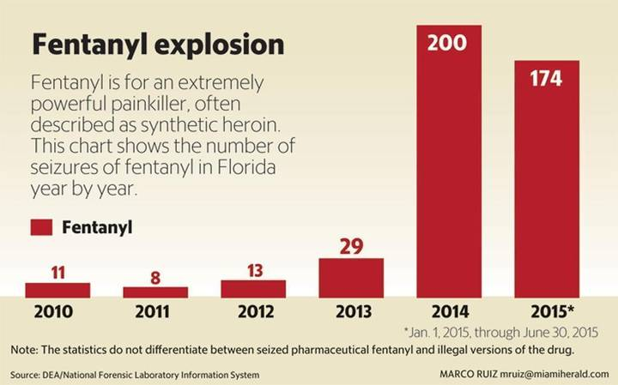
Although prosecutions have been rare, investigators believe the China pipeline is a chief source. Several federal investigations into fentantyl trafficking are currently under way, the Herald has learned. One ring was recently indicted in North Dakota on allegations of using encrypted “Dark Net” Internet servers to import the drug to Florida.
Fighting the surge of synthetics are U.S. customs officers who inspect millions of packages daily and South Florida agents scouring the Internet, working informants, and posing as delivery personnel or drug buyers.
“We can’t control it at the supply end, but we can try to stop it from coming in,” said Alysa Erichs, special agent in charge of U.S. Homeland Security Investigations in South Florida, which has taken an aggressive approach to tracking down synthetics dealers. “We’re the first line of defense that polices the mail to try to get it before it enters the country.”

Secret government bunker houses seized contraband
Secret U.S. Customs and Border Protection bunker referred to as "The Vault" houses seized contraband such as narcotics and guns. Robert Del Toro, Assistant Port Director for U.S. Customs and Border Protection gives inside look of "The Vault."Video by Walt

With little fanfare, Homeland Security Investigations, the DEA, U.S. Postal inspectors and other South Florida agencies have arrested dozens of importers and their associates since 2012. Few defendants risk trials. Overwhelmingly, most plead guilty and cooperate against other dealers in hopes of securing shorter sentences.
But halfway across the world, Chinese manufacturers have little to fear from U.S. law enforcement that has no jurisdiction there. McConnell and three others, including a barbershop employee, were arrested, but the company he ordered from, Egbert Limited, operates unhindered.
A correspondent for McClatchy newspapers in China could not track down Egbert or a number of other synthetic drug distributors because all used bogus return and Internet addresses.
But quickly responding to email price inquiries from a Miami Herald reporter posing as a buyer, an Egbert representative named “Mr. Bellick” quoted prices of $1,700 for a kilogram of ethylone and $3,800 for a kilogram of a variant of fentanyl.
“about the payment, we can accept bitcoins, western union, Moneygram and bank wire,” Mr. Bellick wrote in one email. “we have very good channel to US. 100% pass customs.”

An expanding marketplace
Synthetic drugs are not new and they still haven’t supplanted cocaine, heroin, prescription pill abuse and home-cooked crystal meth on the problem-drug chart. But they’re moving up and fast.
For years in South Florida, there was really only one big synthetic. The European-made drug MDMA, better known as ecstasy, dominated the designer-drug scene.
But law-enforcement crackdowns and increased penalties, combined with the changing tastes of Miami’s club scene — Madonna famously asked Ultra Music Festival revelers in 2012 if they’d seen “Molly” — all but dried up the supply of MDMA. But the demand for designer drugs remains and the market has dramatically expanded since — largely, authorities say, because the China pipeline makes going into the drug business relatively cheap and easy.
MADONNA FAMOUSLY ASKED ULTRA MUSIC FESTIVAL REVELERS IN 2012 IF THEY’D SEEN ‘MOLLY.’
Sending drugs through the mail isn’t exactly cutting edge. In the late 1980s, federal agents took down notorious Chinese gangster Johnny “Onionhead” Eng, who used peppers and spices to mask the smell of heroin concealed in tea boxes and stuffed animals. But few major drug enterprises in Colombia, Mexico or other countries will risk using mail services to send products such as cocaine, which might cost more than $30,000 a kilo by the time it is smuggled into the United States.
“Nobody is going to send cocaine through the mail because it’s easily detected,” Stanfill said. “That would be stupid. But [synthetics] are different because they’re so cheap and easy to send.”
That’s where China comes in. Legal loopholes in China allow unregistered chemical companies to produce narcotics that can be easily exported abroad, said Georgetown University professor Jeremy Haft, author of Unmade in China: The Hidden Truth About China’s Economic Miracle. While it’s easy to picture the communist country’s economy dominated by large state-owned companies, there are really millions of small operations, he said.
“The chemical industry is no exception,” Haft said. “A small lab opens up, hangs a shingle on the Internet, and conducts business. If there’s a threat of law enforcement, they shut down quickly and disappear, only to open up again in another form somewhere else.”
Those shingles abound online, where a simple Google search of “China research chemicals” nets dozens of websites, some crude, others slick and professional.
Jamon Thiry, a South Beach nightclub regular who lived in the swank Flamingo Tower, found his methylone supplier through a company called Kaikai Technology. The company’s website features images of attractive female chemists in lab coats, a page for “hot products” and photos of various drugs.
“I received the pack and is of very great quality thank u so much!” Thiry wrote in numerous emails sent to his supplier, identified only as “Kevin.”
In all, federal agents found that Thiry, using the pseudonym “David Rugby,” had sent 68 wire transfers to China, sometimes with help using a fellow clubgoer, Ramezy Roque, whom he jokingly called his “intern.” The methylone usually arrived at South Florida post-office boxes in packages labeled “Original Pudding.”
His own emails, analyzed by federal agents, cost him. Thiry pleaded guilty to conspiracy to possess and distribute methylone. In March, a judge sentenced him to 7 1/2 years in prison.
Kaikai is still accepting business. Reached via the messaging service Skype, “Kevin” did not answer questions from a Miami Herald reporter.

Replacement if seized: Guaranteed
According to the DEA, many of the chemical factories are clustered in the Hebei region outside Beijing. They send packages using American shipping companies, often labeling them as tea or herbs with fake return addresses. Buyers stateside use shipping company websites to track the packages in real time.
The Chinese government has taken some steps to ban certain synthetic chemicals, including methylone, a Molly drug that flooded the streets of South Florida in 2012 and 2013. Since the ban took effect in January 2014, most Chinese “research chemical” websites marketing to the United States have stopped selling it. But they also have switched to similar substances, such as ethylone and alpha-PVP, aka flakka. In China, unlike in the United States, there is no “analog” law that allows for controlling drugs with similar formulas to banned substances.
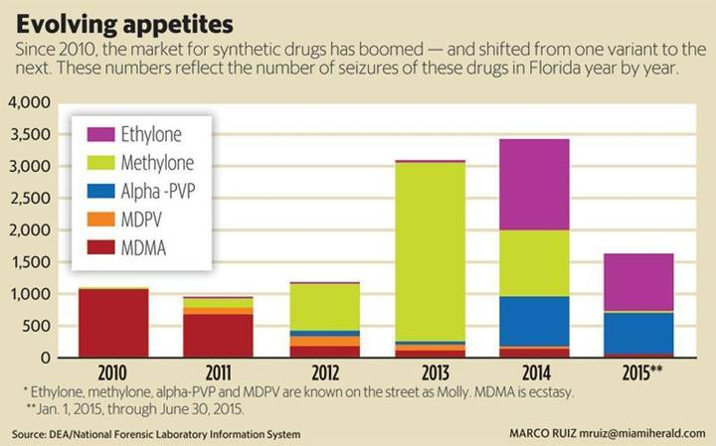
There are more than 300 synthetic drugs imported into the United States and more than 500 distributed globally, most of them produced in China, according to the U.S. State Department.
The U.S. government has raised the problem as a “top priority” and gained some cooperation from Chinese officials in recent years, leading to some bans and intelligence on certain synthetic drugs, State Department officials told the Miami Herald.
The United States and China also have collaborated under the auspices of the United Nations Office on Drugs and Crime, which is holding a conference next April on psychoactive substances. “The Chinese were not initially open, but they are now less reticent,” said one State Department official, who spoke on condition of anonymity.
(Update: On Friday, Justice Department officials announced they held two meeting this week with their Chinese counterparts to discuss international drug trafficking, including differences in their legal systems, investigative practices and national problems. The discussions, which included DEA officials, covered the "emerging threat" of "designer drugs" exported from China to the United States.)
Despite the dialogue, the China pipeline remains very much a buyer’s market. In their own highly competitive industry, some Chinese suppliers will even fully guarantee products, often promising replacements if packages get lost or seized. Email exchanges between a Chinese supplier and a Hialeah man named Enrique Enriquez — who pleaded guilty to a distribution charge on Monday — reveal suppliers are wary of U.S. law enforcement but hungry for American money.
“next order will be fast as we have study shipping tactics already,” the supplier wrote to Enriquez, who federal prosecutors say was part of a Hialeah gang known as Y-LO. “fedex is a little bit tight as most supplier sent K powder and many illegal products via fedex to USA. so usa customs notice that and it reason why most products are stop in custody.”
In emails obtained by the Miami Herald, a supplier calling himself Vladimir insisted that several parcels lost in transit would arrive. Enriquez replied: “we trust u. we will not order from other supplier. we will keep doing long term business with u. business is booming.”

More drug marketing
And business has boomed — so much that suppliers are even marketing attractive new packaging options.
Through the Web, South Florida dealers can buy synthetic drugs as any variety of colored pills, capsules or raw crystal forms, or packaged in brightly colored pouches with the names of cartoons. In July, for example, Miami federal jurors convicted Ronen Nahmani, 41, who imported synthetic cannabis, in liquid and leafy form, from China for distribution throughout Florida. Some of the packages were labeled “Scooby Snax.”
The sheer variety of synthetic options also has mushroomed. Miami-Dade police chemists identified 26 different types last year alone, a four-fold increase since 2011.
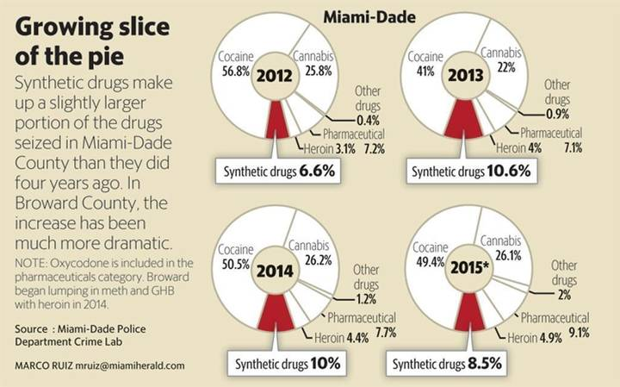
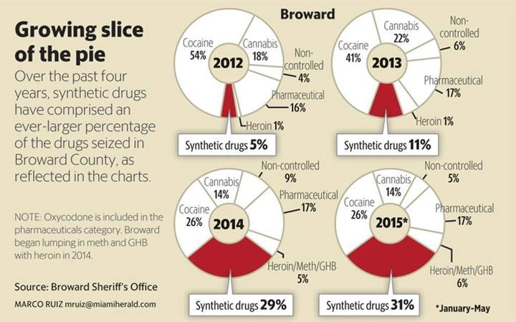
“Once they are controlled at the state levels, then enterprising chemists will develop another drug,” said Oliver Spicer, a managing chemist with Miami-Dade Police’s crime lab. “These drugs came about to circumvent drug laws.”
But buyers don’t know that. Take the moniker Molly, a catch-all name agents believe is a play on the word “molecule” and was originally hawked as a pure form of the club drug ecstasy. In 2013, at least one Miami importer tried to pass off a few kilos of alpha-PVP as Molly, but the product didn’t sell because it didn’t give the right euphoric high to enhance the club experience. In one case, a Miami Ultra festival attendee named Adonis Pena Escotodied of an alpha-PVP overdose.
“These young kids and adults are playing Russian roulette because they have no idea what they’re putting in their bodies,” said Ferrer, the U.S. attorney in Miami. “When they believe they’re taking Molly, they have no idea what it is.”
Alpha-PVP or flakka — a synthetic drug that provides a fiery wave of stimulation to the brain — surfaced in Miami-Dade and Broward in 2014. But flakka — Spanish slang for “skinny” — really took off among the transient and homeless population in Broward.
THESE YOUNG KIDS AND ADULTS ARE PLAYING RUSSIAN ROULETTE BECAUSE THEY HAVE NO IDEA WHAT THEY’RE PUTTING IN THEIR BODIES. WHEN THEY BELIEVE THEY’RE TAKING MOLLY, THEY HAVE NO IDEA WHAT IT IS.Wilfredo Ferrer, U.S. attorney for Southern Florida
Police have blamed the drug for people doing everything from streaking naked in the streets to breaking into a police station. Flakka has been found in the system of more than 40 people in Broward who died in multi-drug overdoses, murders, accidental drownings and suicides. But, contrary to numerous media reports, the drug has been listed as the direct cause of death in only one overdose case, according to the Broward Medical Examiner’s Office.

Low risk, big profit
Despite public and law enforcement scrutiny, perpetrators continue selling synthetic drugs because the profit margins are so high. A kilo of ethylone might cost $1,500 and net $100,000, a big score even for dealers used to plying the streets with traditional drugs such as cocaine.
Pompano Beach’s Kevin Bully, 25, has a long history of arrests dealing cocaine and other drugs. But federal prosecutors say he found his niche by ordering alpha-PVP from a company based in Hong Kong. Flush with new money, Bully moved to affluent Boca Raton before he was arrested in July. He is awaiting trial.
But many South Florida dealers are not stock-in-trade street toughs. At least six young men arrested in significant synthetic cases over the last few years attended FIU. “These young men are unusual because they were middle-class students who were pursuing their college degrees while they were involved with the Molly trade,” said Andrew Levi, a criminal defense attorney who represented one dealer.
McConnell, for instance, was described by his lawyer as a brilliant young man who built his Molly operation in the mold of McDonald’s, franchising 20-something-age dealers while supplying them with methylone. Two of them, Andrew Pouya and Craig Wiseman, cooperated with agents against him.
McConnell also battled addiction to his own products and mental health woes. But he was was prosecuted like a cocaine kingpin. He pleaded guilty and faces up to 20 years in prison when sentenced Sept. 28.
Il Tae Jin, 27, was a few credits shy of graduating from FIU’s hospitality management program. He turned to the Molly trade to feed gambling and alcohol habits and cover tuition. His cooperation against fellow dealer Julio Cesar Velez helped him get a reduced sentence of one year in prison; he’ll be released in January.
Then there was Miami’s David Espinosa, 25, who defied the image of a dealer. As a child, he attained the rank of an Eagle Scout. Espinosa, at the time of his arrest in 2013 for importing methylone from China through the mail, was just a few credits shy of finishing a degree in criminal justice at FIU.
“I can’t think of too many Eagle Scouts I’ve sentenced,” U.S. District Judge William Dimitrouleas told Espinosa before meting out a 2 1/2-year prison sentence.
Despite an increase in seizures, arrests and convictions, many experts believe the number of tech-savvy traffickers in South Florida and elsewhere tapping the China pipeline is likely to only rise.
“It’s a perfect storm,” said criminal defense attorney Paul Petruzzi, who has represented McConnell and other major synthetic drug dealers. “It’s fundamentally changed the world of drug trafficking, and the federal government was not ready for it. You can’t interdict this stuff like big shipments of cocaine. You can’t fight this war the way that Reagan and Bush talked about in the 1980s.”
Read more here: http://www.miamiherald.com/news/local/crime/article35417625.html#storylink=cpy

The China pipeline, part 2: The rise and fall of a Molly kingpin
A small-timer goes big through the China Pipeline
FIU student pocketed $30,000 a week from synthetic drug sales
One last buy, an orange Lamborghini, led to his downfall
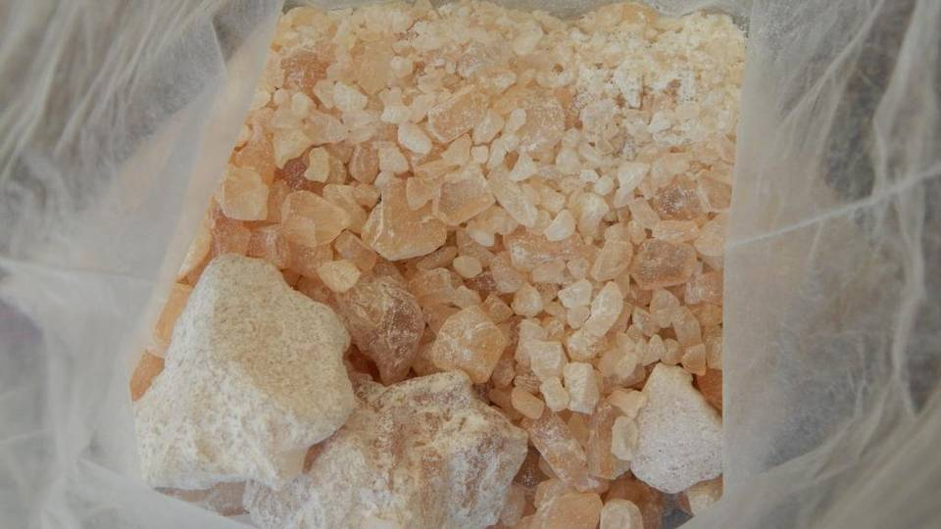
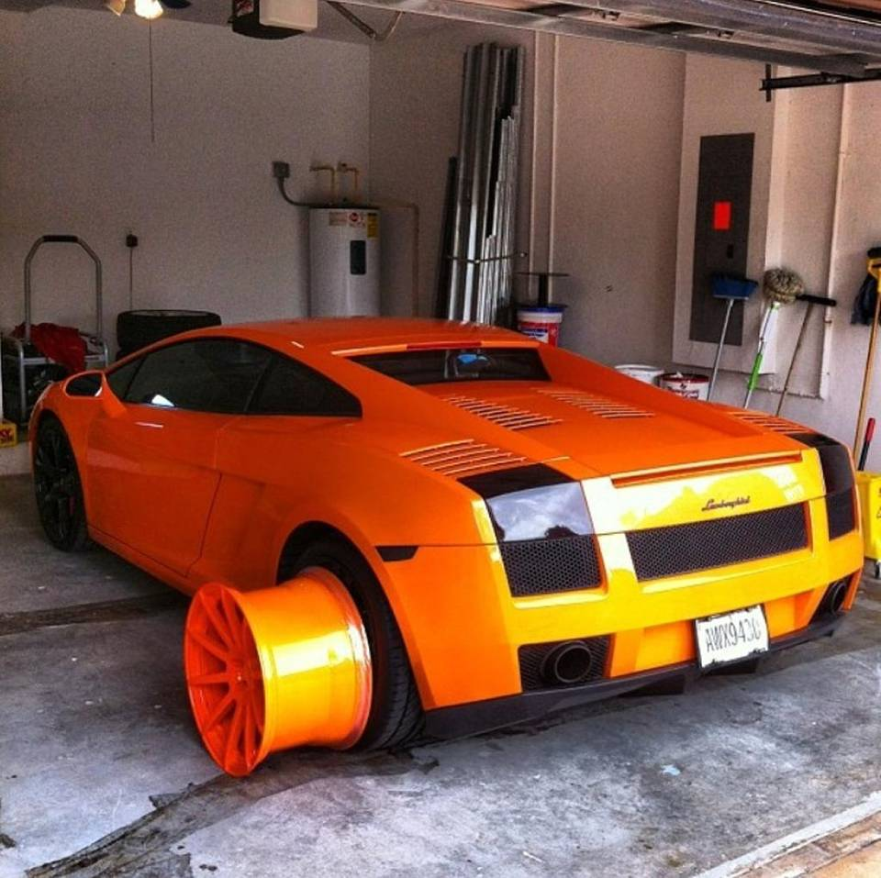
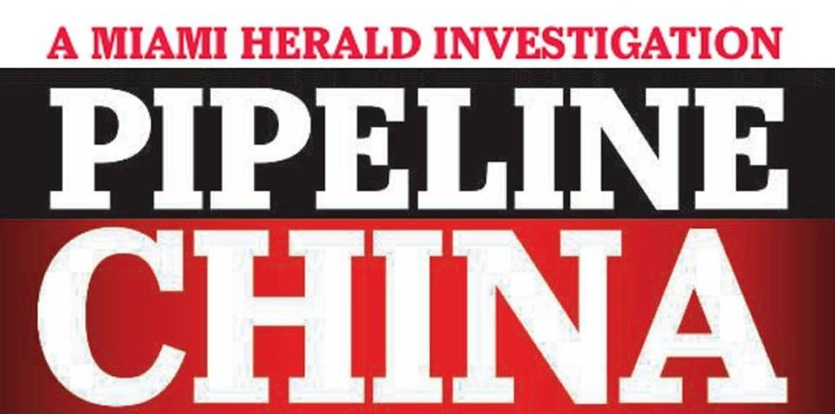

1 of 3
This bright orange Lamborghini Gallardo, one of many luxury cars acquired by Miami’s Molly kingpin, also helped lead to his downfall. Agents used it to help pinpoint the former FIU student. Handout
SECOND IN A THREE-PART SERIES.
BY DAVID OVALLE
AND JAY WEAVER
dovalle@MiamiHerald.com
Scoring synthetic drugs online through the China pipeline wasn’t quite as easy as ordering vitamins on Amazon.
But for a bright, ambitious Florida International University student looking to move up from small-time dealing, it wasn’t very hard either. An Internet search turned up plenty of chemical labs. Emails brought samples from overseas and led to a producer willing to concoct a Molly blend that dance-club kids prized — methylone in a perfect brownish hue and crystalline texture.
Draining his savings, he wired $10,000 to China. The product, mailed to post-office boxes around South Florida, was snapped up by buyers from as far away as the University of Central Florida.
“I sold four kilos in about 10 minutes. I made $30,000 in a matter of minutes,” he said.
Soon, dozens of kilos of methylone — one of an array of dangerous chemicals packed into capsules and sold as Molly — flooded South Florida. And almost overnight, a college kid studying construction management became a club-drug kingpin burning through cash. Rolex watches, benders at strip clubs, luxury cars, including an orange Lamborghini Gallardo that proved a not-so-subtle tipoff that he was not a typical struggling undergrad.
“I spent it like you wouldn’t believe,” said the 26-year-old former FIU student during an in-depth interview from federal prison. The Miami Herald agreed not to name him because his eventual cooperation with authorities led to death threats and a Miami federal judge ordered his criminal court file sealed.
“He was known as a significant supplier in the area,” said Alysa Erichs, Special Agent in Charge of the U.S. Homeland Security Investigations South Florida field office. “And he made a significant amount of money at a young age.”
Breaking up his fleeting empire gave federal law enforcement authorities in South Florida one of their first windows into the next generation of tech-savvy drug dealers exploiting the loosely regulated China pipeline, the prime international smuggling route for synthetic drugs. Many of the so-called “designer” drugs, often mixed in fly-by-night labs from untested and unknown chemicals of widely varying potency, can be toxic. The most notorious, flakka, has been identified in the bodies of more than 40 death cases in Broward County alone over the past year.
The dealer — Tony for this article — was debriefed by federal agents holed up in a Miami hotel room over several days in May 2013. His information helped nail two other Molly dealers, who in turn cooperated against another former FIU student, David McConnell, a major importer who will be sentenced Sept. 28.

Aspirations of becoming a contractor
Tony did not come to Miami with plans to become a drug dealer. “I never even smoked weed before I left New York.”
He grew up in a middle-class Brooklyn family that moved to the Long Island suburbs, son of a school principal and a successful contractor. His upbringing was cliché suburbia: baseball, karate, summer sleep-away camps. In high school, the honors student traveled to Europe as a “student ambassador,” joined the chess club and wrestled competitively.
Tony graduated early at age 17, visiting schools across the country with aspirations of a degree in construction management. FIU offered him a partial scholarship, and the lure of the tropics proved inescapable.
THERE WAS SOMETHING ABOUT MIAMI, THE BEACHES, THE WEATHER, THE WOMEN. I LOVED THE WHOLE SCENE, PROBABLY FOR ALL THE WRONG REASONS.‘Tony,’ club-drug kingpin
“There was something about Miami, the beaches, the weather, the women,” he said. “I loved the whole scene, probably for all the wrong reasons.”
Tony moved into an FIU dorm and, like lots of students, immersed himself in the club scene — Mansion in South Beach, Space in downtown Miami, college nightspots in Coconut Grove. At the clubs, he saw a lot of gorgeous women popping pills. So he did, too. At the time, it was almost all sold as ecstasy.
“I was scared at first, but it didn’t have a negative connotation like heroin. It was a cool thing to do,” he said.
Each quarter-gram dose of ecstasy lasted up to six hours. “You get an instant rush of euphoria. It’s just the ultimate confidence booster. You feel free.”
Frustrated with scraping by on a couple hundred dollars a week from a part-time retail job, Tony began dabbling in pill peddling in 2011 while still plodding through classes at FIU. At a Coconut Grove nightclub, he bought an ounce of Molly, just emerging as the new party drug of choice. He cut it with Vitamin C crystals to stretch it, selling to friends at $10 a pop. Initially, he considered himself more of a party host than a drug dealer.
“For me growing up, seeing drug dealers, they had a certain aura about them I didn’t like. It was very street. I was just dealing with Mollies,” Tony said. “I was dealing to other college students. It didn’t feel wrong.”
His class attendance dropped as his attention shifted to expanding his drug business. Hunting for a bulk supplier of empty pill capsules led him to a popular flea market in the gritty West Little River neighborhood of Miami, where vendors hawk everything from perfumes and tattoos to gold chains and gold teeth.
Inside the market, off Northwest 79th Street, Tony found a small store specializing in drug paraphernalia — money counters, scales, and an array of pipes. He found the empty capsules he needed but also stumbled on a source of synthetic drugs. At the time, they were being sold as legal substances in brightly colored packages, usually in gas stations and inner-city markets. He dabbed some on his tongue. It had the same effect as Molly.
Tony became a regular, filling his capsules from the packages. He barely went to class or showed up for his job but, at 21, was suddenly pulling in $1,000 a week and living in a rented house in Doral with some buddies. He bought an old Mercedes and paid for a cheap paint job and fancy rims.
“I felt like I was on top of the world,’’ he said. “I was with a different girl every night. That’s what goes with that lifestyle.”

Flea market reveals the China pipeline
After a year, though, he yearned for more and pondered how to cut out the middleman, the shopkeeper. “He was making a killing off me,” he said.
On one visit, the product was sold out but the shopkeeper assured him a few kilos would be delivered soon. A few days later, the supply was there. Inside the cramped store, the shopkeeper showed him the brown chemical rocks — sealed in a bag inside a box. When the shopkeeper left to tend to another customer, Tony sneaked a peak at the return address on the parcel: China.
He’d found the pipeline.
Tony wrote the company name on the palm of his hand. Back home, he searched the Net and scoured Alibaba, the Chinese version of Amazon. He never found the shopkeeper’s exact connection, but he came across a slew of online sources for “research chemicals.”
Tony fired off dozens of emails and got many responses. He bought small quantities,delivered through the mail — much of it “garbage” he wouldn’t sell. Then one supplier he knew only as “Billy” sent him methylone that provided the right buzz. But buyers complained it appeared too “sandy.” He and Billy went back and forth through emails and phone calls, haggling over samples, tweaking the chemistry.
Finally, the right stuff arrived in December 2012 — just in time for the holiday rush.
He began arranging buys on a throw-away laptop from Walmart or on computers at a Kinko’s. He or one of his friends drove around town picking up packages as he turned from street dealer to supplier, selling kilos of raw synthetics to others who paid top dollar and did the packaging themselves.
Money rolled in. Usually, about $30,000 a week.
He plowed some into a few legit ventures: a Miami barbershop and car rental business. And he made some practical purchases: a $335,000 two-story, four-bedroom house in West Kendall that he promptly renovated.
But he also embraced the high life. Tony and his boys made it rain hard at strip clubs — Tootsies, King of Diamonds, Club Dream. “I spent $9,000 on my birthday.” Then there was the $64,000 diamond chain, the four or five Rolex watches, the luxury cars: a Bentley, Maserati, Porsche.
From a seller on eBay, Tony bought a bright orange Lamborghini Gallardo — the same model that pop star Justin Bieber was later popped in for drag racing on Miami Beach — and outfitted it with custom-forged aluminum alloy wheels. In a home video clip, he smiles broadly and says “Lambo life,” before zooming down the street propelled by a snarling V-10 engine.
The car soon led to his downfall.

A bright orange V-10 clue
Agents with the U.S. Homeland Security Investigations, or HSI, had begun looking for the source of the methylone pouring into South Florida. They got an initial clue when agents in New York City discovered one of Tony’s packages from China and busted one of his cousins who picked it up there.
But the real break came in March 2013, as South Florida agents geared up for the upcoming Ultra electronic music festival, an event that draws thousands of fans, some looking to score Mollies. One club promoter facing drug charges told agents that Miami’s major supplier of Mollies drove a distinctive orange Lamborghini.
It didn’t take long for agents to trace the vehicle to Tony, who had it registered in his name.
The noose tightened quickly. Agents busted two of his buyers, Ian Rae Johnson and Shawn Hawes, who were selling marijuana and Molly to a parade of well-heeled customers from a Kendall home. Agents found a big bag of methylone and tens of thousands of dollars in cash stuffed inside clothes in a bedroom closet.
Johnson told HSI agents that Tony — whose true identity he did not know — had recently sold him a bag of methylone for $7,000. The key tip: Tony often drove a nondescript Honda CRV during his deals.
The club promoter also told agents that someone named “Juan Carlos Garcia,” one of Tony’s associates, had been picking up suspicious packages at post offices and UPS stores across Broward County. Records showed 24 packages in that name shipped from China, Hong Kong and New York between January and July 2013.
On the afternoon of July 11, 2013, agents got a tip that a package had arrived at a UPS store in Sunrise. Investigators watched as a man believed to be “Garcia” parked, retrieved the package and walked back to his car, according to a criminal complaint by HSI Agent Kevin Selent.
HE SPED OFF DOWN INTERSTATE 75 AND — IN A MADE-FOR-THE-MOVIES SCENE — HE TOSSED SEVERAL CELLPHONES OUT OF THE CAR WINDOW WITH AGENTS IN HOT PURSUIT.
Nearby, Tony was also watching from his Honda CRV. Agents spotted him. He sped off down Interstate 75 and — in a made-for-the-movies scene — he tossed several cellphones out of the car window with agents in hot pursuit.
They soon broke it off. No chase was necessary. Arrested at the scene, “Garcia” turned out to be Rafael Marte, one of Tony’s underlings. Inside his package, according to the criminal complaint, were 10 kilos of methylone. Marte quickly flipped on his boss. Agents put Tony’s West Kendall home under surveillance, along with his girlfriend’s place, where Tony soon showed up. After talking with his attorney, Tony agreed to cooperate with investigators.
He had little choice. The evidence against him was overwhelming
Inside his white Porsche Panamera, agents found a black bag stuffed with $149,700 in cash. Marte’s phone revealed a string of text messages about “work” that he and Tony had to do the day of the pickup, according to the complaint. Text messages also placed him at the scene.
And there was a clincher. A couple of times, Tony had contacted his China supplier using his FIU email account — from a campus computer lab.
“That was the nail in the coffin,” he said. “I made a mistake. I was rushing.”
His brief, but lucrative reign as South Florida’s club-drug kingpin lasted less than seven months. After he was arrested, federal agents say, the price of Molly skyrocketed.
“Miami was dry,” said Erichs, special agent in charge of HSI. “The kilo prices went through the roof.”
Tony faced up to 20 years in prison on each count, but his extensive cooperation with agents and lack of criminal history softened the blow. He pleaded guilty to possession with intent to distribute a controlled substance.
Still-shocked supporters from New York wrote letters to U.S. District Judge James Cohn urging leniency. Among them: a retired New York judge, an uncle who is a retired New York City cop, a Brooklyn-district city council member and his mother, a longtime educator.
“I write this letter to you now, wondering where it went wrong and how do we pick up the pieces so that [Tony] can get back to who I believe he has the potential to be,” his mother wrote.
Cohn gave him two years in prison. He will be a free man early next year.
Read more here: http://www.miamiherald.com/news/local/crime/article35867541.html#storylink=cpy

The China pipeline, part 3: The deadly toll of synthetic drugs in South Florida
Synthetic drug-related deaths, nearly 300, on rise in Miami-Dade, Broward
Heroin substitute fentanyl, not infamous flakka, is deadliest
Experts: Untested chemical concoctions reduce users to “guinea pigs”
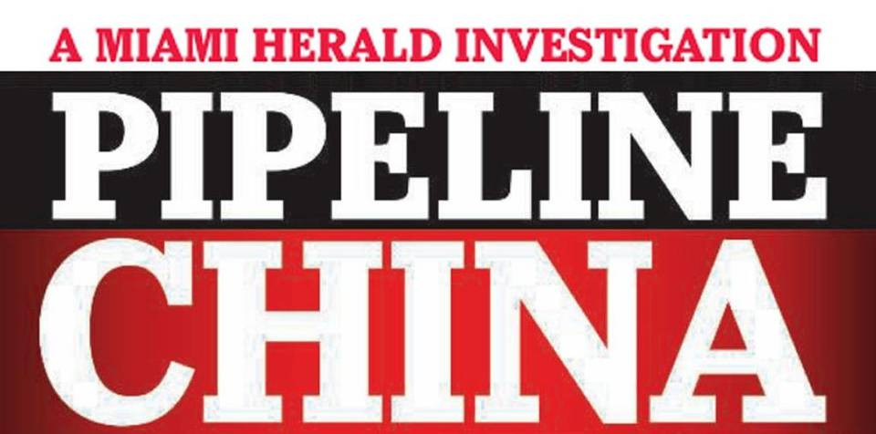
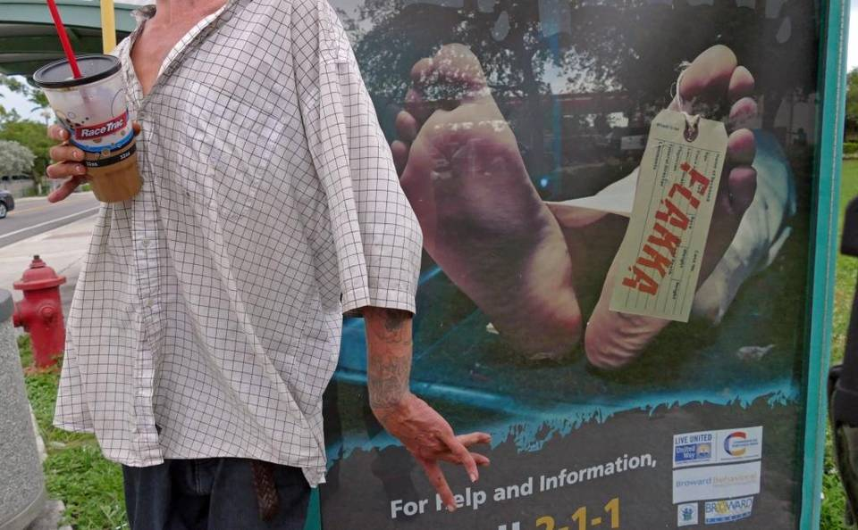
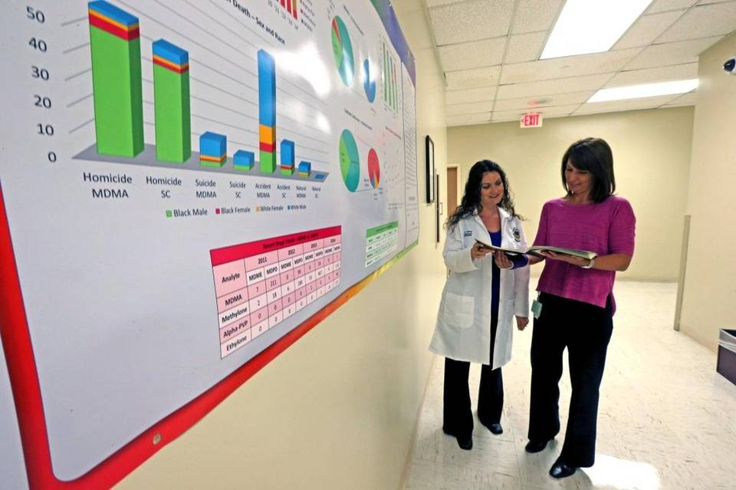

1 of 12
A flakka dealer named Ben high on the drug was stopped next to a Broward public service ad in Pompbano Beach by Broward sheriff’s Lt. Osvaldo Tianga earlier this month. Tianga called in paramedics to take him to the hospital. Walter Michot MIAMI HERALD STAFF
BY JAY WEAVER AND DAVID OVALLE
jweaver@MiamiHerald.com
Third in a three-part series.
Jordan Hirschfeld, a graduate of Michael Krop High who hoped to one day become a lawyer like his father, died in a Brickell apartment, the syringe still stuck in his arm after injecting a synthetic heroin called fentanyl. He was 28.
Java Jackson, high on the synthetic drug flakka, screamed at deputies and a medical crew that a snake was spitting acid on him and his clothes were burning before his over-revving heart failed at Broward Medical Center. He was 26.
Shaun Cole, a Scottish soldier attending the electronic music fest Ultra, had downed booze, cocaine and the synthetic drug ethylone before he plunged to his death from atop a Biscayne Boulevard office building. He was 22.

A personal tale about substance abuse & the synthetic drug Flakka
Synthetic drug-related deaths are on the rise in Miami-Dade & Broward counties. In this video, 26 year old Christopher Patterson describes the draw of Flakka. He spoke to the Miami Herald at the The Cove Recovery Center in Fort Lauderdale. Video by David Ovalle & Jose Iglesias.

The drug deaths of the three young men this year shared a common thread, one that ties them to scores of other overdose, suicide, accident and even murder victims in Miami-Dade and Broward counties: The synthetic substances medical examiners found in their bodies most likely arrived though the China Pipeline, which delivers illegal drugs, sold as bulk research chemicals on the Internet, to stateside dealers through the mail.
Authorities are scrambling to shut down the pipeline but they acknowledge that it remains the primary source of an array of dangerous so-called designer drugs flowing into South Florida. The grim result: a rising number of addicts, emergency room visits and deaths — particularly related to newer, more potent synthetics like infamous flakka and the less known —but even more lethal —fentanyl.
“This is Breaking Bad gone wild,” said George Hime, assistant director of the Miami-Dade County Medical Examiner’s toxicology lab. “There is no quality control. They don’t even know what they’ve created. Is it something that can cause pleasure for a short period of time? Yes. But it could also kill you.”
Flakka has run rampant among the homeless and in poor corners of Broward, offering a cheap and powerful rush aptly described as “$5 insanity.” Flakka, street slang for a chemical called alpha-PVP, induced one man up the coast in Brevard County to strip, proclaim himself the Norse god Thor and try to have sex with a tree. Two other men, suffering a serious flakka-fueled lapse in judgment, tried to break into Fort Lauderdale police headquarters.
Fentanyl users haven’t produced such attention-grabbing crazy rages, but the drug has quietly proven even deadlier in South Florida, according to a Miami Herald review of medical examiner records in both Miami-Dade and Broward counties. A fast-acting painkiller 50 times more potent than heroin, it has been used as a surgical analgesic for decades.
But investigators believe that underground labs in China fueling the synthetics pipeline have concocted illegal fentanyl as well as chemically tweaked “analogs” that are typically sold as heroin or mixed with it.
“Fentanyl and its analogs are often laced in heroin and are extremely dangerous, more so than alpha-PVP,” said Diane Boland, director of the Miami-Dade Medical Examiner’s toxicology lab. “People are dying at an alarming rate, especially those who believe they are using heroin when it’s in fact fentanyl. A small dose is enough to cause death.”
PEOPLE ARE DYING AT AN ALARMING RATE, ESPECIALLY THOSE WHO BELIEVE THEY ARE USING HEROIN WHEN IT’S IN FACT FENTANYL.
Diane Boland, director of the Miami-Dade M.E.’s toxicology lab
One offshoot — “beta-hydroxy-thiofentanyl” — was ordered from China last year by dealers in North Dakota (where it led to two overdose deaths), Oregon and Canada, who authorities say intended to ship it to Florida for sale. That was the same substance that had filled the syringe found in the cold arm of Jordan Hirschfeld.
His father, Neal Hirschfeld, a Fort Lauderdale lawyer, had never heard of fentanyl before it killed his son. “We had no experience with synthetics from China. I was completely shocked.”
And the Hirschfelds were unfortunately far better educated than most about addiction, having helped Jordan through battles with marijuana, alcohol and anti-anxiety medication. Jordan — described by his mother, Caryl Rapplean, as “full of life . . . tall, handsome, funny, smart” — had repeatedly tried to break the cycle at a boot camp in Utah, a rehab facility in Malibu and numerous local treatment centers.
“It was a battle we just couldn’t win,” his father said. “We tried everything and lost.”

Fast-rising death toll from fentanyl
While alcohol, prescription pills and established drugs like pot and cocaine still show up more frequently in toxicology reports, synthetics have been on a rapid rise that has alarmed police, the medical community and public health experts in South Florida. Medical examiner records in the two counties show that one or more of the most common synthetics have been detected in nearly 300 victims since 2011.
Jordan Hirschfeld fell victim to what has emerged as the deadliest designer drug. In less than a year going back to October 2014, fentanyl has outright killed or contributed to the overdose deaths of 53 people in Miami-Dade. Broward recorded 30 fentanyl-related deaths between June 2014 and June of this year alone. Jordan was the first of eight to die from the variant “beta-hydroxy-thiofentanyl,” which also has killed at least four other people in Broward.
FENTANYL HAS KILLED OR CONTRIBUTED TO THE OVERDOSE DEATHS OF AT LEAST 53 PEOPLE IN MIAMI-DADE AND 30 IN BROWARD IN ABOUT A YEAR.
Stefano Rotati of Pinecrest, a 29-year-old University of Miami graduate with model good looks and a promising musical career as a drummer, was another fentanyl fatality. In May, he collapsed inside a Miami apartment and later died at Jackson Memorial Hospital.
Audrey Rotati said her son had struggled with prescription painkiller abuse after injuring his back when his car was rear-ended a few years ago, but she didn’t believe he would knowingly take a risk on synthetic heroin.
“My little piece of heaven on Earth. He really was a sweet guy,” she said. “I’m 99.9 percent sure he didn’t know it was fentanyl he had taken.”
Flakka also has taken a heavy toll, particularly in Broward, where it has been linked to 43 fatalities in the last year, a figure that leads the nation and has drawn national media coverage. Many victims have been street people with addiction histories, but at least one baby, who died in July of prematurity at birth, also had the drug in his system. Flakka also has been present in 19 deaths in Miami-Dade since 2013.
But in both counties, flakka has rarely been cited as the sole or primary cause of death, instead usually listed among multiple drugs that ultimately proved toxic.
Java Jackson was Broward’s lone straight-out flakka overdose. On Memorial Day, a Broward Sheriff’s Office report described him at a Dania Beach home as screaming for his mother, hallucinating about an acid-spitting snake and burning clothes. He was, deputies reported, “extremely combative” during an ambulance ride. At the Broward Medical Center, his mother “pleaded” to have her 26-year-old son, who she said had been previously hospitalized after a flakka frenzy, committed for substance abuse treatment.
It was too late. He died the same day.
Months later, reached by phone, Erica Jackson said she was still too distraught to talk about her son. “It still brings up open wounds for me,” she said last week.

Overdoses reflect only part of the impact
Medical examiners, public health experts and law enforcement agencies stress that overdoses from a single drug reflect only a small part of the impact of the new wave of Chinese-made synthetics.
Flakka and other drugs often play a contributing role in a fatality, part of a cocktail of alcohol and other drugs that can turn lethal or trigger pyschotic behavior. For example, no one can say for sure why Shaun Cole, the Scottish soldier at Ultra, decided to climb atop a building or if he fell or jumped. But blood from his broken body contained alcohol, cocaine and ethylone, a synthetic often sold as the club drug Molly.
Molly, the catch-all name for a number of euphoria-inducing drugs popular in dance clubs and at concerts, also has been detected in at least 135 homicide, suicide and accidental deaths in Miami-Dade since 2011. (The Broward medical examiner’s office said it was unable to provide statistics for Molly-related deaths over the same period.)
That number is not surprising. Law enforcement agencies say drugs marketed as Molly remain the most prevalent synthetics in South Florida. They are offshoots of European-made MDMA, usually known as ecstasy, which had dominated the designer-drug scene during the previous decade.
Molly consisted mainly of methylone until a 2014 ban imposed in China and the United States. Chemists quickly skirted it by simply tweaking the formula to produce a similar substance called ethylone.
Sometimes called bath salts, both drugs are classified as synthetic cathinones, derived from the Middle Eastern khat plant. Overdose deaths directly attributed to Molly are less common, according to toxicologists, but still happen. In 2013, a 21-year-old Ultra music fan named Anthony Cassano began showing signs of “erratic behavior” before he was rushed to the hospital. Cause of death: “methylone toxicity.”

Untested, unknown chemicals add to risk
But experts say pills hawked as Molly, like other synthetics, often contain untested or unknown chemicals or ingredients — either blended in the lab or mixed in by dealers to stretch a supply and profits. Small Chinese labs, operating with little regulation, have unleashed so many variations that scientists stateside studying effects can’t keep up.
CHINESE LABS HAVE UNLEASHED SO MANY VARIATIONS THAT SCIENTISTS STATESIDE STUDYING EFFECTS CAN’T KEEP UP.
The scant research has generally been on small rodents and isolated human cells, said Gregory Dudley, a professor of chemistry and biochemistry at Florida State University who has testified in Molly-related court cases.
“There is frighteningly little research, particularly when it comes to human users,” Dudley said. “We just don’t know. Any reasonable person can conclude they are probably dangerous, and certainly there is anecdotal evidence, but we can’t quantify the dangers.”
It can take years for toxicologists to even figure out what some victims have taken.
George Salgado, a 21-year-old Miami fitness instructor, believed he was taking three tabs of LSD in April 2012. Afterward he stripped off his clothes and, eyes bulging and skin pouring sweat, attacked a man. He died after a police officer shot him multiple times with a Taser, his body temperature spiking to 105 degrees. Toxicologists couldn’t initially identify the drug.
That same year, teenage college students Marco Pomares and Hector Miranda vanished in a marshy area of West Miami-Dade after inhaling an unknown drug . They were later found, dead from exposure.
This year, the county medical examiner’s office developed more sophisticated testing protocols and was able to identify the same drug in both cases: a powerful synthetic hallucinogen called 25I-NBOMe.
A similar drug, 25C-NBOMe, was detected in the brain of graffiti artist Israel “Reefa” Hernandez-Llach, who died after being shot with a Taser by a Miami Beach police officer in 2013. The medical examiner ultimately ruled the cause of his death was heart failure from the “energy device discharge.”
Deborah Mash, a brain researcher at the University of Miami who has studied the effects of synthetic drugs, describes users in two words: “Guinea pigs.”
“It’s very, very scary,” she said. “We don’t know the potency, and we don’t know what’s in them.”

Flakka’s addictive appeal: Cheap, powerful rush
Still, for some hard-core users, the bang for the buck overrides the risks.
Flakka, which means “skinny” in Spanish, has been slow to spread in Miami-Dade, where law enforcement authorities say Molly remains queen of the club scene. But it took off in Broward’s transient and drug-addicted population as authorities shut down prescription-drug “pill mills” peddling painkillers.
FLAKKA SEIZURES HAVE SOARED IN BROWARD, FROM ZERO IN 2013 TO 800 SO FAR THIS YEAR.
Flakka seizures have mushroomed since in Broward, soaring from zero in 2013 to 200 last year. So far this year, the Broward Sheriff’s Office crime lab has examined 800 seizures.
Christopher Patterson, 26, of Miami, who said he has used a variety of narcotics, including heroin, since he was 15, had a relapse with flakka while undergoing drug treatment in Broward earlier this year. It was cheap, easily available and not detected on many drug tests.
On a flakka binge, he wound up wandering the drug dens of Pompano Beach, paranoid and filled with a maddening rush of calm euphoria and superhuman strength before returning to rehab.
“It was this mixture that felt like ecstasy, Molly, cocaine and crack. It was like this weird combination feeling that I just did not enjoy,” Patterson said in an interview at the Cove Center for Recovery in Fort Lauderdale. “But being an addict, knowing it wouldn’t show up on my drug test, it was so cheap I used it a few times before I was caught.”
Mash, the UM brain researcher, described flakka — which can be smoked, snorted, swallowed or injected — as “super coke.” At higher doses, the drug can deliver an overload of pleasure-inducing dopamines to the brain and a sense of super strength, but that can come with dangerous side effects of soaring fever, rapid heart rate and paranoia. She suggests that in some people, flakka has led to “excited delirium,” a brain disorder characterized by the bizarre rampages that have made headlines across the state.

‘Say no 2 flock’
Faced with what amounts to a flakka epidemic in some neighborhoods, Broward Sheriff Scott Israel and local officials this year launched a series of law-enforcement sweeps and community forums. One major goal is to keep the stuff out of schools and the hands of kids.
WHILE IT ISN’T A PROBLEM WITH SCHOOLS RIGHT NOW, I’D BE WATCHING FOR IT. . . . A VERY LITTLE AMOUNT, AND YOU’RE OFF TO THE RACES.
Craig Mallak, Broward Medical Examiner
“It’s coming in green and blue and yellow and red [tablets]; they’re adding fruit colors to it,” Broward Medical Examiner Craig Mallak said at one public forum this summer. “While it isn’t a problem with schools right now, I’d be watching for it because we’re going to start seeing it. . . . A very little amount, and you’re off to the races.”
Broward has produced a series of chilling public service ads posted in flakka hot spots, including bus stops. The posters, headlined “Lose your mind, lose your life,” show a corpse with a toe tag that reads “flakka.” In one gritty Pompano Beach warehouse district, locals constructed their own ad: red plastic cups in a chain-link fence spelling out: “Say no 2 flock.”
It’s not yet clear how well the messages are getting through.
During one early summer patrol, Broward Sheriff’s Lt. Osvaldo Tianga, who specializes in flakka and other synthetic drugs, came across 26-year-old Jenika Senter. She had moved from New England to the Fort Lauderdale area to get treatment for her heroin addiction — only to fall prey to flakka.
The sunburned and tattooed woman sat in a wheelchair, the result of injuries suffered when a car hit her during an earlier flakka binge. First, Tianga tried persuading Senter to enter rehab, even calling her mother in New Hampshire. But when he stopped her later, he found she had a small plastic baggie of flakka hidden in her purse.
“What pisses me off is you have family who cares about you,” Tianga said. “I offered you help an hour ago, but you didn’t want it. You need to go to jail today.”
After spending more than a month in jail for drug possession, Senter was released and enrolled in a court substance abuse program. But in July, she was charged with prostitution and released again in August.
On another outing this month, Tianga spotted a dealer he knew. The man, named Benjamin, twitched repeatedly as he walked down Atlantic Boulevard. Tianga asked to touch his hand to check his temperature — a telltale sign. It was high, so he called Broward Fire Rescue to take the 32-year-old to a local hospital.
The encounter, ironically, occurred in front of one of the county’s anti-flakka posters. And it underlined a message Tianga often delivers at community forums. Cops can’t turn off the pipeline of flakka by themselves.
“We can’t beat this drug alone, I’m sorry,” Tianga told a gathering this summer in Oakland Park. “We need a partnership with the community. We need to be one.”
Read more here: http://www.miamiherald.com/news/local/crime/article36723141.html#storylink=cpy

