Nintendo pills: Three teenagers rushed to hospital after consuming super-strength ecstasy tablets
- Nov 18, 2014 13:40
- By Luke Traynor

The teens, one boy and two girls, needed emergency treatment after taking the potent form of the Class A drug at an under-18s disco
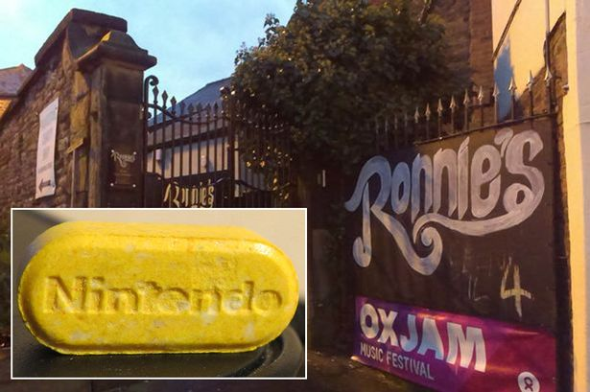
Super strength: Three teens are in hospital after taking Nintendos pills at an under-18s disco
Super-strength ecstasy pills branded Nintendos to cynically appeal to youngsters are responsible for putting three 14-year-old children in hospital.
The teenagers, one boy and two girls, were rushed to emergency wards after taking the potent form of the Class A drug at an under-18s disco on Saturday evening.
Shocked witnesses described the children as "having seizures", with "heads rolling around", who "weren't with us".
Police and paramedics who attended the scene at Ronnie's Bar, in Macclesfield, Cheshire, were told that ecstasy tablets called Nintendos - after the popular game console - had been consumed.
Ronnie Reece, owner of the Macclesfield bar, said: "My staff came across the three kids who seemed to be having a strange reaction to whatever they had taken.
"It was like they were having fits or seizures.
"Their heads were rolling around.
"They were conscious, but they weren't with us.
"We search everyone and do what we can to prevent drugs from getting onto the premises.
"Unfortunately there are people who either think they are cool or are part of some bigger criminal element that want to pedal this filth to children."
Two boys, both from Sale, Greater Manchester, 16 and 17, were arrested at the scene on suspicion of possessing drugs with intent to supply.
Pill Report 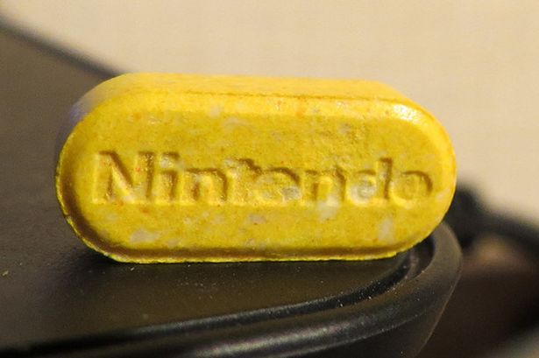
Yellow peril: A Nintendo pill
One of the girls remains in hospital but her condition is not believed to be life-threatening.
A batch of the bright Nintendos were seized by officers which can appear in a variety of colours including red, orange, green and yellow.
They are suspected of containing PMA, a powerful substance five times stronger than the more-typical MDMA or ecstasy, which has been responsible for up to 16 deaths in Britain.
One online account of a user taking a Nintendo for the first time last August revealed he wrote: "...rolling hard, I'm guessing because it's our first time its real strong for us, we're rolling everywhere.
"Staring at my lampshade and laughing for ages, saying how pretty the walls and lights are!"
The innocent-looking mint-style Nintendos contain a large dose of MDMA and is typically swallowed whole rather than crushed or snorted.
First surfacing in Belgium, the pill shows the Japanese game giant's logo, and is a spin-off of others ecstasy brands like Mitsubishi, Superman, Li-Ion and Butterfly.
Drugs deaths has previously touched Macclesfield when last year three people died in the town after taking ecstasy.
Oil rig worker Rachel Clayton, 34, and Emma Speed, 30, were found dead at a house in April last year while the drug was also found in the system of a 34-year-old man who was found dead in a caravan two months earlier.
Cheshire Police have issued a warning to revellers not to take the tablets.
Sergeant Adam Alexander, of Cheshire Police, said: "We continue to investigate the circumstances surrounding what happened."

