The truth about fat and sugar: Cardiologist explains why FAT is the best medicine - and why it's so crucial to our health

- Dr Aseem Malhotra is a cardiologist and founder of Action on Sugar
- Says fat has been unfairly demonised when sugar is the real villain
- Claims full fat diary can actually prevent heart disease and type 2 diabetes
- And diabetics told to eat carbs are unwittingly wrecking their health
By DR ASEEM MALHOTRA
PUBLISHED: 06:38 EST, 15 February 2016 | UPDATED: 14:12 EST, 15 February 2016

For decades, we were told that eating fat would lead us to early grave. Horror stories of clogged arteries and coronaries were the norm, while foods such as pasta were seen as healthy.
But research is increasingly disproving this theory - and sugar is now public enemy number one.
In fact, fat is good for us and should be our medicine, claims cardiologist Dr Aseem Malhotra, who is based in Surrey.
He says a mounting slew of evidence suggests that far from contributing to heart problems, having full fat dairy in your diet may actually protect you from heart disease and type 2 diabetes.
Here, writing for Men's Health, he explains his controversial view...
+8
Fuel: Dr Malhotra, a cardiologist, says he eats a three-egg omelette cooked in coconut oil for breakfast, having ditched his previous diet of sugared cereal, toast and orange juice for breakfast
This morning, as I do most days, I breakfasted on a three egg omelette cooked in coconut oil, with a whole milk coffee.
I enjoyed a wedge of full fat cheese with my lunch, poured a liberal dose of olive oil on my evening salad and snacked on nuts throughout the day.
In short, I ingested a fair amount of fat and, as a cardiologist who has treated thousands of people with heart disease, this may seem a particularly peculiar way to behave.

Fat, after all, furs up our arteries and piles on the pounds – or at least that’s what prevailing medical and dietary advice has had us believe.
As a result, most of us have spent years eschewing full fat foods for their ‘low fat’ equivalents, in the hope it will leave us fitter and healthier.
Yet I’m now convinced we have instead been doing untold damage: far from being the best thing for health or weight loss, a low fat diet is the opposite.
In fact, I would go so far as to say the change in dietary advice in 1977 to restrict the amount of fat we were eating helped to fuel the obesity epidemic unfolding today.
+8
Far from being the enemy, fat is good for us and should be our medicine, claims Dr Malhotra
It’s a bold statement, but one I believe is upheld by an array of recent research.
WHY I ENCOURAGE MY PATIENTS TO EAT FAT
These days I make a point of telling my patients – many of whom are coping with debilitating heart problems – to avoid anything bearing the label ‘low fat’.
Better instead, I tell them, to embrace full fat dairy and other saturated fats within the context of a healthy eating plan.
It’s an instruction that is sometimes greeted with open-mouthed astonishment, along with my request to steer clear of anything that promises to reduce cholesterol – another of those edicts we are told can promote optimum heart and artery health.
As we will see, the reality is far more nuanced: in some cases lowering cholesterol levels can actually increase cardiovascular death and mortality, while in healthy people over 60 a higher cholesterol is associated with a lower risk of mortality. Why, exactly, we will come to later.
First though, let me make it clear that until very recently, I too assumed that keeping fat to a minimum was the key to keeping healthy and trim.
In fact, to say my diet revolved around carbohydrates - sugared cereal, toast and orange juice for breakfast, a panini for lunch and pasta for dinner was not an uncommon daily menu.
Good solid fuel, or so I thought, especially as I am a keen sportsman and runner.
Still, I had a wedge of fat round my stomach which no amount of football and running seemed to shift.
That, though, wasn’t the reason I started to explore changing what I ate.

THE TOXIC TRUTH ABOUT SUGAR
That process started in 2012, when I read a paper called ‘The toxic truth about sugar’ by Robert Lustig in the science journal Nature.
In it, Lustig, a Professor of Paediatrics who also works at the University of California’s Centre for Obesity Assessment, said the dangers to human health caused by added sugar were such that products packed with it should carry the same warnings as alcohol.
+8
Obesity is not about how many calories we eat, but what we eat, he claims. For example, refined carbohydrates - such as pasta - fuel the over production of insulin, which in turn promotes fat storage
It was an eye-opener: as a doctor I already knew too much of anything is bad for you, but here was someone telling us that something most of ate unthinkingly every day was, slowly, killing us.
The more I looked into it, the more it became abundantly clear to me that it was sugar, not fat, which was causing so many of our problems.
This is why, along with a group of fellow medical specialists, I launched the lobbying group Action on Sugar last year with the aim of persuading the food industry to reduce added sugar in processed foods.
I would go so far as to say the change in dietary advice in 1977 to restrict the amount of fat we were eating helped to fuel the obesity epidemic unfolding today
Then earlier this year I had another light-bulb moment.
In February Karen Thomson, the granddaughter of pioneering heart transplant surgeon Christian Barnard, and Timothy Noakes, a highly-respected Professor of Exercise and Sports Medicine at the University of Cape Town, invited me to speak at the world’s first ‘low carb’ summit in South Africa.
I was intrigued, particularly as the conference hosts are both fascinating characters.
A former model, Ms Thomson has courageously battled a number of addictions including alcohol and cocaine, but lately it is another powder – one she labels ‘pure, white and deadly’ – that has resulted in her opening the world’s first carbohydrate and sugar addiction rehab clinic in Cape Town.
Professor Noakes, meanwhile, has recently performed a remarkable U-turn on the very dietary advice he himself expounded for most of his illustrious career: that is, that athletes need to load up on carbohydrates to enhance performance.
A marathon runner, he was considered the poster boy for high carbohydrate diets for athletes – then he developed type 2 diabetes.
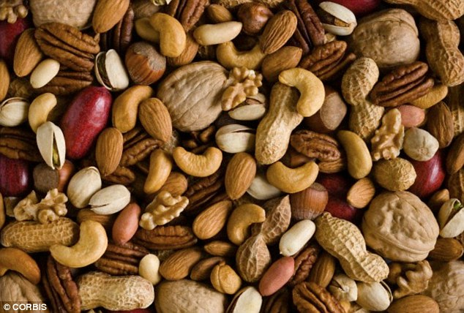
+8
Foods containing 'good' fats, such as nuts, are key to helping reduce inflammation in the body
THE TERRIFYING LINK BETWEEN SUGAR AND DISEASE
Effectively tearing pages out of his own textbook, Professor Noakes has now said athletes – and this goes for those of us who like to jog around the park too – can get their energy from ketones, not glucose.
That is, from fat not sugar.
Alongside them were 15 international speakers ranging from doctors, academics and health campaigners who between them produced an eloquent and evidence-based demolition of 'low fat' thinking – as well as suggesting that it is carbohydrate consumption, not fatty foods, which is fuelling our obesity epidemic.
As one scientist said: 'You don’t get fat from eating fatty foods, just as you don’t turn green from eating green vegetables'
Opening the conference was Gary Taubes, a former Harvard physicist who wrote The Diet Delusion, in which he argued that it is refined carbohydrates that are responsible for heart disease, diabetes, obesity, cancer, and many other of our Western maladies.
The book caused controversy when it was released seven years ago, but his message is finally gaining traction.
And that message is this: obesity is not about how many calories we eat, but what we eat.
Refined carbohydrates fuel the over production of insulin, which in turn promotes fat storage.
In other words: it’s not calories from fat themselves that are the problem. It’s a robust message that was reinforced time and again at the conference.
Take Swedish family physician Dr Andreas Eenfeldt, who runs the country’s most popular health blog Diet Doctor.
+8
'I would go so far as to say the change in dietary advice in 1977 to restrict the amount of fat we were eating helped to fuel the obesity epidemic unfolding today,' Dr Malhotra claims
In his home country, studies show that up to twenty three per cent of the population are embracing a high fat, low carbohydrate diet.
A ticking time bomb you might think – but contrary to expectations, while obesity rates are soaring everywhere else, they are now starting to show a decline there.
More research on this correlation is yet to be done – but in the meantime The Swedish Council on Health Technology has made its position clear.
After a two year review involving 16 scientists, it concluded that a high fat, low carb diet may not only be best for weight loss, but also for reducing several markers of cardiovascular risk in the obese.
A mounting slew of evidence suggests that far from contributing to heart problems, having full fat dairy in your diet may actually protect you from heart disease and type 2 diabetes
In short, as Dr Eenfeldt told the conference: ‘You don’t get fat from eating fatty foods just as you don’t turn green from eating green vegetables.’
This, of course, is a difficult message for many to swallow; particularly for heart patients, most of whom have spent years pursuing a low fat, low cholesterol diet as the best way to preserve heart health.
It’s a public health message that was first promoted in the sixties, after the globally respected Framingham Heart study sanctified high cholesterol as a major risk factor for heart disease.
It’s a cornerstone of government and public health messages – yet what people didn’t know was that the study also threw up some more complex statistics.
Like this one: for every 1mg/dl per year drop in cholesterol levels in those who took part in the study there was a 14 per cent increase in cardiovascular death and an 11 per cent increase in mortality in the following 18 years for those aged over 50.
It’s not the only statistic that doesn’t sit with the prevailing anti-cholesterol message.

THE LINK BETWEEN FAT AND CHOLESTEROL
In 2013, a group of academics studied previously unpublished data from a seminal study done in the early seventies, known as the Sydney Diet Heart study.
They discovered cardiac patients who replaced butter with margarine had an increased mortality, despite a 13 per cent reduction in total cholesterol.
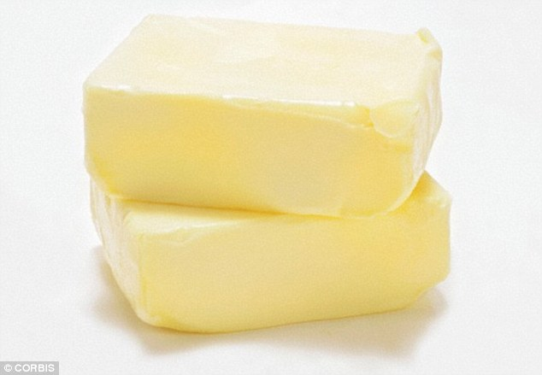
+8
A landmark Australian study found cardiac patients who replaced butter with margarine had an increased mortality, despite a 13 per cent reduction in total cholesterol. Dr Malhotra claims this is because a lower cholesterol is not in itself the mark of success, it only works in parallel with waist size and blood sugar levels
And the Honolulu heart study published in the Lancet in 2001 concluded that in the over-sixties a high total cholesterol is inversely associated with risk of death.
Startling, isn’t it? A lower cholesterol is not in itself the mark of success, it only works in parallel with other important markers, like a shrinking waist size and diminishing blood markers for diabetes.
Conversely, a mounting slew of evidence suggests that far from contributing to heart problems, having full fat dairy in your diet may actually protect you from heart disease and type 2 diabetes.
What most people fail to understand is that, when it comes to diet, it’s the polyphenols and omega 3 fatty acids abundant in extra virgin olive oil, nuts, fatty fish and vegetables that help to rapidly reduce thrombosis and inflammation independent of changes in cholesterol.
Yet full fat dairy has remained demonised – until now.
In 2014, two Cambridge Medical Research Council studies concluded that the saturated fats in the blood stream that came from dairy products were inversely associated with type 2 diabetes and heart disease.
Meaning that in moderate amounts – no-one is talking about devouring a cheese board in one sitting here – cheese is actually a proponent of good health and longevity.
The same study, incidentally, found that the consumption of starch, sugar and alcohol encourages the production of fatty acids made by the liver that correlate with an increased risk of these killer diseases.
+8
We have become a nation of 'over-medicated sugar addicts who are eating and pill-popping their way to years of misery with chronic debilitating diseases and an early grave,' Dr Malhotra claims

HOW CARBS HAVE WRECKED THE HEALTH OF DIABETICS
It is around type 2 diabetes, in fact, that the anti-fat pro-carb message of recent decades has done some of the greatest damage.
A lot of patients suffering from type 2 diabetes – the most common kind – are labouring under the dangerous misapprehension that a low fat, starchy carbohydrate fuelled diet will help their medication work most effectively.
They couldn’t be more wrong.
Earlier this year, a critical review in the respected journal Nutrition concluded that dietary carbohydrate restriction is one of the most effective interventions for reducing features of metabolic syndrome.
+8
To protect your heart, ditch low-fat spread for butter or, better still, a bottle of extra virgin olive oil
It would be better to rename type 2 diabetes 'carbohydrate intolerance disease'.
Try telling this to the public though.
Like the man who called into a national radio show in Cape Town on which I was taking part to discuss the relationship between diet and heart disease.
Diagnosed with type 2 diabetes, he was under the impression he had to consume sugar so his diabetes medications could ‘work’ – when in fact it was going to worsen his symptoms.
And how many doctors and patients know that although some of these medications to control blood sugar may marginally reduce the risk of developing kidney disease, eye disease and neuropathy, they don’t actually have any impact on heart attack, stroke risk or reduce death rates?
In fact, overmedicating on diabetes drugs is actually causing dangerously low blood sugar levels.
This is responsible for approximately 100,000 emergency room visits per year in the United States.
But who can blame the public for such misguided perceptions?
In my opinion a perfect storm of biased research funding, biased reporting in the media and commercial conflicts of interest have contributed to an epidemic of misinformed doctors and misinformed patients.
The result is a nation of over-medicated sugar addicts who are eating and pill-popping their way to years of misery with chronic debilitating diseases and an early grave.
It’s why, these days, I very seldom touch bread, have got rid of all added sugars and have embraced full fat as part of my varied Mediterranean-inspired diet.
I feel better, have more energy and – even though I didn’t set out to do so – I’ve lost that fatty tyre around my waist, despite reducing the time I spend exercising.
Perhaps you can’t face making all those changes in one go.
In which case, if you do one thing, make it this: next time you are in the supermarket and are tempted to pick up a pack of low-fat spread, buy a pack of butter instead or, better still, a bottle of extra virgin olive oil.
Your heart will thank you for it.
The father of modern medicine Hippocrates once said, 'let food be thy medicine and medicine be thy food'.
It’s now time we let 'fat' be that medicine.
Dr Aseem Malhotra is a cardiologist and advisor to the National Obesity Forum.
@DrAseemMalhotra
He is currently crowdfunding for his documentary film 'The Pioppi Protocol – 21 days to whole heart health'.

