Good Fats, Bad Fats
Leer en español
Personal Health
By JANE E. BRODY JAN. 29, 2018
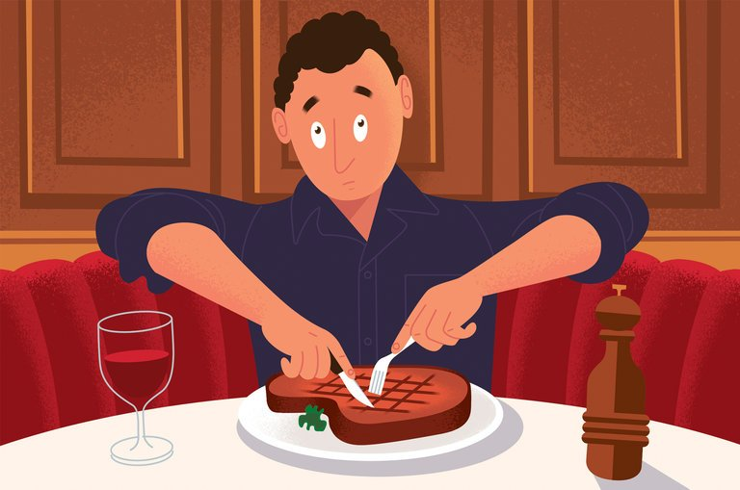
CreditPaul Rogers
The media love contrarian man-bites-dog stories that purport to debunk long-established beliefs and advice. Among the most popular on the health front are reports that saturated fats do not cause heart disease and that the vegetable oils we’ve been encouraged to use instead may actually promote it.
But the best-established facts on dietary fats say otherwise. How well polyunsaturated vegetable oils hold up health-wise when matched against saturated fats like butter, beef fat, lard and even coconut oil depends on the quality, size and length of the studies and what foods are eaten when fewer saturated fats are consumed.
So before you succumb to wishful thinking that you can eat well-marbled steaks, pork ribs and full-fat dairy products with abandon, you’d be wise to consider the findings of what is probably the most comprehensive, commercially untainted review of the dietary fat literature yet published. They are found in a 26-page advisory prepared for the American Heart Association and published last June by a team of experts led by Dr. Frank M. Sacks, professor of cardiovascular disease prevention at the Harvard T.H. Chan School of Public Health.
The report helps to explain why the decades-long campaign to curb cardiovascular disease by steering the American diet away from animal fats has been less successful than it might have been and how it inadvertently promoted expanding waistlines and an epidemic of Type 2 diabetes.
When people cut back on a particular nutrient, they usually replace it with something else to maintain their needed caloric input. Unfortunately, in too many cases, saturated fats — and fats in general — gave way to refined carbohydrates and sugars, the so-called SnackWell phenomenon that prompted fat-wary eaters to overindulge in high-calorie, low-nutrient foods.
Still, people do miss their unhealthy fats and, in the latest rage, many have latched onto coconut oil in the mistaken belief that its main highly saturated fat, lauric acid, and other nutrients can enhance health rather than undermine it.
As documented in the new advisory, misleading conclusions that saturated fats do not affect the risk of developing and dying from cardiovascular diseases have largely resulted from studies that were done in good faith but failed to take into account what people who avoided saturated fats ate in their place.
Several of the otherwise well-designed trials involved too few participants or did not last long enough to reach a scientifically valid conclusion. It can take up to a decade or longer to show that consuming healthier fats can produce a decline in cardiovascular deaths, and few well-controlled clinical trials last that long.
Some studies may have failed to show a benefit from reducing saturated fats because participants substituted margarine and other partially hydrogenated vegetable oils containing trans fats that were later shown to be even more damaging to blood vessels than animal fats. This was a problem in the Sydney Heart Study, conducted from 1968 to 1973; the experimental group was given margarine high in trans fats, resulting in more cardiovascular events than among those who continued to eat lots of saturated fats like butter.
On the other hand, as Dr. Sacks’s team summarized the results of four “core” trials conducted in the 1960s, lowering saturated fat and replacing it with vegetable oil rich in polyunsaturated fat, primarily soybean oil free of trans fats, lowered coronary heart disease by 29 percent, similar to the benefit from taking a statin to reduce cholesterol.
In later studies, the most important influence on the results was the types of foods study participants ate in place of saturated and other fats. For example, in a study of 252 British men who had suffered heart attacks, following a low-fat, high-carbohydrate diet reduced cholesterol levels by a meager 5 percent and had virtually no effect on future heart attacks. The carbohydrates they ate were mainly refined, low-fiber flours and sugars that promote weight gain and diabetes, two leading risk factors for heart disease.
In North America and Europe, the team noted, the effect of lowering saturated fat was essentially negated by people’s consumption of more “refined grains, fruit juice, sweet desserts and snacks, sugar-sweetened beverages, and other foods” that hardly promote good health.
Alas, the advisory team noted, there have been no trials to date testing the cardiovascular benefits of replacing dietary fat with “healthful nutrient-dense carbohydrates and fiber-rich foods such as whole grains, vegetables, fruits and legumes that are now recommended in dietary guidelines.”
However, the most recent studies conducted that analyzed the effects of specific nutrients showed that when 5 percent of calories from saturated fats were replaced by an equal number of calories from polyunsaturated fats, monounsaturated fats (like olive and canola oils) or whole-grain carbohydrates, the risk of coronary heart disease was reduced respectively by 25 percent, 15 percent and 9 percent.
Furthermore, when polyunsaturates and monounsaturates replace saturated fats, death rates decline from cancer, dementia and lung diseases as well as from heart disease and stroke, the team reported. In other words, if you are truly concerned about preserving good health over all, focus on a Mediterranean-style diet heavy on plant foods and unsaturated vegetable oils, with whole grains like brown rice and bulgur, fruits and vegetables as the main sources of carbohydrates.
In an interview, Dr. Sacks said the advice derived from the best research “is pretty straightforward: consume few saturated fats like butter, full-fat dairy, beef and pork fat, and coconut, palm and palm kernel oils and replace them with natural vegetable oils high in polyunsaturates — corn, soybean, safflower, sunflower, peanut, walnut and grapeseed oils.” Also healthful are canola and olive oil, rich in both monounsaturates and polyunsaturates.
Currently, Dr. Walter Willett, professor of epidemiology and nutrition at the Harvard T.H. Chan School of Public Health, said that based on the National Health and Nutrition Examination Survey, “almost half the calories in the American diet come from carbohydrates, and of those 80 percent are from refined starches, sugar and potatoes. The average American diet is not very healthy.”
In an interview, he described dairy fat as “not optimal — not nearly as good as plant fats but not quite as bad as other animal fats.” He said, “You don’t have to totally abandon cheese, but dairy foods should be limited to one serving every one to three days, not three servings a day.”
As for coconut oil, Dr. Sacks said, “It’s the nutritional fat du jour but it has not been proven to be healthful.” It is fine to use “on your body,” he said, as a moisturizer for skin or hair, “but not necessarily in your body,” although consuming small amounts is unlikely to be harmful.

