Meet The Healthy, Functioning Man Who Survived With Almost No Brain
October 7, 2015 | by Aamna Mohdin
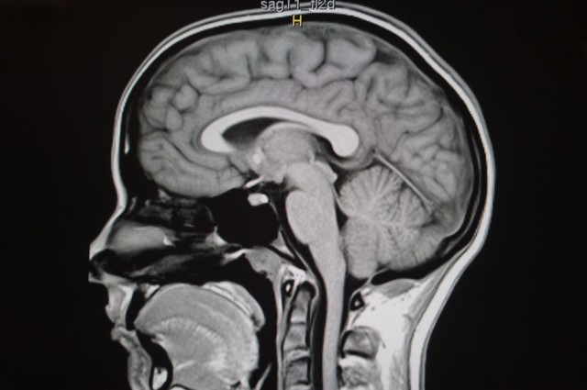photo credit: Magnetic resonance image of a normal brain. SMK4pix/Shutterstock.
Share on facebook132 Share on twitter0 Share on reddit Share on google_plusone_share More Sharing Services
When it comes to our brains, does size really matter? One of the biggest myths about the brain is that bigger is always better. But what about those who sit on the extreme end of that scale? How much of our brain do we actually need to survive? Looking through the archives of medical history, there are a number of people with tiny brains, or brains with huge chunks missing entirely, which defy all odds.
In a 2007 Lancet study, doctors described an incredible medical oddity – the 44-year-old civil servant who had lived a normal life despite having an incredibly tiny brain. The French man went into hospital after he experienced weakness in his left leg for two weeks. Doctors were quite surprised when they took scans of his brain and found a huge fluid-filled chamber.
The scans showed that the man had a “massive enlargement of the lateral, third, and fourth ventricles, a very thin cortical mantle and a posterior fossa cyst,” researchers noted in the study. In short, while fluid normally circulates throughout the brain, it’s regularly drained. But instead of draining the fluid into the circulatory system, the fluid in this man’s brain built up. Eventually, the accumulation of fluid resulted in only a tiny amount of actual brain material.
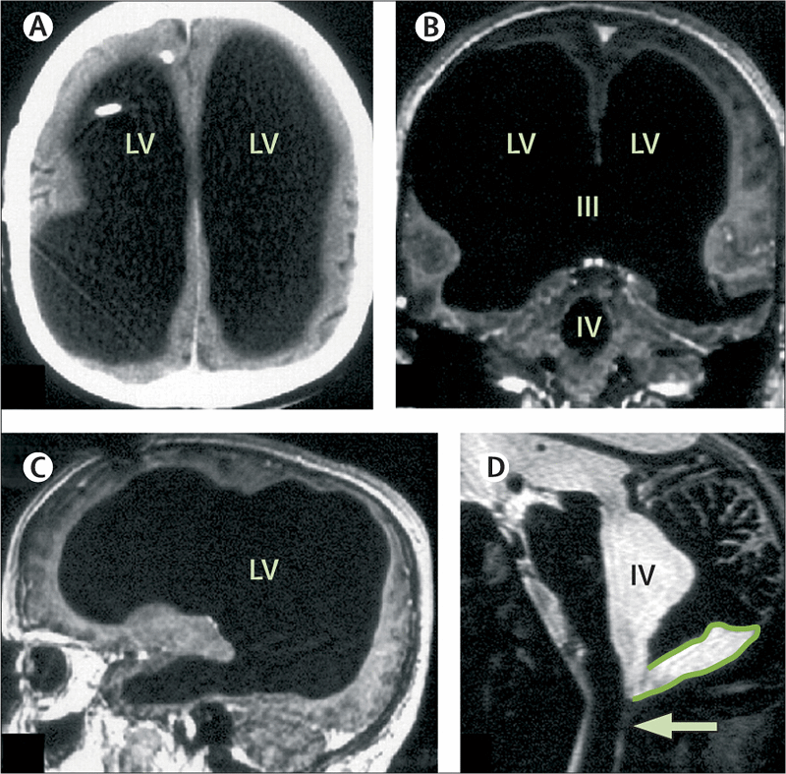
The large black space is the fluid that built up in his brain. Feuillet et al./The Lancet.
The man’s medical history showed that he had to get a shunt inserted into his head as an infant to get rid of the buildup of fluid on the brain, known as hydrocephalus. The shunt was eventually removed when at age 14, he complained of left leg weakness and some unsteadiness. The man went on to live a normal life and he got married and had two children. Tests showed that he had an IQ of 75 which, though below the average of 100, is not considered a mental disability.
“What I find amazing to this day is how the brain can deal with something which you think should not be compatible with life,” Dr. Max Muenke, from the National Human Genome Research Institute, told Reuters.
Earlier last year, IFLScience reported on the ninth known case of someone living without a cerebellum. This is the part of the brain that controls a number of important functions such as balance, motor movements and motor learning. The 24-year-old Chinese woman went into a hospital complaining of nausea and vertigo, and doctors discovered that she suffered from a rare condition known as cerebellar agenesis.
In another case, 12-year-old Trevor Judge Waltrip shocked medical professionals when he survived as long as he did with only his brain stem. Trevor passed away last year after going his entire life without a brain. He suffered from a rare condition calledhydranencephaly, whereby the cerebral hemispheres are replaced entirely with cerebrospinal fluid. People with hydranencephaly usually survive for up to 12 weeks, which made Trevor’s case so remarkable. He was able to breathe on his own and respond to stimuli, but was blind and unable to communicate.
These cases show not only the adaptability and resilience of the human brain, but also how little we know about one of our most important organs. Cases like this force neuroscientists to rethink how we view the brain, particularly what functions different regions have and how the brain adapts when these regions become damaged.

