The brain implant cured man's OCD - but turned him into an obsessive Johnny Cash fan
- 60 year old Dutch OCD sufferer had implant fitted to control symptoms
- Soon after hearing the song 'Ring of Fire' he became a Johnny cash fan
- Claims raw and low-pitched voice of the singer helped soothe him
- Says there is a Cash song 'for every emotion' and listens to no other music
By Mark Prigg
Published: 19:02 EST, 19 May 2014 | Updated: 07:53 EST, 20 May 2014

Researchers have revealed a patient was turned into a Johnny Cash fan after an implant was put into his brain.
'Mr. B', a 60 year old Dutch man who had suffered from severe obsessive-compulsive disorder (OCD) and anxiety since the age of 13.
Following a successful implant to treat the symptoms, doctors were stunned to find he had become a huge Johnny Cash fan after hearing the song Ring of Fire.
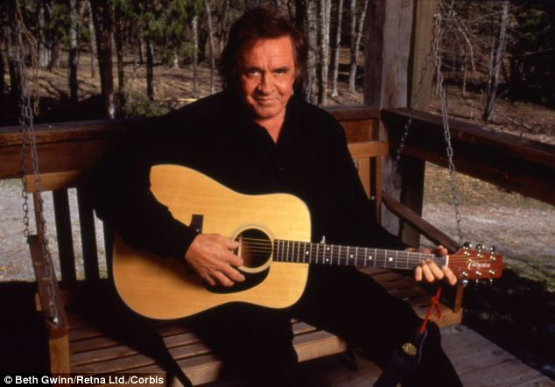
Following a successful implant to treat the symptoms, a dutch 60 year old told doctors he had become a huge Johnny Cash fan after hearing the song Ring of Fire.

MR B'S MUSICAL TASTES
Before the implant, Mr B's musical taste was broad, covering Dutch-language songs, the Beatles and his favourite band, the Rolling Stones.
Following the implant, he had been listening to the radio, when he heard 'Ring of Fire' of the Country and was deeply affected by the song.
'Mr. B. started to listen to more songs of Johnny Cash and noticed that he was deeply moved by the raw and low-pitched voice of the singe,' the team said.
'Moreover, he experienced that he preferred the performance of the songs in the Seventies and Eighties, due to the fullness of the voice of the older Johnny Cash in that period.
'His favorite songs, 'Folsom prison blues', 'Ring of fire' and 'Sunday morning coming down' had a certain rhythm with a fast tempo in common that moved him.'
The authors, Mariska Mantione and colleagues, said the unnamed man had suffered from severe obsessive-compulsive disorder (OCD) and anxiety since the age of 13.
Medications and psychotherapy had failed to help, so he was given deep brain stimulation (DBS) as a last resort treatment.

'Our patient reported that after DBS he was grasped in particular by the rhythm of Johnny Cash songs and by the tone of his voice,' the team said.
The electrodes were placed in the nucleus accumbens region of the brain.
Mr. B. reported he felt very confident, calm and assertive and he started to call himself 'Mr. B. II', the new and improved version of himself.
'It could be suggested that the image he creates when listening to songs of Johnny Cash seems to match his 'new' confident self,' the researchers wrote.
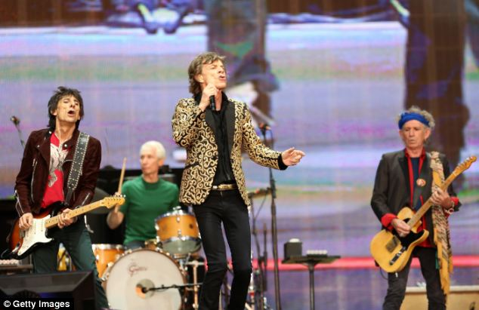
Before the implant, Mr B's musical taste was broad, covering Dutch-language songs, the Beatles and his favourite band, the Rolling Stones. However, after it, he said those bands were 'banned' and only listened to Johnny Cash
'Like Mr. B. states: 'it seems as if Johnny Cash goes together with DBS.'
The team also found the change is taste was directly linked to the implant.
'Moreover, his former musical taste reoccurred immediately when stimulation was interrupted due to battery depletion, suggesting a direct causal link between musical preference and stimulation of the accumbens. '
Interviews also revealed that before the implant, the man had little interest in music.
'Mr. B., had never been a huge music lover,' they wrote.
'His musical taste was broad, covering Dutch-language songs, the Beatles and the Rolling Stones, with a preference for the last named.
'While music did not occupy an important position in his live, his taste in music had always been very fixed and his preferences stayed the same throughout decades.'
After undergoing the surgery, 12 months later the patient admitted his new musical taste.
'He had been listening to the radio, when he coincidentally heard 'Ring of Fire' of the Country and Western singer and experienced that he was deeply affected by the song.
'Mr. B. started to listen to more songs of Johnny Cash and noticed that he was deeply moved by the raw and low-pitched voice of the singer.
'Moreover, he experienced that he preferred the performance of the songs in the Seventies and Eighties, due to the fullness of the voice of the older Johnny Cash in that period.
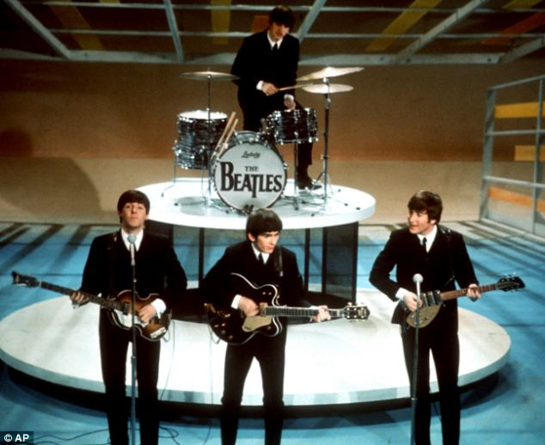
Banned: The Beatles were also a pre-operation favourite of Mr B - but he can no longer enjoy them
'His favorite songs, 'Folsom prison blues', 'Ring of fire' and 'Sunday morning coming down' had a certain rhythm with a fast tempo in common that moved him.
'Mr. B. reported that he felt good following treatment with DBS and that the songs of Johnny Cash made him feel even better.
'From this moment on, Mr. B. kept listening simply and solely to Johnny Cash and bought all his CD’s and DVD’s.
'When listening to his favorite songs he walks back and forth through the room and feels like he finds himself in a movie in which he plays the hero’s part.
'He reports that there is a Johnny Cash song for every emotion and every situation, feeling happy or feeling sad and although Mr. B. played almost simply and solely Johnny Cash songs for the following years, the music never starts to annoy him.
'From the first time Mr. B. heard a Johnny Cash song, the Dutch-language songs, the Beatles and the Rolling Stones have been banned. '

