Brainwaves
Current thoughts on mind, life and culture
- About

Know Your Neurons: What Is the Ratio of Glia to Neurons in the Brain?
By Ferris Jabr | June 13, 2012
|
Previously, on Know Your Neurons:
Chapter 1: The Discovery and Naming of the Neuron
Chapter 2: How to Classify Different Types of Neurons
Chapter 3: Meet the Glia
Chapter 4: What is the Ratio of Glia to Neurons in the Brain?
By Daisy Yuhas and Ferris Jabr
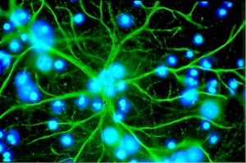
The green branches of an astrocyte, one of several kinds of glial cells, surrounded by blue nuclei of other cells (Credit: Karin Pierre, Institut de Physiologie, UNIL, Lausanne. via Wikimedia Commons)
Last time on Know Your Neurons, we talked about glia—one of two major types of cells in the brain and nervous system alongside neurons. Glia "outnumber neurons by as much as 50 to one," we wrote, echoing Eric Kandel's widely used textbook, The Principles of Neural Science, which states: "Glial cells far outnumber neurons—there are between 10 and 50 times more glia than neurons in the central nervous system of vertebrates." Other textbooks, including Mark Bear's Neuroscience—Exploring the Brain, make similar claims, as have many articles in the popular press.
Noah Gray (@noahWG), a senior editor at Nature, and Mo Costandi (@mocost), a neuroscientist turned freelance writer, responded to our post on Twitter, citing recent evidence that the 10:1 glia to neuron ratio is a myth and that the ratio in human and other primate brains is much closer to 1:1. We decided to investigate further.
After surveying the research literature, we did not find a single published study that directly supports a 10:1 glia to neuron ratio in the whole human brain. If anyone knows of such a study, please cite it in the comments section. We found many studies from as early as the 1950s that settled on a ratio much closer to 1:1 in the brains of humans and other primates, although most of these studies focused solely on the intricately wrinkled outer layer of the vertebrate brain, known as the cortex, which probably does not have the same glia to neuron ratio as the rest of the brain. The most compelling evidence for a 1:1 ratio comes from a 2009 study by neurophysiologistSuzana Herculano-Houzel and her colleagues, who invented a new, highly efficient way to count cells and applied it to four whole human brains.
Some researchers, however, will not fully accept the new method until Herculano-Houzel directly compares it to more traditional cell-counting techniques. And some scientists who study glia are reluctant to admit that these once overlooked cells might not constitute the majority. Even if Herculano-Houzel's method somehow skews the ratio too close to 1:1, the evidence as a whole certainly does not support anything near a 10:1 ratio. Despite this discrepancy, some textbooks will likely continue to tout the 10:1 ratio as undisputed fact. Ben Barres of Stanford University is writing the sections on glia in the upcoming edition of Kandel's textbook. Although he maintains that no one has rigorously determined the glia to neuron ratio in published research, he is convinced that glia make up at least 80 percent of the cells in the human brain—a conclusion he reached based on calculations about changing levels of DNA in the developing brain.
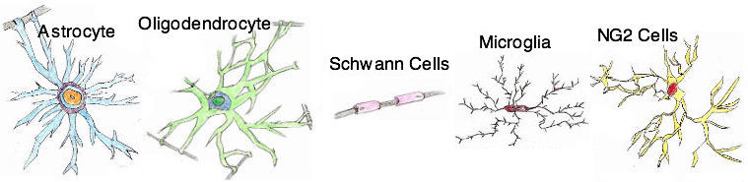
A selection of different types of glial cells. NG2s may be a new category (Credit: Daisy Yuhas)
The Available Evidence
Since at least the 1950s scientists have tried to estimate the relative number of neurons and glial cells in the human brain. They encountered difficulties right away.
The most rigorous method involves slicing up different regions of a fresh or preserved brain into thin sheets of brain prosciutto, counting cells in each sheet under a microscope and multiplying cell counts by total brain volume. The process is fairly straightforward but performing it on an entire brain takes a lot of time—even when computers and machines help with the counting—which explains why so many studies focus on only one region of the brain.
Early on, however, researchers realized that the ratio of glia to neurons varies from one brain region to another, sometimes dramatically. Several early studies found a glia to neuron ratio of about 1:1 in the cortex, for example, but one 1988 study found a glia to neuron ratio of 17 to 1 in the thalamus, a versatile pair of walnut-sized knobs near the middle of the brain. Further complicating things, the glia to neuron ratio differs from species to species. So counting the numbers of glia and neurons in a chunk of rat brain tissue does not give you an accurate estimate of the ratio for the whole rat brain, nor does it necessarily match the ratio in a comparable region of the human brain. Numerous cell-counting studies from the 1950s onwards concluded that the glia to neuron ratio in the primate cortex ranged from 0.5:1 to 2:1. As far as we can tell, none of these studies estimated a 10:1 glia to neuron ratio for either the cortex or the whole brain.
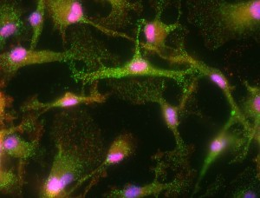
Neurons and glia in light-sensitive tissue at the back of a mouse's eye (Credit: Nakamura et al., BMC Cell Biology 2007, 8:52 doi 10.1186/1471-2121-8-52, via Wikimedia Commons)
If no published evidence directly supports the 10:1 glia to neuron ratio, how did it end up in so many textbooks? And where did the notion come from in the first place? "It's impossible to find the original source," says Claus Hilgetagof the University Medical Center Hamburg-Eppendorf, who has searched in vain for the basis of what he thinks is a long-perpetuated myth. One of his colleagues, Hugues Berry, vaguely remembers learning that the 10:1 ratio originated as a misremembered detail in a presentation at an academic conference. If so, it certainly would not be the first time that people have adopted a counterintuitive statistic as fact.
In a Brain Structure and Function column reviewing the relevant evidence on the brain's glia to neuron ratio, Hilgetag and Helen Barbas of Boston University highlight the research of neurophysiologist Suzana Herculano-Houzel of the Instituto de Ciências Biomé́dicas/Federal University of Rio de Janeiro, Brazil. She has developed a unique, speedy method for counting all the cells in a whole brain.
Herculano-Houzel's technique transforms an intact brain into a soup of nuclei—small sacks that contain cells' DNA. The idea behind her method is that each brain cell contains exactly one nucleus; therefore, the total number of nuclei in a brain matches the total number of brain cells. First, Herculano-Houzel slices up an entire brain into regions of interest—such as the cerebellum and the cerebral cortex—and grinds up all the tissue by hand in a kind of glass mortar and pestle. Dissolving the tissue in saline detergent creates a solution in which the nuclei of both neurons and glia float freely. Tagging the DNA inside the nuclei with fluorescent proteins makes all the nuclei glow blue under ultraviolet (UV) light. Herculano-Houzel measures the density of these glowing nuclei and multiplies that number by the solution's volume to determine the total number of nuclei, which should correspond to the total number of cells in that brain region. Next, she adds an antibody called anti-NeuN that binds to proteins on most neuronal nuclei, but does not bind to any glial nuclei. Another fluorescent antibody attaches to anti-NeuN, making nuclei from neurons glow green under UV light. After vigorously shaking the solution to evenly distribute nuclei from neurons and glia, Herculano-Houzel takes several samples of the soup, counts the fluorescing green nuclei in each sample under the microscope and calculates the total number of neuronal nuclei in the solution, which should equal the total number of neurons in that brain region. Subtracting that number from the total nuclei count tells her how many glial cells that section of brain contained.
Herculano-Houzel and her colleagues used this technique to analyze the brains of four deceased men and published their results in 2009: they consistently found a whole human brain glia to neuron ratio of almost exactly 1:1. Specifically, they found that the human brain contains about 170.68 billion cells, 86.1 billion of which are neurons and 84.6 billion of which are glial cells. Their study also suggests that the ratio of glia to neurons differs dramatically from one general brain region to the next. 60.84 billion cells in the cerebral cortex are glia, while only 16.34 billion cells are neurons, giving this large region a glia to neuron ratio of about 3.76 to 1. It's the inverse in the cerebellum, an evolutionarily ancient part of the brain that sits astride the brain stem. According to Herculano-Houzel's study, the cerebellum contains 69.03 billion neurons and only 16.04 glial cells, which means there are about 4.3 neurons for every glia in this region.
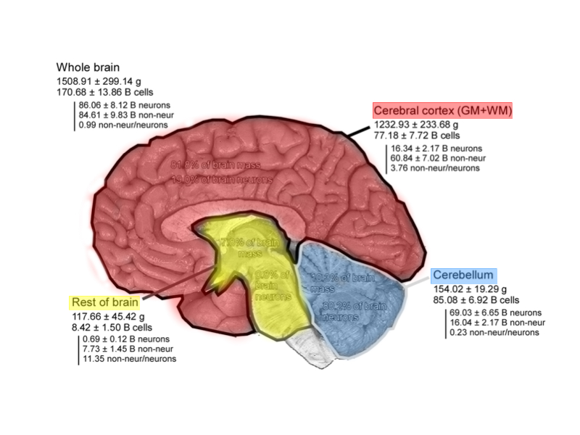
Adapted from "Equal Numbers of Neuronal and Nonneuronal Cells Make the Human Brain an Isometrically Scaled-Up Primate Brain"
Zooming in even further, her study counted 6.18 billion neurons and 8.68 billion glia in the gray matter of the cortex, vs. 1.29 billion neurons and 19.88 billion glia in the white matter. Gray matter is largely made up of the unmyelinated parts of neurons—neurons that are not sheathed by glial cells—whereas white matter is comprised of axons wrapped in insulating oligodendrocytes. These results might explain why so many early counting studies that only sampled cortical gray matter found a roughly 1:1 or slightly higher glia to neuron ratio. Overall the cerebral cortex—including both gray and white matter—contains far more glia than neurons, but its outermost gray layer is more balanced. And the cerebellum's incredible density of neurons balances out the glia to neuron ration throughout the whole brain.
When Herculano-Houzel first published her innovative technique in 2005, the main objection was that she had not directly compared it to more typical stereological methods, in which cells are counted in slices of brain tissue. When her results with whole brains matched counts from different brain regions in previous stereological studies, however, Herculano-Houzel says most critics backed off. Some researchers remain concerned that grinding and dissolving the brain destroys a significant number of nuclei. Herculano explains, however, that the saline detergent she uses (Triton X-100) destroys fatty tissues, like cell membranes, but preserves the protein-rich nuclear membrane. Furthermore, she says, fixing brain tissue in formaldehyde before grinding strengthens the bonds between proteins, making them especially difficult to break. Other researchers say they are hesitant to trust a method that has not been widely used outside of a single research group. So far, however, at least seven different research teams in the U.S., Europe and Asia have availed themselves of Herculano-Houzel's method.
Rewriting the Textbooks?
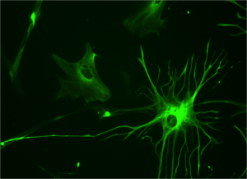
Human astrocyte stained with green fluorescent protein (Credit: Bruno Pascal, Wikimedia Commons)
Neurobiologist Ben Barres of Stanford University says he never believed the widely parroted 10:1 glia to neuron ratio—until he looked into the matter himself. Now, he is certain that glia make up at least 80 percent of cells in the human brain. Here is his main reasoning.
The human brain contains a finite number of cells, each of which holds the same amount of DNA (about 6.5 picograms). The developing human brain produces most of its neurons within the first trimester of pregnancy, but glia do not finish growing in number until a few years after birth. By comparing the total amount of DNA in a 20-week-old human brain to the total amount of DNA in an infant's brain, Barres reasoned, one could figure out the glia to neuron ratio. Barres found a study published in 1973 that analyzed DNA levels in 139 human brains ranging in age from 10 weeks to seven years. The forebrains (which do not include the cerebellum) contained about 0.25 millimoles of DNA at week 20 and peaked at around 2 millimoles of DNA by age two. Based on these numbers—and accounting for DNA from blood vessel cells—Barres concludes that growing numbers of glia explain the increase in total forebrain DNA and that glia therefore make up at least 80 percent of cells in the human brain.
Even though Barres is confident in his own unpublished calculations—and intends to write that glia far outnumber neurons in the newest edition of the Principles of Neural Science—he argues that no one has conducted the kind of rigorous study that would definitively answer the question of the glia to neuron ratio once and for all. Barres envisions a study in which researchers stain whole human brains with just about every known marker for both neurons and glia—making sure to capture as many of the different cell types as possible—before slicing up the brains and meticulously counting the cells in each section. He says all the necessary tools are available. It is only a matter of funding the project and finding the time for all that counting.
Who Cares?
Let's say scientists figure out exactly how many glia and neurons the brain contains and everyone agrees on the numbers—what will that accomplish? Why does it matter?
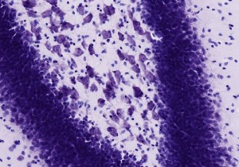
Neurons and glia in a mouse hippocampus (Credit: http://brainmaps.org, via Wikimedia Commons)
Some scientists think that the glia to neuron ratio is just about one of the least important questions you can ask about the brain. Instead, they argue, scientists should focus on how brain cells behave. Other scientists point out that aging, as well as many neurological diseases, involve the loss of brain cells. Understanding exactly which brain cells die and which survive could spur the development of new treatments. Some biologists and neuroscientists are also very interested in whether the glia to neuron ratio has changed over the course of evolution and whether, for example, animals with large brains—or brains that are large for their body size—have unusually high or low numbers of glia. In a 2007 study, scientists sliced up five minke whale brains, counted the cells with the help of computers and found 12.8 billion neurons surrounded by 98.2 billion glia. However, the study did not include the cerebellum, which contains most of the mammalian brain's neurons according to Herculano-Houzel's work.
Many researchers have argued that glia deserve more attention in part because they are so numerous. But prevalence is not equivalent to significance. Scientists no longer need to depend on the alleged 10:1 ratio to justify glia research. Glial cells are fascinating and important because of their structural diversity, functional versatility and the fact that they can change the behavior of firing neurons even though they cannot discharge electrical impulses of their own. They guide early brain development and keep their fellow brain cells healthy throughout life. Glia are not mere structural filler, but—as the origin of their name implies (Greek for glue)—they help keep things together. Regardless of the true glia to neuron ratio, scientists have already shown that glia are, functionally, the brain's other half.
References
Azevedo, Frederico A.C. , Ludmila R.B. Carvalho, Lea T. Gribergb, José Marcelo Farfel, Renata E.L. Ferretti, Renata E.P. Leite, Wilson Jacob Filho, Roberto Lent, and Suzana Herculano-Houzel. "Equal Numbers of Neuronal and Nonneuronal Cells Make the Human Brain an Isometrically Scaled-Up Primate Brain." The Journal of Comparative Neurology, 2009, 513:532-541.
Dobbing, J and Sands, J. Quantitative growth and development of human brain. Arch Dis Child. 1973 October; 48(10): 757–767.
Eriksen N, Pakkenberg B. Total neocortical cell number in the mysticete brain. Anat Rec (Hoboken). 2007 Jan;290(1):83-95.
Herculano-Houzel, Suzana and Roberto Lent. "Isotropic Fractionator: A Simple, Rapid Method for the Quantification of Total Cell and Neuron Numbers in the Brain."The Journal of Neuroscience, 2005, 25(10): 2518-2521.
Hilgetag, Claus and Helen Barbas. "Are there ten times more glia than neurons in the brain?" Brain Structure Function, 2009, 213:365-366.
Kandel ER, Schwartz JH, Jessell TM 2000. Principles of Neural Science, 4th ed. McGraw-Hill, New York.
Pakkenberg, B. and Gundersen, H. J. G. (1988), Total number of neurons and glial cells in human brain nuclei estimated by the disector and the fractionator. Journal of Microscopy, 150: 1–20. doi: 10.1111/j.1365-2818.1988.tb04582.x
The Neurocritic. Fact or Fiction? There are ten times more glia than neurons in the brain. Sep 27, 2009.
The views expressed are those of the author and are not necessarily those of Scientific America

