Paralysed stroke victim experiences every patient's worst nightmare as he hears doctors discussing whether to donate his organs but couldn't speak out
- Jimi Fritze, 43, could hear but not talk after suffering brain haemorrhage
- Family surrounded hospital bed after doctors said he would not survive
- He eventually pulled through and is now taking action against hospital
By Sara Malm
Published: 03:41 EST, 4 April 2014 | Updated: 10:08 EST, 4 April 2014
A stroke patient lying paralysed in hospital listened in horror as doctors discussed organ donation with his family after telling them he would not survive.
Jimi Fritze, 43, heard every word but couldn't protest because he was unable to speak.
His heartbroken relatives had come to say their final goodbyes after doctors said brain scans showed he had 'no hope' of pulling through.
As they surrounded his hospital bed, doctors asked the family about the possibility of donating his organs when he died, not realising Mr Fritze could also hear the conversation.
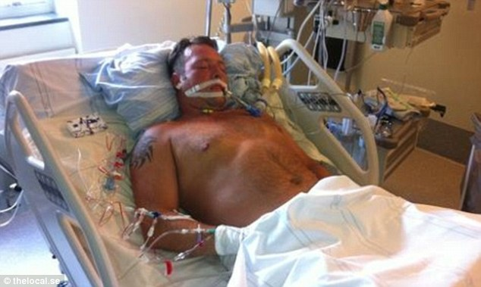
Stroke victim Jimi Fritze listened helplessly as doctors discussed donating his organs with his family, but was unable to speak out. He later recovered and is now taking action against the hospital
He eventually recovered after his family sought advice from another medic.
He has now launched an official complaint against the doctors for breaching rules by discussing organ donation before a patient is brain dead, it was reported by The Local.
Mr Fritze suffered a brain haemorrhage while out with his family on the Gothenburg archipelago around two years ago.

'I managed to catch my girlfriend's attention - I was bright red in the face, and she's a nurse so she managed to keep my airways open,' Mr Fritze said.
An air ambulance was unable to land on the island, so he had to wait nearly two hours to reach Sahlgrenska hospital by boat.
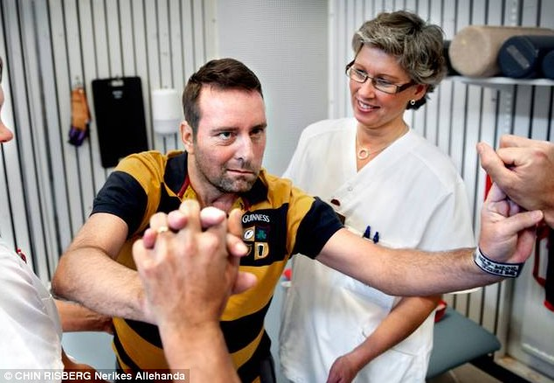
Returning: Mr Fritze is now undergoing rehabilitation at Örebro hospital to regain full function in his limbs
Mr Fritze said: 'Only my ears and eyes were working. They (the doctors) told my girlfriend that there was no hope'.
But three days later another doctor who had returned from holiday gave more positive prognosis.
Mr Fritze said: 'She looked at my scans and said "This doesn't look too bad" and told the staff to give me cortisone to bring down the swelling in my brain.'
It took another three weeks before he could communicate his horror to his family and more than two years on he has only just recovered enough to take action against the hospital.
He has sent an official complaint to the health and welfare board, which oversees quality of healthcare in Sweden.
Mr Fritze was taken to Sahlgrenska Hospital in Gothenburg where doctors told his family he could not be saved
'If that doctor hadn't come back from her holiday, would I have been made to lie there until my body couldn't take it any longer?' Fritze asked in his complaint.
A stroke is a serious medical condition that occurs when the blood supply to part of the brain is cut off either from a blockage or a bleed.
They affect different areas of the brain, so it is common for patients to lose some faculties while retaining others.
'As always, we are cooperating with IVO (Nursing and Care Review) to get to the bottom of what has happened, and before that we cannot go into detail regarding an individual case.
'We are of course taking this complaint very seriously, as we do with all complaints,' Sahlgrenska Hospital's press spokesperson Stefan Sarajärvi said this week.

