Learning How Little We Know About the Brain
NOV. 10, 2014
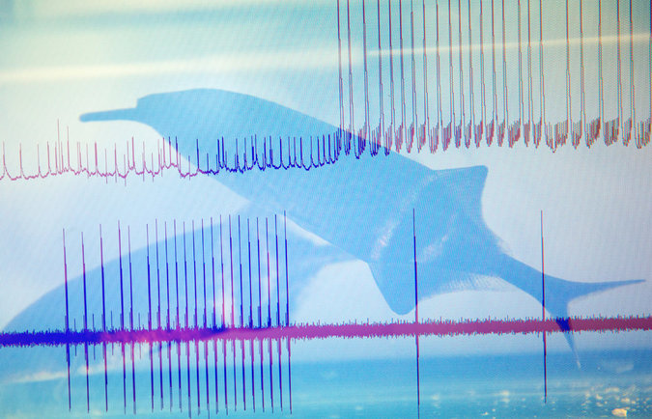
A double exposure of weakly electric fish with recordings of brain activity. Credit Béatrice de Géa for The New York Times
By JAMES GORMAN
Research on the brain is surging. The United States and the European Union have launched new programs to better understand the brain. Scientists are mapping parts of mouse, fly and human brains at different levels of magnification. Technology for recording brain activity has been improving at a revolutionary pace.
The National Institutes of Health, which already spends $4.5 billion a year on brain research, consulted the top neuroscientists in the country to frame its role in an initiative announced by President Obama last year to concentrate on developing a fundamental understanding of the brain.
Scientists have puzzled out profoundly important insights about how the brain works, like the way the mammalian brain navigates and remembers places, work that won the 2014 Nobel Prize in Physiology or Medicine for a British-American and two Norwegians.
Yet the growing body of data — maps, atlases and so-called connectomes that show linkages between cells and regions of the brain — represents a paradox of progress, with the advances also highlighting great gaps in understanding.
Photo
Larry Abbott, at Columbia University, has helped develop theoretical models of how perception works in weakly electric fish. Credit Béatrice de Géa for The New York Times
So many large and small questions remain unanswered. How is information encoded and transferred from cell to cell or from network to network of cells? Science found a genetic code but there is no brain-wide neural code; no electrical or chemical alphabet exists that can be recombined to say “red” or “fear” or “wink” or “run.” And no one knows whether information is encoded differently in various parts of the brain.
Brain scientists may speculate on a grand scale, but they work on a small scale. Sebastian Seung at Princeton, author of “Connectome: How the Brain’s Wiring Makes Us Who We Are,” speaks in sweeping terms of how identity, personality, memory — all the things that define a human being — grow out of the way brain cells and regions are connected to each other. But in the lab, his most recent work involves the connections and structure of motion-detecting neurons in the retinas of mice.
Larry Abbott, 64, a former theoretical physicist who is now co-director, with Kenneth Miller, of the Center for Theoretical Neuroscience at Columbia University, is one of the field’s most prominent theorists, and the person whose name invariably comes up when discussions turn to brain theory.
Edvard Moser of the Norwegian University of Science and Technology, one of this year’s Nobel winners, described him as a “pioneer of computational neuroscience.” Mr. Abbott brought the mathematical skills of a physicist to the field, but he is able to plunge right into the difficulties of dealing with actual brain experiments, said Cori Bargmann of Rockefeller University, who helped lead the N.I.H. committee that set a plan for future neuroscience research.
“Larry is willing to deal with the messiness of real neuroscience data, and work with those limitations,” she said. “Theory is beautiful and internally consistent. Biology, not so much.” And, she added, he has helped lead a whole generation of theorists in that direction, which is of great value for neuroscience.
Dr. Abbott is unusual among his peers because he switched from physics to neuroscience later in his career. In the late 1980s, he was a full professor of physics at Brandeis University, where he also received his Ph.D. But at the time, a project to build the largest particle accelerator in the world in Texas was foundering, and he could see a long drought ahead in terms of advances in the field.
He was already considering a career switch when he stopped by the lab of a Brandeis colleague, Eve Marder, who was then, and still is, drawing secrets from a small network of neurons that controls a muscle in crabs.
his career working with particle colliders, but he realized that the complex mathematics of physics came in quite handy for trying to understand the brain. Michael Mason, Claire Maldarelli and Jeffery DelViscio
She was not in her lab when Dr. Abbott came calling, but one of her graduate students showed him equipment that was recording the electrical activity of neurons and translating it into clicks that could be heard over speakers each time a cell fired, or spiked. “You know what?” he said recently in his office at Columbia, “We wouldn’t be having this conversation if they didn’t have that audio monitor on. It was the sound of those spikes that entranced me.”
“I remember I walked out of the door and I kind of leaned up against the wall, in terror, saying, ‘I’m going to switch,’ ” he added. “I just knew that something had clicked in me. I’m going to switch fields, and I’m dead, because nobody knows me. I don’t know anything.”
Dr. Marder served as his guide to the new field, telling him what to read and answering his many questions. He was immediately accepted both in her lab and by other experimentalists, she said, “because he’s both wicked smart and humble.”
“He did something that was astonishing,” Dr. Marder said. “Six months in, he actually understood what people knew and what they didn’t know.”
Dr. Abbott recalled that it took a while for them to develop a productive collaboration. “Eve and I talked for a year and then finally started to understand each other,” he said.
Together, they invented something called the dynamic clamp technique, a way to link brain cells to a computer to manipulate their activity and test ideas about how cells and networks of cells work.
A decade ago, he moved from Brandeis to Columbia, which now has one of the biggest groups of theoretical neuroscientists in the world, he says, and which has a new university-wide focus on integrating brain science with other disciplines.
Dr. Abbott collaborates with scientists at Columbia and elsewhere, trying to build computer models of how the brain might work. Single neurons, he said, are fairly well understood, as are small circuits of neurons.
The question now on his mind, and that of many neuroscientists, is how larger groups, thousands of neurons, work together — whether to produce an action, like reaching for a cup, or to perceive something, like a flower.
There are ways to record the electrical activity of neurons in a brain, and those methods are improving fast. But, he said, “If I give you a picture of a thousand neurons firing, it’s not going to tell you anything.”
Computer analysis helps to reduce and simplify such a picture but, he says, the goal is to discover the physiological mechanism in the data.
For example, he asks why does one pattern of neurons firing “make you jump off the couch and run out the door and others make you just sit there and do nothing?” It could be, Dr. Abbott says, that simultaneous firing of all the neurons causes you to take action. Or it could be that it is the number of neurons firing that prompts an action.
His tools are computers and equations, but he collaborates on all kinds of experimental work on neuroscientific problems in animals and humans. Some of his recent work was with Nate Sawtell, a fellow Columbia researcher, and Ann Kennedy a graduate student at the time in Dr. Sawtell’s lab, now doing post-doctoral research at Caltech. Their subject was the weakly electric fish.
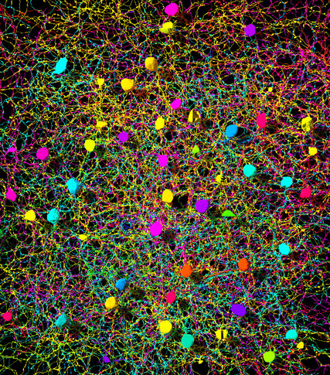
A tangle of neurons involved in motion detection in a mouse retina taken with an electron microscope, with color added. Credit Alex Norton/EyeWire
Unlike electric eels and other fish that use shocks to stun prey, this fish generates a weak electric field to help it navigate and to locate insects and other prey. Over the years, researchers, notably Curtis Bell at the Oregon Health and Science University, have designed experiments to understand, up to a point, how its brain and electric-sensing organs work.
Dr. Abbott joined with Dr. Kennedy and Dr. Sawtell, the senior author on the paper that grew out of this work, and others in the lab to take this understanding a step further. The fish has two sensing systems. One is passive, picking up electric fields of other fish or prey. Another is active, sending out a pulse, for communication or as an electrical version of sonar. They knew the fish was able to cancel out its own pulse of electricity by creating what he called a “negative image.”
They wired the brain of a weakly electric fish and — through a combination of testing and developing mathematical models — found that a surprising group of neurons, called unipolar brush cells, were sending out a delayed copy of the command that another part of the brain was sending to its electric organ. The delayed signal went straight to the passive sensing system to cancel out the information from the electric pulse.
“The brain has to compute what’s self-generated versus what’s external,” said Dr. Sawtell.
This may not sound like a grand advance, but, Dr. Abbott said, “I think it’s pretty deep,” adding that it helps illuminate how a creature begins to draw a distinction between itself and the world. It is the very beginning of how a brain sorts a flood of data coming in from the outside world, and gives it meaning.
That is part of the brain’s job, after all — to build an image of the world from photons and electrons, light and dark, molecules and motion, and to connect it with what the fish, or the person, remembers, needs and wants.
“We’ve looked at the nervous system from the two ends in,” Dr. Abbott said, meaning sensations that flow into the brain and actions that are initiated there. “Somewhere in the middle is really intelligence, right? That’s where the action is.”
In the brain, somehow, stored memories and desires like hunger or thirst are added to information about the world, and actions are the result. This is the case for all sorts of animals, not just humans. It is thinking, at the most basic level.
“And we have the tools to look there,” he said. “Whether we have the intelligence to figure it out, I view that, at least in part, as a theory problem.”

