Itching: More Than Skin-Deep
By DENISE GRADY
FEB. 17, 2014
Inside
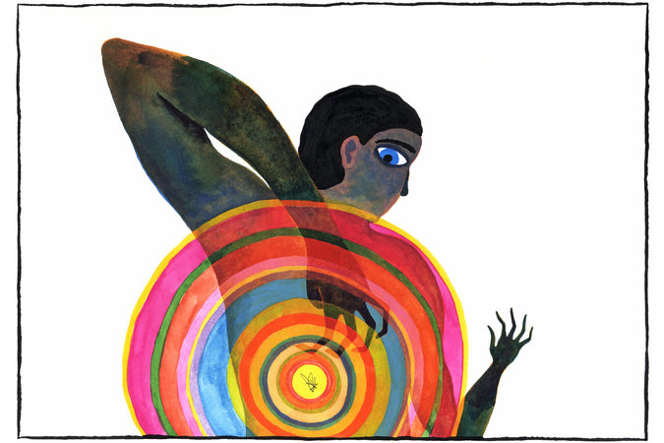
Launch media viewer
Balint Zsako
The experiment was not for the squirmish. Volunteers were made to itch like crazy on one arm, but not allowed to scratch. Then they were whisked into an M.R.I. scanner to see what parts of their brains lit up when they itched, when researchers scratched them and when they were finally allowed to scratch themselves.
The scientific question was this: Why does it feel so good to scratch an itch?
“It’s quite intriguing to see how many brain centers are activated,” said Dr. Gil Yosipovitch, chairman of dermatology at the Temple University School of Medicine and director of the Temple Center for Itch (he conducted the experiment while working at Wake Forest School of Medicine). “There is no one itch center. Everyone wants that target, but it doesn’t work in real life like that.”
Instead, itching and scratching engage brain areas involved not only in sensation, but also in mental processes that help explain why we love to scratch: motivation and reward, pleasure, craving and even addiction. What an itch turns on, a scratch turns off — and scratching oneself does it better than being scratched by someone else. The study results were published in December in the journal PLOS One.
Itching was long overshadowed by pain in both research and treatment, and was even considered just a mild form of pain. But millions of people suffer from itching, and times have changed. Research has found nerves, molecules and cellular receptors that are specific for itching and set it apart from pain, and the medical profession has begun to take it seriously as a debilitating problem that deserves to be studied and treated.
Within the last decade, there has been a flurry of research into what causes itching and how to stop it. Along with brain imaging, studies have begun to look at gene activity and to map the signals that flow between cells in the skin, the immune system, the spinal cord and the brain.
The concern is not so much the fleeting nastiness of mosquito bites and poison ivy, but the unending misery caused by chronic itching — the kind that won’t go away, that torments people night and day and very often resists remedies like antihistamines and cortisone cream.
For the first time in the United States, itching research and treatment centers have opened: Temple’s in September, in Philadelphia, and Washington University’s Center for the Study of Itch, in 2011, in St. Louis.

Scratching an Itch
Itching and scratching engage brain areas linked to reward, pleasure, craving and addiction.

FEB. 17, 2014
By The New York Times
Images from PLOS One
“Itch is now where pain was probably 20 years ago,” said Dr. Lynn Cornelius, chief of the dermatology division at Washington University School of Medicine. “It used to be lumped together with pain.”
But now, she said, there is more interest in itching and in sorting out its different types, and more research money being spent on it.
“The science has to lead to treatment, I believe,” Dr. Cornelius said. “If that happens, it will translate to better and better, more targeted therapies, so clinicians won’t just look upon someone itching as someone who needs antihistamines.”
Scratching, and therefore itching, appear widespread in the animal kingdom — though no one knows for sure why animals claw, bite or peck themselves, or scrape against trees or fences.
Even fruit flies engage in “robust grooming behaviors” that look a lot like scratching when they are infected with mites, said Diana Bautista, an assistant professor of cell and developmental biology at the University of California, Berkeley. Her research includes studying various strains of itchy mice that are models for human ailments.
“I have a collection of movies showing different animals scratching,” Dr. Bautista said. “I’m hoping they will help me determine if there is a difference between itch-evoked scratching versus wiping and other behaviors in diverse species.”
One of her favorite videos shows a seal lying on the beach, briskly rubbing its head with a flipper.
In people, there are different types of itching. The most familiar type, from a mosquito bite or hives, occurs when cells in the skin release histamine, which causes nerves in the skin to fire off signals to the spinal cord and brain. Antihistamine pills or creams usually bring relief.
But antihistamines are often no help to people with chronic itching, which can be caused by skin diseases like eczema or psoriasis, kidney or liver failure, dry skin, an overactive thyroid gland, certain cancers, and pinched or damaged nerves. And the itching from psoriasis almost certainly has a different mechanism from that caused by a pinched nerve.
“It’s a very hot area,” Dr. Cornelius said. “It’s a huge clinical problem and a huge unmet market.”
Recent research has shown that substances other than histamine, released from inflammatory cells, are involved in chronic itching, along with three different types of nerve cells, Dr. Bautista said. Drug companies are trying to find ways to block those substances.
“Before, the focus was on next-generation antihistamines,” Dr. Bautista said. “Now, it’s on new molecular and cellular targets to develop new therapies. The pharmaceutical industry is recognizing that they have to go beyond antihistamines.”
But pain pathways have to be dissected in minute detail if new targets are to be found. Many researchers say that one of the most important advances in the field was reported in the journal Nature in 2007 by a Washington University team led by Zhou-Feng Chen, who is now director of the itch center. Working with mice, his team was studying receptors, molecules on cells that respond to certain chemical signals to change the cells’ behavior.
The group was the first to find a receptor in the spinal cord that was specific for itching, called gastrin-releasing peptide receptor, or GRPR. The discovery helped to prove that signals for itching and pain travel on different pathways.
In an interview, Dr. Chen said that mice without the receptor — or with the receptor blocked by a drug — did not itch. Nor was the group without a receptor harmed by the lack of it.
“If you block function of this receptor alone, you pretty much stop chronic itching,” he said..
The receptor is present in humans, too, and Dr. Chen said it might be possible to develop a drug that would block it.
For many patients, new treatments cannot come soon enough.
Chronic itching becomes more common with age. One reason is that older people often develop dry skin, but Dr. Yosipovitch said the itching also might occur because certain nerves in the skin deteriorate — nerves that transmit pain and inhibit itching. “Then itch kind of pops out,” he said.
Aging monkeys have provided some clues. When Dr. Yosipovitch was still at Wake Forest, he and his colleagues noticed older female macaques scratching their backs and lower limbs, the same spots where older people tend to itch.
They sent samples from the monkeys to Dr. Chen, who found extra activity in the skin and spinal cord from the gene that produces GRPR, the itch receptor. Why the gene becomes more active with aging is not known, but this finding in a primate supports the idea that the receptor is a good target for new drugs in people, Dr. Chen said.
Many older people have trouble with itching in hard-to-reach spots on the back, between or just below the shoulder blades.
“It drives them crazy,” said Dr. Cornelius, at Washington University. They rub against door jambs, stockpile back scratchers, and enlist others to scratch them.
The condition has a name, notalgia paresthetica, and is often associated with spine and disk problems that pinch or damage nerves. The skin in the itchy spots may darken.
Wildebeest scratch their itches.
“Some neurologists, I would say the majority, do not know about this,” Dr. Yosipovitch said.
He and other doctors have prescribed various remedies — numbing patches, sometimes along with the hot-pepper ingredient capsaicin; Botox injections; pills like gabapentin that affect nerve transmission; and physical therapy to change posture. Often, it is possible to find something that helps.
Dr. Yosipovitch said many patients found their way to him only after seeing multiple doctors who could not help and who sometimes misdiagnosed their problems as mental rather than physical.
“They’re not crazy,” he said.
Joshua Riegel, 18, has a rare disease that was misdiagnosed as a mental issue and for which he was given antidepressants. Jeremy M. Lange for The New York Times
One of the patients was a boy who had scratched his arms and legs raw. Unable to find a cause or a treatment that worked, doctors had referred him and his family to a psychiatrist.
In an interview, the patient, Joshua Riegel, now 18, said, “They said I was doing it to manipulate my parents.” Thus began what he calls “that weird part of my life where they thought I was mentally ill.”
He was 12 or 13 when the psychiatrist prescribed antidepressants, which he dutifully took for two or three years. But they brought on terrible side effects: At one point he was hospitalized with suicidal thoughts.
As a last resort, his parents took him from their home in Hillsville, Va., to see Dr. Yosipovitch, who was then at Wake Forest.
“He had a hunch on what it was,” Mr. Riegel said.
Tests found a rare form of a genetic disease, epidermolysis bullosa, that was causing a particularly destructive set of symptoms: intense itching and skin so fragile that scratching ripped it to shreds.
“Dr. Yosipovitch was quite angry I was being told I was mentally ill when I wasn’t,” Mr. Riegel recalled.
Getting off the antidepressants lifted his spirits and let him be normal again. Since then, other drugs have been prescribed for the itching, with mixed results. It never really goes away, but Mr. Riegel uses video games or his cellphone to take his mind off it and keep from scratching.
For people with other types of chronic itching, Dr. Yosipovitch said: “This is just the beginning of a big era. In the next five years I predict there will be drugs targeted specifically for itch. We’re in the middle of the tip of an iceberg.”
A version of this article appears in print on February 18, 2014, on page D1 of the New York edition with the headline: Itching: More Than Skin-Deep.

