The schoolboy who has to run TRIATHLONS to stay alive: Eight-year-old suffers from a deadly illness that causes him to keep gaining weight and forces him to undergo extreme exercise
- Jake Vella, has a hormonal illness that makes him gain weight despite exercising
- No matter what he does, he will continue to get larger as a result of the condition
- Doctors are unsure how long he has left - with no sufferer making it to their 20s
- But in a bid to remain as healthy as possible, the schoolboy completes triathlons
- He dreams of replicating the success of Team GB's Brownlee brothers
By Stephen Matthews For Mailonline
PUBLISHED: 05:31 EDT, 4 April 2017 | UPDATED: 06:20 EDT, 4 April 2017

A schoolboy who suffers from a rare condition that means he keeps gaining weight is fighting for his life - by competing in triathlons.
Jake Vella, eight, has a deadly hormonal illness that makes him pile on the pounds despite maintaining a healthy diet and regularly exercising.
But no matter what he does, he will continue to get larger as a result of the condition - of which less than 100 people have ever been diagnosed.
Doctors are unsure how long he has left to live as no sufferer has ever managed to survive into their 20s.
+4
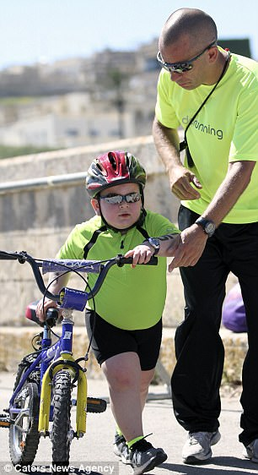
+4
Jake Vella, eight, has a hormonal illness that makes him gain weight despite his regular exercise and healthy diet. But in an effort to remain as healthy as possible, he completes triathlons (pictured during a race left, and right with his coach Matt Azzopardi)
The condition can also lead to the development of certain tumours. In Jake's case, It has caused one to grow on his back.
But in an effort to remain as healthy as possible and to try and fight the weight gain, he completes triathlons.
Despite the judgemental looks he receives, he dreams of replicating the success of the Brownlee brothers, Team GB's famous Olympic medallists.
His mother, Maruska, from Malta, said: 'Triathlons help Jake to keep fit and active. It's good for his health and also gives him a chance to socialise with other kids.
'He leads a normal life, goes to school, plays the drums, but he has to be very careful not to get sick. We are frightened that a simple flu could lead to other complications.
'He trains with the Malta Youth Triathlon Association three times a week, and it really is like a second family to him.
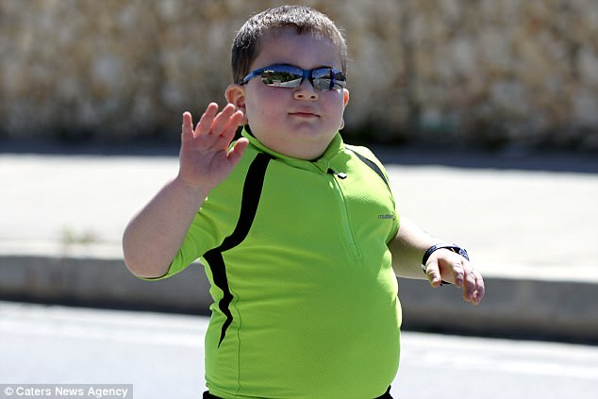
+4
No matter what he does, he will continue to get larger as a result of the condition - of which less than 100 people have ever been diagnosed
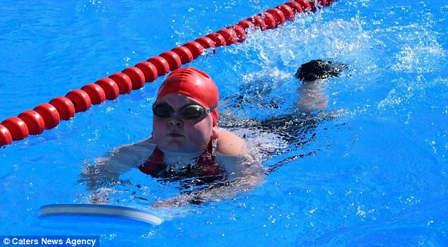
+4
Despite the judgemental looks he receives, he dreams of replicating the success of the Brownlee brothers, Team GB's famous Olympic medalists

WHAT IS ROHHAD?
ROHHAD is an acronym for rapid-onset obesity with hypothalamic dysregulation, hypoventilation and autonomic dysregulation.
It affects the part of the nervous system that controls involuntary actions and the endocrine system.
Scientists suspect the condition is genetic but are still unsure.
The disease is incredibly rare, and less than 100 people in the world have been diagnosed with it.
Signs and symptoms:
- Dramatic weight gain over a six to 12-month period
- Inability to maintain normal water balance in the body
- Inability to regulate body temperature
- Slow heartbeat and excessive sweating
- Very shallow breathing during sleep
There is currently no cure for ROHHAD, with the average life expectancy being between five and nine, reports suggest.
Because it can affect many different parts of the body, children are often cared for by a team of healthcare providers from various fields.
The weight gain is often hard to control through exercise and diet - but keeping active helps to avoid excess from being piled on.
'All the other young athletes and their families are so supportive of Jake, and they are the first ones to cheer him across the finish line.
'Now we have shared Jake's story on social media, people from all over have come forward to say how he has touched their hearts. We are so overwhelmed.'
Jake was diagnosed with ROHHAD, which causes sufferers to experience rapid weight gain, in 2015.
It stands for rapid-onset obesity with hypothalamic dysregulation, hypoventilation, and autonomic dysregulation.
The life-threatening condition affects the nervous system controlling involuntary actions.
People with this disease can exhibit a wide range of symptoms which include slow heartbeat, excessive sweating, altered pupil response to light and also may be unable to maintain normal water balance in the body.
Jake's trainer Matt Azzopardi said: 'He is extremely positive and motivated and easily the most dedicated. He never misses a training session without valid reason and is constantly eager to train.
'Jake is very lovable and steals the heart of all who know him. It is sad and heart breaking to see what he has to go through.'
Mr Azzopardi added: 'I look at his family with a mixture of sympathy and admiration - despite the hardship they do their utmost to ensure that Jake gets as normal a life as possible.
'Jake was always included in the group and followed the same training and adapted as and when the need arises.
'Some alterations are necessary in order to meet his special needs such as having to stop and go to the bathroom or keeping an eye on his heart rate and ensuring he doesn't get too hot.
'But I always tell him not to change, to keep going and to do his best. He is an inspiration for so many.'
Read more: http://www.dailymail.co.uk/health/article-4378144/Boy-fighting-life-taking-triathlons.html#ixzz4dI1RitaE
Follow us: @MailOnline on Twitter | DailyMail on Facebook

