10 Vision-Saving Advances in Medicine

Contributor Information
Marrecca Fiore
Editorial Director
Medscape
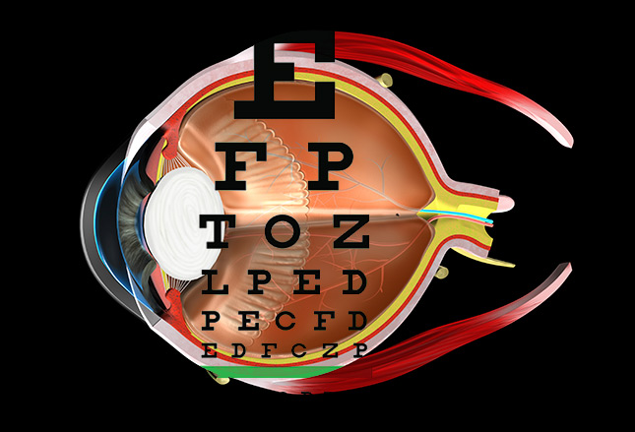

Saving Vision
Nearly 300 million people around the world suffer from some type of vision loss or blindness. Improved medical technology is not only making it easier for nearsighted and farsighted patients to see, but it's also improving the odds of saving the vision of patients with diseases such as macular degeneration and glaucoma. Even certain types of blindness, once considered incurable, are inching toward a possible cure, with the bionic eye providing glimpses of light to those who once could see only darkness.
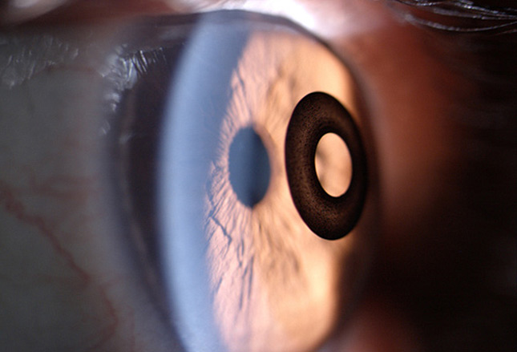

Corneal Inlay May Soon Replace Reading Glasses
As patients age, their ability to read and view objects close up diminishes due to presbyopia. While many may easily acclimate themselves to wearing reading glasses or bifocal glasses or contacts, others may find this new form of vision loss and the need for corrective lenses bothersome.
There may soon be another option. A small, ring-like device called a corneal inlay promises to correct vision whether patients are nearsighted, farsighted, or both. The ring is implanted under the eye's outer surface by a physician and allows wearers to see near and far at the same time. The device is in use elsewhere in the world, and there are three US versions in the works, but none has been FDA approved.

For Glaucoma, Diamonds May Help Prevent Vision Loss
Patients diagnosed with glaucoma rely on eye drops to prevent pressure buildup in their eyes that may lead to blindness. Proper dosing and remembering to use the drops at regular intervals can be difficult, however. Researchers at the University of California, Los Angeles (UCLA) are working to solve both problems and are developing contact lenses made from tiny nanodiamonds.
The lenses are coated with time-release medication to ensure that the right dose of medication is released in the right place at the right time. The project will soon move to animal studies.
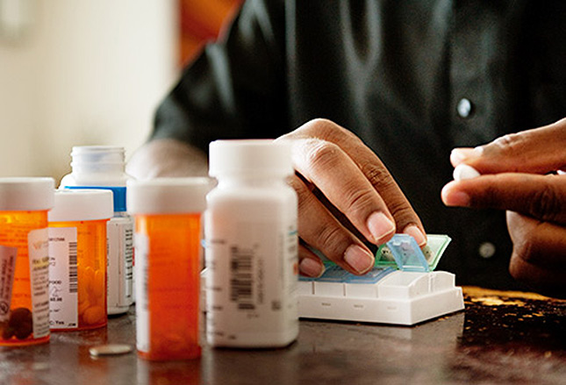

HIV Meds for Macular Degeneration
Nucleoside reverse transcriptase inhibitors (NRTIs), the drugs most often used to treat HIV and AIDS, may one day be used to treat macular degeneration. Researchers have observed in mice that NRTIs possess intrinsic anti-inflammatory activity and believe that this would be beneficial to patients who have age-related macular degeneration with geographic atrophy. While the research is still in the animal testing phase, which means it's still a ways off from human trials, the good news is that the medication is already on the market, is not expensive, and is considered safe.
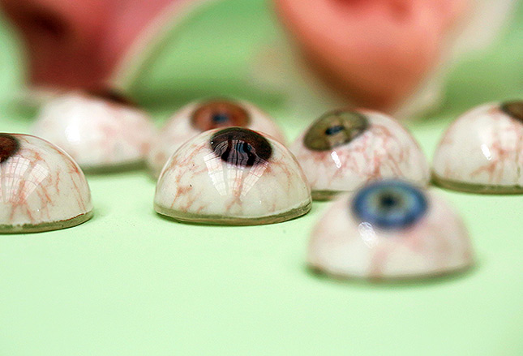

Printing New Eyes
Replacing an eye after illness or accident is costly. A traditional glass or acrylic eye can cost $5000 and take hours to mold and hand-paint. And these new "eyes" still may never look quite right. New 3D printing technology may change that and could bring the cost of a prosthetic eye down to as low as $150. The new technology is also said to allow for precise color matching with the existing eye. A joint project between Britain's Manchester Metropolitan University and London's Fripp Design aims to have eyes ready for market within a year.

Gene Therapy for Vision Loss
Researchers at the University of California, Berkeley, placed a gene into the retinas of blind mice that allowed the animals to detect whether lights were flashing. They also added a chemical "switch" to allow brain cells to respond to the light. This technique also helped restore sight in dogs. It is not yet known when the treatment might be ready to test on humans, but researchers are working to make that happen sooner rather than later.
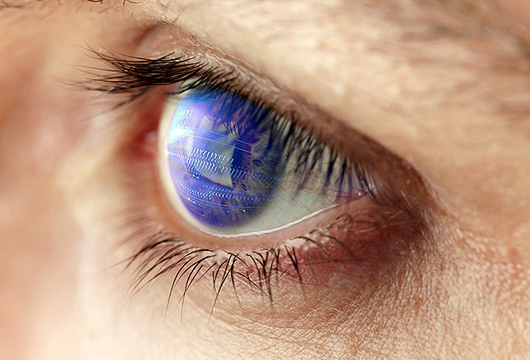

Dr TV: Diagnosing Glaucoma
Scientists at City University London mapped eye movements while people watched TV. They found that healthy eyes follow a different path from eyes that are not healthy. The study is in its early days, but the researchers hope that it will translate into easier—and earlier—diagnosis of and treatment for glaucoma and other diseases of the eye.
Researchers anticipate that the technology will someday be used by patients who don't have access to physicians, such as those living in rural and other areas struggling with physician shortages. In this case, it might be Dr TV who ultimately makes the diagnosis.
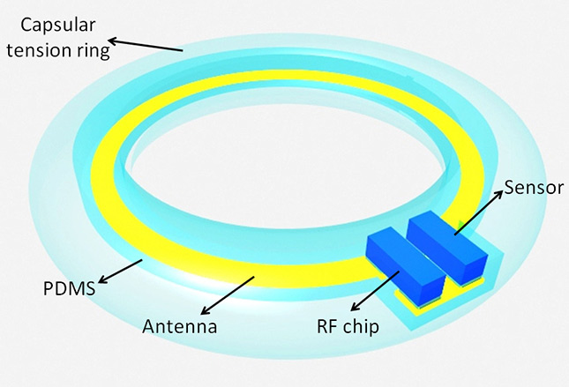

Implant May Reduce Office Visits
Patients with glaucoma must visit their ophthalmologists on a regular basis for pressure checks. The office visits are important to ensure that excess pressure on the optic nerve does not lead to blindness. Researchers at the University of Washington are working to reduce office visits with the use of an implantable electronic sensor placed in the eye to track pressure changes. The wireless gadget, researchers hope, will be able to send this important data to a handheld device or smartphone, or straight to physicians, thus reducing unnecessary office visits.
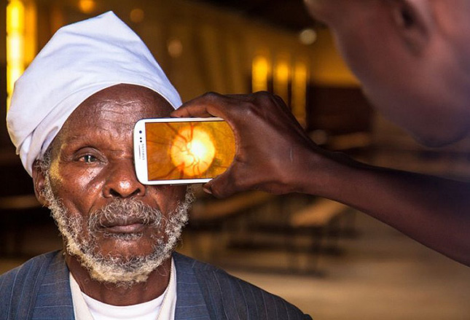

Smartphone Eye Exams
Products currently on the market are improving access to eye care worldwide. Peek™ and D-EYE™ each pair a small lens attachment with an app that turns a smartphone into a portable exam tool. The tools allow doctors to examine eyes in places where it may be hard or impractical to transport bulky equipment.
The iExaminer™ System marries an iPhone® with a device that your primary care physician may use to look into your eyes. It takes detailed pictures that can then be shared with a specialist if the primary care doctor suspects a problem.
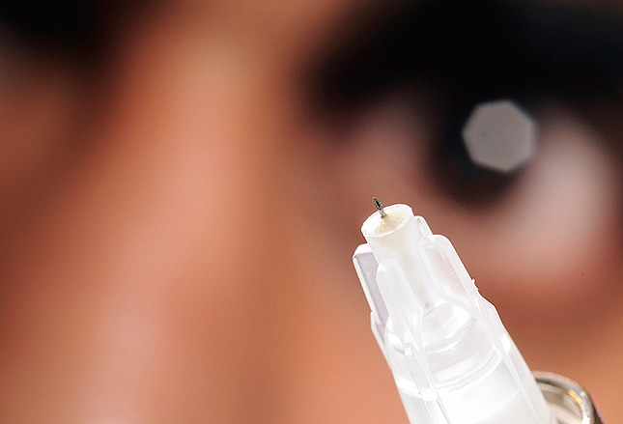

A Sharp Eye Drop Replacement
Could a needle painlessly replace the daily eye drops that patients with certain eye diseases require? Researchers at Georgia Tech have come up with needle points that are so fine, they can inject drugs painlessly and precisely where they're needed inside the eye.
The needle treatment is being developed for vision-stealing conditions such as glaucoma and overgrowth of blood vessels in the cornea. To date, the needles have been tested in animals only.
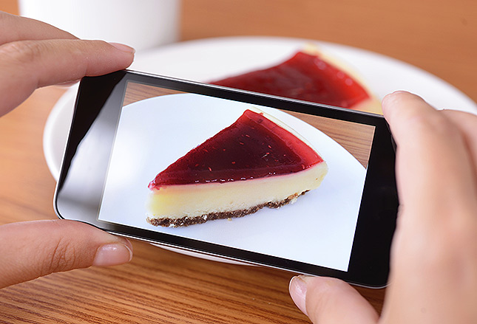

Apps for the Blind
A crop of new apps are being developed to help people with vision problems. Two examples are TapTapSee and VizWiz. With these apps, the visually impaired person points the camera on his phone at an object, and the app then tells him what it is. If the app doesn't know, it can send details out to a network to see if someone else can help. The LookTel Money Reader can tell a visually impaired person the value of paper money. And the KNFB Reader app takes a picture of a printed document so that the phone can read it aloud.

