PCOS: An Infertility Issue That Is Little Understood
By Jane E. Brody
November 24, 2014 12:59 pm November 24, 2014 12:59 pm Comment
Photo
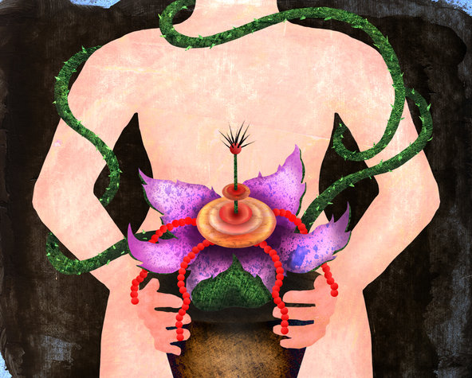
Jane Brody on health and aging.
Sometimes medical syndromes are named long before they are fully understood.
Take polycystic ovarian syndrome, or PCOS, which affects as many as 10 percent of women of childbearing age, often impairing their fertility.
But not all of these women have polycystic ovaries, a fact that can result in misdiagnosis. As it turns out, cysts — sacs of fluid on the ovaries — are just one manifestation of a complex hormonal condition.
First described in 1935, PCOS was initially called Stein-Leventhal syndrome, for the two American gynecologists who identified it, Dr. Irving F. Stein Sr. and Dr. Michael L. Leventhal. They recognized that ovarian cysts can interrupt ovulation and cause infertility in significant numbers of women.
Irregular menstrual cycles and difficulty conceiving are among the most common symptoms, the result of ovarian follicles that fail to mature fully and to release eggs. Affected women often have enlarged ovaries and, when menses does occur, prolonged bleeding.
Over time more cysts — swollen follicles, really — may form. On an ultrasound exam, they resemble a string of pearls stretched over the surface of the ovary. Yet some experts believe cysts are a result, rather than the cause, of the syndrome.
“Whether the condition starts in the ovaries is not certain,” Dr. R. Scott Lucidi, an expert on PCOS at Virginia Commonwealth University, said in an interview.
Indeed, women with few or no ovarian cysts may be diagnosed with PCOS. According to the so-called Rotterdam criteria, a woman with any two of the following conditions may have the condition:
■ Symptoms of elevated levels of androgens, or male sex hormones, which can include acne, excessive hairiness and sometimes male-pattern hair loss.
■ Irregular menses, with prolonged periods between cycles.
■ Twelve or more follicular cysts on the ovaries, as seen on an ultrasound.
Dr. Lucidi and others have suggested that insulin resistance could be the underlying factor responsible for the disparate symptoms of PCOS.
In people resistant to insulin, the hormone does not effectively transfer glucose from blood to body cells to be used for energy. As blood levels of glucose build, more insulin is produced to try to lower it.
Excess insulin promotes fat storage and can result in weight gain and obesity. About half of American women with PCOS are obese. Insulin also can stimulate the ovaries to produce androgens.
But just as some young women with a lot of ovarian cysts do not have PCOS, some women with metabolic syndrome and insulin resistance are thin.
PCOS tends to cluster in families, with predisposing genes passed from either parent to both daughters and sons. In affected males, early balding or excessive hairiness can be a sign that the genes have been inherited. In women, symptoms can vary from being very mild to extensive.
Some experts believe that the fundamental defect may not be insulin resistance, but hormonal dysregulation by or of the hypothalamus. This small region at the base of the brain produces hormones that stimulate the pituitary gland, which in turn affects organs throughout the body.
In most women with PCOS, the pituitary gland produces excessive amounts of luteinizing hormone, which, like insulin, can stimulate the ovaries to secrete androgens, according to a practice guideline written by Dr. Robert L. Barbieri, head of obstetrics and gynecology at Brigham and Women’s Hospital in Boston.
When ovarian follicles are enlarging, women with PCOS also produce high levels of estradiol but low levels of progesterone, resulting in a thick uterine lining and over time an increased risk of endometrial cancer.
There is no cure for PCOS, and the best approach to treatment is individualized, depending on the goals of each patient, Dr. Lucidi said.
For women with prolonged intervals between menses or excessive hairiness, or both, contraceptives containing estrogen and progestin are used to regulate the menstrual cycle and suppress the production of androgens.
Often, the blood pressure drug spironolactone is also given to counteract androgen-caused acne or hirsutism in adult women.
For a woman trying to become pregnant, a different regimen is needed. Two drugs, clomiphene and letrozole, are commonly prescribed to stimulate ovulation. Both these drugs prompt the pituitary to secrete follicle-stimulating hormone (FSH), which enhances the growth of small follicles and thus can trigger ovulation.
Dr. Barbieri noted that “most women with PCOS who undergo ovulation induction go on to conceive and bear children.” Perhaps the most challenging therapy involves weight reduction. Losing 10 percent of body weight can result in more regular menstrual cycles and reduced levels of testosterone, Dr. Barbieri wrote.
For women with PCOS, the most effective diet for achieving and maintaining weight loss is low in carbohydrates, rather than low in fat.
Without being extreme, women with PCOS should reduce their carbohydrate intake overall and in particular avoid sugars and refined carbohydrates (white bread, white rice and anything stripped of its natural fiber or made with refined white flour).
They should instead select foods high in fiber made from whole grains, as unprocessed as possible. They are also advised to avoid eating carbohydrate-rich foods by themselves, and space them out during the day to keep insulin levels from spiking. Consuming four or more small meals instead of a few large ones each day is also helpful.
Regular moderate or vigorous exercise done five or more times a week is an important part of the regimen

