Meet Sebastian, 7, whose weight has TRIPLED in two years because of a rare condition which affects just a handful of people around the world... and it could kill him
Sebastian Aguiar is seven-years-old and weighs almost 70kg
- The boy from western Sydney suffers from ROHHADS syndrome
- He weighed a healthy 25kg less than two years ago
- He is one of only about 75 people in the world with the condition
- He is believed to be only person in Australia suffering from the disease
- ROHHAD syndrome is potentially lethal and incurable
- It affects breathing, body temperature, heart rate and blood pressure
- A fundraising page has been set up to send him to Chicago for tests
- It is his only hope as the syndrome is potentially lethal and incurable
By Leesa Smith for Daily Mail Australia
Published: 06:57 EST, 24 September 2014 | Updated: 08:16 EST, 24 September 2014

At the age of seven, Sebastian Aguiar weighs the same as a fully grown adult and is three times heavier than he was two years ago.
But Sebastian, who tips the scales at nearly 70kg, doesn't gorge on junk food or have an adversion to exercise.
In fact, he would love to run around after his friends - that would mean living a normal life.
The little boy suffers from Rapid-Onset Obesity with Hypathalamic Dysfunction, Hypoventilation and Auto-Nomic Dysregulation (ROHHADS), one of 75 people in the world to suffer from the potentially deadly but rare condition.
Weighing a healthy 25kg just two years ago, Sebastian is now almost 70kg and stops breathing without warning - meaning he has to have a tracheotomy tube in his throat and sleeps with a ventilator every night.
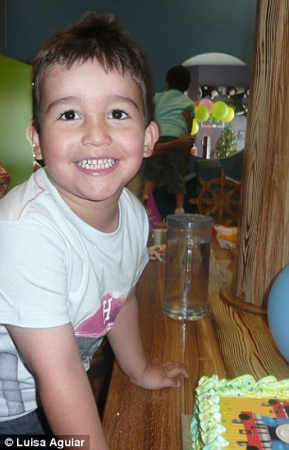
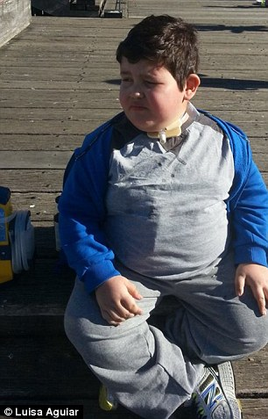
Sebastian at his fifth birthday (left) before he became ill and in April this year after he put on 45kg (right)
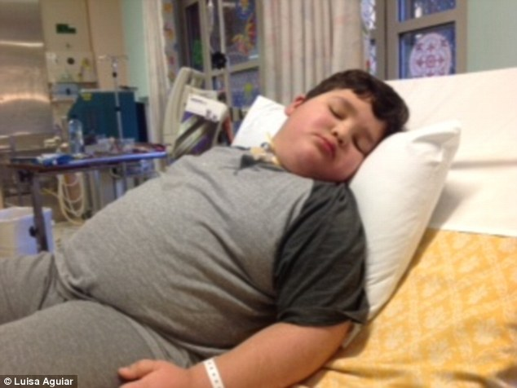
Sebastian is too exhausted to play with his toys anymore as he spends a lot of time in hospital
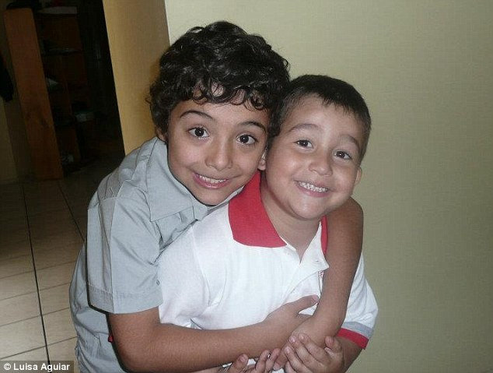
In happier days when he was an energetic lively boy with his brother Jalin (left)
Unable to understand why he can't play anymore, Sebastian, the only ROHHADS sufferer in Australia, needs medication to stay awake during the day and to fall asleep at night, is now also suffering from depression as the disease has robbed him of his childhood after spending two traumatic years in and out of hospital.
The boy from Hinchinbrook in western Sydney is on medication for his hormones and thyroid which are not producing enough for him to function properly.
The condition, which is potentially lethal and incurable, affects the ability to breath and also impacts on the body's temperature, heart rate and blood pressure - therefore Sebastian's oxygen levels can run dangerously low.
Sebastian had to have a tracheotomy inserted in December after he almost lost his life.
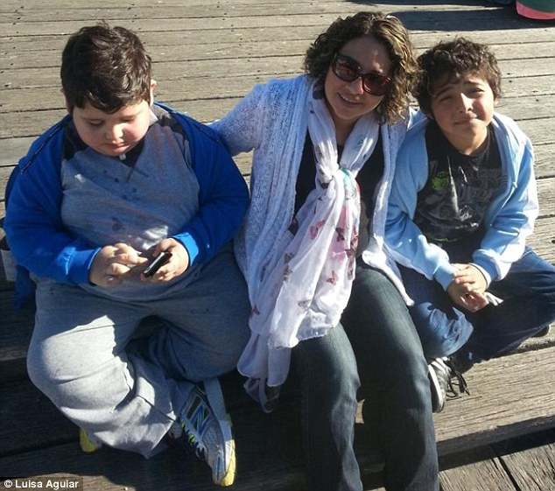
Sebastian (left) now has a tracheotomy tube inserted in his throat pictured with his mum, Luisa, and Jalin
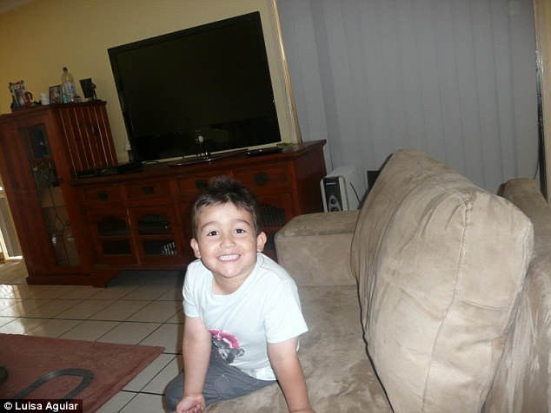
Sebastian's love of playing soccer, swimming and playing with his toys are merely memories now
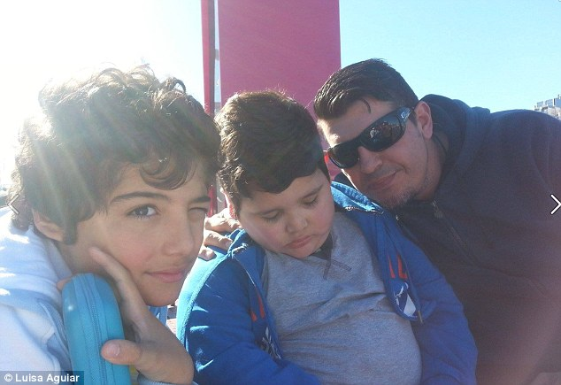
Sebastian (centre), with Jalin (left) and his dad Freddy, needs medication to stay awake during the day and to fall asleep at night
His mother Luisa Aguiar, who has another son Jalen, 9, and daughter Kiara, 20 months, said the most heartbreaking part was her son not being able to understand what has happened to him.
'He says to me "Why me Mummy? What did I do to deserve this?",' Ms Aguiar told Daily Mail Australia.
He has also become very self-conscious of the way he looks.
'He doesn't like having photos taken - when he brushes his teeth he closes his eyes so he doesn't have to see himself,' she said.
Sebastian's love of playing soccer, swimming and playing with his toys are merely memories now.
'He used to love playing with his cars and trains but he asked him to put his toys away because he's too tired - he just can't do it,' his mother said.
Ms Aguiar describes the family's journey as a 'roller coaster' and a 'nightmare'.
'Some days we just scream and cry and say "why us?".'
But she says her son's determined spirit will get him through.
'He's very stubborn,' she said. 'He's got a lot of fight in him.'
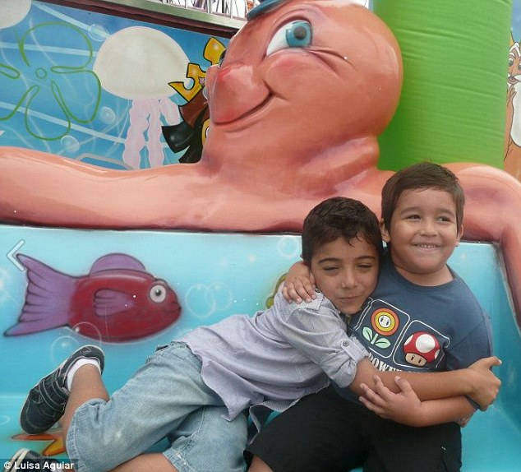
Sebastian(right) with brother Jalin (left) often asks his mother why he has become this way
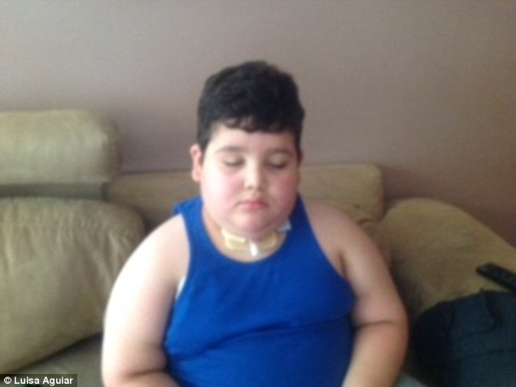
Sebastian now also suffering from depression after spending two stressful years in and out of hospital.
However, the good news is his weight has remained stable since February thanks to a restricted diet of only taking in 1,000 calories a day.
The only thing that brings joy to Sebastian's life is attending school at St John the Baptist in Bonnyrigg Heights in western Sydney.
'It's the only thing that makes him happy - it gives him a purpose in life,' Ms Ms Aguiar said.
'He gets to be a child after being in hospital so often.'
The school has started a fundraising page for Sebastian in a quest to raise at least $100,000 for him to travel to The Lurie's Childrens Hospital in Chicago - his one and only possible hope to increase his quality of life.
After more than a year of not being able to find out what was wrong, it was suggested by the Chicago hospital to Sebastian's doctor, who sent the details of his condition around the world, that Sebastian may have ROHHADS syndrome.
'Kids pass away from it which is quite scary but we just have to stay positive and stay on top of the disease,' Ms Aguiar said.
'I'm hoping and praying we can raise the money because I received an email saying the tests will cost up to $200,000.'
The fundraising page is currently sitting at $28,000.
To offer you support to help get Sebastian to Chicago please go to: Sebastian's fight for life

Read more: http://www.dailymail.co.uk/health/article-2767691/This-7-year-old-boy-TRIPLED-size-two-years-rare-disease-affects-75-people-world.html#ixzz3EFYlRYS8
Follow us: @MailOnline on Twitter | DailyMail on Facebook

