Pyruvate Dehydrogenase & Krebs Cycle

Contents of this page:
Pathway localization
Pyruvate dehydrogenase
Roles of acetyl-coenzyme A
Regulation of pyruvate dehydrogenase
Krebs cyclePyruvate Dehydrogenase & Krebs Cycle
Contents of this page:
Pathway localization
Pyruvate dehydrogenase
Roles of acetyl-coenzyme A
Regulation of pyruvate dehydrogenase
Krebs cycle
Pathway localization:
Glycolysis enzymes are located in the cytosol of cells. Pyruvate enters the mitochondrion to be metabolized further.
Mitochondrial compartments:  The mitochondrial matrix contains Pyruvate Dehydrogenase and enzymes of Krebs Cycle, plus other pathways such as fatty acid oxidation.  The mitochondrial outer membrane contains large VDAC channels, similar to bacterial porin channels, making the outer membrane leaky to ions and small molecules.  The inner membrane is the major permeability barrier of the mitochondrion. It contains various transport catalysts, including a carrier protein that allows pyruvate to enter the matrix. It is highly convoluted, with infoldings called cristae. Embedded in the inner membrane are constituents of the respiratory chain and ATP Synthase. | 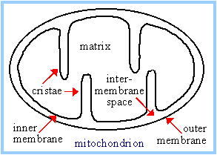

Pyruvate Dehydrogenase catalyzes oxidative decarboxylation of pyruvate, to form acetyl-CoA. The overall reaction is shown at right. | 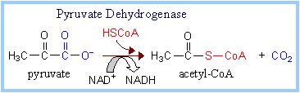

Pyruvate Dehydrogenase is a large complex containing many copies of each of three enzymes, E₁, E₂, and E₃. The structure of the complex is depicted in figures on p. 769 & 774 of Biochemistry, 3rd Edition, by Voet & Voet.  The inner core of the mammalian Pyruvate Dehydrogenase complex is an icosahedral structure consisting of 60 copies of E₂.  At the periphery of the complex are:  - 30 copies of E₁ (itself a tetramer with subunits α₂β₂) and  - 12 copies of E₃ (a homodimer), plus 12 copies of an E₃ binding protein that links E₃ to E₂.  Prosthetic groups are listed below, a cartoon showing 3 subunits is at right, and a diagram summarizing the reactions catalyzed is on p. 770. | 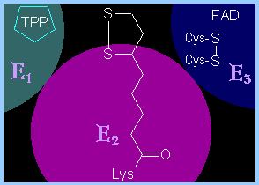

Enzyme | Abbreviated | Prosthetic Group
Pyruvate Dehydrogenase | E₁ | Thiamine pyrophosphate (TPP)
Dihydrolipoyl Transacetylase | E₂ | Lipoamide
Dihydrolipoyl Dehydrogenase | E₃ | FAD
FAD (Flavin Adenine Dinucleotide) is a derivative of the B-vitamin riboflavin (dimethylisoalloxazine-ribitol). The flavin ring system undergoes oxidation/reduction as shown below. Whereas NAD⁺ is a coenzyme that reversibly binds to enzymes, FAD is a prosthetic group, that is permanently part of the complex.
FAD accepts and donates 2 electrons with 2 protons (2 H):  FAD + 2 e⁻ + 2 H⁺ �� FADH₂ | 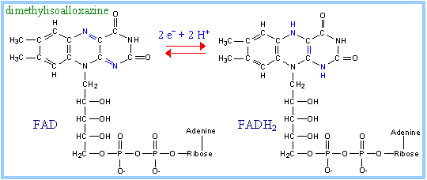
Thiamine pyrophosphate (TPP) is a derivative of thiamine (vitamin B₁). Nutritional deficiency of thiamine leads to the disease beriberi. Beriberi affects especially the brain, because TPP is required for carbohydrate metabolism, and the brain depends on glucose metabolism for energy.
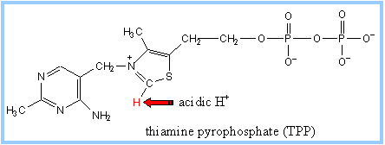  A proton readily dissociates from the C that is between N and S in the thiazole ring of TPP. The resulting carbanion (ylid) can attack the electron-deficient keto carbon of pyruvate. See also diagram p. 771. | 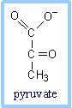

Lipoamide includes a dithiol that undergoes oxidation and reduction.  The carboxyl group at the end of lipoic acid's hydrocarbon chain forms an amide bond to the side-chain amino group of a lysine residue of E₂.  A long flexible arm, including hydrocarbon chains of lipoate and the lysine R-group, links the dithiol of each lipoamide to one of two lipoate-binding domains of each E₂. Lipoate-binding domains are themselves part of a flexible strand of E₂ that extends out from the core of the complex.  The long flexible attachment allows lipoamide functional groups to swing back and forth between E2 active sites in the core of the complex and active sites of E1 & E3 in the outer shell of the complex.  The E3 binding protein (that binds E3 to E2) also has attached lipoamide that can exchange reducing equivalents with lipoamide on E2.  For diagrams showing the approximate arrangement of functional domains, based on structural studies of Pyruvate Dehydrogenase and a related enzyme see:  - a website of the laboratory of Wim Hol.  - an article by Milne et al. (Fig. 5, requires a subscription to J. Biol. Chem.). | 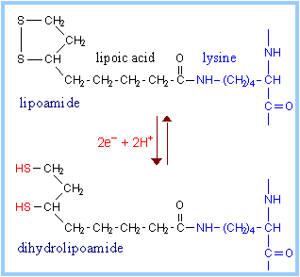

Organic arsenicals are potent inhibitors of lipoamide-containing enzymes such as Pyruvate Dehydrogenase. These highly toxic compounds react with "vicinal" dithiols such as the functional group of lipoamide as shown at right. | 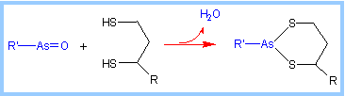

In the overall reaction, the acetic acid generated is transferred to coenzyme A.  The final electron acceptor is NAD⁺.  Complete structures of these coenzymes are presented in the section on bioenergetics. | 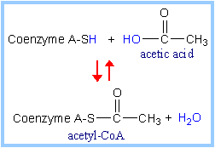 | 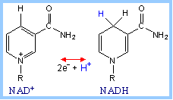

The sequence of reactions catalyzed by the Pyruvate Dehydrogenase complex is summarized in Fig. 21-6 p. 770, and in the animation at right. The mechanism is depicted in greater detail on p. 771-772.  The reaction proceeds as follows: | 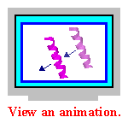  of Pyruvate Dehydrogenase
- The keto carbon of pyruvate reacts with the carbanion of TPP on E₁ to yield an addition compound. The electron-pulling positively charged nitrogen of the thiazole ring promotes loss of CO₂. What remains is hydroxyethyl-TPP.
- The hydroxyethyl carbanion on TPP of E₁ reacts with the disulfide of lipoamide on E₂. What was the keto carbon of pyruvate is oxidized to a carboxylic acid, as the disulfide of lipoamide is reduced to a dithiol. The acetate formed by oxidation of the hydroxyethyl moiety is linked to one of the thiols of the reduced lipoamide as a thioester (~).
- The acetate is transferred from the thiol of lipoamide to the thiol of coenzyme A, yielding acetyl CoA.
- The reduced lipoamide swings over to the E₃ active site. Dihydrolipoamide is reoxidized to the disulfide, as 2 e⁻ + 2 H⁺ are transferred to a disulfide on E₃ (disulfide interchange).
- The dithiol on E₃ is reoxidized as 2 e⁻ + 2 H⁺ are transferred to FAD. The resulting FADH₂ is reoxidized by electron transfer to NAD⁺, to yield NADH + H⁺.
Acetyl CoA, a product of the Pyruvate Dehydrogenase reaction, is a central compound in metabolism. The "high energy" thioester linkage makes it an excellent donor of the acetate moiety. | 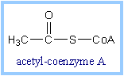

For example, acetyl CoA functions as:  - input to the Krebs Cycle, where the acetate moiety is further degraded to CO₂.  - donor of acetate for synthesis of fatty acids, ketone bodies, and cholesterol.  Regulation of Pyruvate Dehydrogenase complex (see also p. 780-781): | 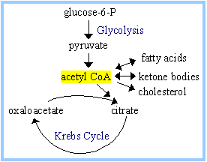
Product inhibition by NADH and acetyl CoA: NADH competes with NAD⁺ for binding to E₃. Acetyl CoA competes with Coenzyme A for binding to E₂.
Regulation by phosphorylation/dephosphorylation of E₁: Specific regulatory Kinases and Phosphatases are associated with the Pyruvate Dehydrogenase complex within the mitochondrial matrix.
- Pyruvate Dehydrogenase Kinases catalyze phosphorylation of serine residues of E₁, inhibiting the complex.
- Pyruvate Dehydrogenase Phosphatases reverse this inhibition.
Pyruvate Dehydrogenase Kinases are activated by NADH and acetyl-CoA, providing another way the two major products of the Pyruvate Dehydrogenase reaction inhibit the complex. Pyruvate Dehydrogenase Kinase activation involves interaction with E₂ subunits to sense changes in oxidation state and acetylation of lipoamide caused by NADH and acetyl-CoA.
During starvation, Pyruvate Dehydrogenase Kinase increases in amount in most tissues, including skeletal muscle, via increased gene transcription. Under the same conditions, the amount of Pyruvate Dehydrogenase Phosphatase decreases. The resultinginhibition of Pyruvate Dehydrogenase prevents muscle and other tissues from catabolizing glucose and gluconeogenesis precursors. Metabolism shifts toward fat utilization, while muscle protein breakdown to supply gluconeogenesis precursors is minimized, and available glucose is spared for use by the brain.
A Ca⁺⁺-sensitive isoform of the phosphatase that removes phosphate residues from E₁ is expressed in muscle cells. The increased cytosolic Ca⁺⁺ that occurs during activation of muscle contraction can lead to Ca⁺⁺ uptake by mitochondria. The higher Ca⁺⁺ stimulates the phosphatase, and dephosphorylation activates Pyruvate Dehydrogenase. Thus mitochondrial metabolism may be stimulated during exercise.
Lecture notes relating to Krebs Cycle are not provided in the usual format, because lectures will be presented by students. Some questions on Krebs Cycle are included in the self-study quiz for this class.
Select the interactive tutorial at right for information about the Krebs Citric Acid Cycle. Within the tutorial, drag the cursor over each enzyme name for information about that reaction.
Note that FADH₂, listed as a product of succinate oxidation, is reoxidized to FAD as redox carriers within the Succinate Dehydrogenase complex pass electrons to coenzyme Q of the respiratory chain. Thus it would be more appropriate to list coenzyme QH₂ as a product of the Succinate Dehydrogenase reaction. The initial acceptor, FAD, is included in the diagram for consistency with most textbooks.
Copyright � 1998-2007 by Joyce J. Diwan. All rights reserved.

Pathway localization:
Glycolysis enzymes are located in the cytosol of cells. Pyruvate enters the mitochondrion to be metabolized further.
Mitochondrial compartments:
The mitochondrial matrix contains Pyruvate Dehydrogenase and enzymes of Krebs Cycle, plus other pathways such as fatty acid oxidation.
The mitochondrial outer membrane contains large VDAC channels, similar to bacterial porin channels, making the outer membrane leaky to ions and small molecules.
The inner membrane is the major permeability barrier of the mitochondrion. It contains various transport catalysts, including a carrier protein that allows pyruvate to enter the matrix. It is highly convoluted, with infoldings called cristae. Embedded in the inner membrane are constituents of the respiratory chain and ATP Synthase.

Pyruvate Dehydrogenase catalyzes oxidative decarboxylation of pyruvate, to form acetyl-CoA. The overall reaction is shown at right.

Pyruvate Dehydrogenase is a large complex containing many copies of each of three enzymes, E₁, E₂, and E₃. The structure of the complex is depicted in figures on p. 769 & 774 of Biochemistry, 3rd Edition, by Voet & Voet.
The inner core of the mammalian Pyruvate Dehydrogenase complex is an icosahedral structure consisting of 60 copies of E₂.
At the periphery of the complex are:
- 30 copies of E₁ (itself a tetramer with subunits α₂β₂) and
- 12 copies of E₃ (a homodimer), plus 12 copies of an E₃ binding protein that links E₃ to E₂.
Prosthetic groups are listed below, a cartoon showing 3 subunits is at right, and a diagram summarizing the reactions catalyzed is on p. 770.

Enzyme | Abbreviated | Prosthetic Group
Pyruvate Dehydrogenase | E₁ | Thiamine pyrophosphate (TPP)
Dihydrolipoyl Transacetylase | E₂ | Lipoamide
Dihydrolipoyl Dehydrogenase | E₃ | FAD
FAD (Flavin Adenine Dinucleotide) is a derivative of the B-vitamin riboflavin (dimethylisoalloxazine-ribitol). The flavin ring system undergoes oxidation/reduction as shown below. Whereas NAD⁺ is a coenzyme that reversibly binds to enzymes, FAD is a prosthetic group, that is permanently part of the complex.
FAD accepts and donates 2 electrons with 2 protons (2 H):
FAD + 2 e⁻ + 2 H⁺ �� FADH₂
Thiamine pyrophosphate (TPP) is a derivative of thiamine (vitamin B₁). Nutritional deficiency of thiamine leads to the disease beriberi. Beriberi affects especially the brain, because TPP is required for carbohydrate metabolism, and the brain depends on glucose metabolism for energy.

A proton readily dissociates from the C that is between N and S in the thiazole ring of TPP. The resulting carbanion (ylid) can attack the electron-deficient keto carbon of pyruvate. See also diagram p. 771.

Lipoamide includes a dithiol that undergoes oxidation and reduction.
The carboxyl group at the end of lipoic acid's hydrocarbon chain forms an amide bond to the side-chain amino group of a lysine residue of E₂.
A long flexible arm, including hydrocarbon chains of lipoate and the lysine R-group, links the dithiol of each lipoamide to one of two lipoate-binding domains of each E₂. Lipoate-binding domains are themselves part of a flexible strand of E₂ that extends out from the core of the complex.
The long flexible attachment allows lipoamide functional groups to swing back and forth between E2 active sites in the core of the complex and active sites of E1 & E3 in the outer shell of the complex.
The E3 binding protein (that binds E3 to E2) also has attached lipoamide that can exchange reducing equivalents with lipoamide on E2.
For diagrams showing the approximate arrangement of functional domains, based on structural studies of Pyruvate Dehydrogenase and a related enzyme see:
- a website of the laboratory of Wim Hol.
- an article by Milne et al. (Fig. 5, requires a subscription to J. Biol. Chem.).

Organic arsenicals are potent inhibitors of lipoamide-containing enzymes such as Pyruvate Dehydrogenase. These highly toxic compounds react with "vicinal" dithiols such as the functional group of lipoamide as shown at right.

In the overall reaction, the acetic acid generated is transferred to coenzyme A.
The final electron acceptor is NAD⁺.
Complete structures of these coenzymes are presented in the section on bioenergetics.

The sequence of reactions catalyzed by the Pyruvate Dehydrogenase complex is summarized in Fig. 21-6 p. 770, and in the animation at right. The mechanism is depicted in greater detail on p. 771-772.  The reaction proceeds as follows: | of Pyruvate Dehydrogenase
- The keto carbon of pyruvate reacts with the carbanion of TPP on E₁ to yield an addition compound. The electron-pulling positively charged nitrogen of the thiazole ring promotes loss of CO₂. What remains is hydroxyethyl-TPP.
- The hydroxyethyl carbanion on TPP of E₁ reacts with the disulfide of lipoamide on E₂. What was the keto carbon of pyruvate is oxidized to a carboxylic acid, as the disulfide of lipoamide is reduced to a dithiol. The acetate formed by oxidation of the hydroxyethyl moiety is linked to one of the thiols of the reduced lipoamide as a thioester (~).
- The acetate is transferred from the thiol of lipoamide to the thiol of coenzyme A, yielding acetyl CoA.
- The reduced lipoamide swings over to the E₃ active site. Dihydrolipoamide is reoxidized to the disulfide, as 2 e⁻ + 2 H⁺ are transferred to a disulfide on E₃ (disulfide interchange).
- The dithiol on E₃ is reoxidized as 2 e⁻ + 2 H⁺ are transferred to FAD. The resulting FADH₂ is reoxidized by electron transfer to NAD⁺, to yield NADH + H⁺.
Acetyl CoA, a product of the Pyruvate Dehydrogenase reaction, is a central compound in metabolism. The "high energy" thioester linkage makes it an excellent donor of the acetate moiety.

For example, acetyl CoA functions as:
- input to the Krebs Cycle, where the acetate moiety is further degraded to CO₂.
- donor of acetate for synthesis of fatty acids, ketone bodies, and cholesterol.
Regulation of Pyruvate Dehydrogenase complex (see also p. 780-781):
Product inhibition by NADH and acetyl CoA: NADH competes with NAD⁺ for binding to E₃. Acetyl CoA competes with Coenzyme A for binding to E₂.
Regulation by phosphorylation/dephosphorylation of E₁: Specific regulatory Kinases and Phosphatases are associated with the Pyruvate Dehydrogenase complex within the mitochondrial matrix.
- Pyruvate Dehydrogenase Kinases catalyze phosphorylation of serine residues of E₁, inhibiting the complex.
- Pyruvate Dehydrogenase Phosphatases reverse this inhibition.
Pyruvate Dehydrogenase Kinases are activated by NADH and acetyl-CoA, providing another way the two major products of the Pyruvate Dehydrogenase reaction inhibit the complex. Pyruvate Dehydrogenase Kinase activation involves interaction with E₂ subunits to sense changes in oxidation state and acetylation of lipoamide caused by NADH and acetyl-CoA.
During starvation, Pyruvate Dehydrogenase Kinase increases in amount in most tissues, including skeletal muscle, via increased gene transcription. Under the same conditions, the amount of Pyruvate Dehydrogenase Phosphatase decreases. The resultinginhibition of Pyruvate Dehydrogenase prevents muscle and other tissues from catabolizing glucose and gluconeogenesis precursors. Metabolism shifts toward fat utilization, while muscle protein breakdown to supply gluconeogenesis precursors is minimized, and available glucose is spared for use by the brain.
A Ca⁺⁺-sensitive isoform of the phosphatase that removes phosphate residues from E₁ is expressed in muscle cells. The increased cytosolic Ca⁺⁺ that occurs during activation of muscle contraction can lead to Ca⁺⁺ uptake by mitochondria. The higher Ca⁺⁺ stimulates the phosphatase, and dephosphorylation activates Pyruvate Dehydrogenase. Thus mitochondrial metabolism may be stimulated during exercise.
Lecture notes relating to Krebs Cycle are not provided in the usual format, because lectures will be presented by students. Some questions on Krebs Cycle are included in the self-study quiz for this class.
Select the interactive tutorial at right for information about the Krebs Citric Acid Cycle. Within the tutorial, drag the cursor over each enzyme name for information about that reaction.
Note that FADH₂, listed as a product of succinate oxidation, is reoxidized to FAD as redox carriers within the Succinate Dehydrogenase complex pass electrons to coenzyme Q of the respiratory chain. Thus it would be more appropriate to list coenzyme QH₂ as a product of the Succinate Dehydrogenase reaction. The initial acceptor, FAD, is included in the diagram for consistency with most textbooks.
Copyright � 1998-2007 by Joyce J. Diwan. All rights reserved.

