Origin of gold found in rare neutron-star collisions
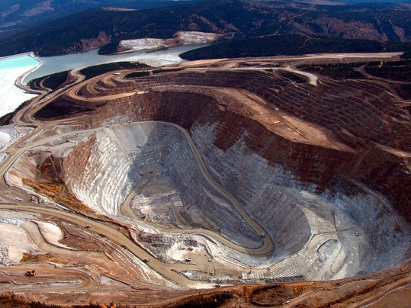
Fairbanks Gold Mining Inc./AP - Fort Knox Mine, which is currently the largest operating gold mine in Alaska. A new study based on observations from space suggests the gold on Earth came from rare neutron-star collisions.

By Joel Achenbach
Gold — atomic number 79, element symbol Au, the most widely beloved of the precious metals — might have its origin in extremely rare and violent explosions in the far reaches of outer space. The bling apparently begins with a blam.
For many years, scientists had theorized that the heavy elements of the periodic table, such as gold, platinum, lead and uranium, had their origin in supernova explosions. But the source, scientists announced Wednesday, might be even more exotic: the collision of two ultra-dense objects called neutron stars.
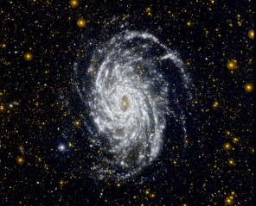
The year in space: In 2013, scientists captured stunning images of the planets, a galaxy, a planetary nebula and more from space.
“We now have kind of a smoking gun,” said Edo Berger, an astronomer who led the research at the Harvard-Smithsonian Center for Astrophysics in Cambridge, Mass.
The elements on Earth are all of cosmic origin. Carbon and oxygen atoms in our bodies, for example, come from the interior of stars, where they were formed under high pressure and heat. They were later spewed into the universe in supernova explosions. It is literally true, as Carl Sagan was fond of saying, that we are all star stuff.
But what hasn’t been known is whether these supernova events could account for the heaviest of the elements. A heavy element such as gold has 79 protons, 79 electrons and 118 neutrons. That’s a lot of mass for one atom. Most of the elements are simpler; gold and the other heavy elements are cosmically extravagant.
The neutron stars might provide the explanation.
Neutron stars are the collapsed cores of stars that have exploded in a supernova. A neutron star might be roughly the diameter of Washington but contain as much mass as our sun, all of it crammed together by the force of gravity, until even the atoms have collapsed, leaving the object with the density of an atomic nucleus.
A teaspoon full of neutron-star material would weigh, on Earth, about 5 billion tons, Berger said.
Most of these cosmic fruitcakes are solitary wanderers, but some are paired up, as remnants of binary stars. They will orbit a common point in space and gradually drift closer and closer, spiraling toward one another in obedience to Einstein’s laws of general relativity. One day, they will collide.
In the Milky Way galaxy, with hundreds of billions of stars, such a neutron-star collision is likely to happen about once every 100,000 years, Berger said.
Astronomers are fortunate in that the universe is so vast, containing many billions of galaxies, that any all-sky survey might possibly see something even as rare as a neutron-star collision. So it was that on June 3, NASA’s Swift space telescope observed a flash of light, called a short gamma-ray burst (GRB), in an extremely distant galaxy in the constellation Leo.
Astronomers scrambled to reobserve that tiny patch of space with a powerful telescope in Chile and with the Hubble Space Telescope.
They saw something glowing where they’d earlier seen the GRB. After comparing their observations with theoretical models, the astronomers concluded that they were seeing the radioactive afterglow from a huge quantity of heavy metals formed by a neutron-star smashup.
This observation potentially explains this type of short-duration GRB. These flashes of light can briefly outshine an entire galaxy. The June event, in a galaxy 3.9 billion light-years away, lasted only two-tenths of a second.
Although neutron-star collisions had been proposed as a source of such GRBs, now there is a direct observation.
“When they make contact, several exciting things happen very quickly,” Berger said. “Most of the material actually collapses to form a black hole. Some of the material then gets sucked into the black hole. That is the event that causes the gamma-ray burst. Some of the material gets spewed out into space. That material, since it came from neutron stars, is very rich in neutrons, and as a result, is very efficient at forming these heavy elements, including gold.”
And these explosions make a lot of it — about 20 Earth-masses of gold in the June event, according to a back-of-the-envelope calculation by Daniel Kasen, a University of California at Berkeley astrophysicist. Kasen said that comes out to about 100 trillion oil tankers of gold.
“You need a lot of neutrons to throw at some seed nucleus to build it up to something heavy like gold or lead or platinum,” Kasen said. “I’m partial to the name ‘blingnova’ to describe this kind of event, since what we are seeing is basically an ostentatious glimmering of riches.”
If platinum is your thing, then rejoice: These collisions create seven times as much platinum as gold. Berger said the neutron-star collisions produce essentially everything up and down the periodic table.
There’s still a lot that must be done with those gold atoms before they wind up on someone’s front tooth. The gold is basically dust in the wind, atomized, until it winds up in a cloud of material that can coalesce, through the force of gravity, into a solar system of planets with a star at the center.
Then the gold atoms have to find one another and become concentrated. Over a billion years or more, the planet’s geological processes will concentrate elements such as gold so that it will form veins and nuggets. Gold is chemically inert and doesn’t want to bond with other elements.
“It’s a process of distillation. That’s what planets do,” said Robert Hazen, a mineralogist at the Carnegie Institution of Washington. Gold is rare on Earth — about one part per billion in the Earth’s crust, Hazen said.
Most of Earth’s gold is trapped in the planet’s core, he said. And, he added, there’s a long-standing conjecture that at the very center of the Earth is a small core that’s pure gold.
So, does Earth have a heart of gold? They haven’t found a way to check on that — yet.

