Fat 'breathed out' of body via lungs, say scientists
By Michelle Roberts Health editor, BBC News online

Fat can be breathed out as well as burned off as you lose weight, biochemists who have studied metabolism at a microscopic level say.
But they warn that people still need to huff and puff with exercise to keep slim - hyperventilating on its own will not do the trick.
The Australian team traced the route of fat out of the body as atoms.
Their findings are published in the Christmas edition of the British Medical Journal.

These results show that the lungs are the primary excretory organ for weight loss”

When fat is broken down to its constituent parts, a couple of things happen.
Chemical bonds are broken, a process which releases heat and fuel to power muscles.
But the atoms - the stuff fat is made of - remain, and much of these leave the body via the lungs as carbon dioxide, say the scientists.
Fat storage and metabolism
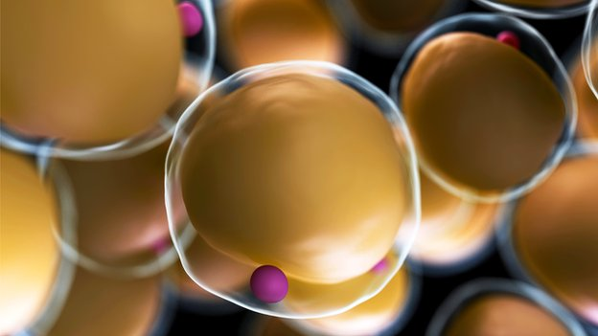Fat cells are used by the body as an energy store
Fat from food is stored in the body in cells called adipocytes. It is stored as a compound called triglyceride.
Triglyceride consists of three kinds of atoms; carbon, hydrogen and oxygen, and this means that when it is broken down around a fifth of it forms water (H2O) and four-fifths becomes carbon dioxide (CO2).
The water formed may be excreted in the urine, faeces, sweat, breath, tears, or other bodily fluids and is readily replenished by drinking water.
But the exhaled carbon (in CO2) can only be replaced by eating food or consuming beverages such as fruit juice.
Eat less, move more
The study authors, Ruben Meerman and Andrew Brown from The University of New South Wales, said: "None of this biochemistry is new, but for unknown reasons it seems nobody has thought of performing these calculations before.
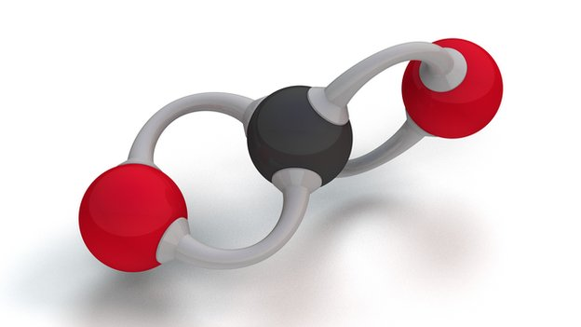Carbon dioxide is the main 'atomic' waste product when fat is metabolised
"These results show that the lungs are the primary excretory organ for weight loss."
They estimate that an average person loses at least 200g of carbon every day and roughly a third of that occurs as we sleep.
Replacing one hour of rest with moderate intensity exercise, such as jogging, removes an additional 40g of carbon from the body, raising the total by about a fifth to 240g.
So to keep weight off you need to balance what you eat against what you burn off and exhale.
"Losing weight requires unlocking the carbon stored in fat cells, thus reinforcing that often-heard refrain of 'eat less, move more,'" say the researchers.
Duane Mellor of the British Dietetics Association likened fat metabolism to burning petrol in a car - it makes heat and drives movement, but also creates and releases waste.
"The atoms left after breaking down fat for energy are like the exhaust fumes," he said.
Dr Tom Barber, associate professor of endocrinology at Warwick University and University Hospitals Coventry and Warwickshire, said the work was interesting and novel, and busted the misperception that fat is simply burned off as energy - something that even many doctors think.
"But it does not change the health message that we need to do exercise to keep fat off," he said.

